Revisions
Version | Primary Author(s) | Description of Version | Date Completed
0.1 | Denny Marton | Initial draft. | 22/03/06
0.2 | Denny Marton | Add Appendix section, ER Diagram | 23/03/06
0.3 | Yovita Indra | Modified to create HOL of Transact SQL | 24/04/06

Contents
Revisions i
Contents ii

TRANSACT SQL 1
1 Basic SELECT Statement 1
2 Restricting and Sorting Data 5
3 Single Rows Functions 8
4 Displaying Data from Multiple Table 14
5 Aggregating Data Using Group 19

6 Appendix 45

Basic SELECT Statement
Practice for lesson Transact SQL 1:
- Create a query to display unique job codes from the EMPLOYEES table.
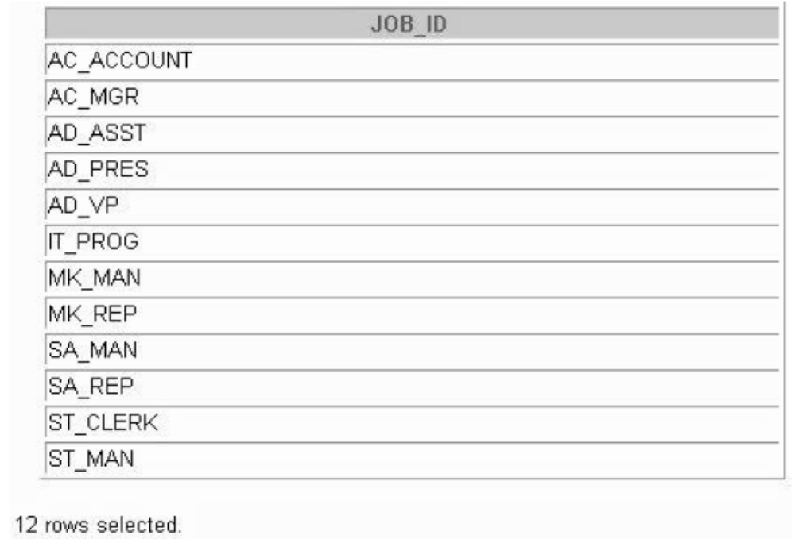
- Show the structure of the DEPARTMENTS table. Select all data from the table.
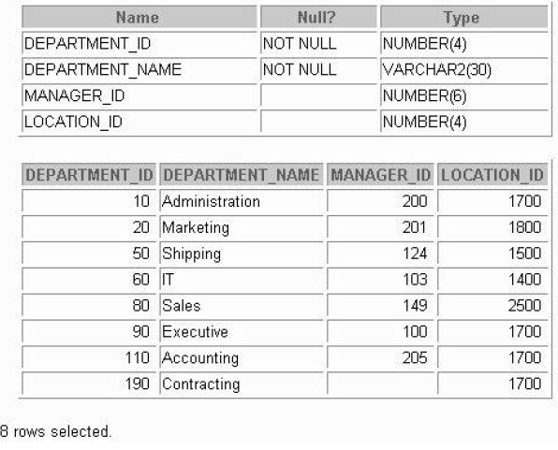
- Show the structure of the EMPLOYEES table. Create a query to display the last name, job code, hire date, and employee number for each employee, with employee number appearing first.
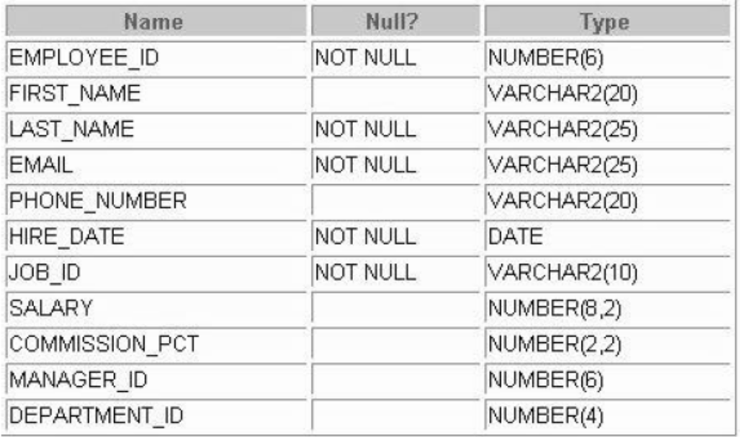
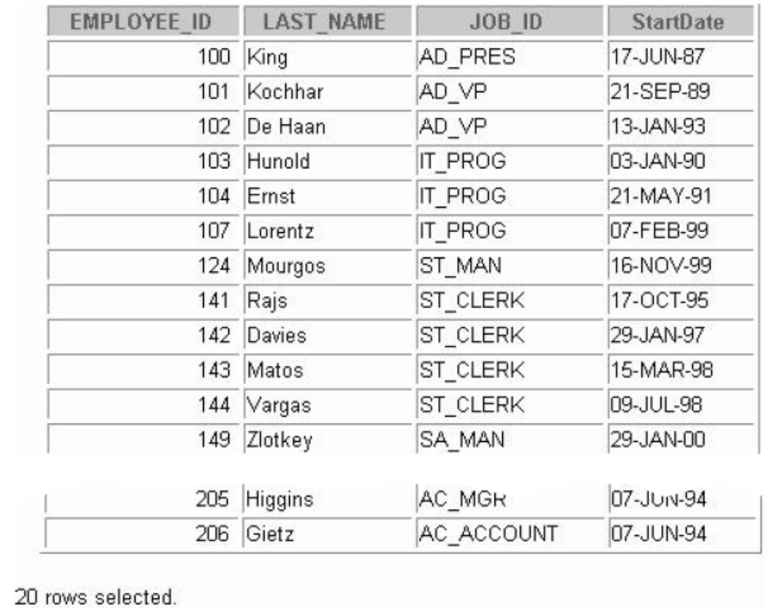
- Create a query to display unique job codes from the EMPLOYEES table.
- Display the last name concatenated with the job ID, separated by a comma and space, and name the column Employee and Title.
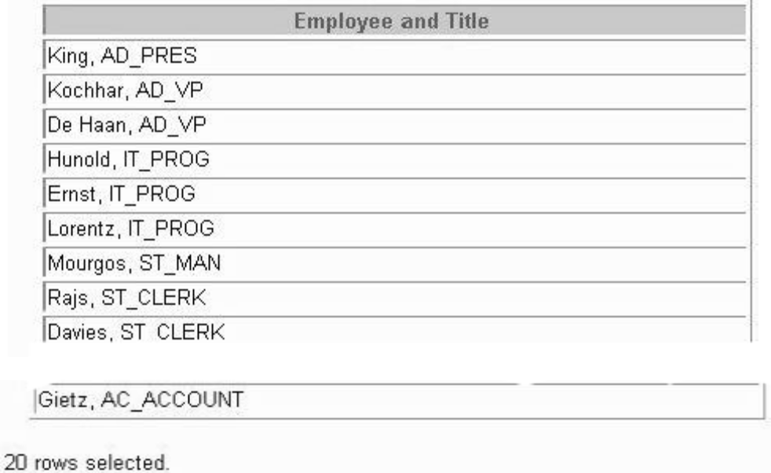
- Create a query to display all the data from the EMPLOYEES table. Separate each column by a comma. Name the column THE_OUTPUT.
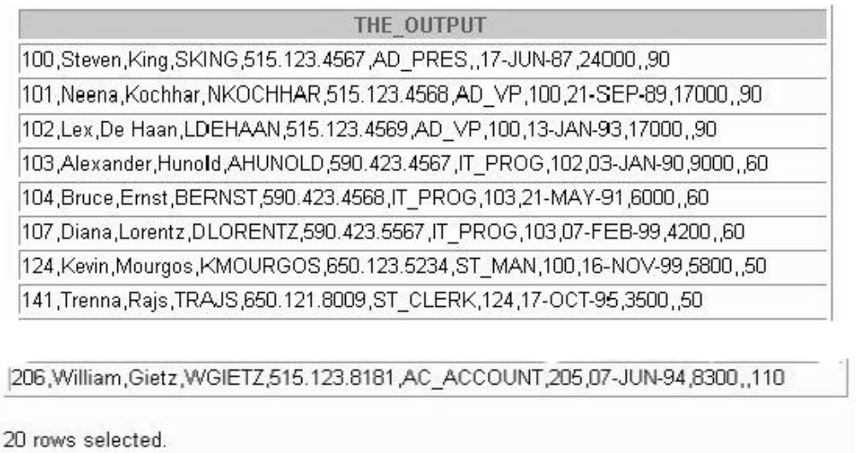

Restricting and Sorting Data
Practice for lesson 5:
- Create a query to display the last name and salary of employees earning more than $12,000.
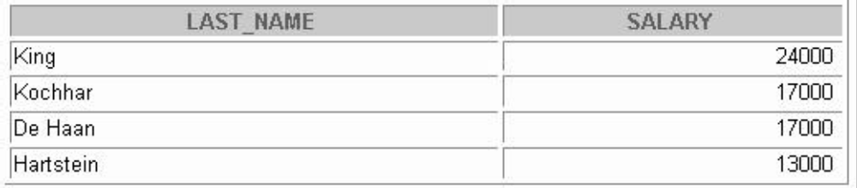
- Display the last name and salary for all employees whose salary is not in the range of $5,000 and $12,000.
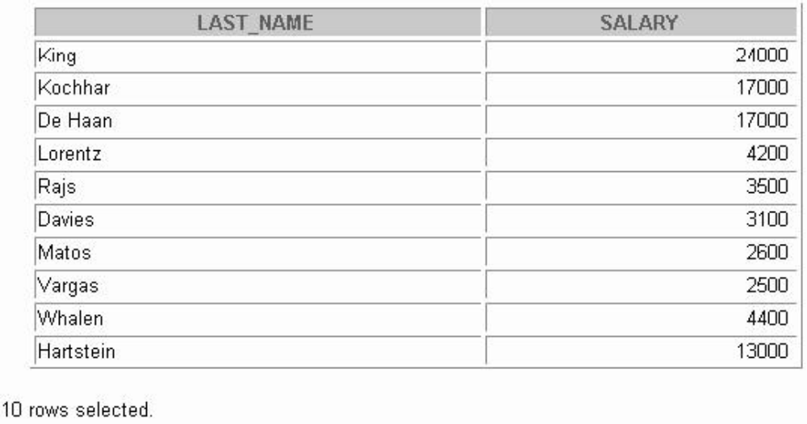
- Display the employee last name, job ID, and start date of employees hired between February 20, 1998, and May 1, 1998. Order the query in ascending order by start date.
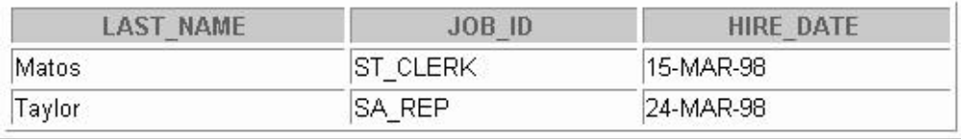
- List the last name and salary of employees who earn between $5,000 and $12,000, and are in department 20 or 50. Label the columns Employee and Monthly Salary, respectively.
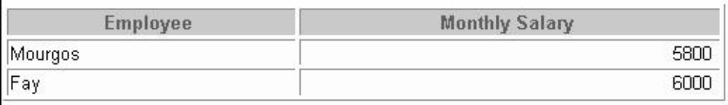
- Display the last name and hire date of every employee who was hired in 1994.
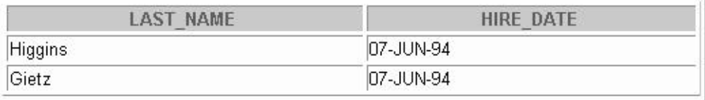
- Display the last name and job title of all employees who do not have a manager.
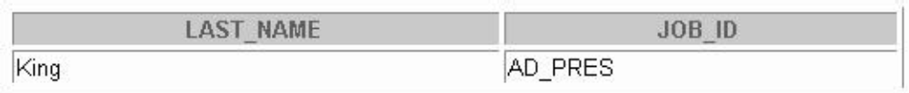
- Display the last name, salary, and commission for all employees who earn commissions. Sort data in descending order of salary and commissions.
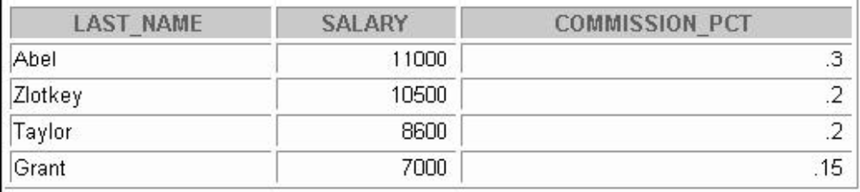
- Display the last names of all employees where the third letter of the name is an a.
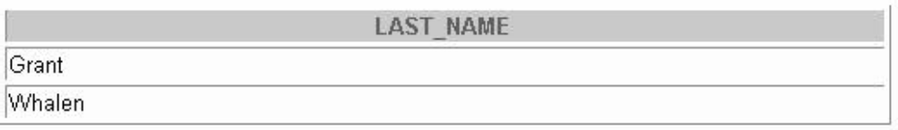
- Display the last name of all employees who have an a and an e in their last name.
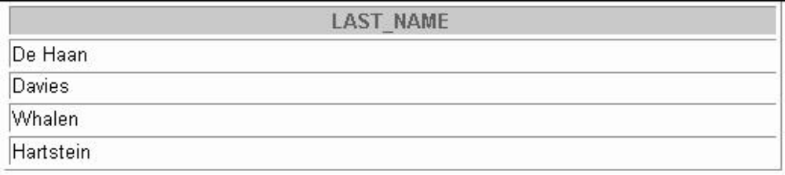
- Display the last name, job, and salary for all employees whose job is sales representative or stock clerk and whose salary is not equal to $2,500, $3,500, or $7,000.
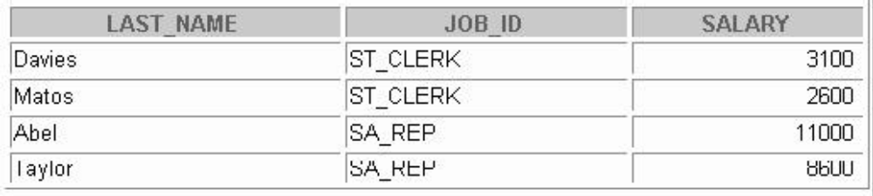
- Display the last name, salary, and commission for all employees whose commission amount is 20%.
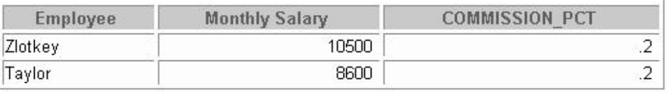

Single Rows Functions
Practice for lesson 6:
- Write a query to display the current date. Label the column Date.
- For each employee, display the employee ID number, last_name, salary, and salary increased by 15% and expressed as a whole number.
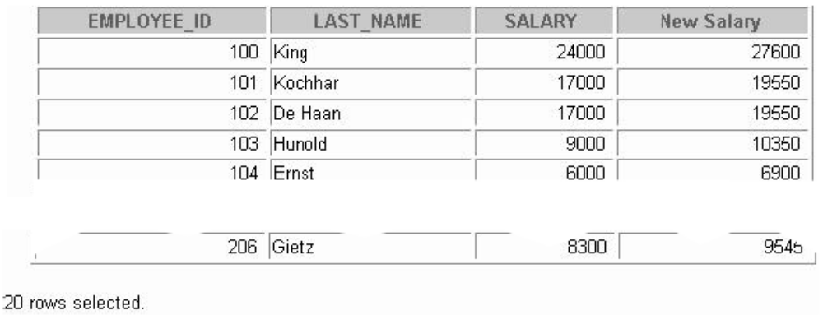
- Subtracts the old salary from the new salary. Label the column Increase.
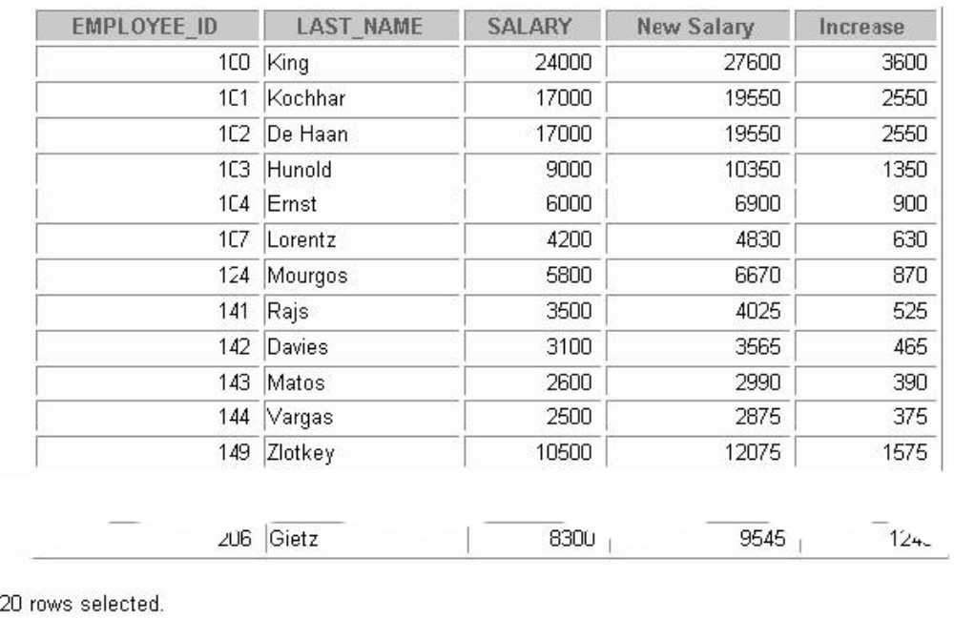
- With the assumption that the salary of each employee is a month salary, calculate the employee’s salary for a year plus 1 month salary as a bonus.
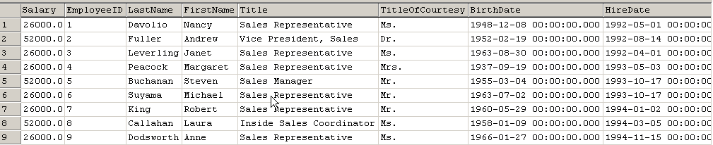
(9 row(s) affected)
- Calculate the average of all employees’ salary.
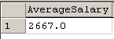
- Write a query that displays the employee’s last names with the first letter capitalized and all other letters lowercase and the length of the names, for all employees whose name starts with J, A, or M. Give each column an appropriate label. Sort the results by the employees’ last names.
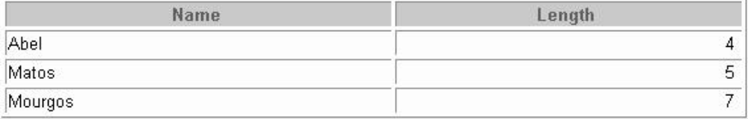
- For each employee, display the employee’s last name, and calculate the number of months between today and the date the employee was hired. Label the column MONTHS_WORKED. Order your results by the number of months employed. Round the number of months up to the closest whole number. Note: Your results will differ.
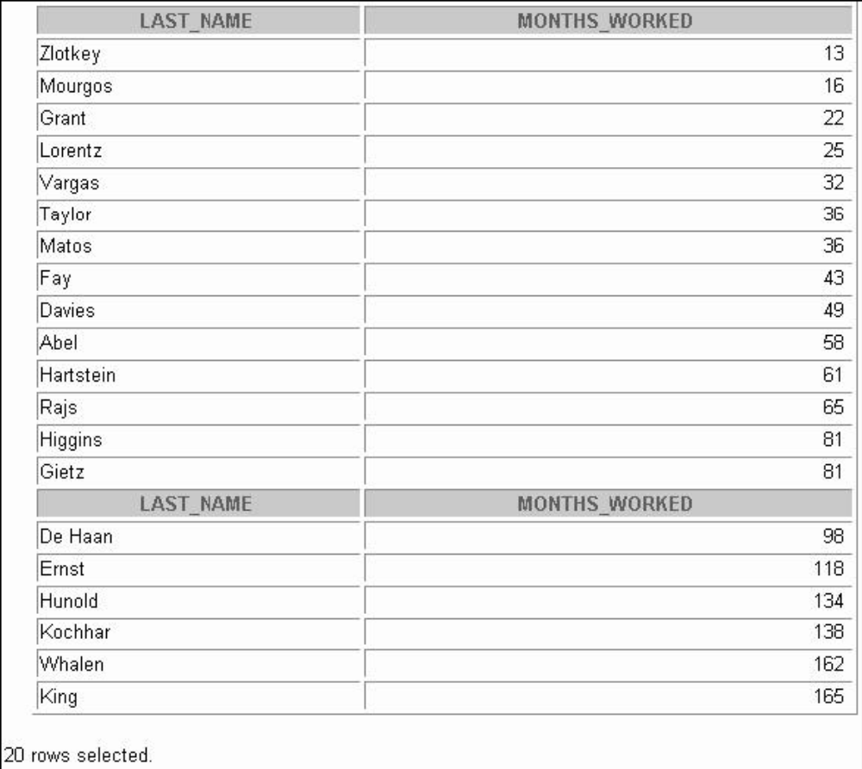
- Write a query that produces the following for each employee:
<employee last name> earns <salary> monthly but wants <3 times salary>. Label the column Dream Salaries.
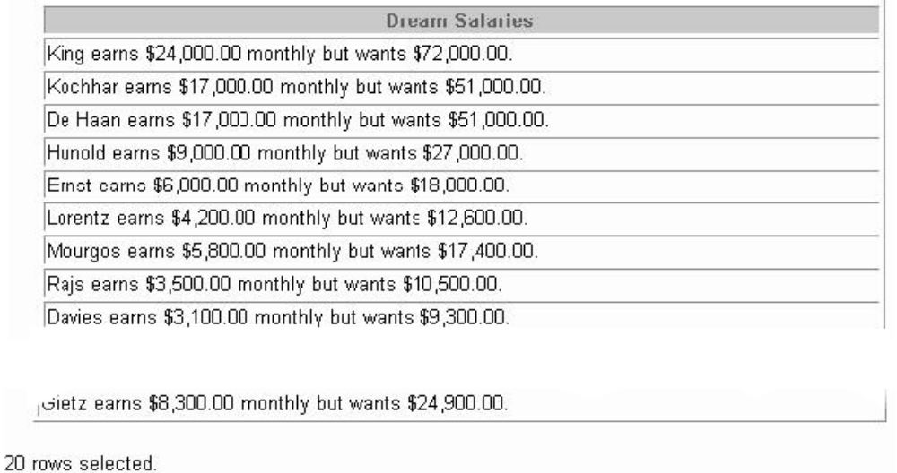
- Create a query to display the last name and salary for all employees. Format the salary to be rupiah, multipled by 10.000 and display with - Rp. 99999, 00

- Display the last name, hire date, and day of the week on which the employee started. Label the column DAY. Order the results by the day of the week starting with Monday.
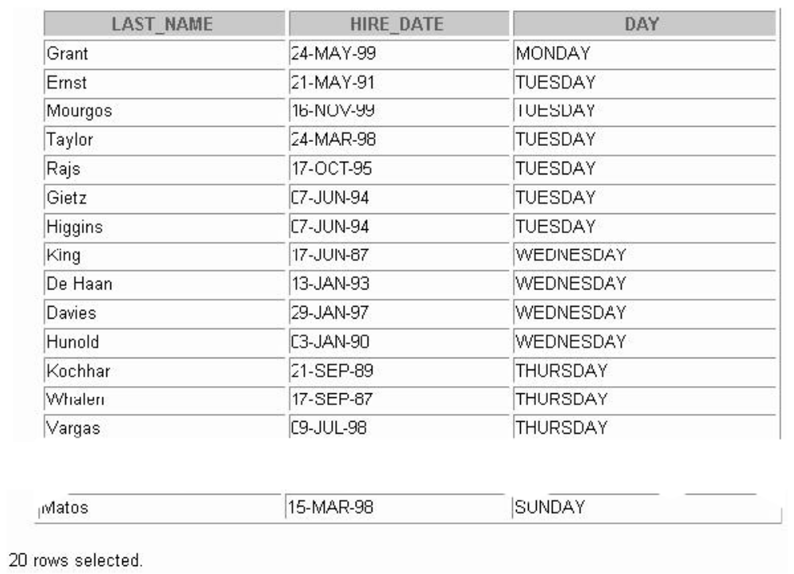
- Create a query that displays the employees’ last names and commission amounts. If an employee does not earn commission, put “No Commission.” Label the column COMM.
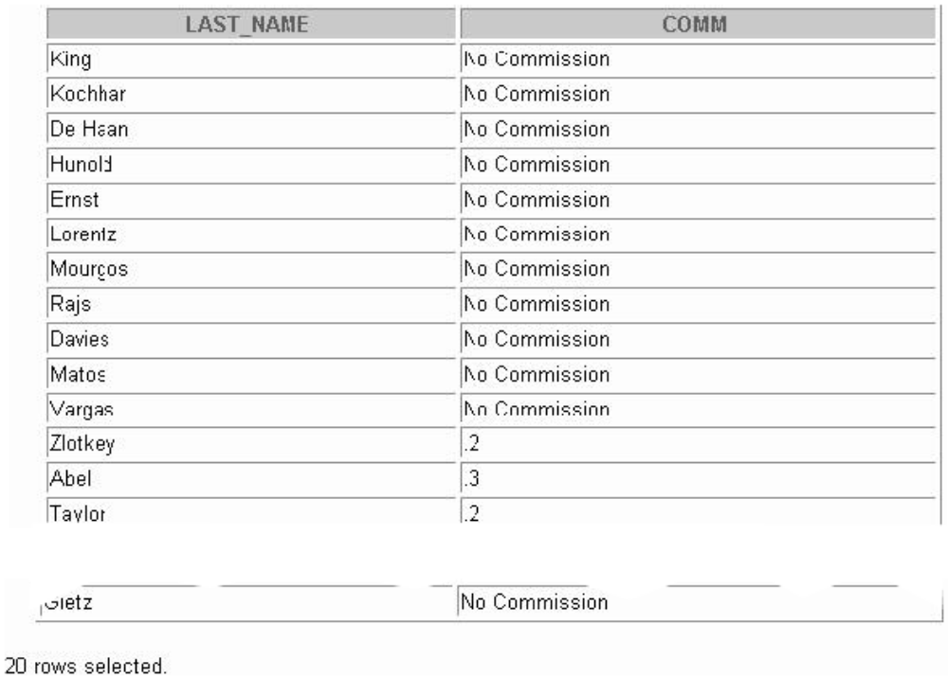
- Create a query that displays the employees’ last names and indicates the amounts of their annual salaries with asterisks. Each asterisk signifies a thousand doll ars. Sort the data in descending order of salary. Label the column EMPLOYEES_AND_THEIR_SALARIES.
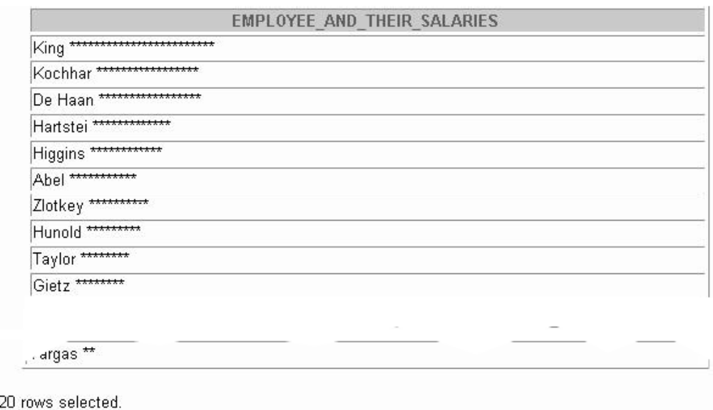
- Using the Case syntax, write a query that displays the grade of all employees based on the value of the column JOB_ID, as per the following data:
Job Grade
AD_PRES A
ST_MAN B
IT_PROG C
SA_REP D
ST_CLERK E
None of the above 0
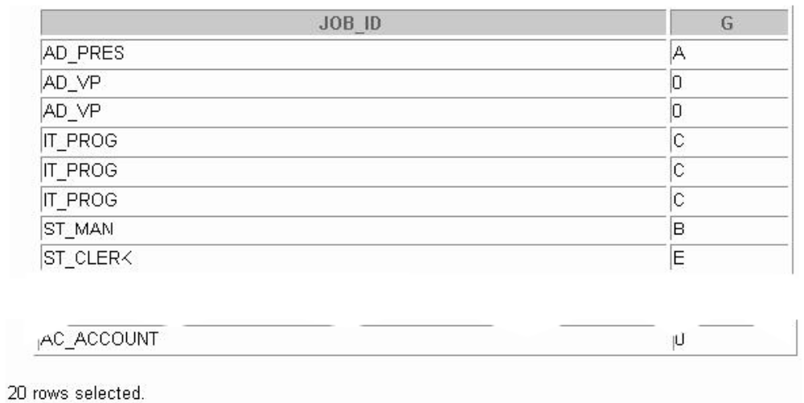

Displaying Data from Multiple Table
Practice for Lesson 7:
- Write a query to display the last name, department number, and department name for all employees.
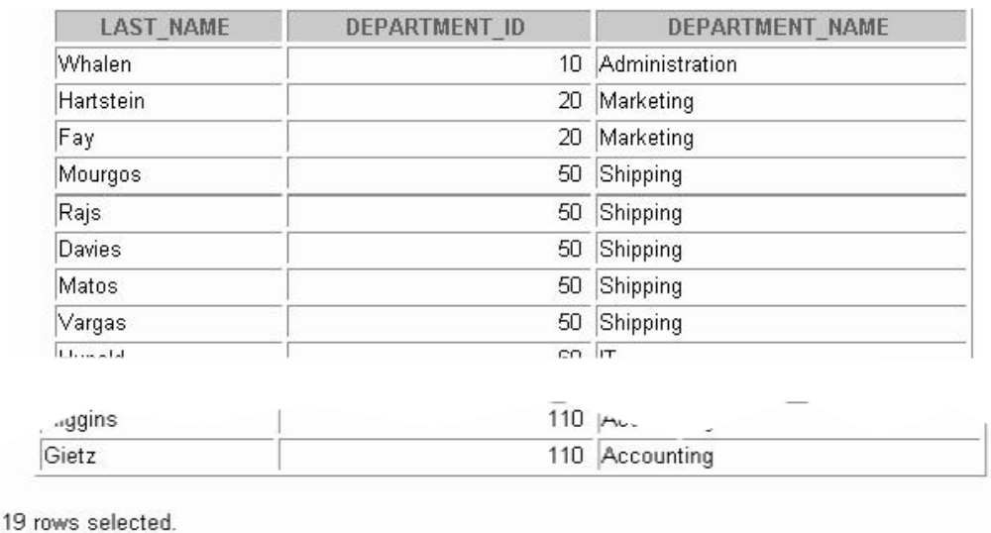
- Create a unique listing of all jobs that are in department 30. Include the location of department 90 in the output.
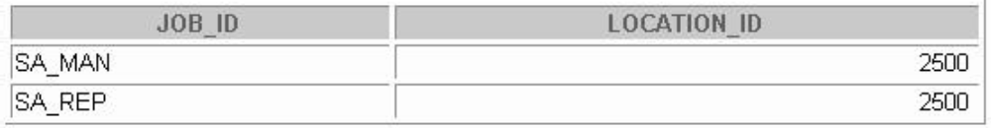
- Write a query to display the employee last name, department name, location ID, and city of all employees who earn a commission.
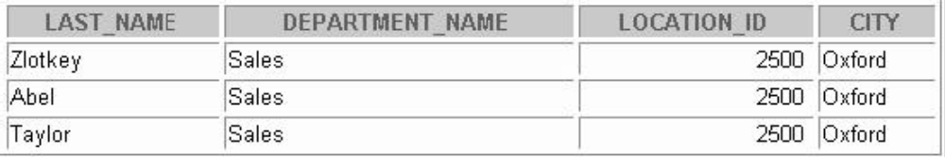
- Display the employee last name and department name for all employees who have an a (lowercase) in their last names. 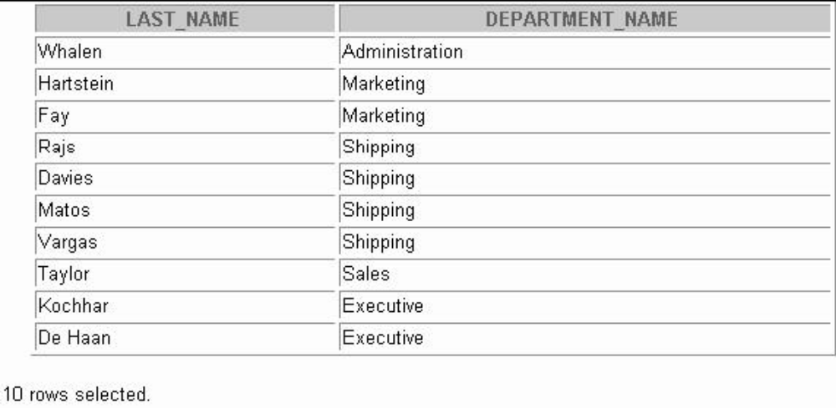
- Write a query to display the last name, job, department number, and department name for all employees who work in Toronto.
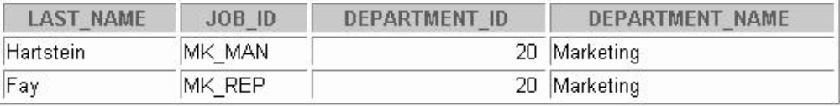
- Display the employee last name and employee number along with their manager’s last name and manager number. Label the columns Employee, Emp#, Manager, and Mgr#, respectively.
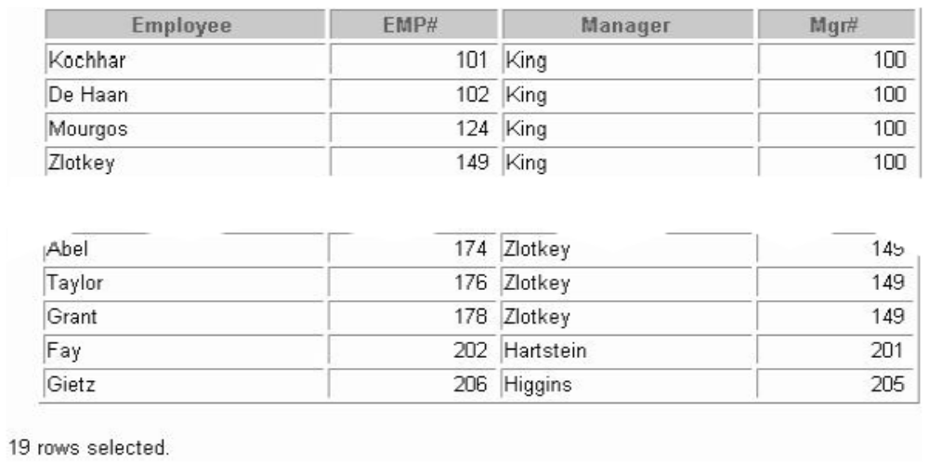
- Display all employees including King, who has no manager. Order the results by the employee number. 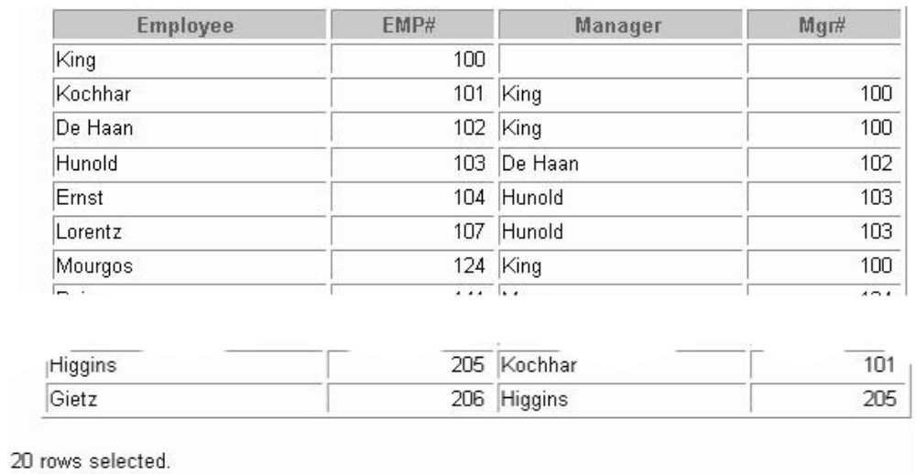
- Create a query that displays employee last names, department numbers, and all the employees who work in the same department as a given employee. Give each column an appropriate label.
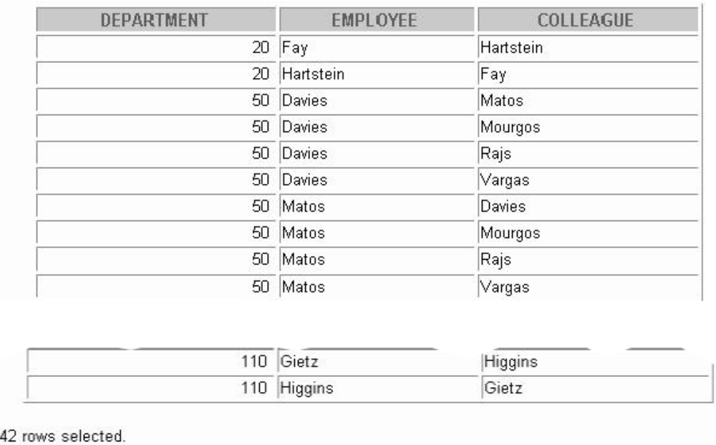
- Show the structure of the JOB_GRADES table. Create a query that displays the name, job, department name, salary, and grade for all employees.
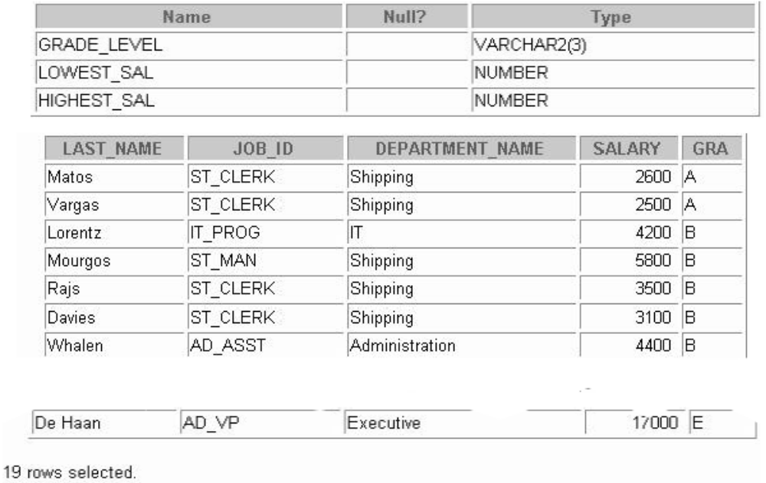
- Create a query to display the name and hire date of any employee hired after employee Davies.
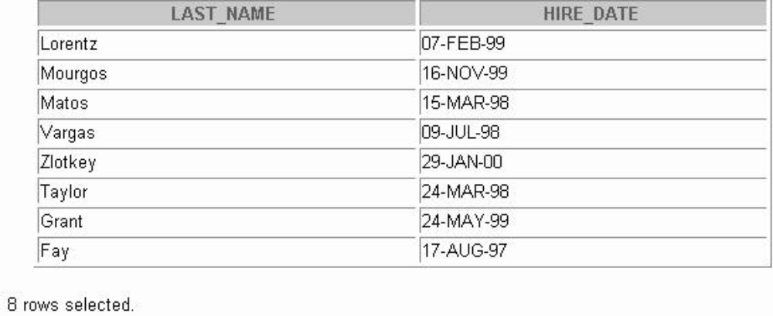
- Display the names and hire dates for all employees who were hired before their managers, along with their manager’s names and hire dates. Label the columns Employee, Emp Hired, Manager, and Mgr Hired, respectively.
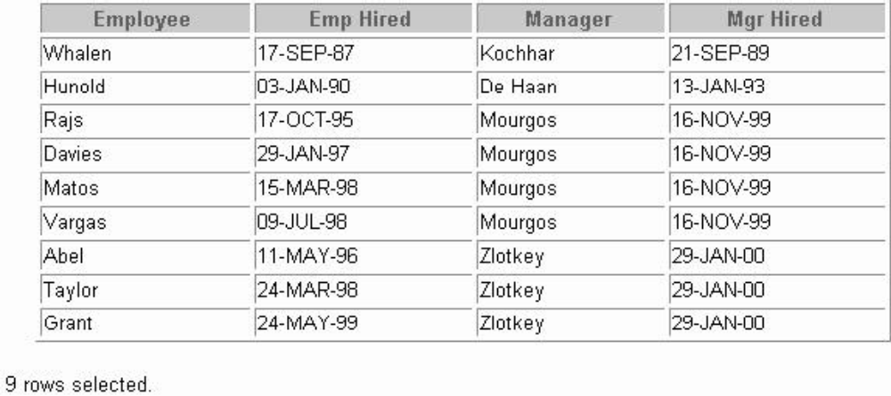

Aggregating Data Using Group
Practice for lesson 8:
- Display the highest, lowest, sum, and average salary of all employees. Label the columns Maximum, Minimum, Sum, and Average, respectively. Round your results to the nearest whole number.
- D the minimum, maximum, sum, and average salary for each job type. 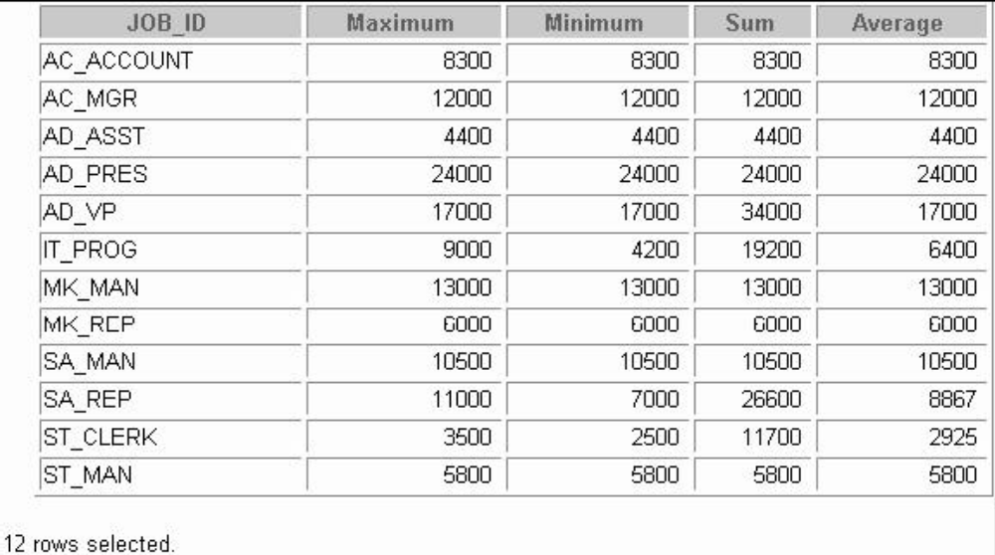
- Write a query to display the number of people with the same job.
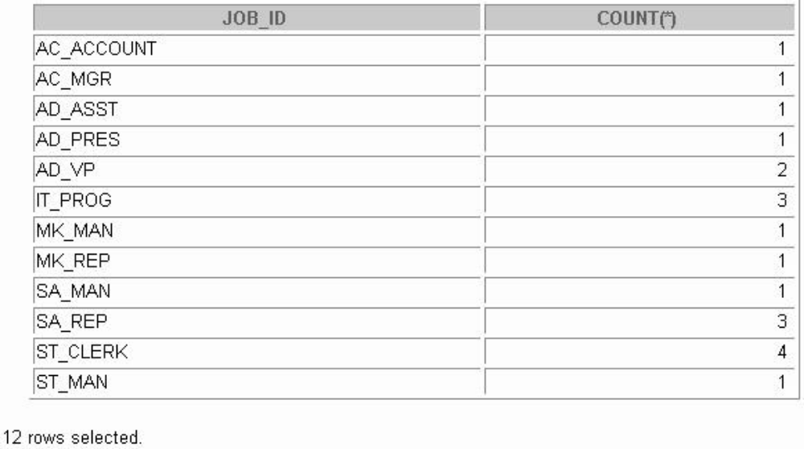
- Determine the number of managers without listing them. Label the column Number of Managers. Hint: Use the MANAGER_ID column to determine the number of managers.
- Write a query that displays the difference between the highest and lowest salaries. Label the column DIFFERENCE.
- Display the manager number and the salary of the lowest paid employee for that manager. Exclude anyone whose manager is not known. Exclude any groups where the minimum salary is less than $6,000. Sort the output in descending order of salary.
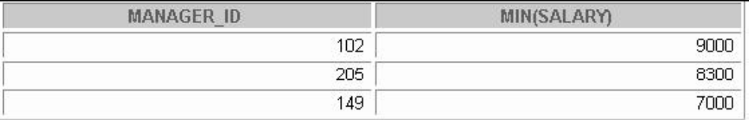
- Write a query to display each department’s name, location, number of employees, and the average salary for all employees in that department. Label the columns Name, Location, Number of People, and Salary, respectively. Round the average salary to two decimal places.
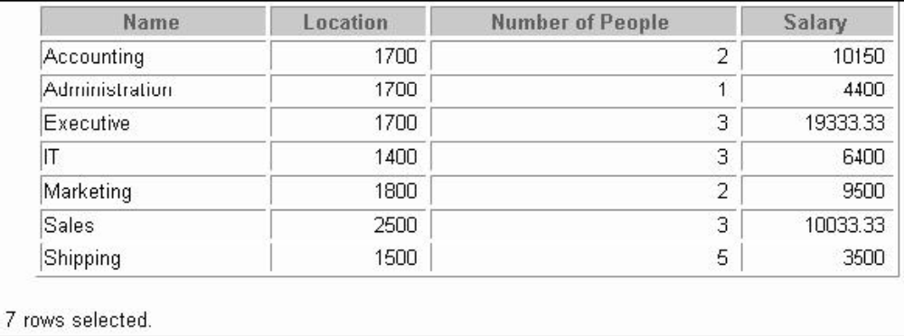
- Create a query that will display the total number of employees and, of that total, the number of employees hired in 1995, 1996, 1997, and 1998. Create appropriate column headings – PIVOT
- Create a matrix query to display the job, the salary for that job based on department number, and the total salary for that job, for departments 20, 50, 80, and 90, giving each column an appropriate heading.
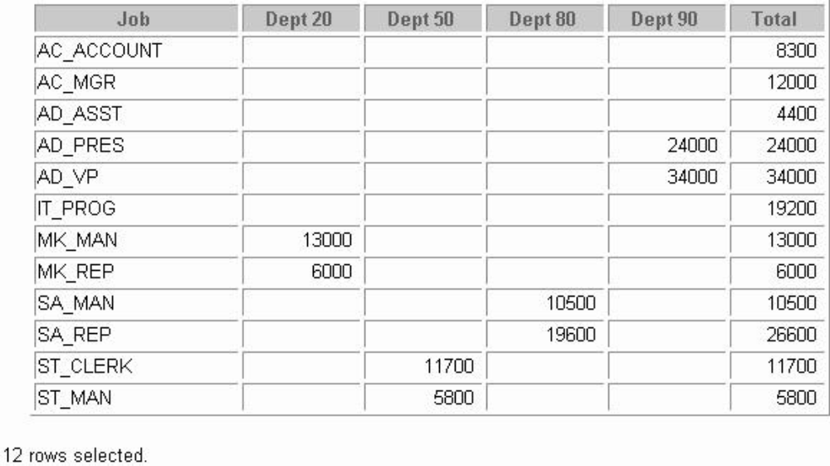

Appendix
ER Diagram of tables used during the practices:
