Mid-Term Exam
(Practice)

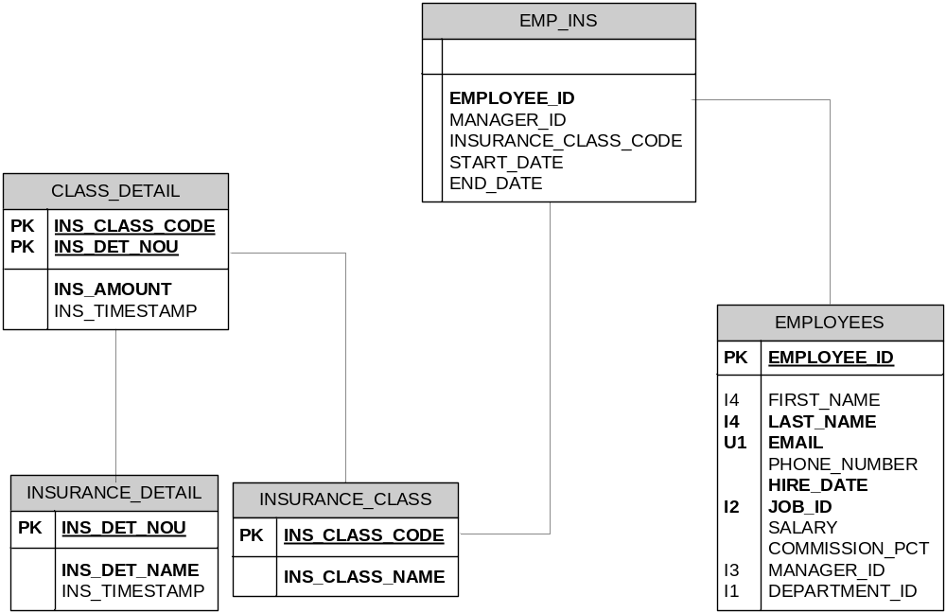

Note:
Use the HR schema

1: Create Insurance_Class table with below specification:

No | Column Name | Datatype | Remarks
1 | Ins_Class_Code | Char(2) | Not Null
2 | Ins_Class_Name | Varchar2(50) | Not Null

2: Create Insurance_Detail table with below specification:

No | Column Name | Datatype | Remarks
1 | Ins_Det_Nou | Integer | Not Null
2 | Ins_Det_Name | Varchar2(50) | Not Null
3 | Ins_TimeStamp | Date | Default from Sysdate

3: Create Class_Detail table with below specification:

No | Column Name | Datatype | Remarks
1 | Ins_Class_Code | Char(2) | Not Null
2 | Ins_Det_Nou | Integer | Not Null
3 | Ins_Amount | Number(20) | Not Null
4 | Ins_TimeStamp | Date | Default from Sysdate

4: Create primary key with below specification:

Table Name | Primary Key Name | Column
Insurance_Class | cPk_Ins_Class | Ins_Class_Code
Insurance_Detail | cPk_Ins_Detail | Ins_Det_Nou
Class_Detail | cPk_Class_Detail | Ins_Class_Code, Ins_Det_Nou

5: Create Foreign Key with below specification:

Table Name | Foreign Key Name | Remarks
Class_Detail | cFK_Ins_Class | Column Ins_Class_Code to Table Insurance_Class Column Ins_Class_Code
Class_Detail | cFk_Ins_Detail | Column Ins_Det_Nou to Table Insurance_Detail Column Ins_Det_Nou

6: Create a query to display all Primary and Foreign Key you have created. Change Constraint_type ‘P’ to ‘Primary Key’ and Constraint_Type ‘R’ to ‘References’.

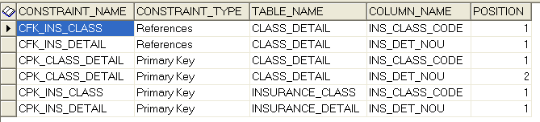

7: Insert below data into Insurance_Class:

No | Ins_Class_Code | Ins_Class_Name | Remarks
1 | A | A Class (Platinum)
2 | B | B Class (Gold)
3 | C | C Class (Silver)
4 | D | D Class (Bronze)
5 | E | E Class

8: Execute Ins_Det.sql for inserting data into Insurance_Detail.
Count number of rows in Insurance_Detail after inserting.

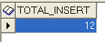

9: Execute Cla_Det.sql for inserting data into Class_Detail
Count number of rows in Class_Detail after inserting.

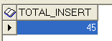

10: Create table Emp_Ins and Insert data from Employees table which is all departments except for Marketing and Accounting departments. Insert only for columns Employee_id and Manager_ID (all records = 102 records)

No | Column Name | Datatype | Remarks
1 | Employee_ID | Number(6) | Not Null
2 | Manager_ID | Number(6)
3 | Insurance_Class_Code | Char(2)
4 | Start_Date | Date
5 | End_Date | Date

11: In emp_ins table, update insurance_class_code column of
- All level 1 employees to ‘A’
- All level 2 employees to ‘B’
- All level 3 employees to ‘C’
Create a query to count records you’ve just updated.

Assumptions:
=========
Level 1 : King (Employee_ID = 100, Manager_ID = null)
Level 2 : All employees under King (Identified by manager_id = 100)
Level 3 : All employees under Level 2 employees

12: Update Emp_Ins table: Set Insurance_Class_Code to ‘D’ for the rest of Employees. Create a query to count records you’ve just updated.

13: Create a query to find all records in Insurance_Detail table that has not been covered by any insurance class.
Hint: Table insurance_detail defines different kind of insurances. Table class_detail defines which insurance classes covers which insurances.

14: Create a read-only view vwInsuranceClassCount that list all insurance classes and number of employees for each of the class.

15: Create a query to list all employees and the sum of insurance amount that is covered for the employee.

16: Create a query to display employees and their insurance class name, starting with employee ‘David Austin’ all the way up to ‘Steven King’.

EMPLOYEE_ID | FIRST_NAME | LAST_NAME | INS_CLASS_NAME
105 | David | Austin | D Class (Bronze)
103 | Alexander | Hunold | C Class (Silver)
102 | Lex | De Haan | B Class (Gold)
100 | Steven | King | A Class (Platinum)

Class detail - emp ins –insu class – insu detail

