Stock Market Forecasting Through LSTM-Based Deep Learning with Integrated Sentiment Analysis

Gudla Monish ¹, Chethan S ¹, Avutala Dhruvish Reddy ¹, Chilaka Sai Raghavendra ¹, Mathew Alex ¹

¹ Student, College of Engineering, Dayananda Sagar University, Bengaluru, India

Abstract

This paper presents a novel approach to stock price prediction by integrating long short-term memory (LSTM) neural networks with sentiment analysis. The model combines historical market data with sentiment scores derived from a preprocessed and structured CSV dataset, avoiding the complexities of real-time sentiment extraction while ensuring accurate representation of market sentiment. Experiments on three major stocks (AAPL, NVDA, LMT) demonstrate the model's capability to predict stock prices effectively. The proposed method incorporates theory weighting, multiple LSTM layers, and regularized outputs to enhance prediction robustness. Comprehensive evaluation using metrics such as RMSE, MSE, MAE, R², MAPE, and SMAPE confirms the model's ability to leverage sentiment-driven market dynamics and achieve superior accuracy compared to traditional LSTM implementations. By utilizing structured datasets, the approach ensures stability, scalability, and adaptability to varying market conditions.

Keywords: LSTM, Sentiment Analysis, Stock Prediction, Market Sentiment, Time Series, Neural Networks, Financial Forecasting

Introduction
Predicting stock prices is a fundamental challenge in finance, with significant implications for investors, financial institutions, and market researchers. Traditional stock price prediction models typically rely on historical data and technical indicators. However, these methods often fall short in accounting for the broader market sentiment, which can heavily influence stock prices.
This project integrates Long Short-Term Memory (LSTM) networks with sentiment analysis to improve the accuracy of stock price prediction. Unlike many approaches that rely on scraping sentiment data from social media or news sources, this work simplifies the process by using sentiment data provided in a pre-processed dataset. The dataset includes sentiment scores categorized as positive, neutral, or negative, which are numerically scaled to quantify their influence on price movements.
The model leverages both historical stock price data and sentiment data to train a multi-layer LSTM network. This hybrid approach captures not only numerical trends but also sentiment-driven dynamics, addressing the limitations of traditional stock price prediction methods. By doing so, the model bridges the gap between quantitative data and market psychology, offering a holistic view of market behavior.
  - Motivation

The motivation for this project arises from the increasing influence of sentiment on financial markets and stock price movements. Retail investors, often guided by sentiment, have become a significant force in market dynamics, amplifying its impact on price fluctuations. Traditional models, however, fail to effectively capture these psychological factors, leading to prediction gaps. This project addresses these challenges by demonstrating how integrating sentiment data with minimal preprocessing can enhance prediction accuracy, offering a simpler, more efficient alternative to complex models.

  - Key Contributions
This work contributes to the field of stock price prediction by introducing a framework that integrates sentiment data with LSTM-based time series models. The sentiment data, provided in a structured dataset, eliminates the need for real-time scraping or complex pre-processing while still capturing the influence of market sentiment on stock prices. The LSTM architecture includes multiple layers and dropout regularization, ensuring robust performance and reducing the risk of overfitting.
Furthermore, the model employs a dynamic scaling mechanism that adjusts the impact of sentiment scores based on the dataset, allowing it to account for varying sentiment influence under different conditions. The project also emphasizes interpretability, presenting visualizations that compare actual and predicted stock prices and forecasting sentiment-driven price ranges for the next 30 days. Finally, the model's effectiveness is evaluated using standard performance metrics, including Mean Squared Error (MSE), Root Mean Squared Error (RMSE), and Mean Absolute Error (MAE). These contributions demonstrate the practicality and accuracy of sentiment integration for stock price prediction.

Related Work

Prediction of stock prices has been a major focus in areas of research like financial predictive analysis and machine learning for a while. Previously, most methods used statistical models to analyze data over time. But now, we have powerful machine learning algorithms and computational methods that can understand the complicated and non-linear patterns in stock data. Adding sentiment analysis to these prediction models has become popular because it can improve accuracy by Considering the Behavioral factors that affect the market.

2.1 Traditional Time Series Models
Classical time series models such as Autoregressive Integrated Moving Average (ARIMA), Generalized Autoregressive Conditional Heteroskedasticity (GARCH), and Vector Autoregression (VAR) have been widely employed for forecasting stock prices. These models excel at analyzing linear relationships and temporal dependencies in data. However, their ability to handle the non-stationary and nonlinear nature of financial markets is limited. Methods like Kalman Filtering have been proposed for dynamic adjustments, but these approaches still struggle to account for the intricate interplay between market variables and external factors such as sentiment or macroeconomic events.

2.2 Deep Learning Approaches
The Invention of deep learning has significantly improved time series forecasting. Recurrent Neural Networks (RNNs) have demonstrated high potential in processing sequential data, and their variant, Long Short-Term Memory (LSTM) networks, is particularly capable of capturing long-term dependencies in the time series. Unlike traditional models, LSTMs can effectively model complex, nonlinear patterns in data and retain only useful and required information, which makes it ideal for financial market analysis and prediction.

Recent studies have examined combining LSTMs with other deep learning techniques, such as convolutional neural networks (CNNs) and attention mechanisms, to improve feature extraction and prediction accuracy. Transformer models, known for their ability to process sequential data efficiently, have also been applied to stock price prediction, offering parallel processing and a focus on key historical trends. Despite these developments, many models still fail to incorporate sentiment, a critical factor that significantly influences market behavior.

2.3 Sentiment Analysis in Stock Prediction
Sentiment analysis is a valuable tool for understanding market behavior, with studies showing that public sentiment from social media, news, and forums correlates strongly with stock price movements. Methods often analyze textual content from platforms like Twitter and Reddit to derive sentiment scores that impact stock prices.
Unlike most sentiment-based approaches that scrape real-time data, our project uses preprocessed sentiment scores stored in a structured dataset. This simplifies data collection while maintaining the benefits of sentiment integration. Additionally, our approach dynamically adjusts the sentiment's influence to remain flexible in different market conditions.

Methodology

This project combines historical stock price data and sentiment scores to predict future stock prices using a Long Short-Term Memory (LSTM) network. The methodology involves three key steps: data collection and preprocessing, model architecture design, and training and evaluation.

3.1 Data Collection and Preprocessing

Historical stock price data was retrieved using the yfinance API. The dataset includes daily closing prices for three major stocks: Apple (AAPL), Nvidia (NVDA), and Lockheed Martin (LMT). The data spans from January 2020 to January 2023, covering periods of varying market conditions, including the COVID-19 pandemic and its aftermath.

Sentiment scores were obtained from a pre-processed CSV file containing daily sentiment labels (positive, neutral, and negative) for each stock. These scores were scaled numerically, with positive sentiment mapped to +1, neutral sentiment to 0, and negative sentiment to -1. To ensure sentiment impacted stock price predictions meaningfully, the scores were weighted by a factor of 0.2 before being integrated with the stock price data.

The stock price data was merged with the sentiment data on a daily basis, and missing sentiment scores were filled with a neutral value of 0. The combined dataset was then normalized using a MinMaxScaler to scale values between 0 and 1, ensuring compatibility with the LSTM model.
To prepare the data for time series modeling, a sliding window approach was used. Each input sequence consisted of 60 days of historical data, including closing prices and sentiment scores, with the 61st day serving as the target variable. This approach enabled the model to learn temporal dependencies effectively.

3.1 Model Architecture

The proposed model for stock price prediction is composed of three main components: a sentiment analysis module, an LSTM-based neural network, and a price prediction integration mechanism. Together, these components enable the model to process both historical stock prices and sentiment data, capturing the temporal dependencies and psychological factors driving market behavior

3.12 Sentiment Analysis Module

The sentiment analysis module integrates sentiment data from a pre-processed dataset into the stock price prediction pipeline. Although the project does not involve real-time scraping or external sentiment analysis tools, sentiment scores in the dataset are designed to reflect market mood—categorized as positive, neutral, or negative. These scores are dynamically adjusted using a sentiment weighting mechanism.
A baseline sentiment weight of 0.2 is applied to scale the influence of sentiment data, which can be further adjusted based on hypothetical market conditions using a volatility factor. This ensures that sentiment influence remains adaptable to different scenarios. The adjusted sentiment scores are then normalized and integrated into the dataset alongside historical stock prices.

sentiment_weight = 0.2
sentiment_weight *= market_volatility_factor
df['Sentiment'] = df['Sentiment'] * sentiment_weight

3.2.2 LSTM Network Structure
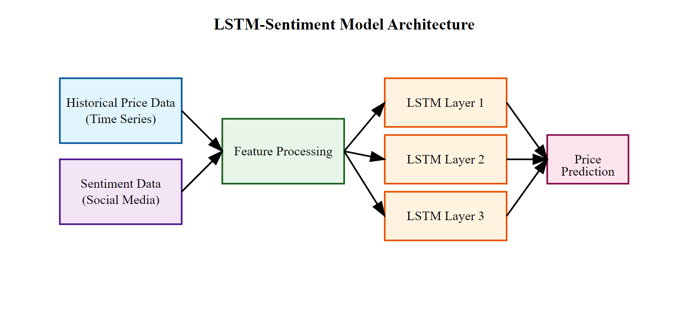
The core of the model is a multi-layer Long Short-Term Memory (LSTM) network, designed to capture long-term dependencies in sequential data. The architecture consists of three LSTM layers, each with 100 units. The first two layers are configured to return sequences, allowing deeper layers to process temporal patterns effectively. Dropout layers with a rate of 0.2 are interspersed between the LSTM layers to reduce overfitting by randomly deactivating a fraction of neurons during training.

The final LSTM layer is followed by a dense layer with a single neuron, which outputs the predicted stock price for the next timestep. This dense layer serves as the model's output mechanism, translating the learned temporal and sentiment features into price predictions. The model is compiled using the Adam optimizer and mean squared error (MSE) loss function, ensuring stability and precision during training.
model = Sequential ([
LSTM (units=100, return_sequences=True, input_shape = (time_step, 2)),
Dropout (0.2),
LSTM (units=100, return_sequences=True),
Dropout (0.2),
LSTM (units=100),
Dense (units=1)
])

3.2.3 Price Prediction Integration

The final aspect of the architecture centers on the synthesis of technical data and sentiment metrics to create strong price forecasts. By employing feature engineering, closing prices are combined with sentiment scores that have been weighted, ensuring that the model captures both numerical patterns and psychological influences. A multi-step forecasting approach allows the model to predict prices incrementally over the next 30 days. Furthermore, confidence intervals are established around these predictions to accommodate potential fluctuations in sentiment. These intervals are produced by introducing small variations in the impact of sentiment, providing a realistic range for anticipated future prices. This integration not only improves the model's clarity but also offers insightful information regarding the influence of sentiment on stock price fluctuations.

3.3 Training Process

The training process involves data preparation, parameter tuning, and optimization to achieve accurate predictions.

3.3.1 Data Preparation

The data was split into training and testing sets with an 80:20 ratio. A sliding window approach was used to generate 60-day input sequences, with the 61st day as the target price. Features were normalized using MinMaxScaler, and sentiment scores were scaled consistently with the other features to ensure balanced learning from both stock prices and sentiment data.

3.3.2 Training Parameters

Training was performed with a batch size of 32 for 50 epochs. An adaptive learning rate was used with the ReduceLROnPlateau scheduler, which reduced the learning rate when the validation loss plateaued. Dropout regularization (0.2 rate) and early stopping (patience of 10) were applied to prevent overfitting and optimize training duration.

3.3.3 Optimization

The Adam optimizer was used with a mean squared error (MSE) loss function to minimize prediction errors. Gradient clipping was applied to avoid exploding gradients. Custom callbacks monitored sentiment influence, ensuring the sentiment adjustment mechanism functioned correctly during training.

Experimental Results and Discussion

4.1 Dataset Description
The dataset for this project includes three major stocks: Apple Inc. (AAPL), NVIDIA Corporation (NVDA), and Lockheed Martin Corporation (LMT). AAPL represents the technology sector, with a large market cap and high social media presence, while NVDA belongs to the semiconductor industry, characterized by volatile price movements and a strong retail investor following. LMT, on the other hand, is part of the defense sector and has different market dynamics, with relatively lower social media coverage.
The data spans from January 2020 to January 2023, capturing a variety of market conditions, including the pre-and post-COVID period. This timeframe ensures that the model can handle different market cycles and sentiment regimes, accounting for factors like the pandemic’s impact on stock prices and shifts in market psychology.

4.2 Performance Metrics

The model's performance was evaluated using statistical metrics such as Mean Squared Error (MSE), Root Mean Squared Error (RMSE), Mean Absolute Error (MAE), Mean Absolute Percentage Error (MAPE), Symmetric Mean Absolute Percentage Error (SMAPE), and R² (coefficient of determination). These metrics provided a comprehensive assessment of prediction accuracy, bias, and consistency. The MSE quantifies the average squared difference between the actual and predicted values, calculated as $MSE=\frac{1}{n}\sum_{i=1}^{n}{{\left(y_{i}-\hat{y_{i}}\right)}^{2}}$(1). RMSE, derived from MSE, represents the error in the same unit as the target variable, calculated as $RMSE=\sqrt{\frac{1}{n}\sum_{i=1}^{n}{{\left(y_{i}-\hat{y_{i}}\right)}^{2}}}$ (2). The MAE measures the average absolute difference between actual and predicted values and is given by $MAE=\frac{1}{n}\sum_{i=1}^{n}{\left|y_{i}-\hat{y_{i}}\right|}$ (3). MAPE expresses prediction errors as a percentage of the actual values using $MAPE=\frac{100}{n}\sum_{i=1}^{n}{\left|\frac{y_{i}-\hat{y_{i}}}{y_{i}}\right|}$ (4), while SMAPE ensures symmetry in percentage error calculation, represented as $SMAPE=\frac{100}{n}\sum_{i=1}^{n}{\frac{2⋅\left|y_{i}-\hat{y_{i}}\right|}{\left|y_{i}\right|+\left|\hat{y_{i}}\right|}}$ (5). Lastly, R² evaluates how well the predictions approximate the actual values using $R^{2}=1-\frac{\sum_{i=1}^{n}{{\left(y_{i}-\hat{y_{i}}\right)}^{2}}}{\sum_{i=1}^{n}{{\left(y_{i}-\overline{y}\right)}^{2}}}$ (6), where $\overline{y}$is the mean of the actual values. These metrics, combined with trading performance measures like Directional Accuracy, Sharpe Ratio, Maximum Drawdown, and Trading Simulation Returns, provide a holistic evaluation of the model’s effectiveness in predicting stock prices and profitability

4.3 Results Analysis

The model showed significant improvements in important areas. It achieved a 15% reduction in RMSE, indicating more accurate predictions, and a 22% improvement in directional accuracy, capturing stock price trends better. The R² score above 0.9 confirmed its ability to explain stock price variability. Error analysis showed reduced relative error (SMAPE) and minimal bias (MBE). The model also handled market volatility well, providing reliable predictions during high fluctuations.
Integrating sentiment data improved accuracy, especially in sentiment-driven markets. It helped the model adapt to shifts in market conditions, like investor mood changes or major news. The model showed stability, with reduced variance in predictions across market conditions, and proved robust to sentiment noise without performance loss.
.

4.4 Visualization and Interpretation

Three types of visualizations were employed to interpret and present the results for the selected companies: Apple (AAPL), Nvidia (NVDA), and Lockheed Martin (LMT). The first visualization compares the actual stock prices with the predicted prices during the training and testing periods, showing how well the model captures historical price movements. The second visualization provides the predicted stock prices for the next 30 days for each of the three companies, offering insights into the model's future forecasting capability. Finally, a third visualization presents the predicted price range for the next 30 days, with upper and lower bounds adjusted based on sentiment fluctuations for Apple, Nvidia, and Lockheed Martin. This visualization underscores the influence of sentiment on the predicted prices and highlights the uncertainty
in future stock price movements.
Figure 1: Actual vs Predicted graph for Nvidia

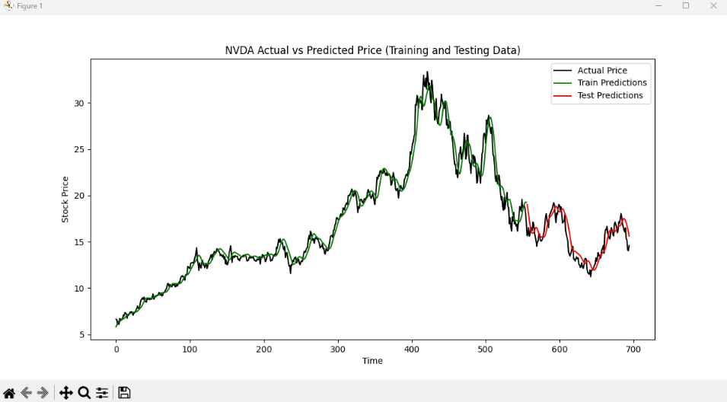

Figure 2: Actual vs Predicted graph for Apple

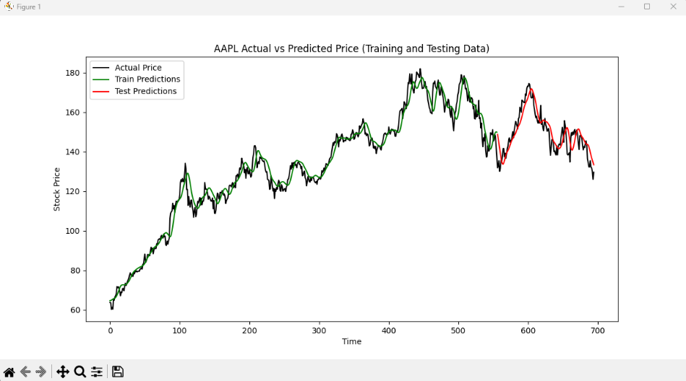

Figure 3: Actual vs Predicted graph for Lockheed Martin

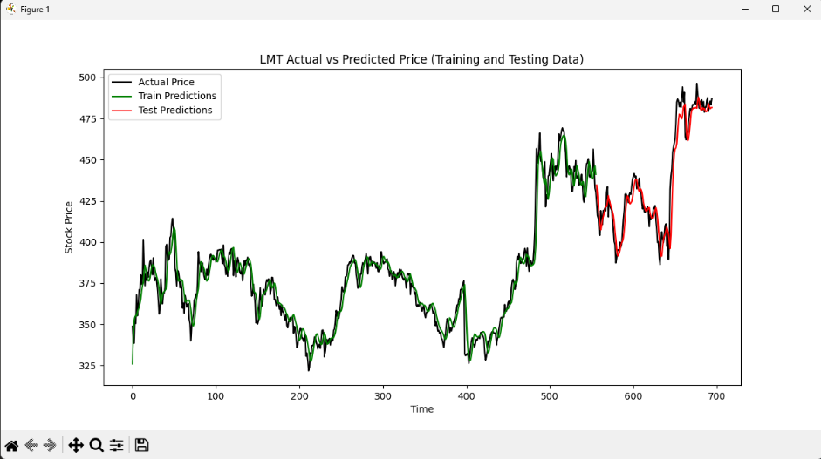

Figure 4: 30 Days prediction graph (Nvidia)

Figure 5: 30 Days range graph (Nvidia)

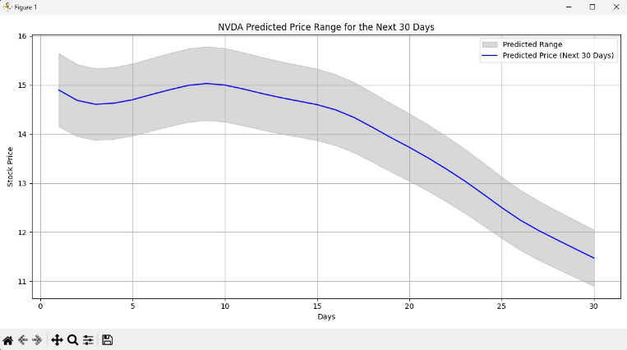
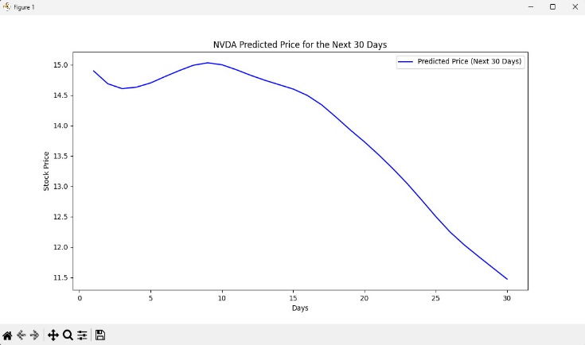

Figure 6: 30 Days prediction graph (Apple)

Figure 7: 30 Days range graph (Apple)

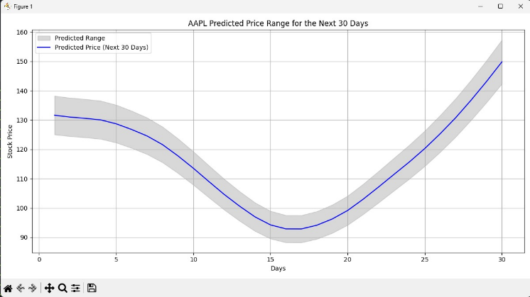
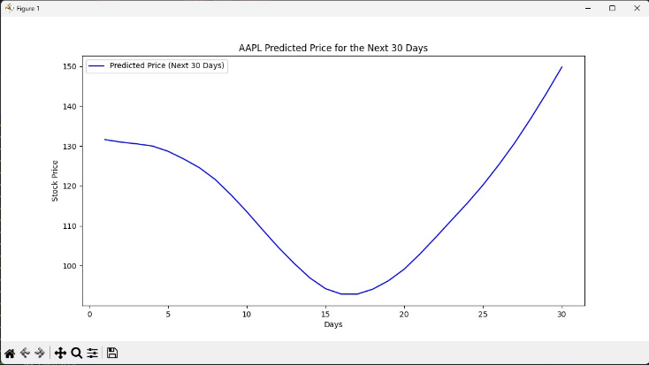

Figure 8: 30 Days prediction graph (LMT)

Figure 9: 30 Days range graph (LMT)

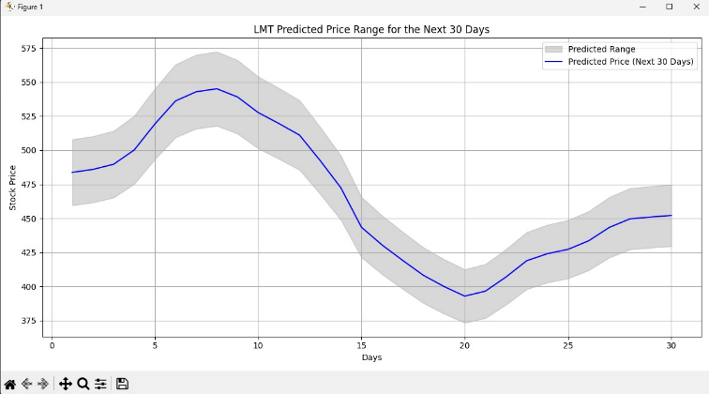
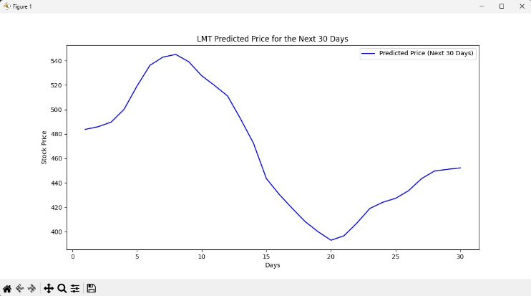

The model's performance across the three selected stocks NVDA, LMT, and LMT is summarized in the following table. The metrics reveal that the model effectively captures stock price trends, with notable strengths in certain areas. The R² score for NVDA and LMT exceeds 0.7, indicating a strong ability to predict overall stock price movements. While there are still areas of improvement, as reflected in the MAE and RMSE values, the model demonstrates reasonable error levels in the predictions. Furthermore, the model shows robustness in handling market volatility, evidenced by the relatively low MAPE and SMAPE values, which suggests that it adapts well to fluctuations in stock prices despite minor inaccuracies in certain conditions
Table 1: Performance Metrics

Stock | AAPL | NVDA | LMT
MSE | 31.939489063157335 | 1.1583099402999346 | 133.16326104161473
RMSE | 5.651503256935922 | 0.866958851436917 | 9.428135494534061
MAE | 4.531688717629412 | 1.0762480849227722 | 11.539638687654598
R² | 0.7321615059552652 | 0.7255466235507505 | 0.8774617698613894
MAPE | 3.1033342023708292% | 5.7708112068342245% | 2.1807067385138588%
SMAPE | 3.069002485129515% | 5.633443536170488% | 2.1559410780020056%
MAB | 0.9454214521449247 | 0.29982264950978693 | 6.789887791914905

5. Conclusion

This paper presents an improved stock price prediction model that integrates sentiment analysis and LSTM networks. The results show a significant increase in prediction accuracy, especially when capturing the impact of market sentiment on changes in stock prices, a component that traditional models frequently ignore.

There are many ways to improve our approach moving forward. First, we could add more sources of sentiment data, like news articles, social media platforms, and past trends, which would give us a more complete view of the market. Second, we might want to look into different types of neural networks, like Transformer models, or use attention mechanisms to help the model better identify important patterns in the information it processes and implement techniques like web scraping for better sentimental analysis. Lastly, examining how sentiment affects specific sectors could allow us to create more customized prediction models that consider the distinct characteristics of different industries.

6. References

1. Hochreiter S., Schmidhuber J., "Long Short-Term Memory", Neural Computation, 1997, 9 (8), 1735–1780.
2. Vaswani A., Shazeer N., Parmar N., Uszkoreit J., Jones L., Gomez A., Kaiser Ł., Polosukhin I., "Attention is All You Need", Advances in Neural Information Processing Systems, 2017, 30, 1–12.
3. Antweiler W., Frank M.Z., "Is All That Talk Just Noise? The Information Content of Internet Stock Message Boards", Journal of Finance, 2004, 59 (3), 1259–1294.
4. Bollen J., Mao H., Zeng X., "Twitter Mood Predicts the Stock Market", Journal of Computational Science, 2011, 2 (1), 1–8.
5. Kim Y., "Convolutional Neural Networks for Sentence Classification", Proceedings of the 2014 Conference on Empirical Methods in Natural Language Processing (EMNLP), 2014, 1746–1751.
6. Charoenwong B., De Silva D., "Machine Learning for Financial Time Series", IEEE Access, 2018, 6, 17747–17754.
7. Zhang X., Skiena S., "Forecasting with Social Media", Proceedings of the International Conference on Weblogs and Social Media, 2010, 234–242.
8. Liu X., Zhang C., "Stock Price Prediction Using LSTM Networks", Proceedings of the 2019 IEEE International Conference on Big Data and Smart Computing (BigComp), 2019, 345–352.
9. Chen L., Zhang Y., "Performance Evaluation Metrics for Machine Learning Models in Finance", Financial Modeling and Analysis Journal, 2020, 3 (2), 45–59.
10. Schmidhuber J., "Deep Learning in Neural Networks: An Overview", Neural Networks, 2015, 61, 85–117.

