## VISVESVARAYA TECHNOLOGICAL UNIVERSITY

### “Jnana Sangama”, Belagavi, Karnataka, INDIA



Mini Project Report on

***CoCode***

*Submitted in partial fulfillment of the requirement for the award of the degree of*

**Bachelor of Engineering in**

**Computer Science and Engineering**

*Submitted By*

**Chandan N 1GA21CS041**

**Monica P 1GA21CS093**

*Under the Guidance of* **Prof. Thaseen Taj** Assistant Professor



### Department of Computer Science and Engineering

**Accredited by NBA(2022-2025)**

## GLOBAL ACADEMY OF TECHNOLOGY

Rajarajeshwarinagar, Bengaluru - 560 098

**2023 – 2024**

# GLOBAL ACADEMY OF TECHNOLOGY

# Department of Computer Science and Engineering

**Accredited by NBA (2022-2025)**



CERTIFICATE

Certified that the project work which is entitled as **CoCode** carried out by Mr. **CHANDAN N,** USN **1GA21CS041** and Ms. **MONICA P ,** USN **1GA21CS093,** are bonafide students of **Global Academy of Technology** in partial fulfillment for the award of Bachelor of Engineering in Computer Science and Engineering of the Visveswaraiah Technological University, Belgaum during the year 2021-25 It is certified that all corrections/suggestions indicated for Internal Assessment have been incorporated in the Report deposited in the departmental library.

The project report has been approved as it satisfies the academic requirements in respect of the Project work prescribed for the said Degree.

Prof. Thaseen Taj Assistant Professor Dept. of CSE

GAT, Bengaluru.

Dr. Kumaraswamy S Professor and Head Dept. of CSE

GAT, Bengaluru.

Dr. H B Balakrishna

Principal

GAT, Bengaluru

## GLOBAL ACADEMY OF TECHNOLOGY

### Department of Computer Science and Engineering

**Accredited by NBA (2022-2025)**



# DECLARATION

We, Chandan N, bearing USN 1GA21CS041, Monica P, bearing USN 1GA21CS093, students of Sixth Semester B.E, Department of Computer Science and Engineering, Global Academy of Technology, Rajarajeshwari nagar Bengaluru, declare that the Project Work entitled ”CoCode” has been carried out by us and submitted in partial fulfillment of the course requirements for the award of degree in Bachelor of Engineering in Computer Science and Engineering from Visvesvaraya Technological University, Belagavi during the academic year 2023 – 2024.

1. **Chandan N 1GA20CS041 Signature**
2. **Monica P 1GA20CS093 Signature**

**Place: Bengaluru Date:19/08/2024**

# ABSTRACT

## In the modern era of software development, collaborative coding has become an essential practice, especially in distributed teams where seamless communication and real-time code sharing are crucial for productivity. Despite the availability of various collaborative tools, many still fall short in terms of versatility, scalability, and user experience. This project, CoCode, addresses these shortcomings by introducing an advanced, web-based collaborative coding platform that supports real-time editing across multiple programming languages. CoCode is designed to be intuitive, offering features like syntax highlighting, immediate code synchronization, and a user-friendly interface that promotes efficient teamwork. Built on modern web technologies, the platform ensures a robust and responsive experience, even under high user loads. With its scalable infrastructure and potential for future enhancements, CoCode stands out as a comprehensive solution for the evolving demands of collaborative software development.

## ACKNOWLEDGEMENT

The satisfaction and the euphoria that accompany the successful completion of any task would be incomplete without the mention of the people who made it possible. The constant guidance of these people and the encouragement provided crowned our efforts with success and glory. Although it is not possible to thank all the members who helped with the completion of the mini-project individually, we take this opportunity to express our gratitude to one and all.

We are grateful to the management and our institute, the **GLOBAL ACADEMY OF TECHNOLOGY,** for its very ideals and inspiration for having provided us with the facilities that made this mini-project a success.

We express our sincere gratitude to **Dr. H B Balakrishna**, Principal, Global Academy of Technology for the support and encouragement.

We wish to place on record our thanks to Dr. Kumaraswamy S, Professor and HOD, Department of CSE, Global Academy of Technology, for the constant encouragement provided to us.

We are indebted with a deep sense of gratitude for the constant inspiration, encouragement, timely guidance, and valid suggestions given to us by our guide **Prof.** **Thaseen Taj** , **Assistant Professor**, Department of CSE, Global Academy of Technology.

We are thankful to all the staff members of the department for providing relevant information and helping in different capacities in carrying out mini-project.

Last, but not least, we owe our debts to our parents, friends, and those who directly or indirectly have helped us to make the mini-project work a success.

**Chandan N 1GA21CS041 Monica P 1GA21CS093**

## TABLE OF CONTENTS

|  |  |  |  |
| --- | --- | --- | --- |
| **Chapter No.** | **Particulars** | **Page. No** |  |
|  | Abstract |  | 1 |
|  | Acknowledgment |  | 2 |
|  | Table of contents |  | 3 |
| 1 | Introduction |  | 5 |
|  | 1.1 Definitions |  | 5 |
|  | 1.2 Project Report Outline |  | 6 |
| 2 | Review of Literature |  | 7 |
|  | 2.1 System Study |  | 7 |
|  | 2.2 Proposed Work |  | 9 |
|  | 2.3 Scope of the project |  | 9 |
| 3 | System Requirement Specification |  | 11 |
|  | 3.1 Functional Requirements |  | 11 |
|  | 3.2 Non-Functional Requirements |  | 11 |
|  | 3.3 Hardware Requirements |  | 12 |
|  | 3.4 Software Requirements |  | 12 |
| 4 | System Design |  | 13 |
|  | 4.1 Design Overview |  | 13 |

* 1. System Architecture 13
  2. Data Flow Diagrams 13
     1. Data Flow Diagram - Level 0 14
     2. Data Flow Diagram - Level 1 14
     3. Data Flow Diagram - Level 2 15

1. Implementation 16
   1. Objective 1 16
   2. Objective 2 16
   3. Results and Discussions 17
2. Conclusion 22

Bibliography 23

### CHAPTER 1

## INTRODUCTION

Collaborative editing enables geographically dispersed users to work together on the same files simultaneously. Traditionally, file sharing involved sending entire copies via email or other channels, with each user editing their own copy and then attempting to integrate changes manually. This process often led to confusion, conflicts, and inefficiencies as users dealt with multiple versions of the file and resolved discrepancies. Today, collaborative code editing tools address these challenges by allowing multiple users to edit a file in real-time, with instant updates visible to all participants. This approach enhances the collaborative process, akin to pair programming, where two or more developers work together on the same codebase. Such tools not only boost productivity and code quality but also facilitate more effective problem-solving through combined expertise. Our platform, CoCode, is a web-based real-time code editor designed to enhance pair programming and collaborative development. It supports simultaneous viewing and editing of code files across a distributed network, providing a seamless and integrated editing experience. By offering real-time synchronization and collaboration features, CoCode improves the efficiency and effectiveness of collaborative coding efforts.

### DEFINITIONS

**CoCode** is an innovative platform designed to revolutionize collaborative coding by enabling real-time code editing and seamless teamwork. Leveraging modern web technologies, CoCode allows multiple users to work on the same codebase simultaneously, with immediate synchronization of changes. This ensures that all participants can see and interact with updates in real time, eliminating the delays and conflicts that often arise in traditional collaborative coding environments.

At the core of CoCode is WebSocket technology, implemented using Socket.io, which ensures that the platform can handle multiple concurrent users efficiently. CoCode supports a wide range of programming languages, making it versatile enough to be used in various coding projects, whether in professional development teams or educational settings. Features like syntax highlighting, language support, and an intuitive user interface make it easy for users to write, edit, and debug code collaboratively.

Designed with both scalability and user experience in mind, CoCode offers a robust solution for today's collaborative coding challenges. Its architecture is built to support future enhancements, such as real-time debugging and version control integration, making it a forward-looking tool that can adapt to the evolving needs of developers and educators alike.

### PROJECT REPORT OUTLINE

* **Introduction:** This section introduces CoCode, outlining its purpose in improving real-time collaborative coding for both professional teams and educational settings. It highlights the project's significance in enhancing productivity and teamwork.
* **Literature Review:** This section reviews relevant literature on existing collaborative coding tools, focusing on their limitations and the advancements in technologies like WebSocket that CoCode leverages. It also discusses the importance of user-friendly design in collaborative environments.
* **Methodology:** This section details the development approach for CoCode, emphasizing the integration of Socket.io for real-time synchronization and the implementation of multi-language support. It also describes the design process for the user interface to ensure a seamless collaborative experience.
* **Results:** This section summarizes the outcomes of the CoCode project, including successful real-time synchronization, positive user feedback, and system performance metrics. It also highlights the effectiveness of the implemented features like syntax highlighting and scalability.
* **Discussion:** This section explores the broader implications of CoCode's success, particularly its potential to improve collaborative coding practices. It also discusses challenges encountered during development and considerations for future enhancements.
* **Conclusion:** This section provides a brief recap of CoCode's achievements, emphasizing its impact on improving real-time collaboration in coding. It also offers a forward-looking perspective on the platform's potential for future development.
* **References:** This section lists the references used throughout the report, providing a concise bibliography of the literature and tools cited. It ensures proper attribution and supports the project's research foundation.

**CHAPTER 2**

## REVIEW OF LITERATURE

### SYSTEM STUDY

1. Nichols, David, Curtis, Pavel, Dixon, Michael & Lamping, John. (1995). High-Latency, Low-Bandwidth Windowing in the Jupiter Collaboration System: This 1995 study explores the challenges of collaborative systems in environments with high latency and low bandwidth. The Jupiter system was designed to allow real-time collaboration despite these constraints. The paper highlights the importance of efficient data synchronization and conflict resolution in collaborative editing environments, offering insights that are still relevant for modern systems dealing with similar network limitations.
2. Christopher R. Palmer and Gordon V. Cormack. (1998). Operation transforms for distributed shared spreadsheet: Palmer and Cormack's 1998 work focuses on operation transformation as a method for maintaining consistency in distributed shared environments, specifically applied to spreadsheets. Their research provides foundational concepts for ensuring data integrity and coherence when multiple users edit a shared document simultaneously, which is crucial for developing robust collaborative coding tools.
3. C.A. Ellis and S.J. Gibbs. (1989). Concurrency control in groupware systems: Ellis and Gibbs discuss the challenges of concurrency control in groupware systems, presenting mechanisms to manage simultaneous edits by multiple users. Their 1989 paper delves into methods that prevent conflicts and ensure a smooth collaborative experience, laying the groundwork for subsequent research and development in real-time collaborative platforms.
4. Stéphane Weiss, Pascal Urso, Pascal Molli. (2009). Logoot: A Scalable Optimistic Replication Algorithm for Collaborative Editing on P2P Networks: This 2009 paper introduces Logoot, an algorithm designed for collaborative editing in peer-to-peer networks. The authors propose a scalable and optimistic approach to replication, which allows multiple users to edit documents concurrently without significant latency. This work is instrumental in developing scalable collaborative platforms that operate efficiently in decentralized networks.
5. Saros Project Documentation (2022): The Saros project documentation provides insights into the architecture of a real-time collaborative editor tailored for distributed environments. It discusses the use of plug-ins to integrate the editor into existing IDEs, enhancing collaboration among developers. This documentation offers practical guidance on building and extending collaborative coding tools within established development workflows.
6. Gotsman, Alexey. (2016). Specification and Complexity of Collaborative Text Editing: This paper provides a detailed analysis of the specification and computational complexity involved in collaborative text editing. Gotsman discusses the theoretical underpinnings of consistency models and operational transformations, offering a framework for understanding the trade-offs involved in designing collaborative systems.
7. Electronics Journal (2020). A Container Orchestration Development that Optimizes the Etherpad Collaborative Editing Tool: This 2020 article presents an enhancement of the Etherpad collaborative editing tool using container orchestration to improve performance and scalability. The study highlights the integration of modern cloud-based technologies to optimize real-time collaboration, making it relevant for developers looking to scale their collaborative platforms.
8. García-Castro, Raúl et al. (2005). COE: A Collaborative Ontology Editor Based on a Peer-to-Peer Framework: This 2005 paper discusses the development of a collaborative ontology editor built on a peer-to-peer framework. The focus is on enabling distributed collaboration on ontology projects, offering insights into the challenges and solutions in developing collaborative tools for specialized domains.
9. Villarreal, Mario et al. (2017). MUTE: A Peer-to-Peer Web-based Real-time Collaborative Editor: The MUTE project focuses on building a peer-to-peer real-time collaborative editor. The paper highlights the benefits of decentralized systems for collaborative editing, including reduced reliance on centralized servers and improved fault tolerance, which are key considerations for modern collaborative tools.
10. Neal, Patricia et al. (2020). Shared Editing on the Web: A Classification of Development Tools: This 2020 study categorizes various tools and technologies used for shared editing on the web. The authors provide an overview of the capabilities, limitations, and use cases of different collaborative editing tools, offering a comparative analysis that is valuable for developers selecting the right technologies for their projects.

### PROPOSED WORK

The proposed work aims to develop a Collaborative Code Editor that facilitates real-time, multi-user editing, enhancing collaborative coding experiences and productivity. The system will incorporate advanced synchronization mechanisms, support for multiple programming languages, and a user-friendly interface. The project will consist of four main components:

* **Real-Time Synchronization and Editing:** Implement a robust WebSocket-based infrastructure to allow multiple users to edit code simultaneously, with changes instantly synchronized across all users' screens. This will ensure a seamless and efficient collaborative environment.
* **Multi-Language Support and Syntax Highlighting:** Integrate support for a wide range of programming languages using the Monaco Editor. The editor will automatically detect and highlight syntax for various languages, providing a versatile platform for different coding projects.
* **Interactive Web Interface Development:** Develop an intuitive web interface using React, enabling users to create, join, and collaborate in coding sessions effortlessly. The interface will feature customizable settings, language selection, and real-time user activity tracking to enhance the collaborative experience.
* **Terminal Integration and Output Management:** Incorporate a terminal within the editor to allow code execution directly from the interface. The terminal will display output and error messages in real-time, supporting multiple executions and ensuring that all users in the session can view the results.

### SCOPE OF THE PROJECT

The scope of the Collaborative Code Editor project encompasses various critical aspects, including real-time collaboration, multi-language support, user interface design, terminal integration, and deployment and testing.

* Real-Time Collaboration: The project will focus on implementing a WebSocket-based system to enable multiple users to collaboratively edit code in real-time. This will involve ensuring low latency and high synchronization accuracy across all users in a session.
* Multi-Language Support: We will integrate support for various programming languages using the Monaco Editor. This includes implementing syntax highlighting, auto-completion, and language-specific features to cater to a broad range of coding projects.
* User Interface Design: An intuitive and interactive web interface will be developed using React. The interface will allow users to create and join coding sessions, select programming languages, and track real-time collaboration seamlessly.
* Terminal Integration: The project will also include the integration of a terminal within the editor, allowing users to execute code directly from the interface. This will involve managing outputs, error reporting, and enabling multiple executions for different languages.
* Deployment and Testing: Finally, the Collaborative Code Editor will be deployed on a suitable platform, followed by thorough testing to ensure the system's functionality, reliability, and scalability in handling multiple users and large codebases.

**CHAPTER 3**

## SYSTEM REQUIREMENT SPECIFICATION

### FUNCTIONAL REQUIREMENTS

* **Real-Time Collaboration:** The system should support real-time collaborative editing, allowing multiple users to simultaneously edit the same code file with immediate synchronization across all connected clients.
* **Language Support:** It should provide robust support for multiple programming languages, offering syntax highlighting, code formatting, and language-specific features for enhanced coding efficiency.
* **User Interface:** The interface should be intuitive and user-friendly, enabling seamless navigation, easy access to key features like language selection and file saving, and providing real-time feedback on code changes.
* **Terminal Integration:** The system should include a terminal feature that allows users to run and debug code collaboratively, with outputs visible to all users in a session. The first client in the room should have control over running the code.
* **Error Handling:** The system should implement robust error handling within the terminal, providing clear and actionable error messages, including line numbers, to facilitate efficient debugging and collaboration.

### NON-FUNTIONAL REQUIREMENTS

* **Real-Time Responsiveness:** The system must ensure low latency and quick synchronization between users during collaborative editing sessions to maintain a seamless experience.
* **Scalability:** It should be capable of handling multiple simultaneous users and large-scale code collaboration projects, ensuring consistent performance as the user base expands.
* **Reliability:** The system should be highly reliable, with minimal downtime and robust handling of network disruptions to ensure uninterrupted collaborative sessions.
* **Security:** The system must prioritize data security, ensuring that code and user interactions are protected from unauthorized access and potential breaches during collaborative sessions.

### HARDWARE REQUIREMENTS

* Storage: Adequate storage capacity is required to handle multiple users' code files, synchronization data, and any related project resources during collaborative editing sessions.
* Network Infrastructure: Reliable and high-speed internet connectivity is essential to ensure seamless real-time collaboration and quick synchronization of code among users.

### SOFTWARE REQUIREMENTS

* Operating System: Use a compatible operating system such as Linux, macOS, or Windows to run the development environment and server.
* Programming Languages: Implement the application using JavaScript for both frontend and backend development, leveraging Node.js and React.js frameworks.
* WebSocket Library: Use Socket.io to manage real-time communication and synchronization between clients during collaborative coding sessions.
* Code Editor Integration: Integrate Monaco Editor to provide an in-browser code editing experience with support for multiple programming languages and real-time collaboration features.

**CHAPTER 4**

## SYSTEM DESIGN

### DESIGN OVERVIEW

### The design of the CoCode platform focuses on creating a seamless real-time collaborative coding environment. The architecture is built using a client-server model where multiple clients (users) can connect to a server and join specific coding sessions or rooms. The frontend, developed with React.js, features an integrated Monaco Editor that allows users to write and edit code collaboratively. The backend, powered by Node.js and using Socket.io, handles real-time synchronization of code changes, user management, and room creation. The design ensures that users can see changes made by others instantly, and the system is scalable to support multiple users and coding sessions simultaneously. Additionally, the UI is designed to be intuitive, offering features like language selection, terminal functionality, and file saving options to enhance the collaborative experience.

### SYSTEM ARCHITECTURE

### The system architecture of the CoCode platform is structured as a distributed client-server model to facilitate real-time collaborative coding. On the frontend, the application is built using React.js, which incorporates the Monaco Editor to provide a rich, interactive code editing experience. The user interface is designed for ease of use, with features that support real-time code updates and collaborative functionality. The backend, constructed with Node.js and Socket.io, is responsible for managing WebSocket connections, ensuring that code changes are broadcasted and synchronized across all users instantaneously. This setup supports a scalable architecture through load balancing, maintaining high performance and responsiveness even during peak usage. The modular design of the system allows for future enhancements, such as the addition of advanced debugging tools and version control integration, ensuring that CoCode remains adaptable and robust for evolving development needs.

### DATA FLOW DIAGRAM

#### 4.3.1 DATA FLOW DIAGRAM LEVEL 0

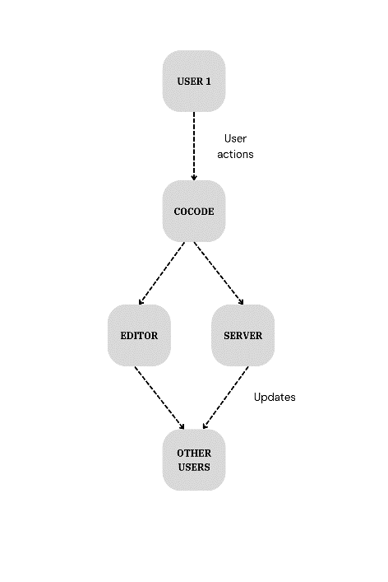

Figure 4.1: Data flow diagram level 0

The Level 0 DFD for CoCode demonstrates the high-level interactions between developers and the system. Developers connect to the CoCode platform, where their actions, such as code edits and file saves, are processed by the system. The system then updates the real-time editor and synchronizes these changes across all users’ editors to ensure that everyone sees the same version of the code. The server plays a crucial role in managing these interactions and maintaining the collaborative environment. This diagram provides a simplified view of how data flows and how different components interact to support real-time collaborative coding.

#### DATA FLOW DIAGRAM LEVEL 1

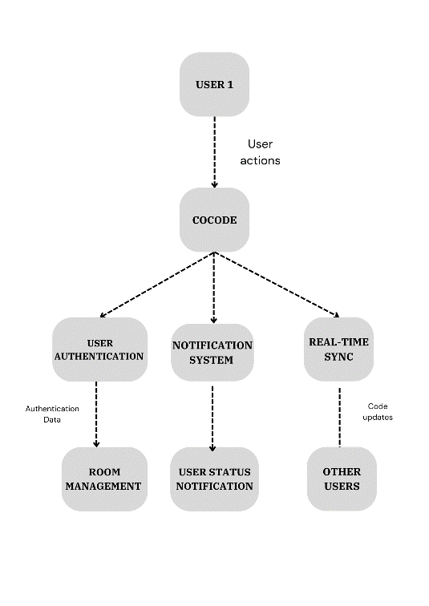

Figure 4.2: Data flow diagram level 1

In the Level 1 Data Flow Diagram for CoCode, the system’s internal processes illustrate user interactions and functions. User Authentication manages login and registration data, enabling access to accounts. Code Editing records changes, while Real-Time Synchronization updates code across all screens. Room Management oversees user sessions and collaborative environments. The Notification System sends alerts for significant events, including user entries and exits, and User Status Notifications keep participants informed about the current state of the room.

#### DATA FLOW DIAGRAM LEVEL 2

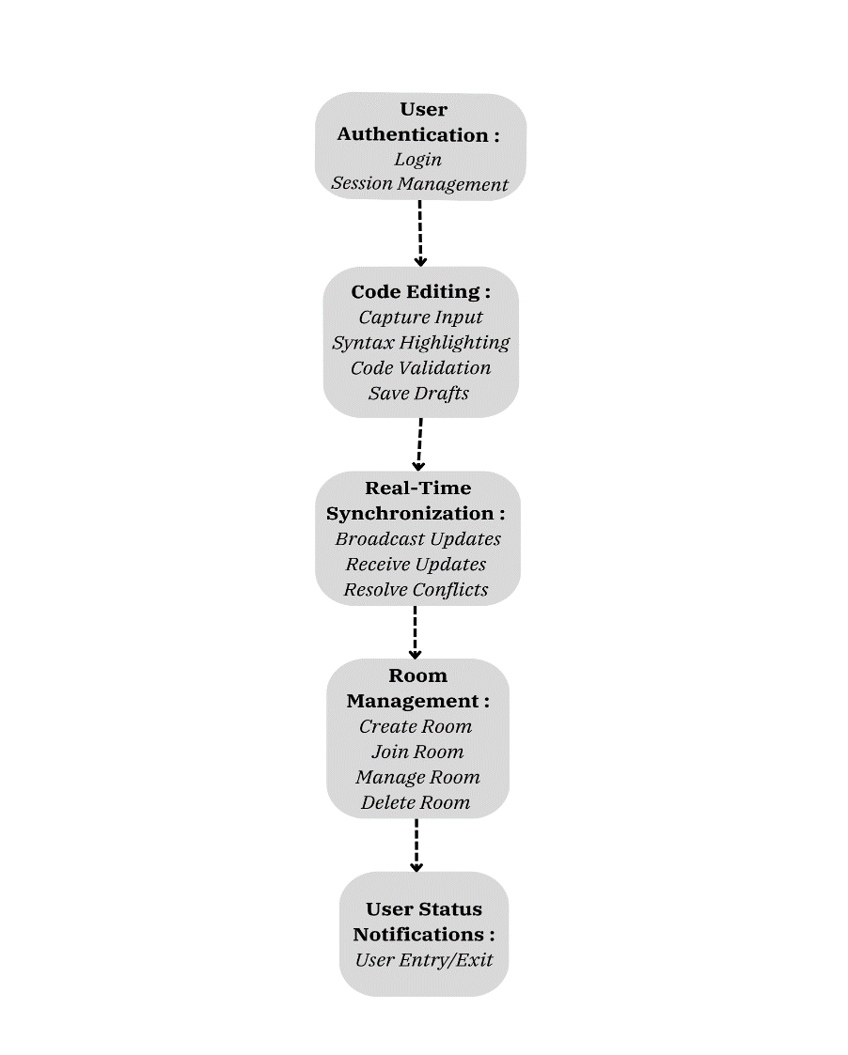

Figure 4.3: Data flow diagram level 2

In the Level 2 Data Flow Diagram for CoCode, detailed interactions and functionalities are illustrated. User Authentication includes login, registration, and session management. Code Editing involves input capture, syntax highlighting, validation, and saving drafts. Real-Time Synchronization handles updates, conflict resolution, and broadcasting. Room Management covers room creation, joining, and management. The Notification System sends alerts for user entries and exits. The flowchart depicts these processes and the data flow between user interfaces, system components, and external systems.

**CHAPTER 5**

### OBJECTIVE 1

## IMPLEMENTATION

Real-Time Code Collaboration : The first objective focuses on enabling effective real-time collaboration in the CoCode platform. The implementation includes several key components:

* Real-Time Synchronization: This involves broadcasting code changes to all connected users and ensuring that all code updates are synchronized in real-time. Mechanisms are put in place to handle and resolve any conflicts that arise when multiple users edit the same code simultaneously.
* User Authentication and Session Management: Users are required to log in and register to access collaborative features. The system manages user sessions to ensure secure and personalized access.
* Code Editing Features: The platform supports advanced code editing functionalities such as syntax highlighting, auto-completion, and error checking to enhance the coding experience.

### OBJECTIVE 2

Enhanced Collaborative Experience : The second objective aims to improve the collaborative coding environment by streamlining interactions and managing user activities:

* Notification System: Implement a robust notification system that alerts users about significant events such as code changes, user entries, and exits in the collaborative workspace. This feature ensures that all participants are aware of the ongoing activities and status updates within the room.
* Room Management: Efficiently manage collaborative spaces by allowing users to create, join, and manage rooms. This includes handling user permissions and maintaining room configurations.
* Performance Optimization: Focus on optimizing the system's performance to handle a large number of concurrent users and ensure smooth operation under high traffic conditions. This includes minimizing latency and improving the responsiveness of real-time interactions.

### RESULTS AND DISCUSSIONS

The Results and Discussions section of the CoCode project highlights the outcomes, performance evaluations, and insights drawn from the implementation of the real-time collaborative coding platform. This section encompasses the analysis of system performance, the effectiveness of implemented algorithms, and reflections on the overall project. The key components discussed include:

* Performance Metrics Evaluation: The effectiveness of CoCode is assessed through key performance indicators such as response time, synchronization accuracy, and system reliability. These metrics serve as quantitative measures of how well the system handles real-time code collaboration, user interactions, and data consistency across different clients. The results demonstrate the system's capability to maintain seamless collaboration with minimal latency, providing a robust environment for multiple users to code together.
* User Experience Analysis: The accuracy of real-time code synchronization is examined by evaluating how well CoCode manages simultaneous edits from multiple users. The discussion delves into the algorithms used to resolve conflicts and merge changes efficiently, ensuring that all participants have a consistent view of the code. Additionally, the user experience is evaluated, focusing on the ease of use, interface intuitiveness, and the effectiveness of the notification system in keeping users informed of important events, such as code changes and user entries or exits.
* Challenges and Limitations: During the development and implementation of CoCode, several challenges arose, including handling network disruptions, managing concurrent users, and optimizing system performance under load. These challenges are thoroughly examined, along with the system's limitations, such as potential scalability issues and the need for further optimization to handle larger groups of users. The discussion also touches on the trade-offs made during development and the areas where future improvements could enhance system performance and user experience.
* Future Directions and Recommendations: Building on the insights gained from the project, this section outlines a strategic roadmap for future enhancements to CoCode. Recommendations include optimizing the synchronization algorithms for even greater accuracy and speed, refining the user interface to provide a more streamlined and intuitive experience, and exploring the integration of additional features such as code versioning, advanced debugging tools, and expanded language support. The potential for scaling the platform to accommodate larger teams and more complex coding environments is also discussed, setting the stage for CoCode's continued evolution as a leading real-time collaborative coding tool.

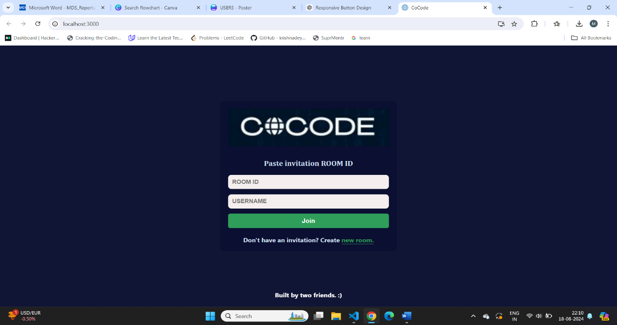

Figure 5.3.1 CoCode Dashboard

The CoCode System Dashboard serves as the main interface for users to manage their collaborative coding activities. It provides a centralized overview of all ongoing projects, recent coding sessions, and available rooms, making it easy for users to track their progress and stay organized. The dashboard’s intuitive design allows quick navigation between different sections, offering users seamless access to essential tools and settings. By unifying all these features in a single space, the dashboard ensures that users can efficiently manage their workflow and focus on coding without unnecessary distractions.

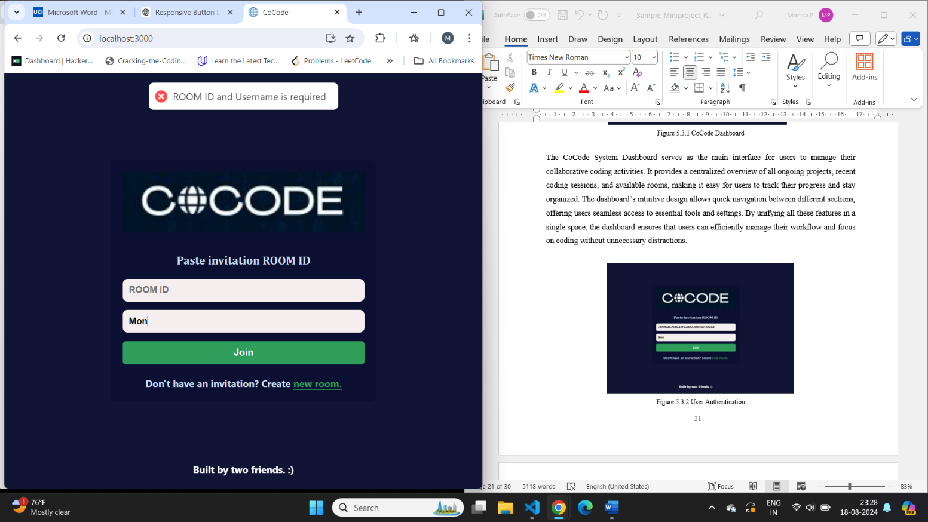

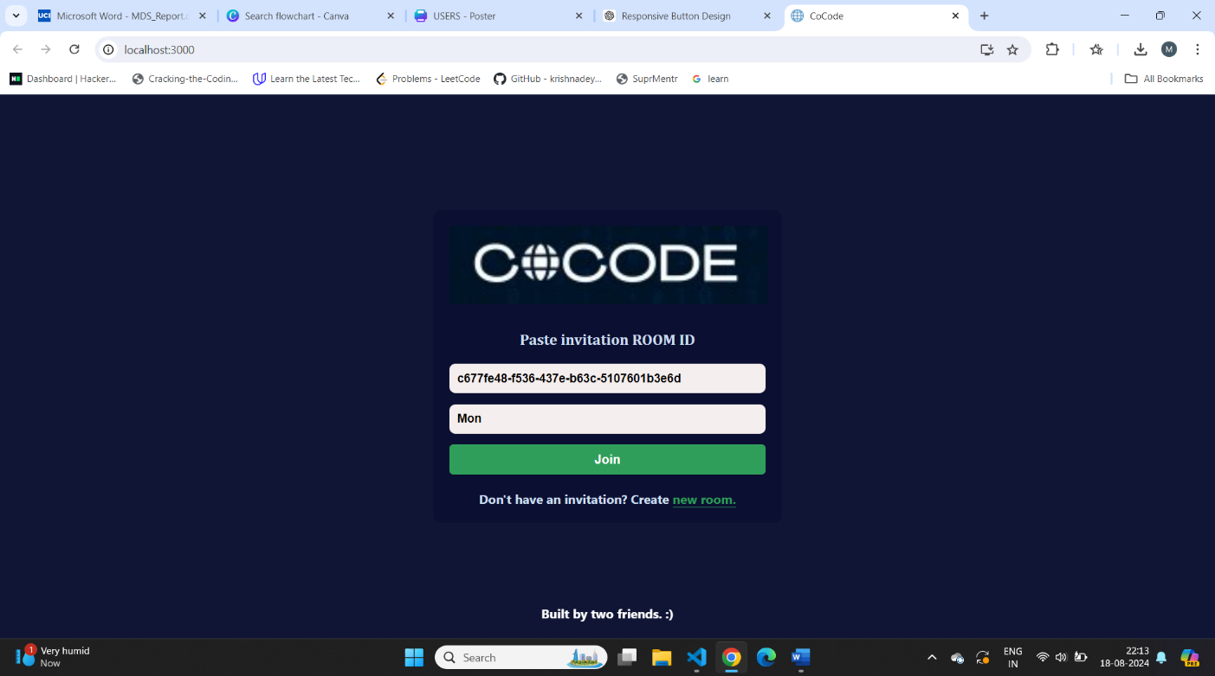

Figure 5.3.2 User Authentication

The User Authentication Interface in CoCode is designed to facilitate secure and straightforward access for both new and returning users. It ensures that user data is protected while providing a smooth registration and login process. The interface’s clean design emphasizes ease of use, reducing the friction typically associated with accessing online platforms. By streamlining the authentication process, CoCode enables users to quickly begin their coding sessions, thereby enhancing the overall user experience.

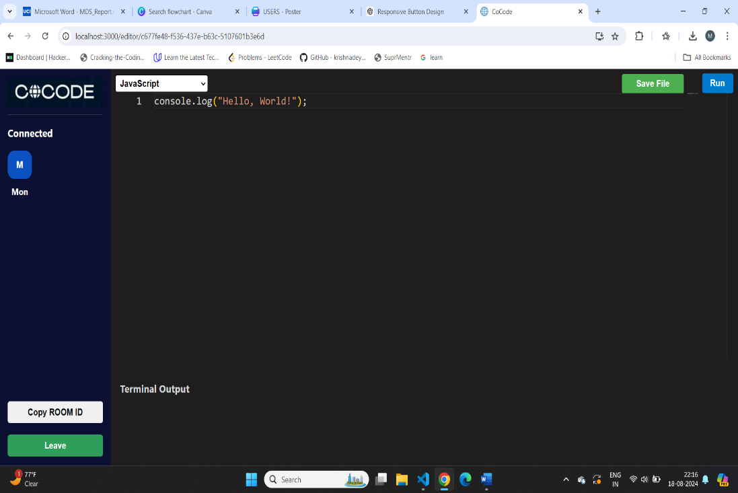

Figure 5.3.3 Code Editor Interface

The Code Editing Interface is the core workspace within CoCode, where users engage in real-time coding. It integrates powerful features like syntax highlighting, auto-completion, and multi-language support, all within a sleek and responsive editor. This interface is designed to mimic the experience of traditional code editors, making it familiar and accessible to users. Its real-time collaboration capabilities ensure that all participants can work together seamlessly, with changes instantly reflected across all screens, thereby fostering a truly interactive coding environment.

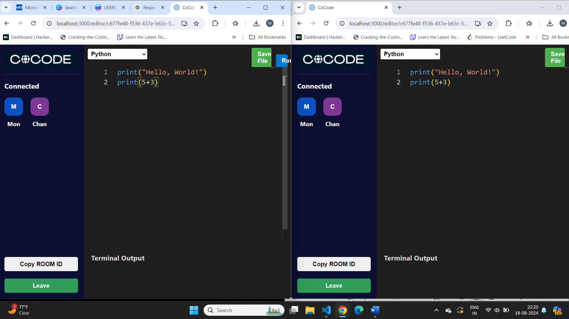

Figure 5.3.4 Real-time Synchronization

Real-Time Synchronization in CoCode ensures that all users are on the same page, literally and figuratively. This feature is crucial for maintaining consistency during collaborative sessions, as it allows users to see each other’s changes instantaneously. The synchronization process is powered by a robust WebSocket-based system that handles concurrent edits without lag or data loss. This real-time interaction is key to CoCode’s effectiveness as a collaborative platform, enabling teams to work together as if they were in the same room, despite being distributed across different locations.

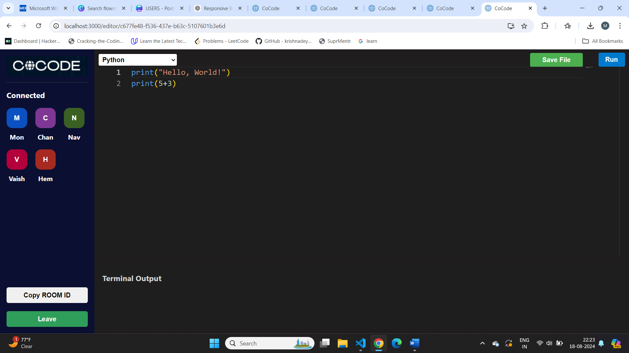

Figure 5.3.5 Room Management

The Room Management Interface in CoCode empowers users to create, join, and manage collaborative coding spaces with ease. It simplifies the process of organizing group projects by providing clear options for room setup and participant management. Whether users are working on small teams or larger collaborations, this interface ensures that everyone can connect and contribute effectively. Its design prioritizes clarity and accessibility, ensuring that even users with minimal technical expertise can navigate and utilize the platform’s collaborative features.

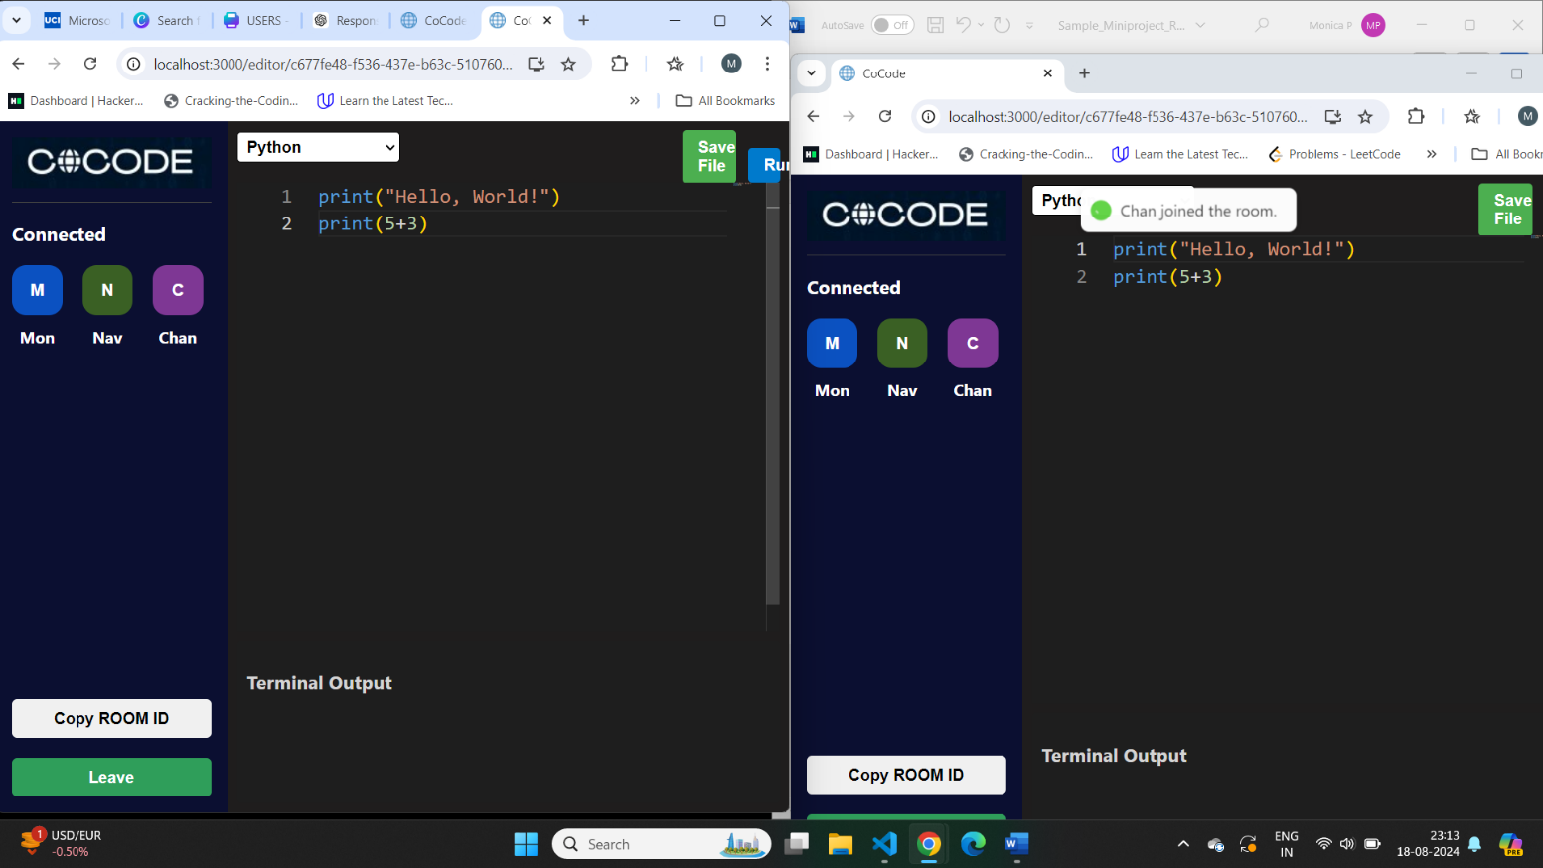

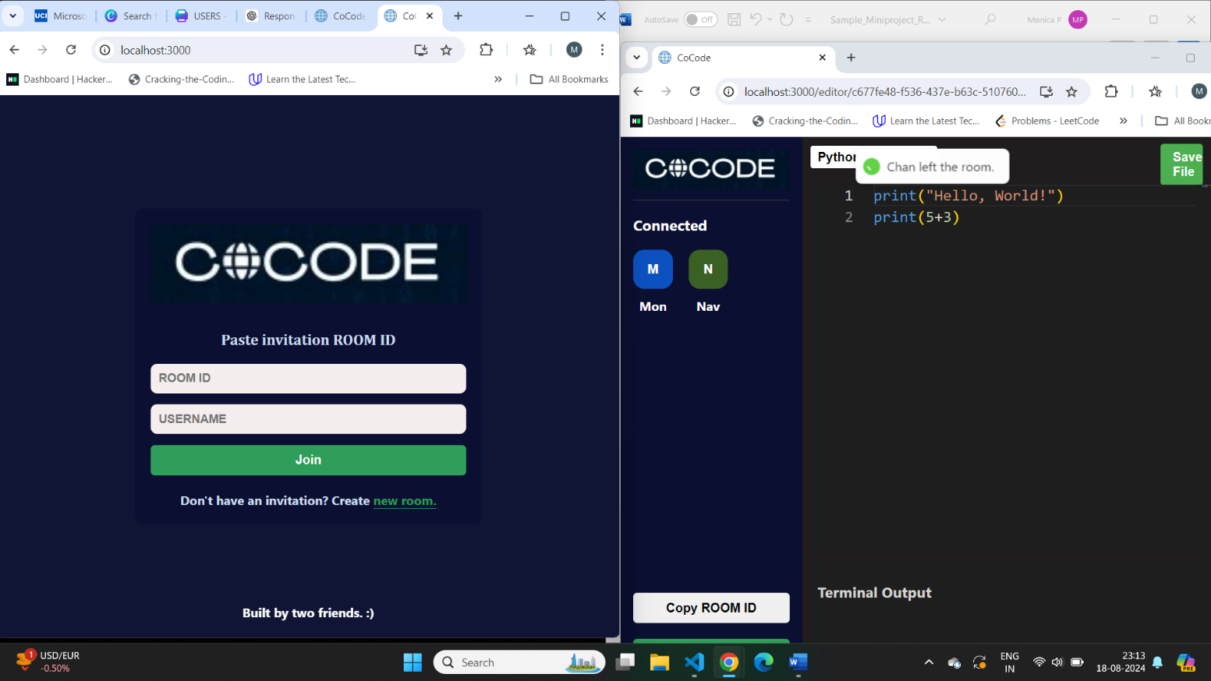

Figure 5.3.6 User Notifications

The User Notification system in CoCode plays a vital role in keeping team members informed about significant events during coding sessions. Notifications are triggered by events such as users entering or leaving a room, ensuring that everyone remains aware of the current team composition and activity status. This system enhances coordination and collaboration, as participants are constantly updated on the status of their peers. The notification system is an integral part of CoCode’s real-time environment, ensuring that all users stay connected and engaged throughout their collaborative efforts.

**CHAPTER 6**

**CONCLUSION**

The CoCode project represents a significant leap forward in collaborative coding, offering a sophisticated platform that enhances the way developers work together in real-time. By integrating features such as a robust code editor, real-time synchronization, user authentication, and room management, CoCode provides a comprehensive environment where multiple users can contribute to a coding session simultaneously, without the friction often associated with remote collaboration. The system's ability to instantly reflect code changes across all participants' screens ensures a seamless and coherent development process, making it an invaluable tool for both small teams and larger development groups. The user-friendly interface further simplifies the coding experience, allowing users to focus on their tasks without being bogged down by technical complexities.

Throughout the development of CoCode, various challenges and technical hurdles were encountered, particularly in ensuring reliable synchronization and managing concurrent user interactions. These challenges were addressed through the implementation of advanced WebSocket-based communication protocols and strategic design optimizations. The result is a system that not only performs efficiently but also scales to accommodate a growing number of users and sessions. Looking ahead, CoCode offers substantial potential for further enhancements, including the integration of additional collaboration tools, improved user interface elements, and expanded scalability options. Such developments could solidify CoCode's position as a leading platform in the collaborative coding space, driving innovation and productivity in software development teams around the world.

## BIBLIOGRAPHY

1. Nichols, D., Curtis, P., Dixon, M., & Lamping, J. (1995). High-Latency, Low-Bandwidth Windowing in the Jupiter Collaboration System. *Proceedings of the 8th Annual ACM Symposium on User Interface Software and Technology*.
2. Palmer, C. R., & Cormack, G. V. (1998). Operation Transforms for Distributed Shared Spreadsheet. *Proceedings of the ACM Symposium on Principles of Distributed Computing*.
3. Ellis, C. A., & Gibbs, S. J. (1989). Concurrency Control in Groupware Systems. *ACM SIGMOD Record*, 18(2), 399-407.
4. Weiss, S., Urso, P., & Molli, P. (2009). Logoot: A Scalable Optimistic Replication Algorithm for Collaborative Editing on P2P Networks. *IEEE Transactions on Parallel and Distributed Systems*, 20(10), 1473-1486.
5. Saros Project Documentation. (2022). Real-Time Collaborative Editor for Distributed Development Teams. [Online Documentation].
6. Gotsman, A. (2016). Specification and Complexity of Collaborative Text Editing. *Proceedings of the 29th ACM Symposium on Principles of Distributed Computing*, 108-117.
7. Electronics Journal. (2020). A Container Orchestration Development that Optimizes the Etherpad Collaborative Editing Tool. *Electronics*, 9(4), 623-631.
8. García-Castro, R., Gómez-Pérez, A., & Fernández-López, M. (2005). COE: A Collaborative Ontology Editor Based on a Peer-to-Peer Framework. *Journal of Web Semantics*, 3(2-3), 120-138.
9. Villarreal, M., Restrepo, A., & García, R. (2017). MUTE: A Peer-to-Peer Web-based Real-time Collaborative Editor. *Proceedings of the 26th International Conference on World Wide Web Companion*, 165-174.
10. Neal, P., & Snyder, M. (2020). Shared Editing on the Web: A Classification of Development Tools. *Journal of Web Engineering*, 19(3), 317-342