Laboratorio No. 5

Almacenamiento SD

**Link de GitHub:** <https://github.com/mon19379/DIGITAL2.git>

**Link Video:** <https://youtu.be/ETXTn_kuzsI>

**Pseudocódigo:**

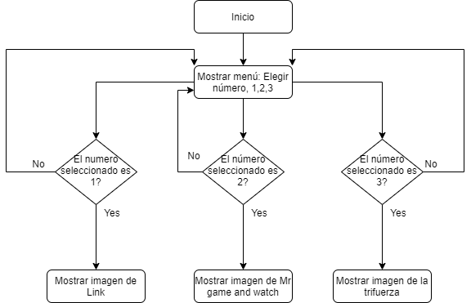

**Código:**

#include <SPI.h>

#include <SD.h>

int menu;

File myFile;

void setup()

{

// Open serial communications and wait for port to open:

Serial.begin(9600);

SPI.setModule(0);

Serial.print("Initializing SD card...");

// On the Ethernet Shield, CS is pin 4. It's set as an output by default.

// Note that even if it's not used as the CS pin, the hardware SS pin

// (10 on most Arduino boards, 53 on the Mega) must be left as an output

// or the SD library functions will not work.

pinMode(PA_3, OUTPUT);

if (!SD.begin(PA_3)) {

Serial.println("initialization failed!");

return;

}

Serial.println("initialization done.");

myFile = SD.open("/");

printDirectory(myFile, 0);

Serial.println("done!");

Serial.println("Escoger imagen 1, 2 o 3 ");

Serial.println("1. Link.txt ");

Serial.println("2. Mr.Game.txt ");

Serial.println("3. Tri.txt ");

}

void loop()

{

menu = Serial.read();

if (menu == 49) {

// re-open the file for reading:

myFile = SD.open("Link.txt");

if (myFile) {

Serial.println("Link.txt:");

// read from the file until there's nothing else in it:

while (myFile.available()) {

Serial.write(myFile.read());

}

// close the file:

myFile.close();

} else {

// if the file didn't open, print an error:

Serial.println("Escoger imagen 1, 2 o 3 ");

Serial.println("1. Link.txt ");

Serial.println("2. Mr.Game.txt ");

Serial.println("3. Tri.txt ");

}

Serial.println("Escoger imagen 1, 2 o 3 ");

Serial.println("1. Link.txt ");

Serial.println("2. Mr.Game.txt ");

Serial.println("3. Tri.txt ");

}

if (menu == 50) {

// re-open the file for reading:

myFile = SD.open("Mrgame.txt");

if (myFile) {

Serial.println("Mrgame.txt:");

// read from the file until there's nothing else in it:

while (myFile.available()) {

Serial.write(myFile.read());

}

// close the file:

myFile.close();

} else {

// if the file didn't open, print an error:

Serial.println("Escoger imagen 1, 2 o 3 ");

Serial.println("1. Link.txt ");

Serial.println("2. Mr.Game.txt ");

Serial.println("3. Tri.txt ");

}

Serial.println("Escoger imagen 1, 2 o 3 ");

Serial.println("1. Link.txt ");

Serial.println("2. Mr.Game.txt ");

Serial.println("3. Tri.txt ");

}

if (menu == 51) {

// re-open the file for reading:

myFile = SD.open("Tri.txt");

if (myFile) {

Serial.println("Tri.txt:");

// read from the file until there's nothing else in it:

while (myFile.available()) {

Serial.write(myFile.read());

}

// close the file:

myFile.close();

} else {

// if the file didn't open, print an error:

Serial.println("Escoger imagen 1, 2 o 3 ");

Serial.println("1. Link.txt ");

Serial.println("2. Mr.Game.txt ");

Serial.println("3. Tri.txt ");

}

Serial.println("Escoger imagen 1, 2 o 3 ");

Serial.println("1. Link.txt ");

Serial.println("2. Mr.Game.txt ");

Serial.println("3. Tri.txt ");

}

}

void printDirectory(File dir, int numTabs) {

while (true) {

File entry = dir.openNextFile();

if (! entry) {

// no more files

break;

}

for (uint8_t i = 0; i < numTabs; i++) {

Serial.print('\t');

}

Serial.print(entry.name());

if (entry.isDirectory()) {

Serial.println(" ");

} else {

// files have sizes, directories do not

Serial.print("\t\t");

Serial.println(entry.size());

}

entry.close();

}

}