**BANK LOAN REPORT QUERY DOCUMENT**

1. **BANK LOAN REPORT | SUMMARY.**

**KPI’s:**

**Total Loan Applications:**

**select count(*) as Total_loan_applications**

**from bank_loan_data;**

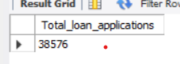

**MTD Loan Applications:**

**select count(id) as MTD_Total_loan_applications**

**from bank_loan_data**

**where year(str_to_date(issue_date, '%d-%m-%Y')) = (select year(max(str_to_date(issue_date, '%d-%m-%Y'))) from bank_loan_data)**

**and month(str_to_date(issue_date, '%d-%m-%Y')) = (select month(max(str_to_date(issue_date, '%d-%m-%Y'))) from bank_loan_data);**

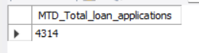

**PMTD Loan Applications:**

**select count(id) as PMTD_Total_loan_applications**

**from bank_loan_data**

**where year(str_to_date(issue_date, '%d-%m-%Y')) = (select year(max(str_to_date(issue_date, '%d-%m-%Y'))) from bank_loan_data)**

**and month(str_to_date(issue_date, '%d-%m-%Y')) = (select month(max(str_to_date(issue_date, '%d-%m-%Y'))) - 1 from bank_loan_data);**

**MOM = (MTD – PMTD) / PMTD**

**Total Funded Amount:**

**select sum(loan_amount) as total_funded_amount**

**from bank_loan_data;**



**MTD Total Funded Amount**

**select sum(loan_amount) as MTD_total_funded_amount**

**from bank_loan_data**

**where year(str_to_date(issue_date, '%d-%m-%Y')) = (select year(max(str_to_date(issue_date, '%d-%m-%Y'))) from bank_loan_data)**

**and month(str_to_date(issue_date, '%d-%m-%Y')) = (select month(max(str_to_date(issue_date, '%d-%m-%Y'))) from bank_loan_data);**

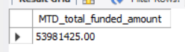

**PMTD Total Funded Amount**

**select sum(loan_amount) as PMTD_total_funded_amount**

**from bank_loan_data**

**where year(str_to_date(issue_date, '%d-%m-%Y')) = (select year(max(str_to_date(issue_date, '%d-%m-%Y'))) from bank_loan_data)**

**and month(str_to_date(issue_date, '%d-%m-%Y')) = (select month(max(str_to_date(issue_date, '%d-%m-%Y'))) - 1 from bank_loan_data);**

**Total Amount Received**

select sum(total_payment) as total_amount_received

from bank_loan_data;

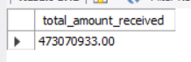

**MTD Total Amount Received**

select sum(total_payment) as MTD_total_amount_received

from bank_loan_data

where year(str_to_date(issue_date, '%d-%m-%Y')) = (select year(max(str_to_date(issue_date, '%d-%m-%Y'))) from bank_loan_data)

and month(str_to_date(issue_date, '%d-%m-%Y')) = (select month(max(str_to_date(issue_date, '%d-%m-%Y'))) from bank_loan_data);

**PMTD Total Amount Received**

select sum(total_payment) as PMTD_total_amount_received

from bank_loan_data

where year(str_to_date(issue_date, '%d-%m-%Y')) = (select year(max(str_to_date(issue_date, '%d-%m-%Y'))) from bank_loan_data)

and month(str_to_date(issue_date, '%d-%m-%Y')) = (select month(max(str_to_date(issue_date, '%d-%m-%Y'))) - 1 from bank_loan_data);

**Average Interest**

**select round(avg(int_rate) * 100,2) as average_int_rate**

**from bank_loan_data;**

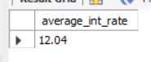

**MTD Average Interest**

**select round(avg(int_rate) * 100,2) as MTD_average_int_rate**

**from bank_loan_data**

**where year(str_to_date(issue_date, '%d-%m-%Y')) = (select year(max(str_to_date(issue_date, '%d-%m-%Y'))) from bank_loan_data)**

**and month(str_to_date(issue_date, '%d-%m-%Y')) = (select month(max(str_to_date(issue_date, '%d-%m-%Y'))) from bank_loan_data);**

**MTD Average Interest**

**select round(avg(int_rate) * 100,2) as PMTD_average_int_rate**

**from bank_loan_data**

**where year(str_to_date(issue_date, '%d-%m-%Y')) = (select year(max(str_to_date(issue_date, '%d-%m-%Y'))) from bank_loan_data)**

**and month(str_to_date(issue_date, '%d-%m-%Y')) = (select month(max(str_to_date(issue_date, '%d-%m-%Y'))) - 1 from bank_loan_data);**

**Average DTI**

select round(avg(dti) * 100,2) as average_DTI

from bank_loan_data;

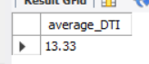

**MTD Average DTI**

select round(avg(dti) * 100,2) as MTD_average_DTI

from bank_loan_data

where year(str_to_date(issue_date, '%d-%m-%Y')) = (select year(max(str_to_date(issue_date, '%d-%m-%Y'))) from bank_loan_data)

and month(str_to_date(issue_date, '%d-%m-%Y')) = (select month(max(str_to_date(issue_date, '%d-%m-%Y'))) from bank_loan_data);

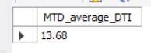

**PMTD Average DTI**

**select round(avg(dti) * 100,2) as PMTD_average_DTI**

**from bank_loan_data**

**where year(str_to_date(issue_date, '%d-%m-%Y')) = (select year(max(str_to_date(issue_date, '%d-%m-%Y'))) from bank_loan_data)**

**and month(str_to_date(issue_date, '%d-%m-%Y')) = (select month(max(str_to_date(issue_date, '%d-%m-%Y'))) - 1 from bank_loan_data);**

**GOOD LOAN ISSUED**

**Good Loan Percentage**

**select round(count(case when loan_status in ('Fully Paid', 'Current') then id end) / count(id) * 100, 0) as Good_loan_perccentage**

**from bank_loan_data ;**

**Good Loan Applications**

**select count(case when loan_status in ('Fully Paid', 'Current') then id end) as Good_loan_Application**

**from bank_loan_data ;**

**Good Loan Funded Amount:**

**select sum(case when loan_status in ('Fully Paid', 'Current') then loan_amount end) as Good_Loan_Funded_Amount**

**from bank_loan_data ;**

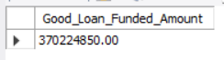

**Good Loan Amount Received**

select sum(case when loan_status in ('Fully Paid', 'Current') then total_payment end) as Good_Loan_Received_Amount

from bank_loan_data ;

**BAD LOAN ISSUED**

**Bad Loan Percentag:**

**select round(count(case when loan_status = 'Charged Off'then id end) / count(id) * 100, 0) as Bad_Loan_Percentage**

**from bank_loan_data ;**

**Bad Loan Applications**

select count(case when loan_status = 'Charged Off' then id end) as Bad_Loan_Application

from bank_loan_data ;

**Bad Loan Funded Amount**

select sum(case when loan_status = 'Charged Off' then loan_amount end) as Bad_Loan_Funded_Amount

from bank_loan_data ;

**Bad Loan Amount Received**

select sum(case when loan_status = 'Charged Off' then total_payment end) as Bad_Loan_Received_Amount

from bank_loan_data ;



**LOAN STATUS:**

select

loan_status,

count(id) as Total_Loan_Application,

sum(total_payment) as Total_Amount_Received,

sum(loan_amount) as Total_Funded_Amount,

avg(int_rate * 100) as Interest_Rate,

avg(dti * 100) as DTI

from

bank_loan_data

group by

loan_status

select

loan_status,

sum(total_payment) as MTD_Total_Amount_Received,

sum(loan_amount) as MTD_Total_Funded_Amount

from bank_loan_data

where month(str_to_date(issue_date, '%d-%m-%Y')) = (select month(max(str_to_date(issue_date, '%d-%m-%Y'))) from bank_loan_data)

group by loan_status;

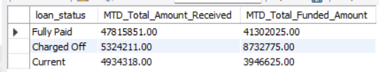

1. **BANK LOAN REPORT | OVERVIEW**
2. **MONTH**

select

month(str_to_date(issue_date, '%d-%m-%Y')) AS Month_Munber,

monthname(str_to_date(issue_date, '%d-%m-%Y')) as Month_name,

count(id) as Total_Loan_Applications,

sum(loan_amount) as Total_Funded_Amount,

sum(total_payment) as Total_Amount_Received

from bank_loan_data

group by month(str_to_date(issue_date, '%d-%m-%Y')), monthname(str_to_date(issue_date, '%d-%m-%Y'))

order by month(str_to_date(issue_date, '%d-%m-%Y')) ;

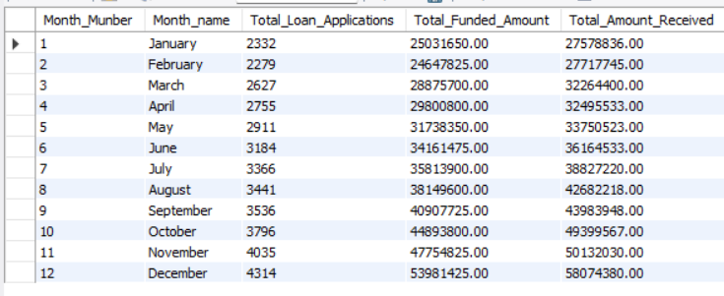

**STATE**

select

address_state,

count(id) as Total_Loan_Applications,

sum(loan_amount) as Total_Funded_Amount,

sum(total_payment) as Total_Amount_Received

from bank_loan_data

group by address_state

order by sum(loan_amount) desc ;

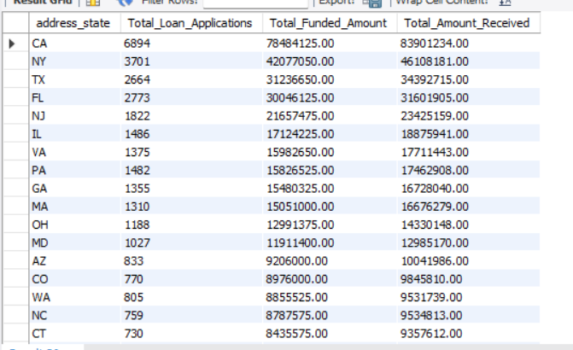

**TERM**

select

term,

count(id) as Total_Loan_Applications,

sum(loan_amount) as Total_Funded_Amount,

sum(total_payment) as Total_Amount_Received

from bank_loan_data

group by term

order by term;

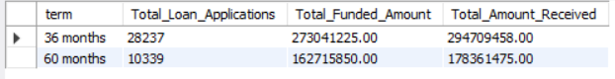

**EMPLOYEE LENGTH**

select

emp_length,

count(id) as Total_Loan_Applications,

sum(loan_amount) as Total_Funded_Amount,

sum(total_payment) as Total_Amount_Received

from bank_loan_data

group by emp_length

order by emp_length;

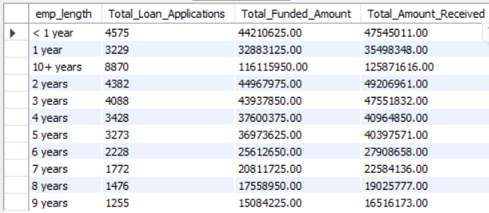

**PURPOSE**

select purpose,

count(id) as Total_Loan_Applications,

sum(loan_amount) as Total_Funded_Amount,

sum(total_payment) as Total_Amount_Received

from bank_loan_data

group by purpose

order by count(id) desc;

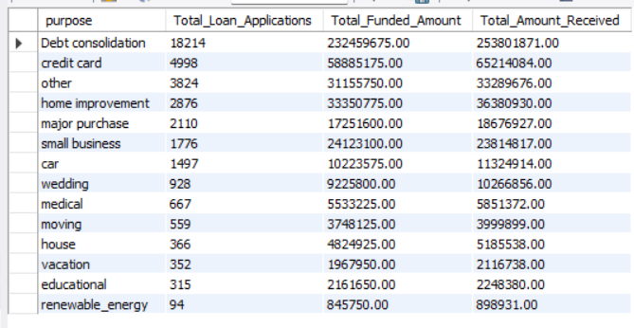

**HOME OWNERSHIP**

select

home_ownership,

count(id) as Total_Loan_Applications,

sum(loan_amount) as Total_Funded_Amount,

sum(total_payment) as Total_Amount_Received

from bank_loan_data

group by home_ownership

order by count(id) desc;

*Note: We have applied multiple Filters on all the dashboards. You can check the results for the filters as well by modifying the query and comparing the results.*

*For e.g*

*See the results when we hit the Grade A in the filters for dashboards.*