1.What are the names of all the countries in the country table?

Ans:

select country_name from country;

2. What is the total number of customers in the customers table?

Ans:

select count(customer_id) as no_of_customers from customers;

3. What is the average age of customers who can receive marketing emails (can_email is set to 'yes')?

Ans:

select avg(age) as avg_age from customers where can_email= 'yes';

4. How many orders were made by customers aged 30 or older?

Ans:

select count(o.order_id) as total_orders

from customers c join orders o on c.customer_id=o.customer_id

where c.age>=30;

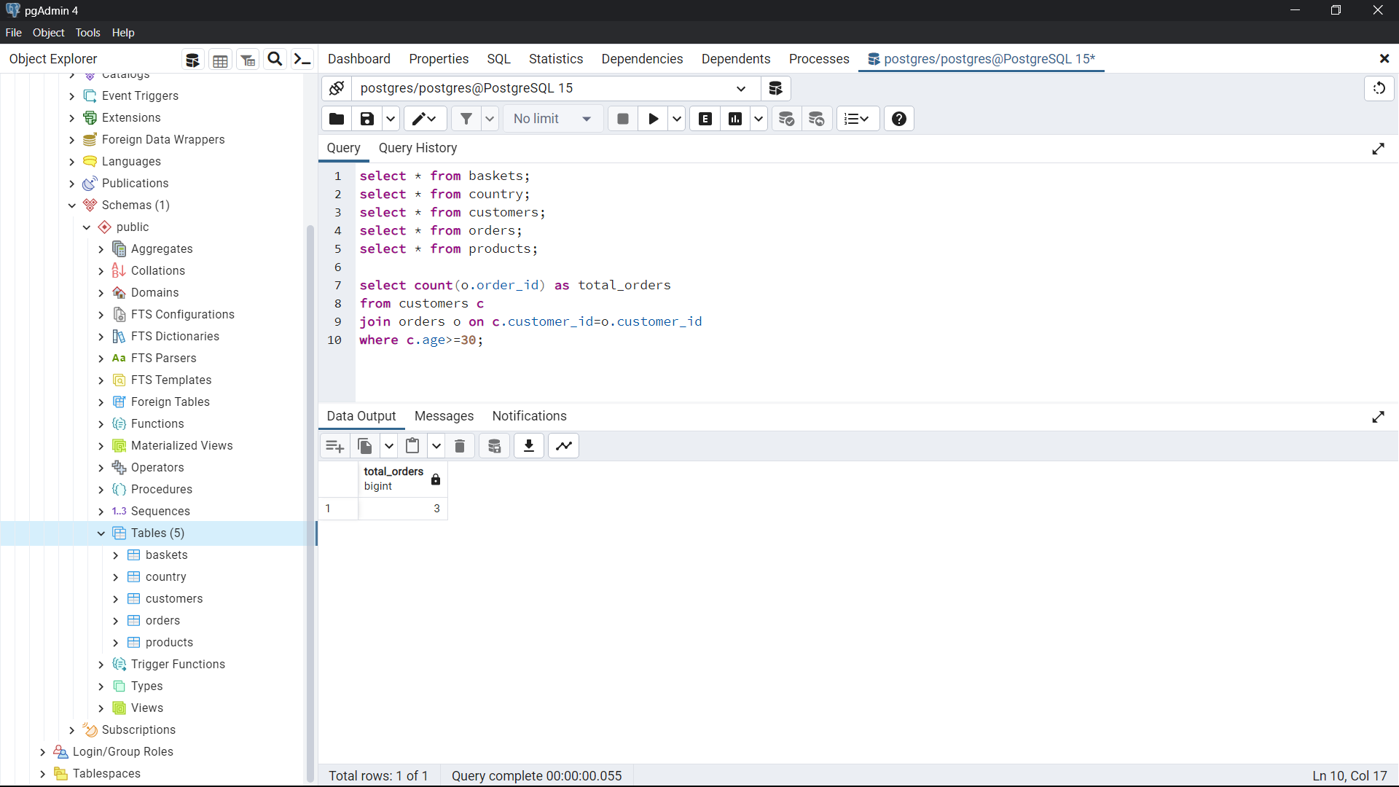

5. What is the total revenue generated by each product category?

Ans:

select p.category,sum(p.price) as total_revenue

from baskets b

join products p on b.product_id=p.product_id

group by 1

order by 1 asc;

6. What is the average price of products in the 'food' category?

Ans:

select category, avg(price) from products

where category='food'

group by 1

7. How many orders were made in each sales channel (sales_channel column) in the orders table?

Ans :

select sales_channel, count(order_id) as total_orders

from orders

group by 1

8.What is the date of the latest order made by a customer who can receive marketing emails?

Ans:

select o.date_shop

from customers c

join orders o on c.customer_id=o.customer_id

where can_email='yes'

order by 1 desc

limit 1

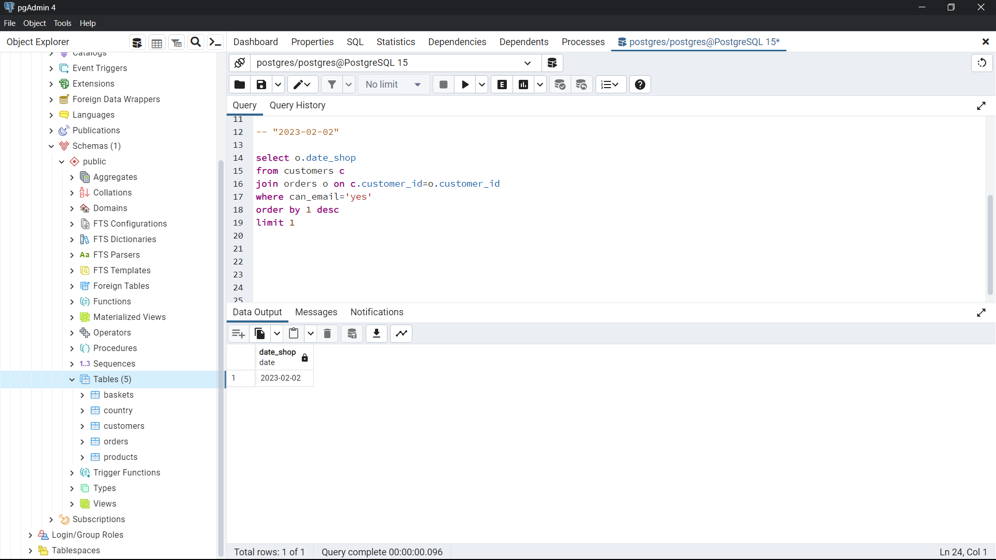

9. What is the name of the country with the highest number of orders?

Ans: select o.country_id,c.country_name, count(o.order_id) as total_orders

from orders o

join country c on o.country_id=c.country_id

group by 1,2

order by 3 desc

limit 1

10. What is the average age of customers who made orders in the 'vitamins' product category?

Ans: with cte1 as

(

select c.customer_id, c.age

from products p

join baskets b on p.product_id=b.product_id

join orders o on b.order_id=o.order_id

join customers c on o.customer_id=c.customer_id

where category='vitamins'

group by 1)

select avg(age) as avg_age_cus from cte1

