1. What are the names of all the customers who live in New York?

Ans:

select firstname, lastname from customers where city='new york';

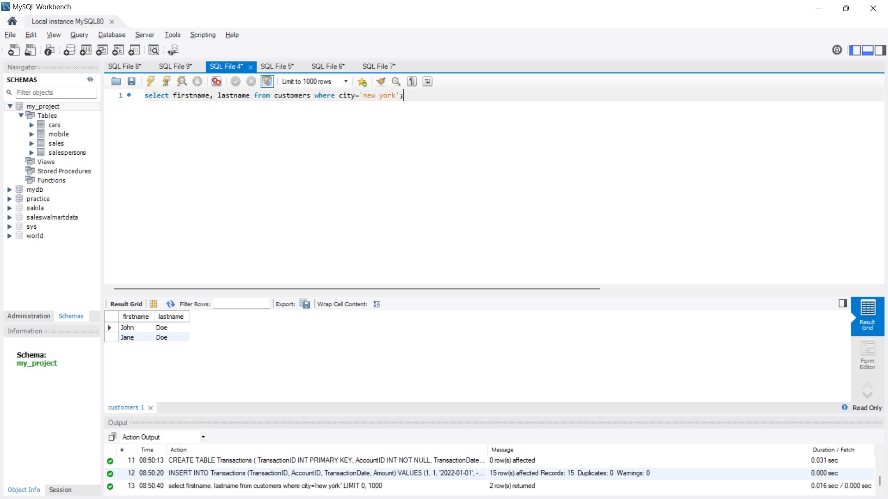

1. What is the total number of accounts in the Accounts table?

Ans:

select count(accountid) as total_accounts from accounts;

1. What is the total balance of all checking accounts?

Ans:

select accounttype, sum(balance) from accounts

where accounttype='checking'

group by accounttype;

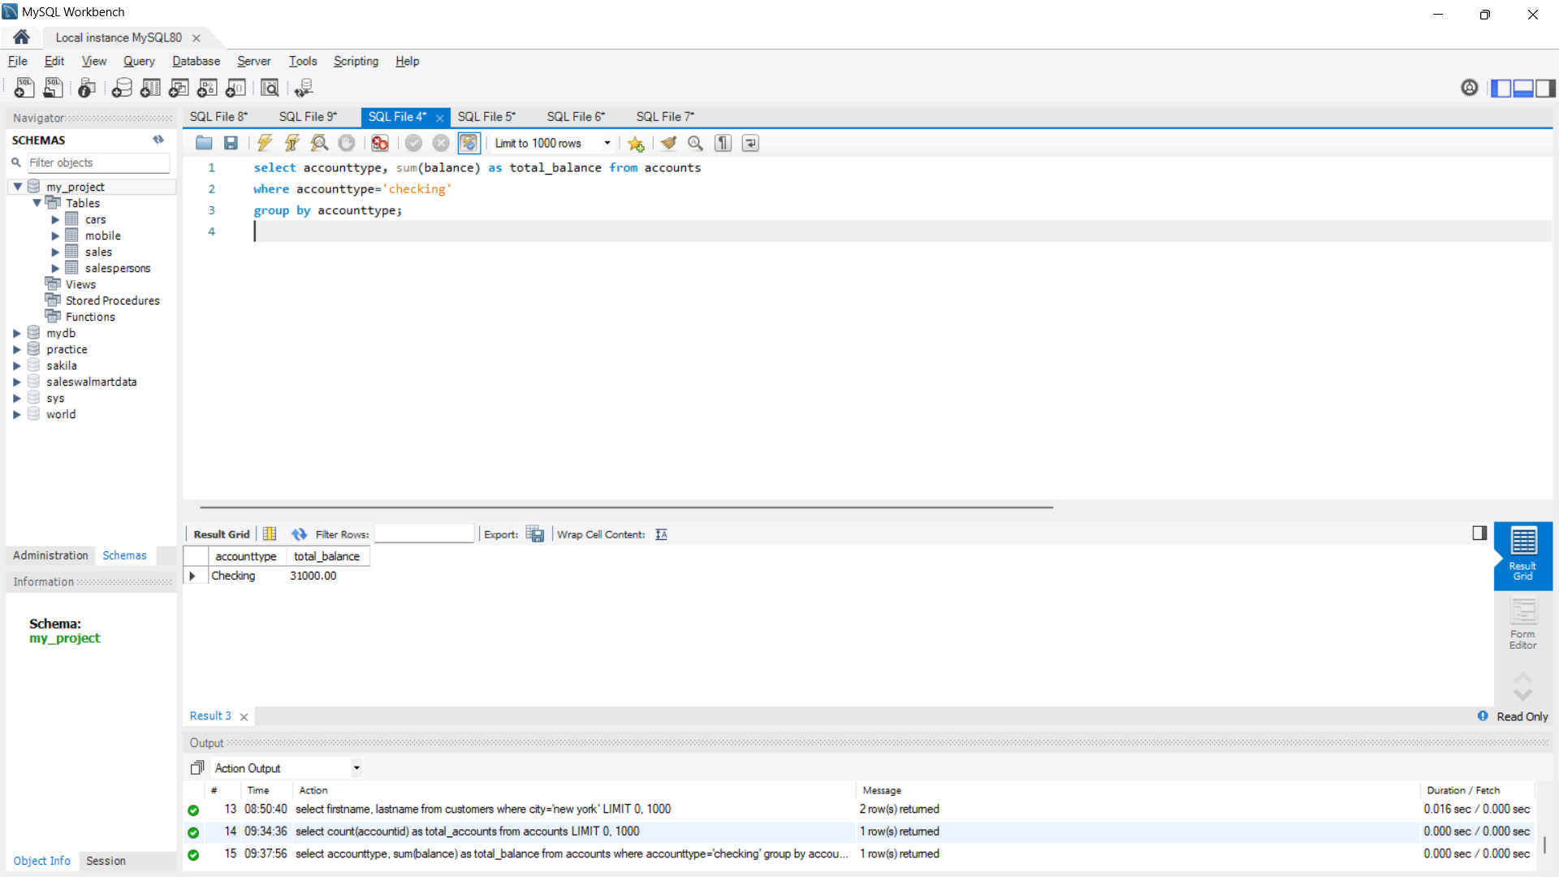

1. What is the total balance of all accounts associated with customers who live in Los Angeles?

Ans:

select c.city, sum(a.balance) as total_balance

from customers c

join accounts a on c.customerid=a.customerid

where city='los angeles' group by 1;

1. Which branch has the highest average account balance?

Ans:

select b.branchname, avg(a.balance) as avg_balance

from branches b

join accounts a on b.branchid=a.branchid

group by 1

order by 2 desc

limit 1

1. Which customer has the highest current balance in their accounts?

Ans:

select c.firstname, c.lastname, max(a.balance) as balance

from customers c

join accounts a on c.customerid=a.customerid

group by 1,2

order by 3 desc limit 1;

1. Which customer has made the most transactions in the Transactions table?

Ans:

select a.customerid, c.firstname, c.lastname, count(t.transactionid) as no_of_transactions

from customers c

join accounts a on c.customerid=a.customerid

join transactions t on a.accountid=t.accountid

group by 1,2,3 order by 4 desc limit 1;

1. Which branch has the highest total balance across all of its accounts?

Ans:

select a.branchid, b.branchname,sum(a.balance) as total_balance

from branches b join accounts a on b.branchid=a.branchid

group by 1,2 order by 3 desc limit 1;

1. Which customer has the highest total balance across all of their accounts, including savings and checking accounts?

Ans:

select a.customerid, c.firstname, c.lastname, sum(a.balance) as total_balance

from customers c join accounts a on c.customerid=a.customerid

group by 1,2,3 order by 4 desc limit 1;

1. Which branch has the highest number of transactions in the Transactions table?

Ans:

with cte1 as

(

select a.branchid, b.branchname, count(t.transactionid) as no_of_transactions,

dense_rank() over(order by count(t.transactionid) desc) as rn

from branches b join accounts a on b.branchid=a.branchid

join transactions t on a.accountid=t.accountid

group by 1 )

select branchname, no_of_transactions from cte1

where rn=1;

