**Online Quiz/Survey Application v-1.0**

DigitalOfficePro Inc.

November 27th 2017

SRS version 1.2

Contents

Introduction 1

Objective 1

Functional requirements 1

Technical requirements 2

# **Introduction**

The purpose of this document is to present a detailed description of the Online Quiz application. It will explain the purpose and features of the system, the interfaces of the system, what the system will do, the constraints under which it must operate and how the system will react to external stimuli.

# Objective

Create an online quiz/survey creator. This application can be easily integrated with other platforms using its api features.

# Functional requirements

1. Quiz must support following question types
   1. Multiple choice (Multiple response) – with multiple answer option
   2. Multiple choice – with single answer option
   3. true/false
   4. image choice – refer typeform picture choice
   5. free text – refer typeform short text/long text.
2. Survey support the following question types.
   1. Multiple choice – with single answer option
   2. true/false
   3. image choice – refer typeform picture choice
   4. free text – refer typeform short text/long text
   5. Rating - – refer typeform rating option.
   6. scale
3. Quiz options/settings
   1. Option for making a quiz graded.(setting pass mark)
   2. Submit result at the end of quiz and show total score.—refer quiz-style1.pptx

In this case if user leave some required questions, submit/finish quiz button should prompt un attempted questions, and navigate through un attended questions .

* 1. Show result on each question attempt(by default this option will be off), finally show total score–refer quiz-style2.pptx
  2. Review option – if it is on user can review the questions and its result after completing the quiz.- by default on
  3. Retake option. If it is on, user can retake the quiz.- by default off .
  4. Hide navigation button (next - previous) - (only through mouse scroll/ left right finger gesture / left-right keyboard navigation)
  5. Option for changing quiz title, Start text, end text, success message & failed message( for graded quiz)
  6. For multi-language support, give option for editing quiz buttons labels like ‘Start Quiz’, ‘Retake’, ‘Continue’, ’Check’, option index (a,b,c,d etc) include any other labels/text shown in quiz . Any text which are not edited by quiz editor in output quiz should be loaded from a string table/collection and can be editable from quiz settings.
  7. Option for selecting output quiz color theme (text color, button color, progress bar color etc).

1. Question settings
   1. Mark a question as required.
   2. Option for randomize answers.
   3. Super size image option( If question is image choice )
   4. Option for adding image/video (you tube url) along with question.
2. Import & export quiz- for future version.
3. Survey should have the following options
4. Api features.
   1. Authenticate using api key. All api call should work only after the authentication
   2. api/create -> to create a new quiz or survey
   3. api/<quiz/survey id>/edit?uid=<>&token=<> -> to edit existing quiz or survey, for first page loading send token along with url.(will get token at the time of authentication)
   4. while calling edit quiz api , there should be an option to pass color theme of editor interface.
   5. api/<quiz/survey id>/preview
   6. api/<quiz/survey id>/attent?uid=<>&token=<>,
   7. there should be an option for passing
   8. api/<quiz/survey id>/getresult/uid/ return specified user result in json format which include total score, correct answer, wrong answer details.

getresult api call without user id return report of all students.

Need some changes in api url to support new requirements.

In case of quiz & survey we need two type of report –

1. brief report
   1. Input
      1. Quiz creator id
      2. Date range( range of date in between trainees attended the quiz), if not specified then return all time report.
   2. Output: returns all quizzes created by a user with the following details for each quiz in given date range( range of date in between trainees attended the quiz).
      1. Quiz/survey name
      2. Quiz/survey id
      3. Is quiz or survey
      4. total questions
      5. total attendees,
      6. total number of attendees completed
      7. total number of attendees passed (only for quiz)
      8. Average score. (only for quiz)
2. detailed report
   1. Input
      1. Quiz/survey id
      2. Date range (range of date in between trainees attended the quiz/survey), if not specified then return all time report.
      3. Attendee_id (optional ), if specified the api will return only this attendee details
      4. Need question and answers(All questions & answer submitted by attendee(s) will return only if this flag is true)
   2. Output: Return the following details of given quiz/survey id in given date range.
      1. Quiz/survey name
      2. Quiz/survey id
      3. Total questions
      4. Pass mark (only for quiz)
      5. All Attendees with following details
         1. Attendee id
         2. Name
         3. Email
         4. Completed date
         5. Correct answers (only for quiz)
         6. Score (only for quiz)
         7. Status(pass/fail if quiz is graded) (only for quiz)
         8. All questions & answer submitted by this attendee
            1. Question
            2. Answer
            3. isCorrect (only for quiz)

In case of survey we need additional report-

1. Survey specific report
   1. Inputs
      1. Survey id
      2. Date range , if not specified then return all time report.
   2. Output: return each question and its options with response percentage.
      1. Survey id
      2. Survey name
      3. Total attendees
      4. Questions , each question with the following details, refer below image
         1. Options , each option with the following details
            1. Option
            2. Response percentage

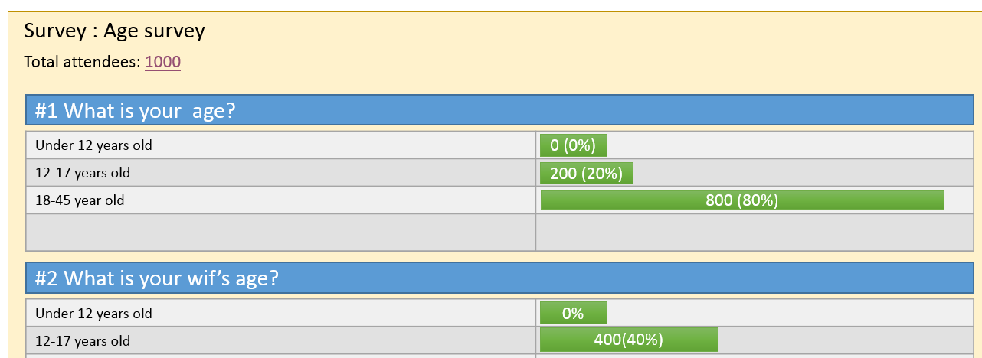

* 1. api/<quiz/survey id>/delete
  2. api/<quiz/survey id>/clear- tracking?uid=’101’ => clear the current score and allow the trainee to retake the quiz (if quiz has no retake option)

**Note**: api names can be changed with more suitable names.

After creating quiz, quiz id should be unique id like short GUID. Don’t use auto number.

# Technical requirements

Use the following technologies for development

* Nodejs with express framework.
* Mongodb
* Angular js