Lily – A VIRTUAL

PERSONAL ASSISTANT

A mini project report submitted by

Monisha Sharma

[intern period - 19th june 2024 : 2nd August 2024 ]

**Introduction:**

A Virtual assistant / digital assistant is an application that understands natural language voice commands and completes tasks for the user.

Popular virtual assistants currently include Amazon Alexa, Apple's Siri, Google Assistant and Microsoft's Cortana.

Though this definition focuses on the digital form of virtual assistants, the term virtual assistant, or virtual personal assistant, is also commonly used to describe contract workers who work from home doing administrative tasks typically performed by executive assistants or secretaries.

**Objective and Motivation :**

The major objective of this project is to create an assistant that lives on the user’s personal computer and can be used to complete menial, reduntant or time-consuming tasks in a way to maximixe productivity and and remove the chore of doing such tasks themselves.

Some things like getting the latest news, latest movies and shows, the weather forecast and checking upcoming events require one to manually go to thier own websites/application to get such information. On the other hand getting to know the time, day ,date, gettign system information, getting current to-do list tasks, opening apps/files/websites are simple tasks but still require moving tabs, clicking of several taskbars ,etc. But if all these simple tasks as well as the information gathering tasks were simply reduced to a single command on a terminal that provides the result on the same page within milliseconds, wouldn’t that improve efficiency and provide a better quality of life?

**Overview:**

As a personal assistant, Lily assists the end-user with day-to-day activities like searching queries in various search engines,live weather conditions, provide an offline pomodoro timer, retrieve current affairs, play song from the device ,sending emails, list upcoming scheduled events, etc.

The virtual assistant begins by greeting the user and introducing itself. The user

statements are analysed with the help of python modules and accordingly given a response back.

**Design and Analysis**

Functional requirements are product features or functions that developers must implement to enable users to accomplish their tasks.

* The virtual assistant should greet the user
* It should be able to detect when the user is on the application and autodetect input
* The virtual assistant should respond to the user when a specific instruction is given.
* Respond that it is unable to answer a certain query
* when accessing google calender it should recieve permission from the account owner before accessing
* A linux environment is ideal
* The text printed inside the speak function need to be executed by the virtual assistant

A non-functional requirement defines the performance attribute of a software system.

* The program should halt while trying to fetch data from the internet or API’s
* If time is between 12 am to 12pm the assistant should understand that it is in “AM”. If time is between 12 pm and 12am the assistant should understand that it is in “PM”
* The program should take a few seconds before running with autostart upon the computer’s restart so as to get a secure connection
* program resides on the user’s PC and utilizes the PC storage to retain user info regarding access permissions

**Architecture:-**

Tech stack

* Python -

Python is an OOPs (Object Oriented Programming) based, high level, interpreted programming language. It is a robust, highly useful language focused on rapid application development (RAD). Python helps in easy writing and execution of codes. Python can implement the same logic with as much as 1/5th code as compared to other OOPs languages.

Funtionalities

* greets the user on startup and keeps a terminal equipped with a help section listing all possible commands in the background as a tab.
* Tells the time, day ,date and weather conditions of the day or the week (min/max temp and rain probability) with additional details of sunset time, sunrise time, moonphase, Air quality and uv index .
* Recommends movies/ tv shows that are trending, top-rated or similiar to another movie/show.
* Gives user’s google calender status regarding upcoming events and providence to allow creation of new calenders or events from the command line taking into consideration recurrance of events and number of hours.
* Provides an offline pomodoro timer that can be configured to user’s timings and runs in the background as a seperate tab and notifies break and work time.
* Gives a small application window to keep track of to-do tasks and allows the list modifciation.
* Allows the user to send emails over a SMTP client session by simply asking to, subject, and inner context. Adds greetings and end regards itself.
* Makes a pseudo music terminal to play , pause, stop songs from the user’s latop storage using pygame module autostops music when exited
* tells jokes and latest news (taken from BBC website)
* gives a brief or detailed system information report
* provides autoclean and autoremoval of junk files ( using sudo command from linux terminal )
* opens app according to keyword
* open websites with the given name
* open files given the file name with extension
* increase/ decrease volume
* informs the user of theri ip address
* searches google for an answer for a question provided by user
* has a ping pong game for 2 players and be invoked by the game command
* exits the application upon saying bye

Sequence diagram

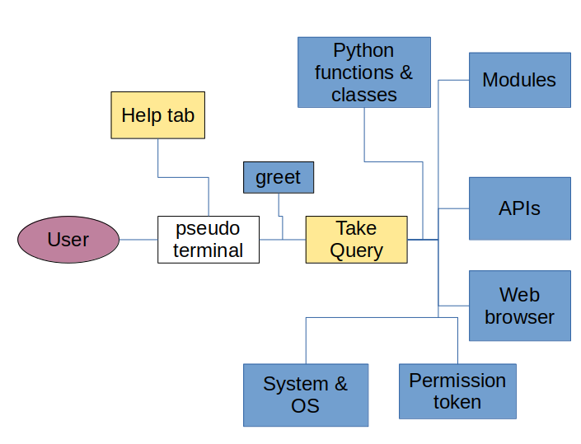

Activity Diagram

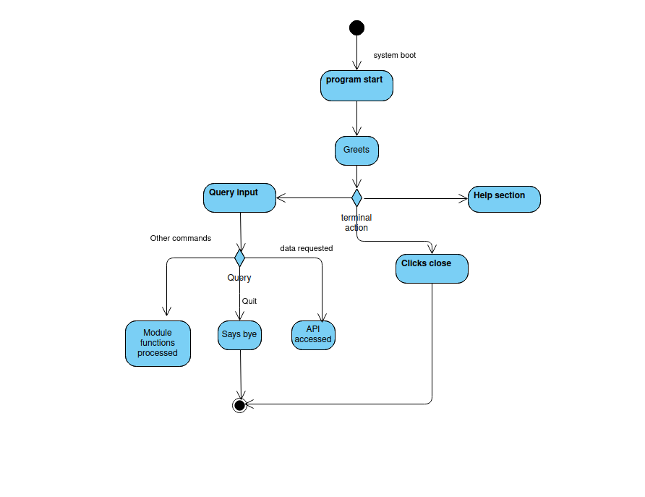

Module Description

* Pyttsx3: pyttsx3 is a text-to-speech conversion library in Python. It is a very easy to use tool which converts the entered text into speech.
* Datetime: The datetime module supplies classes for manipulating dates and times. Usually inbuilt with python.
* Web Browser: The webbrowser module provides a high-level interface to allow displaying Web-based documents to users. Under most circumstances, simply calling the open() function from this module will do the right thing. The webbrowser module can be used to launch a browser in a platform-independent manner as shown below:

>>import webbrowser

>>webbrowser.open('[http://www.python.org](http://www.python.org/)')

* Time and tzlocal to get current time and timezone name
* Os: The OS module in Python provides functions for interacting with the operating system. OS comes under Python’s standard utility modules. This module provides a portable way of using operating system-dependent functionality. The *os* and *os.path* modules include many functions to interact with the file system.
* Smtlib: The smtplib module defines an SMTP client session object that can be used to send

mail to any Internet machine with an SMTP or ESMTP listener daemon.

* Requests: The requests module allows you to send HTTP requests using Python. The HTTP request returns a Response Object with all the response data (content, encoding, status, etc).
* Pygame: Pygame is a cross-platform set of Python modules designed for writing video games. It includes computer graphics and sound libraries designed to be used with the Python programming language. Used to play and control music settings.
* Json : Python supports the JSON format through the built-in module named json . The json module is specifically designed for reading and writing strings formatted as JSON. That means you can conveniently convert Python data types into JSON data and the other way around.
* SerpAPI : The serpapi module allows you to access search data in your Python application. SerpApi supports Google, Google Maps, Google Shopping, Bing, Baidu, Yandex, Yahoo, eBay, App Stores, and more.
* Pyjokes: One line jokes for programmers (jokes as a service)

>>pip3 install pyjokes

* BeautifulSoup from bs4 : Beautiful Soup is a library that makes it easy to scrape information from web pages. It sits atop an HTML or XML parser, providing Pythonic idioms for iterating, searching, and modifying the parse tree.
* Subprocesses : The subprocess module in Python is a built-in module that allows us to create new child processes.
* Socket : This module provides access to the BSD socket interface. It is available on all modern Unix systems, Windows, MacOS, and probably additional platforms.
* Platfrom : The Platform module is used to retrieve as much possible information about the platform on which the program is being currently executed.
* PSUTIL : psutil (process and system utilities) is a cross-platform library for retrieving information on running processes and system utilization (CPU, memory, disks,etc)
* Tkinter with PIL, ttkbootstrap, ttkthemes, themed style : Tkinter is a standard Python interface to the Tk GUI toolkit shipped with Python. Python Tkinter is the fastest and easiest way to create GUI with the other modules to help set the theme and design.
* Turtle : In Python, turtle graphics provides a representation of a physical “turtle” (a little robot with a pen) that draws on a sheet of paper on the floor.
* googlesearch, googleapiclient.discovery, google_auth_oauthlib.flow , google.auth.transport.requests : googlesearch is a Python library for searching Google, easily. googlesearch uses requests and BeautifulSoup4 to scrape Google.
* Pickle : The pickle module can transform a complex object into a byte stream and it can transform the byte stream into an object with the same internal structure.

**Implementation**

Code Flow and Logic

The program is added to the startup menu with a delay of 10 sec so as to give it time to deploy correctly and automatically when the PC is booted.

Upon start Lily greets the user and opens the pseudo-terminal. The terminal contains the main tab or the actual terminal where the user types the query and the query and result gets displayed on the terminal screen and a help tab that list a guide for all commands that are accepted by Lily.

In the input line the user can type he command and either click enter on the keyboard or the enter button on the screen.

Lily will then comprehend the query (Take Query function).

* user asks date/time/day Lily will call datetime module to get current datetime, format it and then speak and display it
* user asks about the weather, the openweatherapi and accuweather api will get called and data will be processed and displayed in appropriate format
* user requests a pomodoro session, a tkinter window will open and using after() in-built funtion timer will be initiated. Adding -e flag will simply change the values accessed by the timer.
* user asks about their calender, googleapi will be called and once user gives permission to access, will use google function to access schedule
* system info gives the systme information either brief or detailed and uses platform and psutil modules
* autoclean + open app calls calls the os and uses “sudo” command to command the terminal
* volume uses audio permissions to change the systme volume
* jokes calls upon the pyjokes module and romdonly acces a joke tospeak and display it
* news + open website creates a request to access the html parses in the website and use bs4 and webbrowser modules to open and access a webpage
* recommendations are taken from the movie database API and according to the query gives a response which is converted to json and results are accessed and displayed
* search google calls webbrowser
* open file uses the webbrowser module to create a new tab in web browser to display the file
* ip address calls the socket module to provide teh address
* mail calls the smtp server and module to connect to server and send mail
* game calls the tutle module to create a drawable ping pong board
* todo function opens a tkinter window that tracks a list of tasks and buttons that can modify the said list

Program Screenshots

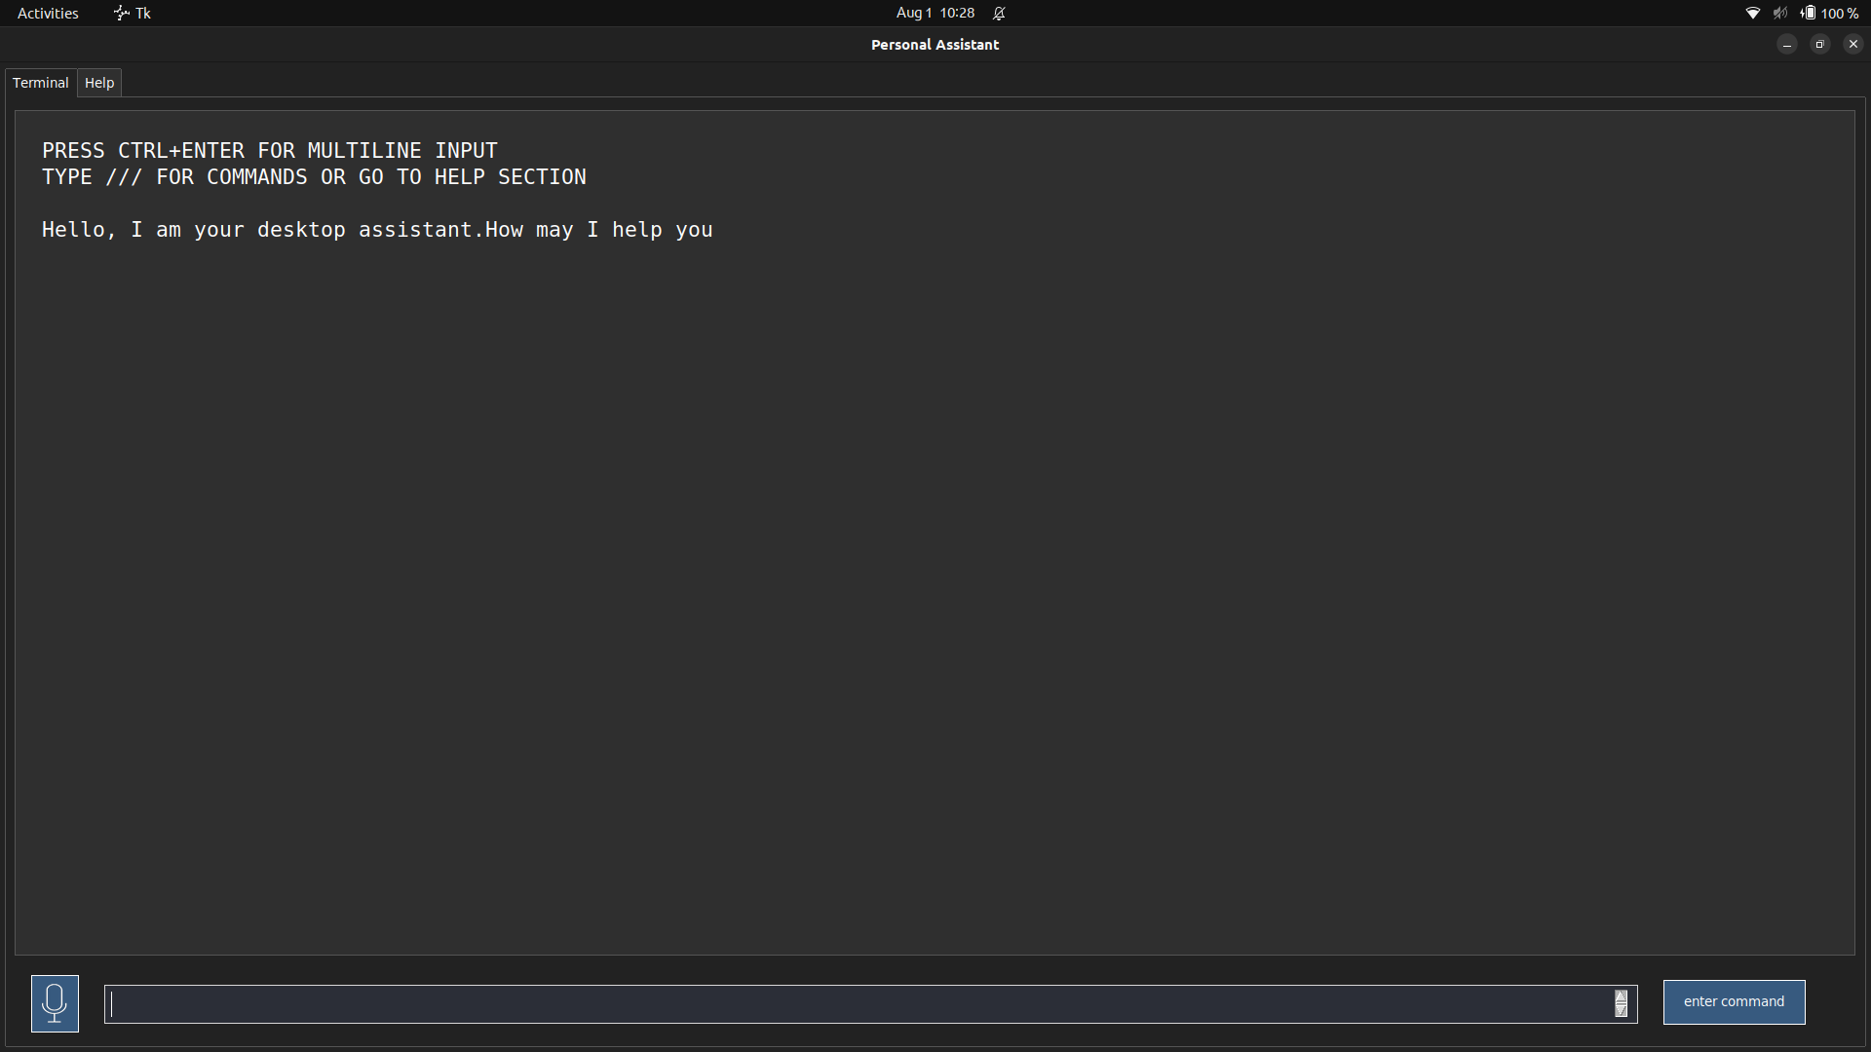

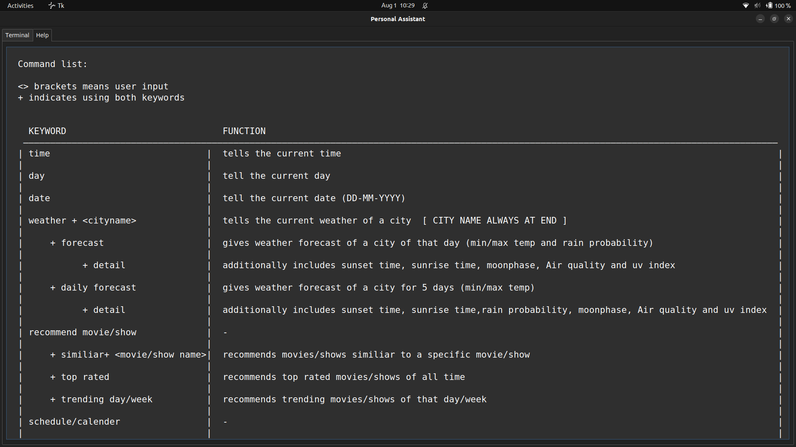

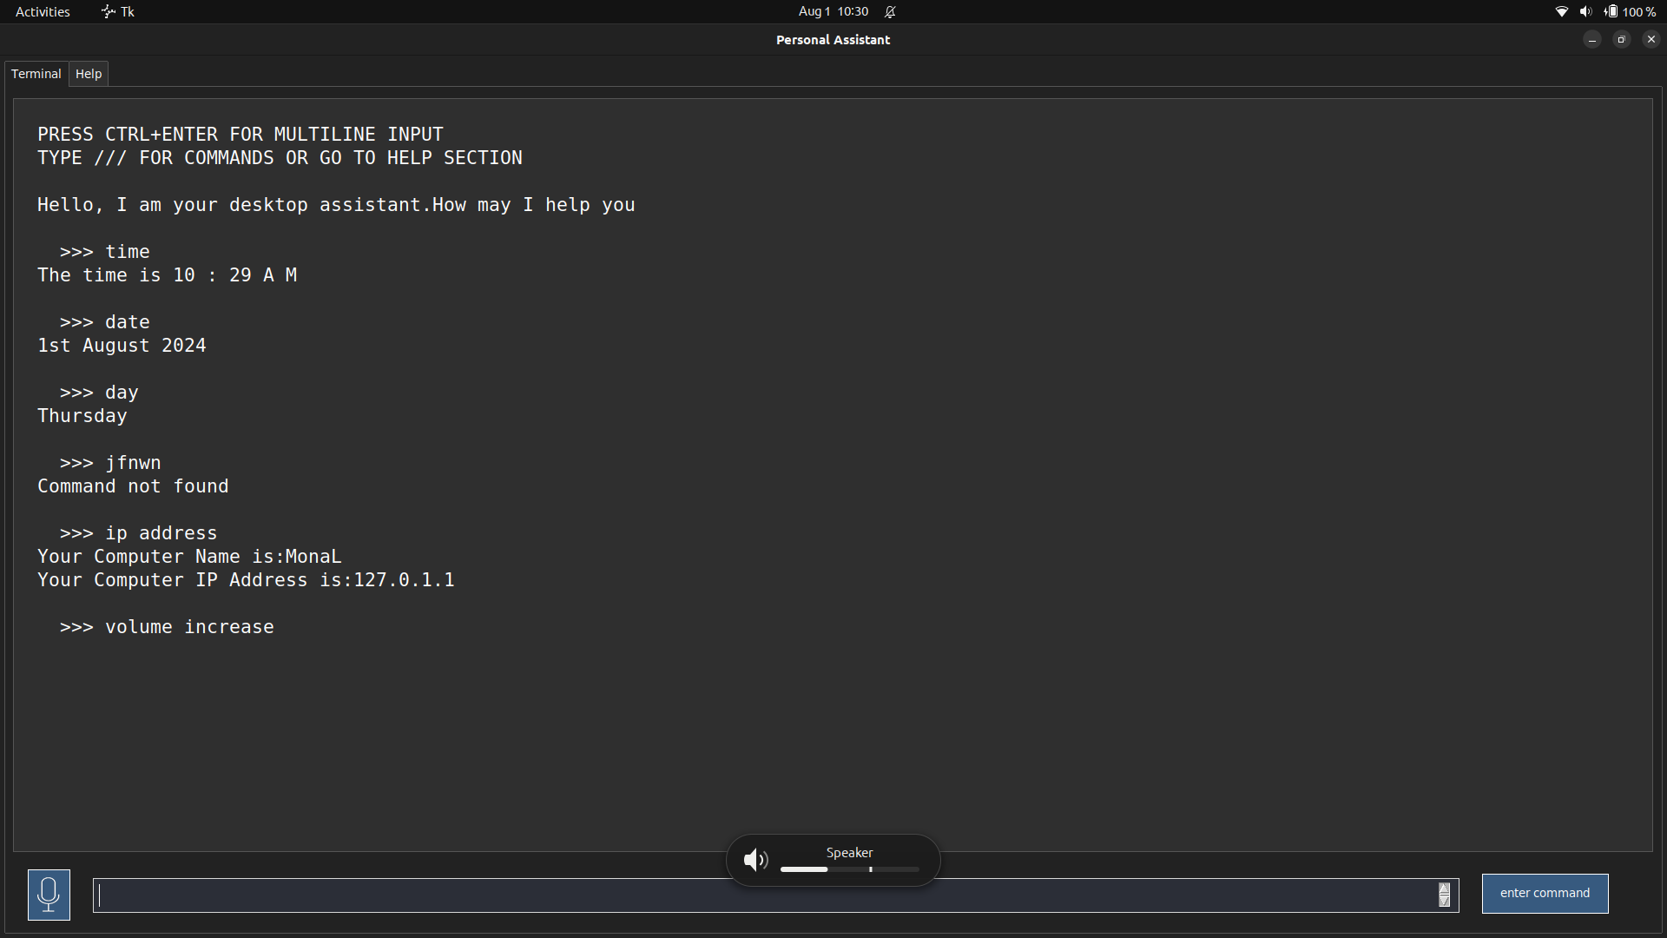

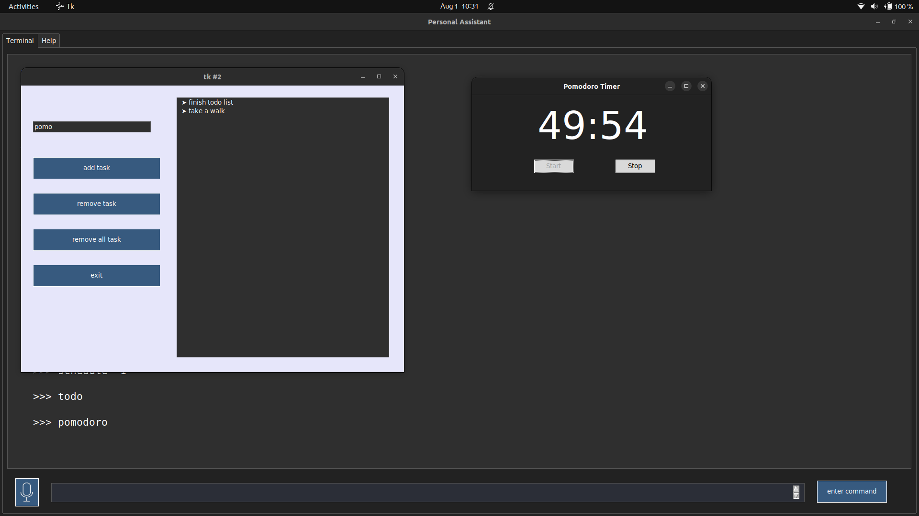

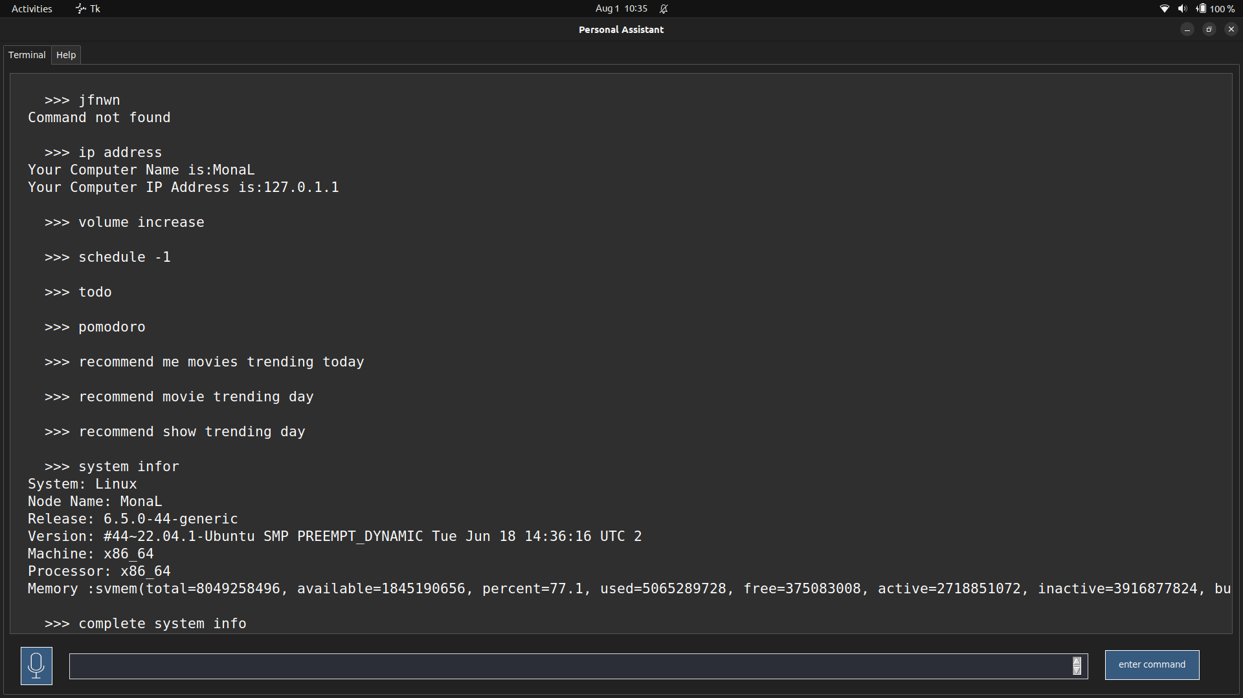

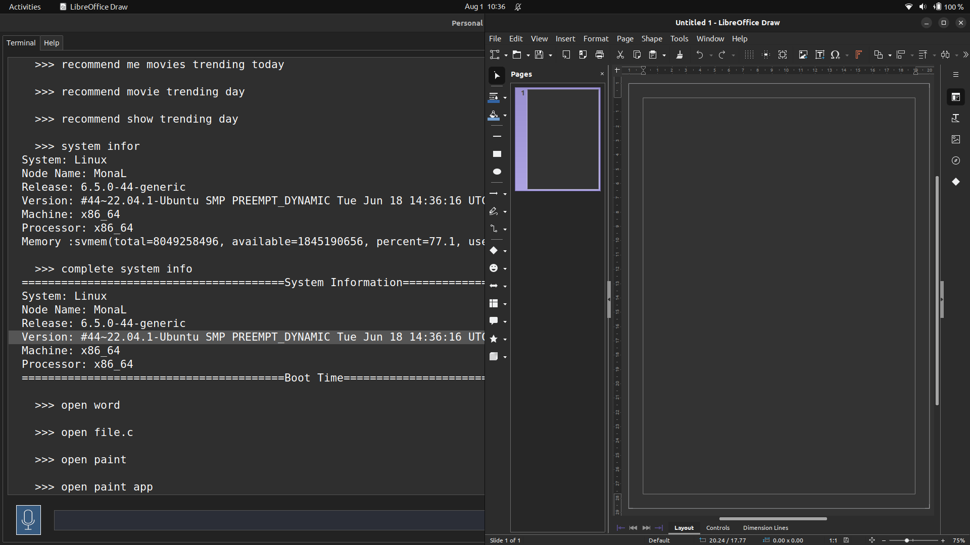

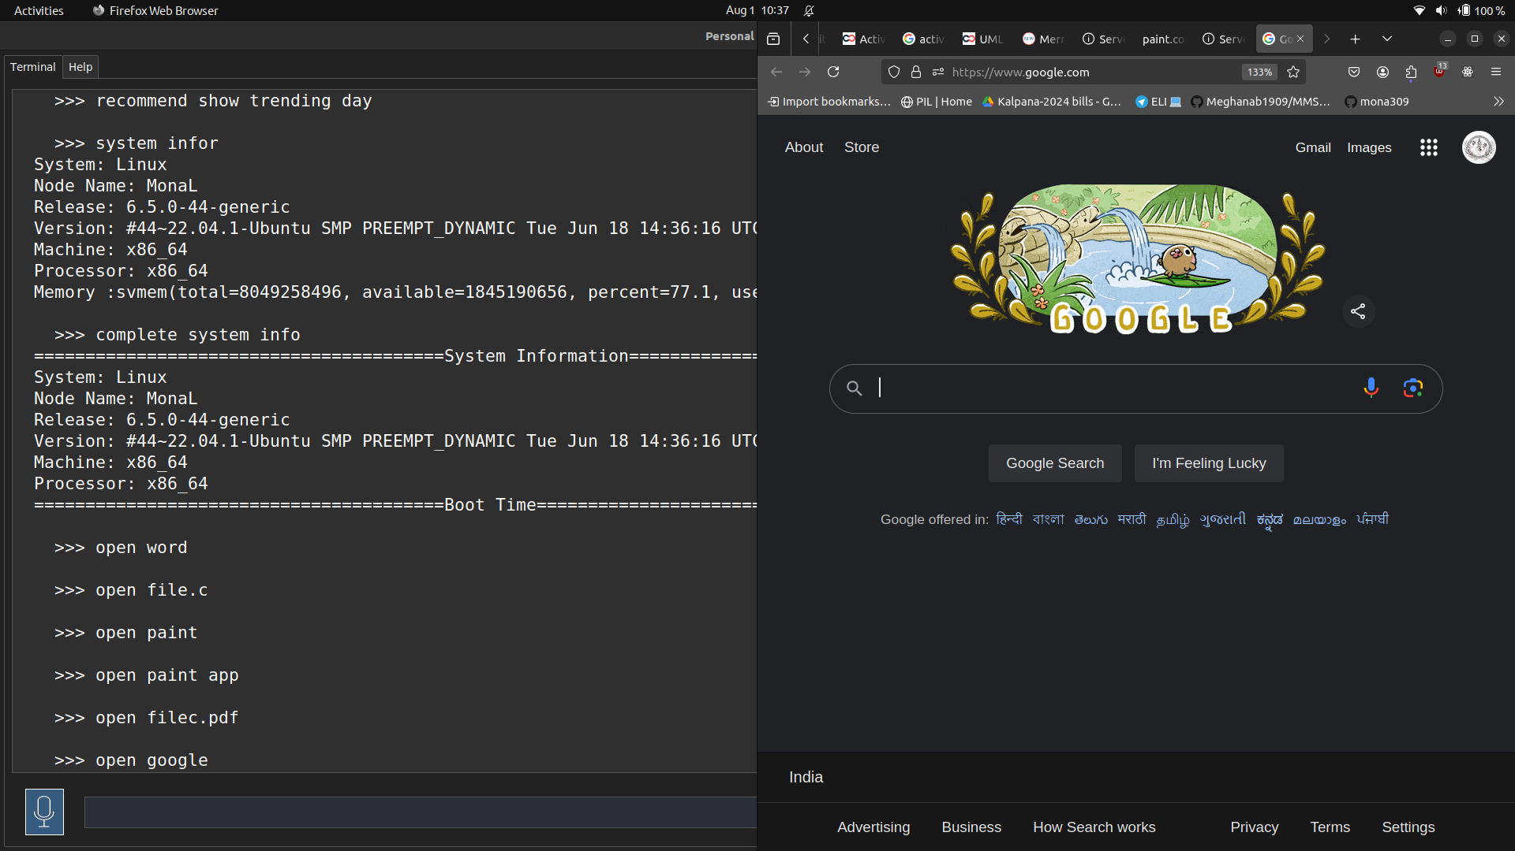

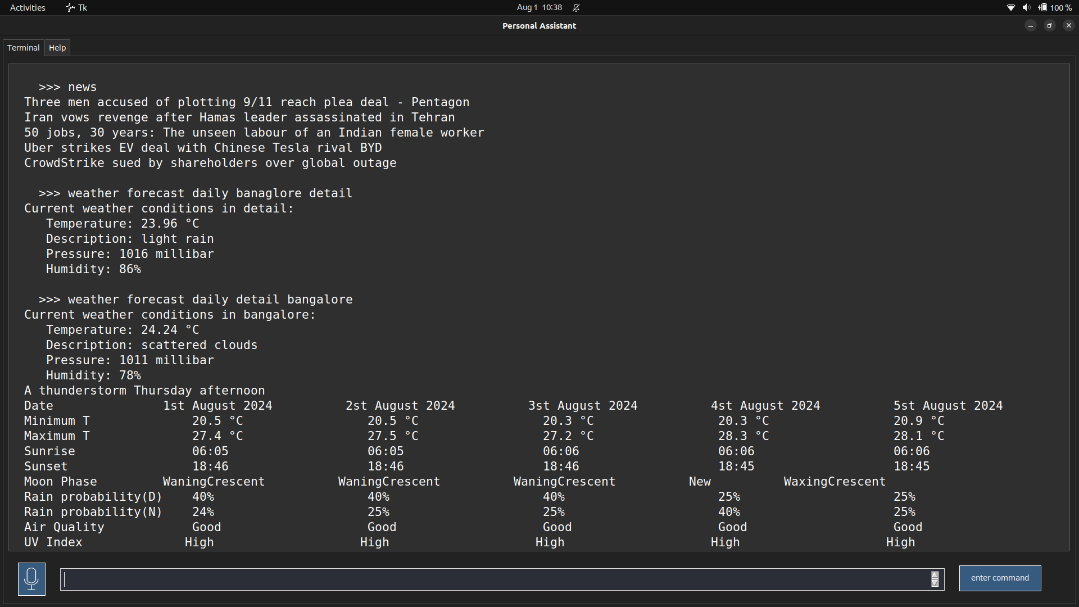

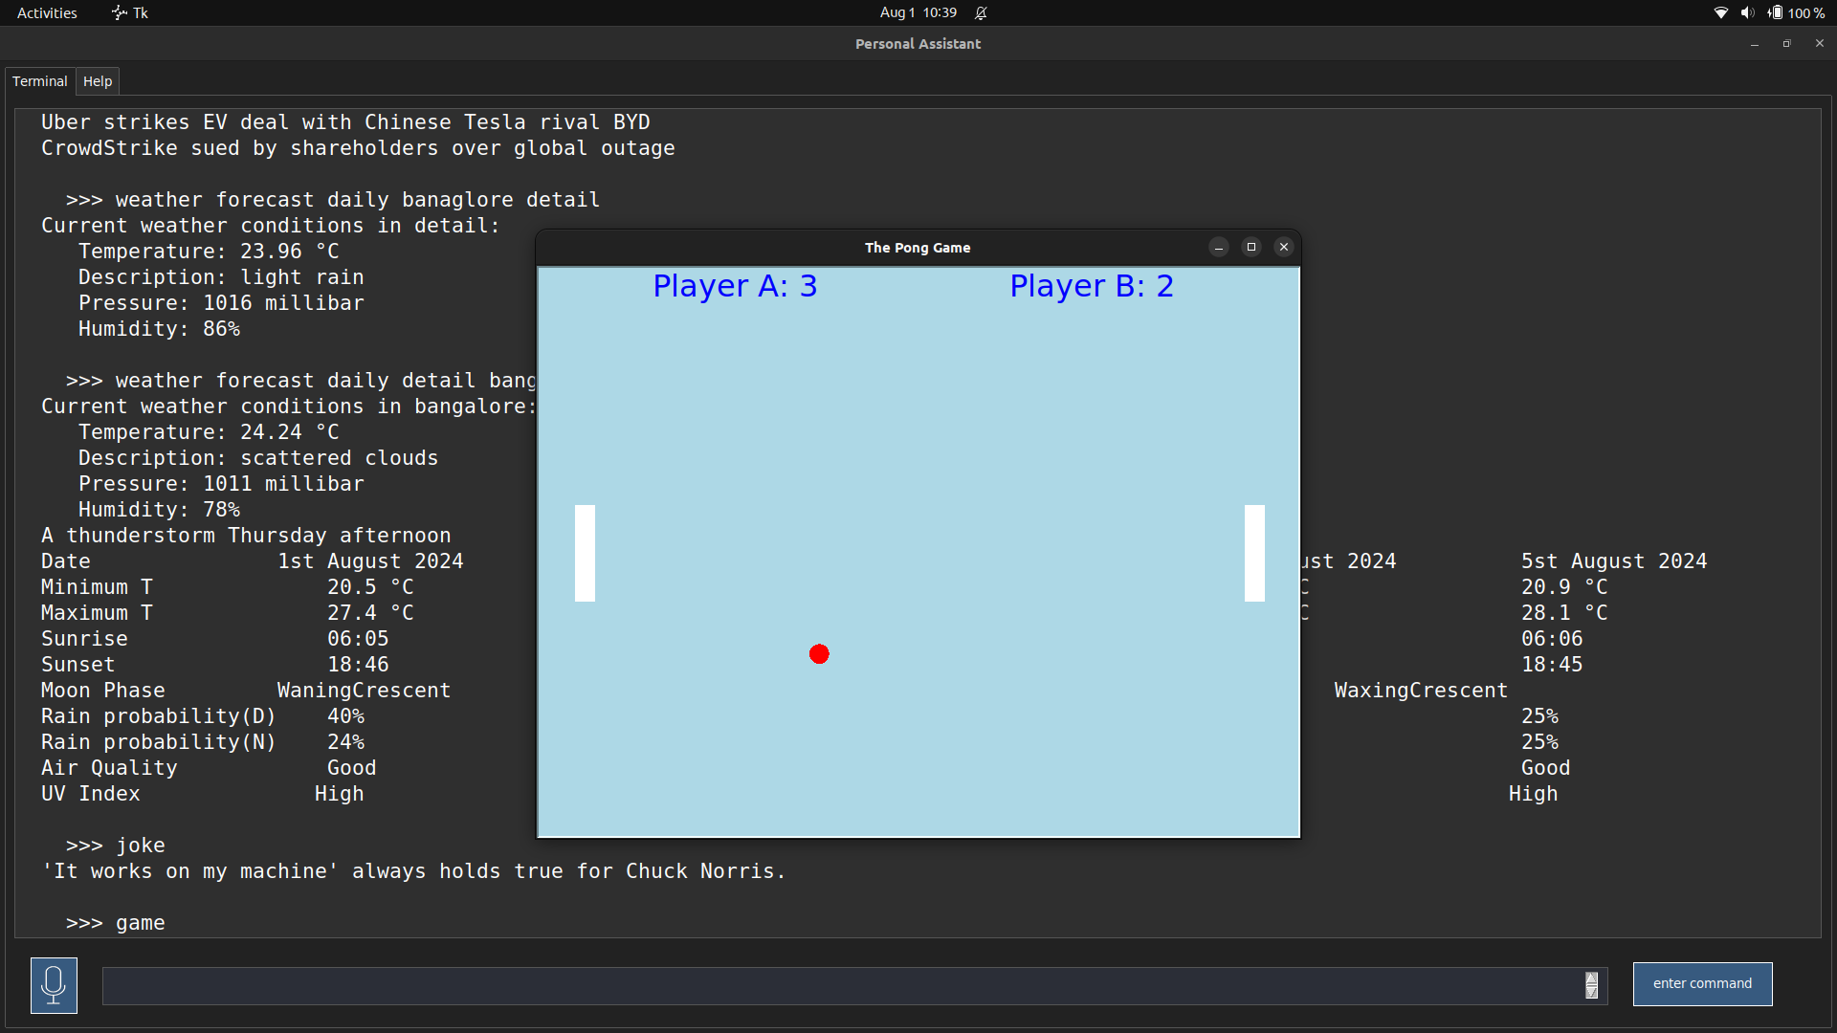

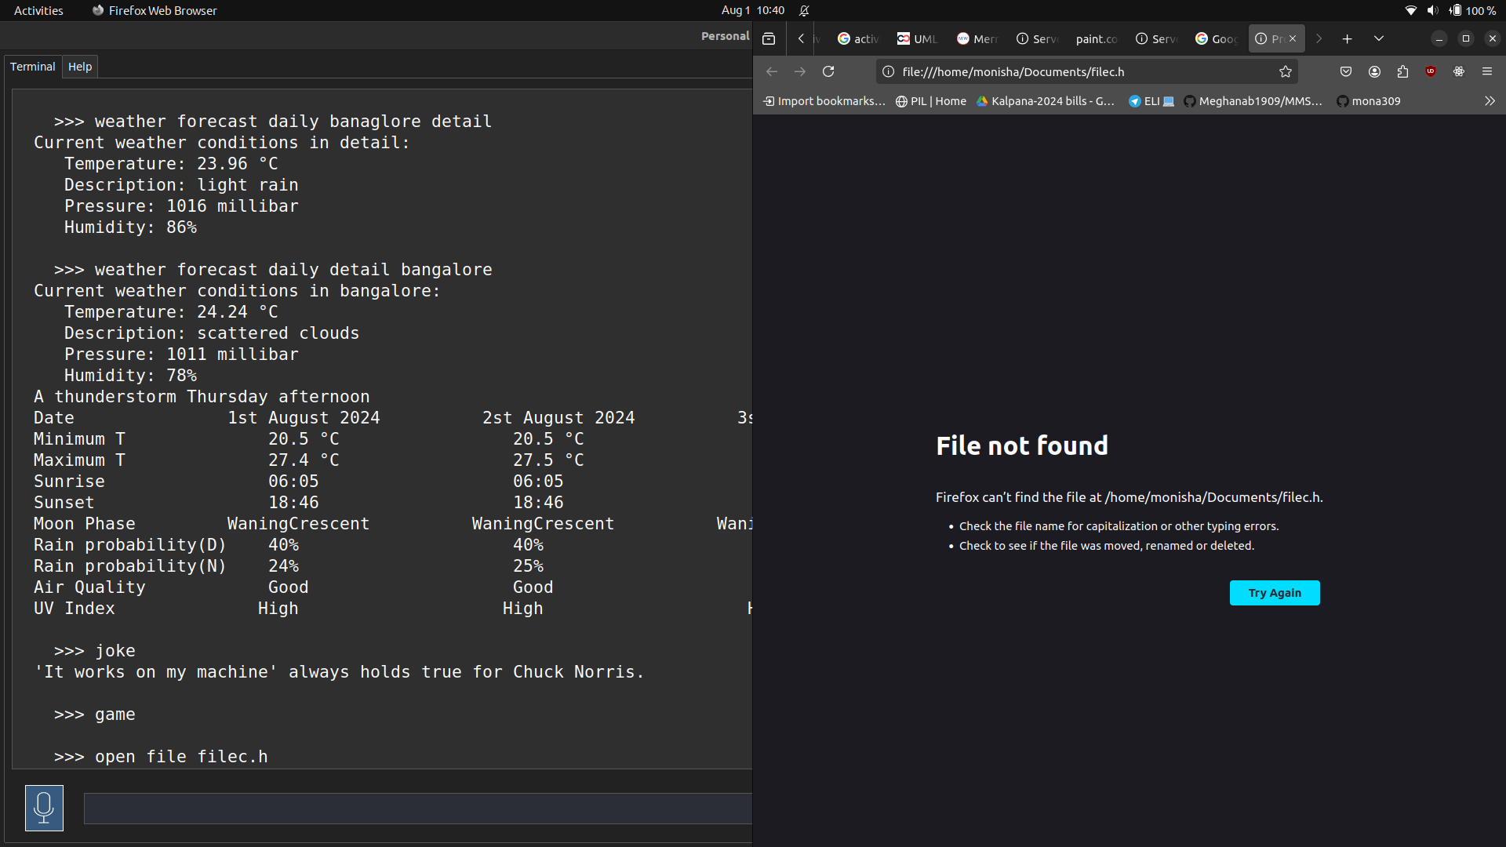

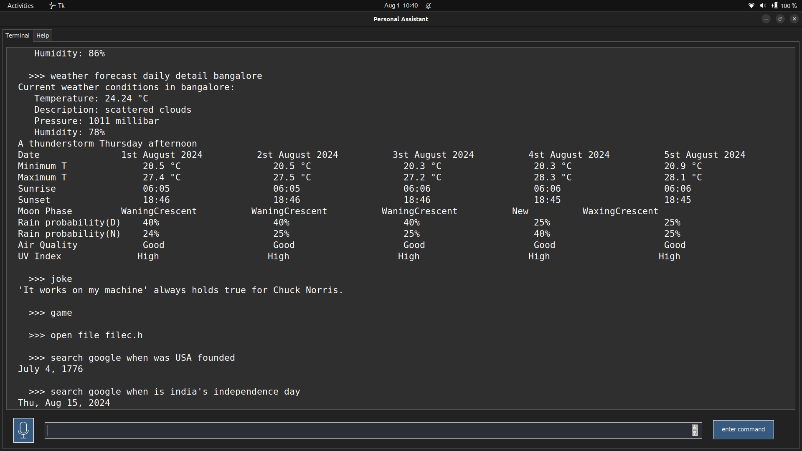

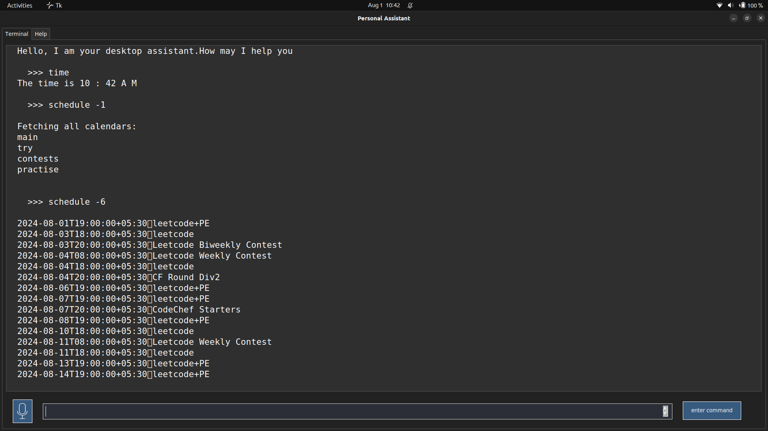

Tools Used

1. Visual Studio Code
2. Python 3.0: Python is an interpreted, high-level and general-purpose programming language. Python's design philosophy emphasizes code readability with its notable use of significant indentation. Its language constructs and object-oriented approach aim to help programmers write clear, logical code for small and large-scale projects.
3. Text Editor in-built in ubuntu 22.X.X

**Conclusion and Futher Scope**

Through this voice assistant, we have automated various services using a single line command. It

eases most of the tasks of the user like searching the web, retrieving weather forecast details,

recommendation help and music related queries. The aim is to make this project a complete personalized assistant. The future plans include integrating Lily with mobile using React Native to provide a synchronised experience between the two connected devices and combining with Rust to make a more secure Linux deployed application. Further, in the long run, Jarvis is planned to feature auto detection of junk files and crytographical uses for data protection as well as having an artificial intelligence backing it to support casual conversation.

Futher Scope

* music player improvised
* rust implementation to add data security
* sql database on pc to store user logins and information
* debain compilation to make a linux deployable application
* integrating Lily with mobile using React Native to provide a synchronised experience between the two connected devices
* speech recogition
* several instances open at same time
* artificial intelligence backing it to support casual conversation.