SIMATS ENGINEERING
ASSIGNMENT TOOL-5
COURSE NAME: Fundamentals of Data Science COURSE CODE: DSA04

COURSE OUTCOME COVERED
CO5: Design and implement end-to-end data-driven solutions by integrating pre-processing, statistical analysis, and machine learning for real-world applications (BL3)
Assessment Tool Weightage: 40%
QUESTIONS: 01 Total Marks: 100
HACKATHON – SOLUTION REPORT
Code of Conduct:
I Y MANASA SAI (192473023) (Name / Reg No) certify that this submission is my original work and that I have adhered to the guidelines specified for this assessment.
I understand that any violation of academic integrity rules will result in disciplinary action.
Signature of the student: Y Manasa

1. Understanding the problem
In simple words: a crop-advice app tells a farmer "grow rice" or "grow millet". If the app learned mostly from rich, well-irrigated districts, it may give confident but wrong advice to a farmer in a dry district, like a guidebook written for one city being used in another. The hackathon asks us to (1) build several models, (2) check how good they are overall and district-type by district-type, (3) check bias toward high-resource areas, and (4) decide which model to deploy and when a human agricultural officer must review.
Item | Our choice
Task | Crop selection (multi-class classification into Rice, Wheat, Millet, Groundnut, Cotton)
Inputs | soil type, rainfall, temperature, humidity, fertiliser use, pest incidents, previous crop
Regions | Irrigated (high-resource), Semi-arid, Drought-prone (low-resource)
Metrics | Accuracy, macro F1-score, region-wise accuracy and F1, bias in recommending resource-heavy crops

2. Data preparation and exploratory analysis (EDA)
- Dataset: 3000 records: Irrigated 1800, Semi-arid 900, Drought-prone 300. Drought-prone districts are only 10% of the data: this imbalance is deliberate, because real low-resource regions usually have fewer records.
- Cleaning steps: rainfall floor of 150 mm (no negative rainfall), humidity clipped to 15–98%, fertiliser ≥ 0, categorical values encoded; no duplicate or missing rows in the synthetic data (with real data, use median imputation and drop_duplicates()).
- Pre-processing: numerical features are standardised (StandardScaler), soil type and previous crop are one-hot encoded (OneHotEncoder). Both are done inside a scikit-learn Pipeline so test data is never used when fitting the scaler (no data leakage).
- Split: 70% training / 30% testing, stratified by region so every region appears in both parts.
- EDA finding: the best crop differs strongly by region. Rice is the best choice for about 81% of irrigated records but only about 1% of drought-prone records, where millet is best for about 67%. So one pooled model has to learn very different rules, and it learns the irrigated rule best because it has the most examples.

3. Models built
Model | Why it was included (simple explanation)
Logistic Regression | Simple baseline: a weighted score for each crop, easy to explain to officers
Decision Tree (depth 6) | A flow-chart of yes/no questions; very easy to read
KNN (k = 7) | Copies the crop of the 7 most similar past farms
Random Forest (300 trees) | Many trees voting together, more stable than one tree
Gradient Boosting | Trees built one after another, each fixing the mistakes of the previous one

4. Results

4.1 Overall performance (test set, 900 farms)
Model | Accuracy | Macro F1 | Worst-region F1 | F1 gap (Irrigated − Drought)
Logistic Regression | 0.782 | 0.633 | 0.276 | 0.349
Decision Tree | 0.763 | 0.627 | 0.31 | 0.311
KNN (k=7) | 0.704 | 0.503 | 0.256 | 0.154
Random Forest | 0.758 | 0.588 | 0.262 | 0.324
Gradient Boosting | 0.781 | 0.641 | 0.307 | 0.366

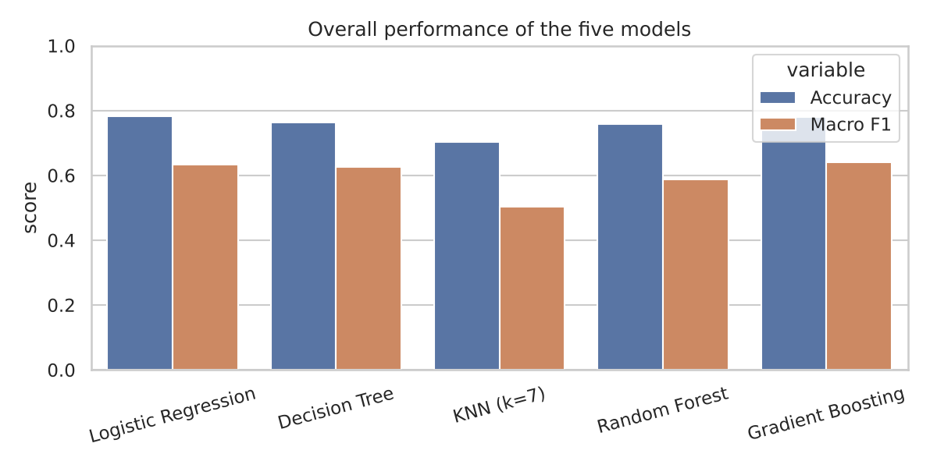
Reading it: Logistic Regression and Gradient Boosting are tied on accuracy (about 78%). Gradient Boosting has the best macro F1 (0.641), which averages F1 over all five crops, so it is the best at not ignoring rarer crops. KNN is clearly weakest.

4.2 Region-wise performance
Model | Irrigated acc / F1 | Semi-arid acc / F1 | Drought-prone acc / F1
Logistic Regression | 0.887 / 0.625 | 0.6 / 0.559 | 0.7 / 0.276
Decision Tree | 0.869 / 0.621 | 0.563 / 0.527 | 0.733 / 0.31
KNN (k=7) | 0.831 / 0.41 | 0.463 / 0.407 | 0.667 / 0.256
Random Forest | 0.876 / 0.586 | 0.544 / 0.48 | 0.689 / 0.262
Gradient Boosting | 0.891 / 0.673 | 0.574 / 0.534 | 0.744 / 0.307

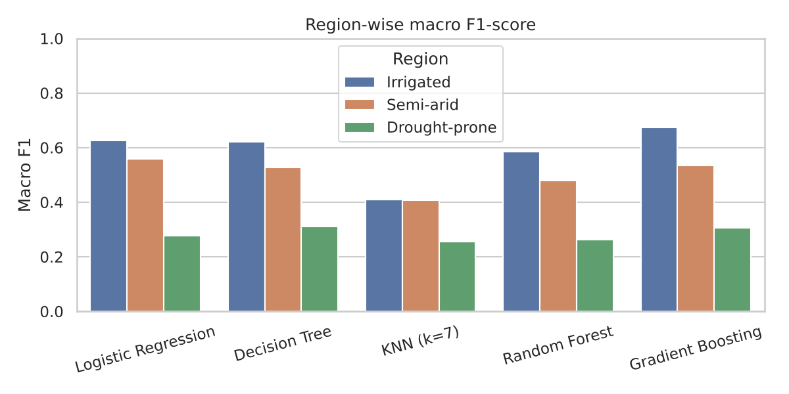
Key finding: overall accuracy hides a regional gap. Every model scores best on irrigated farms and much worse on drought-prone farms (macro F1 of only about 0.26–0.31 against 0.59–0.67). Accuracy in drought-prone areas looks decent (about 70–74%) only because one crop, millet, is correct most of the time; the models are poor at the other crops there. That is why the F1-score and region-wise checks matter, not accuracy alone.
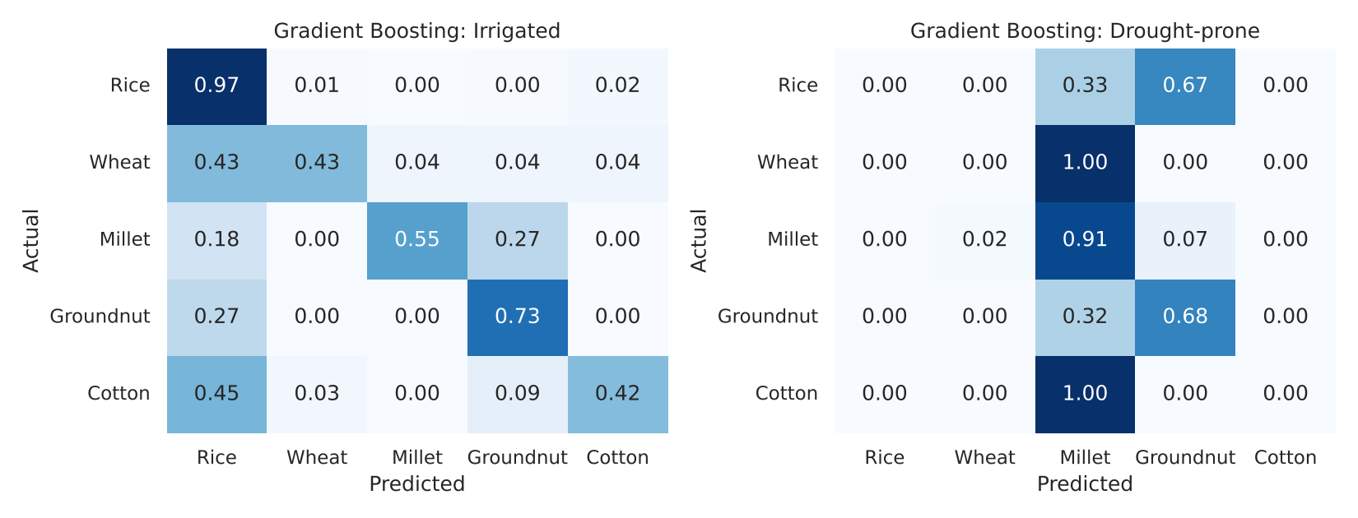

5. Bias assessment: are recommendations tilted toward high-resource areas?
We check how often the chosen model (Gradient Boosting) recommends resource-heavy crops (Rice, Cotton) in each region compared with how often they are really the best choice.
Region | Test records | True share Rice + Cotton | Predicted share Rice + Cotton
Irrigated | 540 | 88.1% | 90.4%
Semi-arid | 270 | 38.1% | 35.2%
Drought-prone | 90 | 7.8% | 0.0%

- In the irrigated region the model slightly over-recommends heavy crops (90.4% vs 88.1%): it has learned "rice" as the default answer.
- In the drought-prone region it never recommends them (0% vs 7.8%), so it misses the few farms where Rice or Cotton is genuinely suitable, usually where local irrigation exists. The bigger risk is the reverse: advice learned from irrigated data being applied to a dry district. The low F1 there shows the model is less reliable on exactly the farmers who can least afford a bad crop.
- Causes: (1) 60% of training data is from irrigated districts and only 10% from drought-prone ones; (2) drought-prone data is noisier; (3) one pooled model learns the majority pattern.
- Mitigation: collect more drought-region data; train with class/region weights or region-specific models; always report per-region metrics; keep human review for low-data regions.

6. Which model to deploy, and when must a human review?

6.1 Recommended model
Deploy Gradient Boosting, because it has the best macro F1 (0.641), ties for the best accuracy (0.781), has the best performance on irrigated and ties on drought-prone farms (worst-region F1 0.307 against 0.310 for the Decision Tree), and supplies probabilities, which are needed to decide when to ask a human. Logistic Regression is the fallback if explainability is the top priority; the Decision Tree is useful for explaining rules to officers. KNN and Random Forest are not recommended.
Honest caution: no model is reliable enough in drought-prone districts yet (F1 ≈ 0.31). The deployment is therefore *decision support with safeguards*, not a fully automatic advisor.

6.2 Conditions under which an agricultural officer must review the output
- Low confidence: the top predicted crop has probability below 55%, or the gap between the top two crops is under 15 percentage points.
- Drought-prone districts: any recommendation with probability below 70% (and, until more data is collected, all recommendations of Rice or Cotton there).
- Unusual inputs: rainfall in the lowest 2% of the training data, or other values outside the range the model was trained on.
- High pest pressure: 4 or more pest incidents recorded.
- High-impact advice: expensive inputs, a change from the farmer's usual crop, or a farmer who asks for a second opinion.

6.3 Effect of these rules on the test set
Region | Share sent for review | Accuracy: auto-approved | Accuracy: flagged
Drought-prone | 66.7% | 76.7% | 73.3%
Irrigated | 10.0% | 92.4% | 59.3%
Semi-arid | 44.1% | 67.5% | 44.5%

Overall, 25.9% of recommendations go to an officer. Accuracy is 86.1% on the auto-approved cases and only 55.4% on flagged ones, so the rules successfully send the doubtful cases to humans (overall accuracy without rules: 78.1%). The rules work well for irrigated and semi-arid districts. In drought-prone districts two thirds of cases are flagged, because the model is unsure there; in this region the accuracy of flagged and auto-approved cases is similar, which confirms that this region needs more data and routine officer review.

7. Conclusion
- Several models were built and compared using accuracy, macro F1 and region-wise performance.
- Overall accuracy (about 78%) hides a large regional gap: irrigated areas are served much better than drought-prone areas.
- Gradient Boosting is recommended, used together with a confidence-based human-review policy, with extra data collection and officer oversight in drought-prone regions.
- Limitations: the data is synthetic; real data would add noise, missing values and more regions. The review thresholds should be tuned on real validation data.

Appendix: complete, copy-paste-ready code
Save as crop_advisory.py and run python crop_advisory.py (needs pandas, numpy, scikit-learn, matplotlib, seaborn). It prints all tables and saves the three charts.
"""
AI-Based Crop Advisory Reliability Assessment (Hackathon, Problem 1)
Task: crop selection model, evaluated overall and region-wise.
NOTE: no real dataset was supplied, so a SYNTHETIC dataset is generated.
To use real data, replace build_data() with: df = pd.read_csv("crop_data.csv")
(same column names).
"""
import numpy as np
import pandas as pd
import matplotlib
import matplotlib.pyplot as plt
import seaborn as sns
from sklearn.model_selection import train_test_split
from sklearn.preprocessing import StandardScaler, OneHotEncoder
from sklearn.compose import ColumnTransformer
from sklearn.pipeline import Pipeline
from sklearn.linear_model import LogisticRegression
from sklearn.tree import DecisionTreeClassifier
from sklearn.neighbors import KNeighborsClassifier
from sklearn.ensemble import RandomForestClassifier, GradientBoostingClassifier
from sklearn.metrics import accuracy_score, f1_score, confusion_matrix

rng = np.random.default_rng(42)
CROPS = ["Rice", "Wheat", "Millet", "Groundnut", "Cotton"]

# ---------------------------------------------------------------- 1. DATA
def build_data():
# 9 districts: 3 irrigated (high-resource), 3 semi-arid, 3 drought-prone (low-resource)
cfg = {
"Irrigated": dict(n=1800, rain=(950, 220), temp=(27, 3), hum=(75, 8), fert=(150, 30), pest=1.0),
"Semi-arid": dict(n=900, rain=(600, 150), temp=(29, 3.5), hum=(55, 10), fert=(90, 25), pest=1.5),
"Drought-prone":dict(n=300, rain=(380, 110), temp=(32, 3.5), hum=(40, 10), fert=(40, 20), pest=2.2),
}
soils = ["Alluvial", "Black", "Red", "Sandy"]
soil_p = {"Irrigated": [.5, .25, .15, .10], "Semi-arid": [.15, .35, .3, .2], "Drought-prone": [.05, .15, .35, .45]}
rows = []
for region, c in cfg.items():
for _ in range(c["n"]):
district = f"{region[:3].upper()}-{rng.integers(1, 4)}"
soil = rng.choice(soils, p=soil_p[region])
rain = max(150, rng.normal(*c["rain"])); temp = rng.normal(*c["temp"])
hum = np.clip(rng.normal(*c["hum"]), 15, 98); fert = max(0, rng.normal(*c["fert"]))
pest = rng.poisson(c["pest"]); prev = rng.choice(CROPS)
u = {
"Rice": 0.006 * (rain - 700) + 0.03 * (hum - 60) + (1.0 if soil in ("Alluvial", "Black") else -0.5) - 0.15 * abs(temp - 27),
"Wheat": -0.15 * abs(temp - 21) - 0.004 * abs(rain - 600) + (0.8 if soil == "Alluvial" else 0.0) + 0.5,
"Millet": -0.006 * (rain - 350) + 0.1 * (temp - 28) + (0.9 if soil in ("Sandy", "Red") else 0) + 0.3,
"Groundnut": -0.003 * abs(rain - 600) - 0.12 * abs(temp - 29) + (1.0 if soil in ("Red", "Sandy") else -0.2) + 0.2,
"Cotton": -0.004 * abs(rain - 750) - 0.1 * abs(temp - 30) + (1.2 if soil == "Black" else -0.3) + 0.01 * (fert - 80),
}
if prev in u: u[prev] -= 0.25 # rotation effect
noise = 0.45 if region == "Irrigated" else (0.7 if region == "Semi-arid" else 1.0)
crop = max(u, key=lambda k: u[k] + rng.gumbel(0, noise))
rows.append([region, district, soil, rain, temp, hum, fert, pest, prev, crop])
return pd.DataFrame(rows, columns=["region", "district", "soil", "rainfall", "temperature",
"humidity", "fertilizer", "pest_incidents", "prev_crop", "crop"])

df = build_data()
print(df.shape); print(df["region"].value_counts()); print(pd.crosstab(df["region"], df["crop"], normalize="index").round(2))

# ---------------------------------------------------------------- 2. PREPARATION
num = ["rainfall", "temperature", "humidity", "fertilizer", "pest_incidents"]
cat = ["soil", "prev_crop"]
X, y, reg = df[num + cat], df["crop"], df["region"]
X_tr, X_te, y_tr, y_te, r_tr, r_te = train_test_split(X, y, reg, test_size=0.3, stratify=reg, random_state=42)

pre = ColumnTransformer([("n", StandardScaler(), num), ("c", OneHotEncoder(handle_unknown="ignore"), cat)])
models = {
"Logistic Regression": LogisticRegression(max_iter=2000),
"Decision Tree": DecisionTreeClassifier(max_depth=6, random_state=42),
"KNN (k=7)": KNeighborsClassifier(n_neighbors=7),
"Random Forest": RandomForestClassifier(n_estimators=300, random_state=42),
"Gradient Boosting": GradientBoostingClassifier(random_state=42),
}

# ---------------------------------------------------------------- 3. TRAIN + EVALUATE
fitted, rows, region_rows = {}, [], []
for name, m in models.items():
pipe = Pipeline([("pre", pre), ("m", m)]).fit(X_tr, y_tr)
fitted[name] = pipe
pred = pipe.predict(X_te)
rows.append([name, accuracy_score(y_te, pred), f1_score(y_te, pred, average="macro")])
for rg in ["Irrigated", "Semi-arid", "Drought-prone"]:
mask = (r_te == rg).values
region_rows.append([name, rg, accuracy_score(y_te[mask], pred[mask]),
f1_score(y_te[mask], pred[mask], average="macro")])
overall = pd.DataFrame(rows, columns=["Model", "Accuracy", "Macro F1"]).round(3)
regional = pd.DataFrame(region_rows, columns=["Model", "Region", "Accuracy", "Macro F1"]).round(3)
worst = regional.groupby("Model")["Macro F1"].min().rename("Worst-region F1")
gap = (regional.pivot(index="Model", columns="Region", values="Macro F1")
.assign(Gap=lambda t: t["Irrigated"] - t["Drought-prone"]))
overall = overall.merge(worst, on="Model").set_index("Model")
overall["F1 gap (Irrigated - Drought)"] = gap["Gap"].round(3)
print(overall); print(regional.pivot(index="Model", columns="Region", values="Macro F1"))

# ---------------------------------------------------------------- 4. BIAS CHECK
best_name = overall["Macro F1"].idxmax()
best = fitted[best_name]
pred = best.predict(X_te)
heavy = ["Rice", "Cotton"] # water / input-intensive crops
bias = []
for rg in ["Irrigated", "Semi-arid", "Drought-prone"]:
mask = (r_te == rg).values
bias.append([rg, mask.sum(), (y_te[mask].isin(heavy)).mean(), pd.Series(pred[mask]).isin(heavy).mean()])
bias = pd.DataFrame(bias, columns=["Region", "Test rows", "True share Rice+Cotton", "Predicted share Rice+Cotton"]).round(3)
print(bias)

# ---------------------------------------------------------------- 5. HUMAN-REVIEW RULES
proba = best.predict_proba(X_te)
top2 = np.sort(proba, axis=1)[:, -2:]
conf, margin = top2[:, 1], top2[:, 1] - top2[:, 0]
train_min, train_max = X_tr["rainfall"].min(), X_tr["rainfall"].max()
review = ((conf < 0.55) | (margin < 0.15) | ((r_te == "Drought-prone").values & (conf < 0.70))
| (X_te["pest_incidents"].values >= 4)
| (X_te["rainfall"].values < X_tr["rainfall"].quantile(0.02)) )
correct = (pred == y_te.values)
print("Flagged for officer review:", round(review.mean(), 3))
print("Accuracy on auto-approved:", round(correct[~review].mean(), 3), " on flagged:", round(correct[review].mean(), 3))
rev = pd.DataFrame({"Region": r_te.values, "flag": review, "ok": correct})
rev_tab = rev.groupby("Region").agg(Flagged=("flag", "mean"),
Acc_auto=("ok", lambda s: s[~rev.loc[s.index, "flag"]].mean()),
Acc_flagged=("ok", lambda s: s[rev.loc[s.index, "flag"]].mean())).round(3)
print(rev_tab)

# ---------------------------------------------------------------- 6. CHARTS
sns.set_theme(style="whitegrid")
fig, ax = plt.subplots(figsize=(8, 4))
o = overall.reset_index().melt(id_vars="Model", value_vars=["Accuracy", "Macro F1"])
sns.barplot(data=o, x="Model", y="value", hue="variable", ax=ax)
ax.set_ylim(0, 1); ax.set_title("Overall performance of the five models"); ax.set_ylabel("score"); ax.set_xlabel("")
plt.xticks(rotation=15); plt.tight_layout(); plt.savefig("chart_overall.png", dpi=150); plt.close()

fig, ax = plt.subplots(figsize=(8, 4))
sns.barplot(data=regional, x="Model", y="Macro F1", hue="Region", hue_order=["Irrigated", "Semi-arid", "Drought-prone"], ax=ax)
ax.set_ylim(0, 1); ax.set_title("Region-wise macro F1-score"); ax.set_xlabel("")
plt.xticks(rotation=15); plt.tight_layout(); plt.savefig("chart_region.png", dpi=150); plt.close()

fig, axes = plt.subplots(1, 2, figsize=(11, 4.2))
for ax, rg in zip(axes, ["Irrigated", "Drought-prone"]):
mask = (r_te == rg).values
cm = confusion_matrix(y_te[mask], pred[mask], labels=CROPS, normalize="true")
sns.heatmap(cm, annot=True, fmt=".2f", cmap="Blues", xticklabels=CROPS, yticklabels=CROPS, ax=ax, cbar=False)
ax.set_title(f"{best_name}: {rg}"); ax.set_xlabel("Predicted"); ax.set_ylabel("Actual")
plt.tight_layout(); plt.savefig("chart_confusion.png", dpi=150); plt.close()

overall.to_csv("res_overall.csv"); regional.to_csv("res_regional.csv", index=False); bias.to_csv("res_bias.csv", index=False)
rev_tab.to_csv("res_review.csv")
import json
json.dump(dict(best=best_name, flagged=float(review.mean()), acc_auto=float(correct[~review].mean()), acc_flag=float(correct[review].mean()),
n_train=int(len(X_tr)), n_test=int(len(X_te)), shares=df["region"].value_counts().to_dict(),
acc_overall=float(correct.mean())), open("res_misc.json", "w"))

