SIMATS ENGINEERING
ASSIGNMENT-1

COURSE NAME: Fundamentals of Data Science COURSE CODE: DSA04

COURSE OUTCOME COVERED
CO1: Analyse the role of data science, facets of data, and the big data ecosystem for informed decision-making. (BL2)

QUESTIONS: 05 Total Marks:100
Annexure A
Exploratory Data Analysis - Based Practical Assessment

Code of Conduct:
I Y MANASA SAI (192473023) (Name / Reg No) certify that this submission is my original work and that I have adhered to the guidelines specified for this assessment.
I understand that any violation of academic integrity rules will result in disciplinary action.
Signature of the student:

Question 1: Education Analytics Dataset
A college wants to identify how attendance, study hours, and internal marks relate to students’ final results.

1. Dataset understanding
Number of rows: 20
Number of columns: 5
Columns and data types:
Column | Data Type
Student_ID | object
Attendance | int64
Study_Hours | int64
Internal_Marks | int64
Result | object
The ID column uniquely identifies each record and is categorical/identifier data. Numeric columns are measurements or quantities. Remaining text columns represent categories or outcomes.

2. Data cleaning
Missing values: 0 (no missing values found).
Duplicate rows: 0 (no duplicate rows found).
No correction or removal was required based on missing values or duplicate rows. The supplied values were retained as given.

3. Descriptive statistics
Variable | Mean | Median | Minimum | Maximum | Std. Deviation
Attendance | 70.15 | 70.00 | 45.00 | 95.00 | 15.94
Study_Hours | 3.35 | 3.00 | 1.00 | 6.00 | 1.42
Internal_Marks | 32.95 | 33.50 | 18.00 | 48.00 | 9.09
Standard deviation is calculated using the sample standard deviation (ddof = 1).

4. Visualizations
The following charts show a numerical distribution, a relationship between two numerical variables, and a categorical count where applicable.
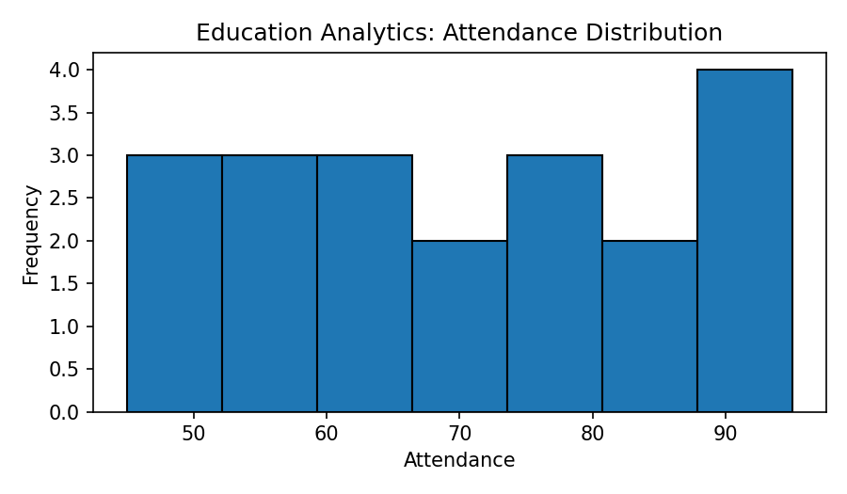
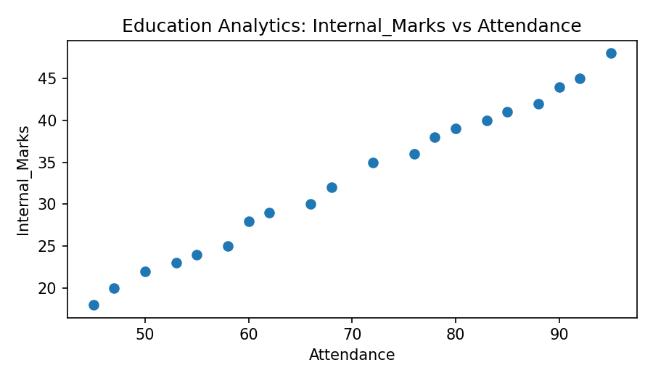
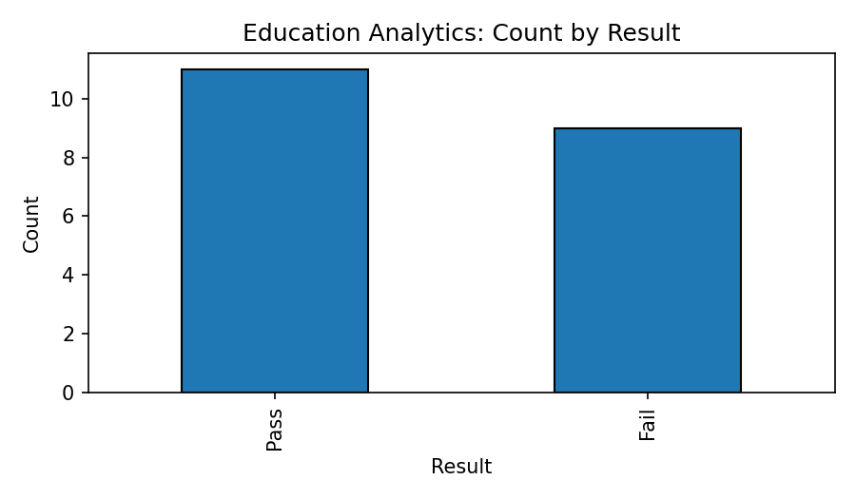

5. Important patterns and observations
- Out of 20 students, 12 passed and 8 failed, giving a pass rate of 60%.
- All students with attendance of 76% or more passed in this dataset; students with attendance below 66% failed.
- Students who passed generally recorded higher study hours and internal marks. Pass-group internal marks range from 32 to 48, while fail-group marks range from 18 to 30.
- Attendance, study hours, and internal marks move together with the final result in this small dataset. This indicates association, not proof of causation.

6. Conclusion
The dataset suggests that higher attendance, more study hours, and higher internal marks are associated with passing. The college can monitor students with low attendance or internal marks and provide academic support early.

Question 2: Healthcare Analytics Dataset
A hospital wants to explore patterns between age, sugar level, blood pressure, BMI, and disease status.

1. Dataset understanding
Number of rows: 20
Number of columns: 6
Columns and data types:
Column | Data Type
Patient_ID | object
Age | int64
Sugar_Level | int64
BP | int64
BMI | int64
Disease_Status | object
The ID column uniquely identifies each record and is categorical/identifier data. Numeric columns are measurements or quantities. Remaining text columns represent categories or outcomes.

2. Data cleaning
Missing values: 0 (no missing values found).
Duplicate rows: 0 (no duplicate rows found).
No correction or removal was required based on missing values or duplicate rows. The supplied values were retained as given.

3. Descriptive statistics
Variable | Mean | Median | Minimum | Maximum | Std. Deviation
Age | 43.20 | 43.50 | 27.00 | 62.00 | 11.32
Sugar_Level | 138.65 | 137.50 | 88.00 | 210.00 | 40.33
BP | 129.75 | 129.00 | 108.00 | 155.00 | 14.52
BMI | 27.30 | 27.50 | 21.00 | 35.00 | 4.26
Standard deviation is calculated using the sample standard deviation (ddof = 1).

4. Visualizations
The following charts show a numerical distribution, a relationship between two numerical variables, and a categorical count where applicable.
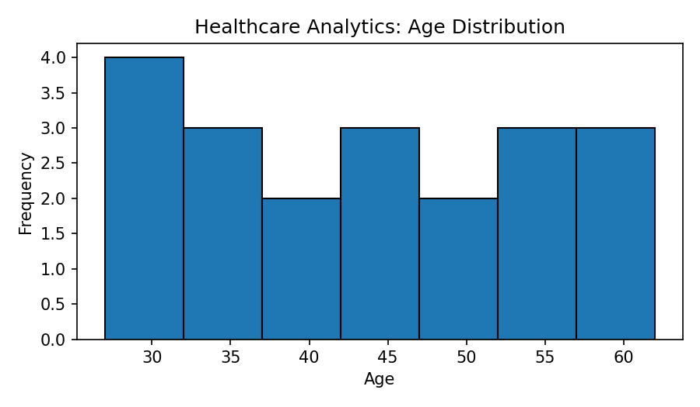
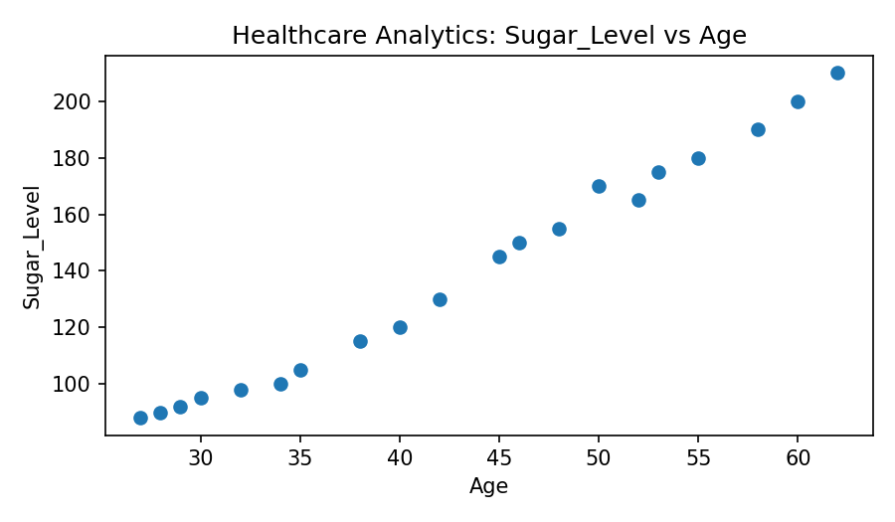
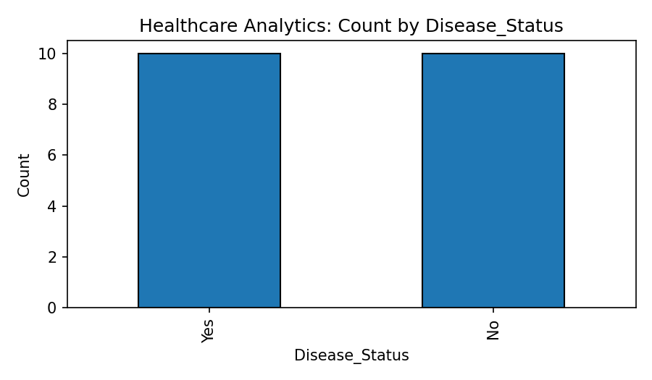

5. Important patterns and observations
- 10 patients are marked Yes and 10 are marked No for disease status.
- Every patient marked Yes has sugar level from 145 to 210, BP from 130 to 155, and BMI from 28 to 35 in this dataset.
- Every patient marked No has sugar level from 88 to 130, BP from 108 to 128, and BMI from 21 to 27.
- Patients marked Yes are generally older than those marked No in this sample. The observed groups are clearly separated on the supplied measurements.
- These are patterns in the assignment dataset only; they should not be treated as clinical diagnostic thresholds or medical advice.

6. Conclusion
The supplied records show higher sugar level, blood pressure, BMI, and age among patients marked as having disease. These variables may be useful for further investigation, but real clinical decisions require validated data and medical assessment.

Question 3: Retail Sales Dataset
A supermarket wants to identify high-selling products and revenue patterns using category, price, quantity sold, discount, and revenue.

1. Dataset understanding
Number of rows: 20
Number of columns: 6
Columns and data types:
Column | Data Type
Product_ID | object
Category | object
Price | int64
Quantity_Sold | int64
Discount | int64
Revenue | int64
The ID column uniquely identifies each record and is categorical/identifier data. Numeric columns are measurements or quantities. Remaining text columns represent categories or outcomes.

2. Data cleaning
Missing values: 0 (no missing values found).
Duplicate rows: 0 (no duplicate rows found).
No correction or removal was required based on missing values or duplicate rows. The supplied values were retained as given.

3. Descriptive statistics
Variable | Mean | Median | Minimum | Maximum | Std. Deviation
Price | 54.00 | 50.00 | 20.00 | 100.00 | 22.80
Quantity_Sold | 24.00 | 21.00 | 10.00 | 45.00 | 9.67
Discount | 4.00 | 4.00 | 2.00 | 7.00 | 1.56
Revenue | 1114.00 | 1050.00 | 810.00 | 1540.00 | 221.42
Standard deviation is calculated using the sample standard deviation (ddof = 1).

4. Visualizations
The following charts show a numerical distribution, a relationship between two numerical variables, and a categorical count where applicable.
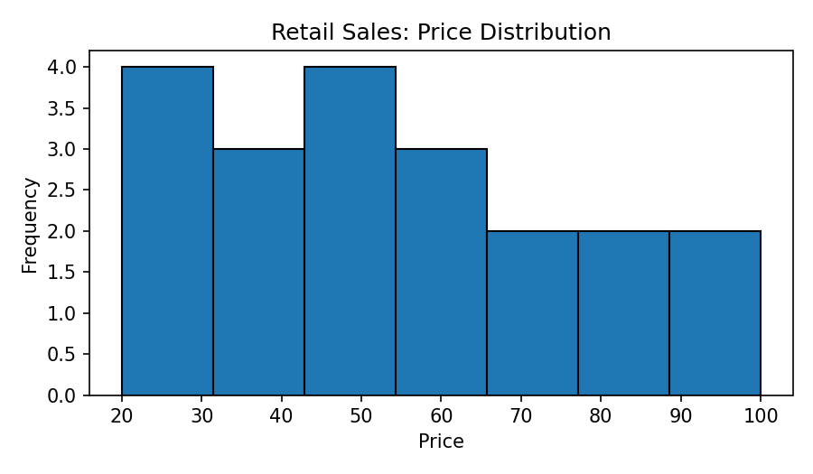
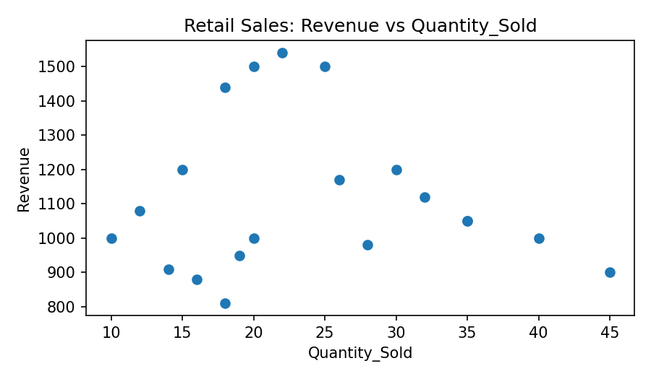
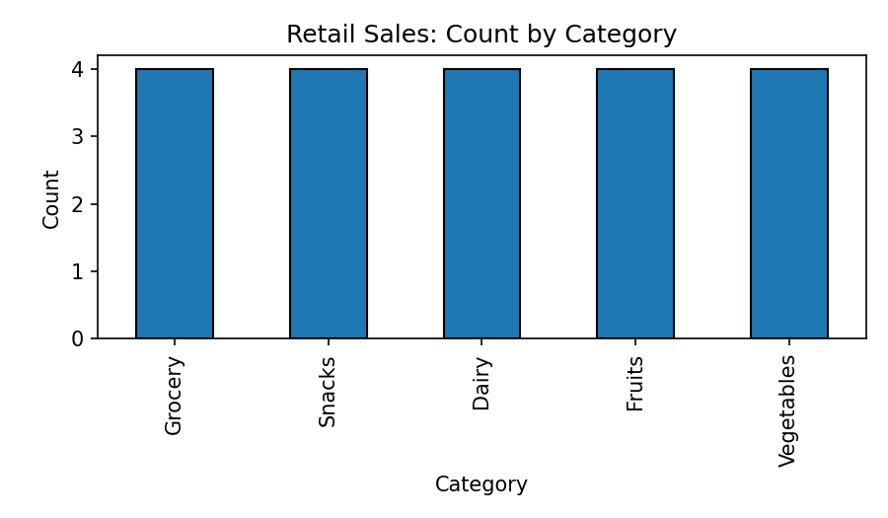

5. Important patterns and observations
- Fruits generate the highest total revenue among categories: ₹5,980 across four products.
- Snacks have the highest total quantity sold: 152 units across four products.
- PR09 (Fruits) has the highest revenue of ₹1,540, followed by PR04 and PR14 at ₹1,500 each.
- PR12 (Snacks) has the highest quantity sold at 45 units, followed by PR07 at 40 units.
- Revenue is not determined by quantity alone: fruit products generate high revenue with relatively high prices, while snacks sell in larger quantities at lower prices.

6. Conclusion
Fruits are the strongest category by total revenue, while Snacks lead in quantity sold. The supermarket can maintain fruit availability for revenue and use snack sales volume when planning stock and promotions.

Question 4: Banking Loan Approval Dataset
A bank wants to examine how income, credit score, loan amount, and employment type relate to loan approval.

1. Dataset understanding
Number of rows: 20
Number of columns: 6
Columns and data types:
Column | Data Type
Customer_ID | object
Income | int64
Credit_Score | int64
Loan_Amount | int64
Employment_Type | object
Loan_Status | object
The ID column uniquely identifies each record and is categorical/identifier data. Numeric columns are measurements or quantities. Remaining text columns represent categories or outcomes.

2. Data cleaning
Missing values: 0 (no missing values found).
Duplicate rows: 0 (no duplicate rows found).
No correction or removal was required based on missing values or duplicate rows. The supplied values were retained as given.

3. Descriptive statistics
Variable | Mean | Median | Minimum | Maximum | Std. Deviation
Income | 43000.00 | 40000.00 | 22000.00 | 75000.00 | 17923.82
Credit_Score | 664.00 | 660.00 | 555.00 | 790.00 | 85.53
Loan_Amount | 223250.00 | 200000.00 | 120000.00 | 400000.00 | 83733.21
Standard deviation is calculated using the sample standard deviation (ddof = 1).

4. Visualizations
The following charts show a numerical distribution, a relationship between two numerical variables, and a categorical count where applicable.
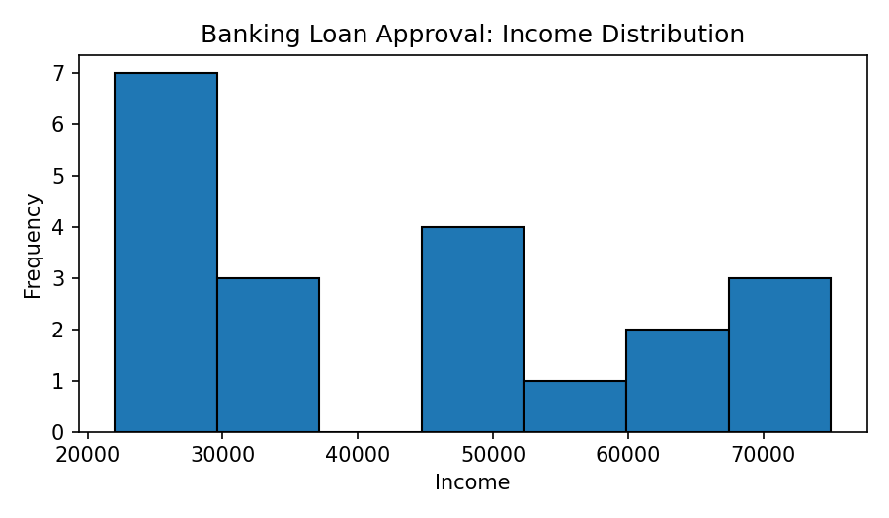
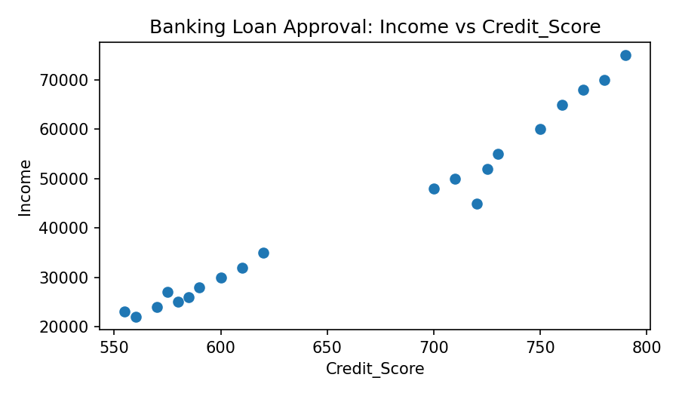
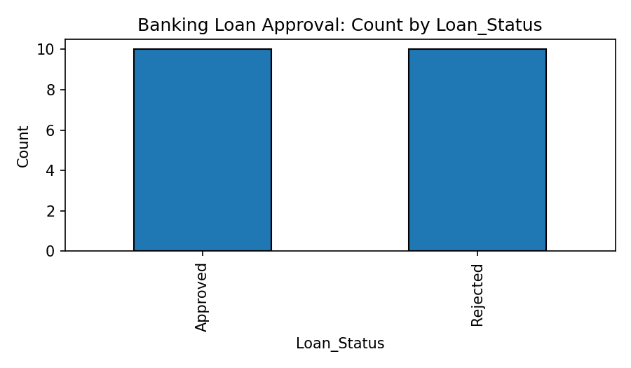

5. Important patterns and observations
- 10 of the 20 applications are Approved and 10 are Rejected.
- All approved applicants in the supplied data are Salaried, with income from ₹45,000 to ₹75,000 and credit scores from 700 to 790.
- All rejected applicants are Self-employed or Unemployed, with income from ₹22,000 to ₹35,000 and credit scores from 555 to 620.
- Approved applications have loan amounts from ₹2,00,000 to ₹4,00,000, while rejected applications range from ₹1,20,000 to ₹2,00,000.
- Employment type, income, and credit score show a clear association with approval status in this dataset. The sample is small and highly structured, so it should not be generalized to real lending decisions.

6. Conclusion
In this dataset, higher income and credit score and Salaried employment are associated with loan approval. A bank should use a larger, representative dataset and fair, validated criteria before making real lending decisions.

Question 5: Agriculture Crop Yield Dataset
An agricultural department wants to identify how rainfall, temperature, fertilizer use, and soil type relate to crop yield.

1. Dataset understanding
Number of rows: 20
Number of columns: 6
Columns and data types:
Column | Data Type
Farm_ID | object
Rainfall_mm | int64
Temperature | int64
Fertilizer_kg | int64
Soil_Type | object
Crop_Yield_kg | int64
The ID column uniquely identifies each record and is categorical/identifier data. Numeric columns are measurements or quantities. Remaining text columns represent categories or outcomes.

2. Data cleaning
Missing values: 0 (no missing values found).
Duplicate rows: 0 (no duplicate rows found).
No correction or removal was required based on missing values or duplicate rows. The supplied values were retained as given.

3. Descriptive statistics
Variable | Mean | Median | Minimum | Maximum | Std. Deviation
Rainfall_mm | 743.00 | 770.00 | 500.00 | 960.00 | 144.34
Temperature | 29.55 | 29.00 | 25.00 | 34.00 | 2.76
Fertilizer_kg | 54.75 | 54.50 | 40.00 | 75.00 | 10.51
Crop_Yield_kg | 2820.00 | 2975.00 | 1800.00 | 3900.00 | 681.41
Standard deviation is calculated using the sample standard deviation (ddof = 1).

4. Visualizations
The following charts show a numerical distribution, a relationship between two numerical variables, and a categorical count where applicable.
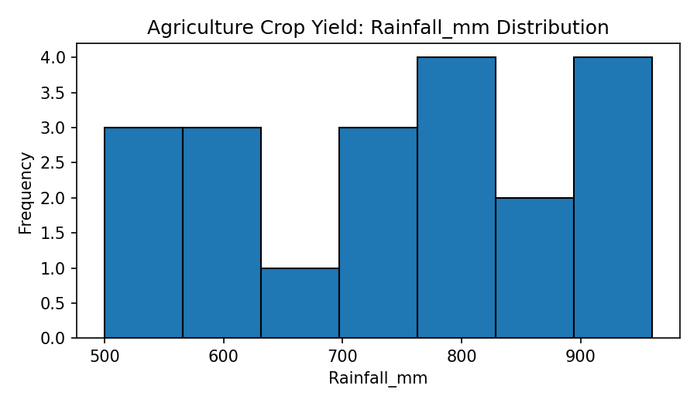
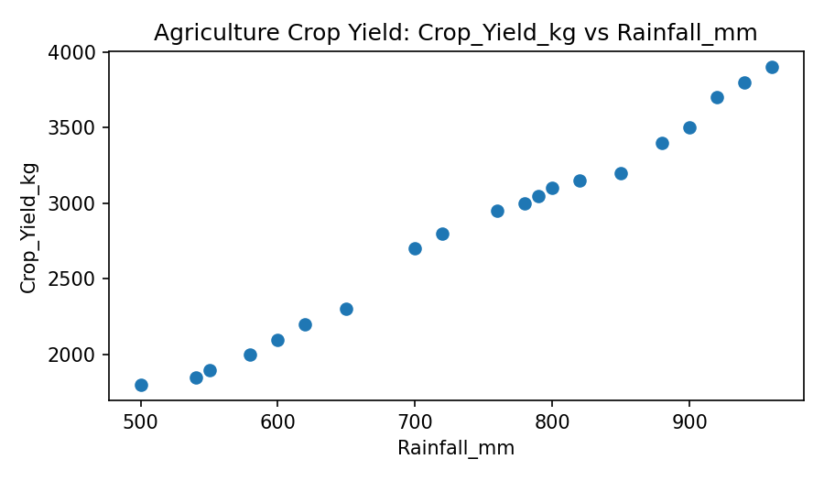
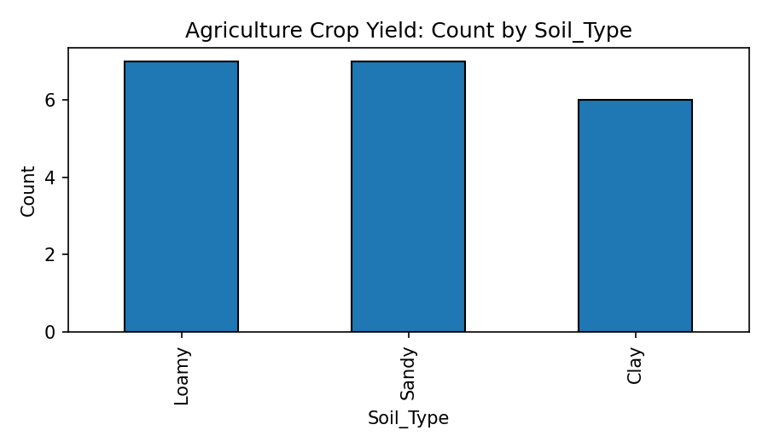

5. Important patterns and observations
- Loamy soil farms show the highest yields in the supplied data, ranging from 3,100 kg to 3,900 kg.
- Sandy soil farms show lower yields, ranging from 1,800 kg to 2,300 kg, while Clay soil farms range from 2,700 kg to 3,150 kg.
- Higher rainfall generally corresponds to higher crop yield in this dataset. Farms with rainfall near 900–960 mm record yields of about 3,500–3,900 kg.
- Fertilizer use also tends to increase with yield in the supplied records; farms using around 60–75 kg generally have higher yields than farms using around 40–48 kg.
- Lower temperatures (approximately 25–28°C) are associated with higher yields in these records, while farms at 32–34°C show lower yields.

6. Conclusion
The dataset indicates that rainfall, fertilizer use, temperature, and soil type are associated with crop yield. Loamy soil and higher rainfall/fertilizer values correspond to greater yields in this sample. Further analysis with more farms and additional factors is needed.

Overall Conclusion
EDA was performed on all five supplied datasets by checking dataset dimensions, data types, missing values, duplicate rows, descriptive statistics, and visual patterns. The analysis identified relationships between student performance and academic factors, health measurements and disease status, product category and sales, applicant characteristics and loan status, and farm conditions and crop yield. These findings summarize the given sample data and should be validated with larger and more representative datasets before being used for important real-world decisions.

Note
The assignment sheet asks for suitable charts such as bar charts, histograms, scatter plots, and box plots. This answer includes histograms, scatter plots, and categorical bar charts. No box plots are included because the supplied datasets are small and the selected charts directly illustrate the main patterns. The analysis does not claim causal relationships.

