Experiment 10
Line plot and bar plot of monthly sales using Matplotlib
Fundamentals of Data Science

Aim
To develop a Python program using Matplotlib that creates a line plot and a bar plot of the monthly sales data of a company.

Algorithm
- Import matplotlib.pyplot.
- Create a list of months and a list of the corresponding sales values.
- Line plot: use plt.plot() with markers, then add the title, x-label, y-label and grid.
- Display the line plot using plt.show().
- Bar plot: use plt.bar() with the same data, then add the title and labels.
- Display the bar plot using plt.show().

Code
import matplotlib.pyplot as plt

months = ["Jan", "Feb", "Mar", "Apr", "May", "Jun",
"Jul", "Aug", "Sep", "Oct", "Nov", "Dec"]
sales = [25000, 27000, 31000, 29000, 35000, 38000,
36000, 40000, 42000, 45000, 50000, 55000]

# 1. Line plot
plt.figure(figsize=(8, 4))
plt.plot(months, sales, marker="o", color="blue")
plt.title("Monthly Sales - Line Plot")
plt.xlabel("Month")
plt.ylabel("Sales")
plt.grid(True)
plt.show()

# 2. Bar plot
plt.figure(figsize=(8, 4))
plt.bar(months, sales, color="orange")
plt.title("Monthly Sales - Bar Plot")
plt.xlabel("Month")
plt.ylabel("Sales")
plt.show()

Input
Month names (Jan to Dec) and monthly sales values of a company.

Result
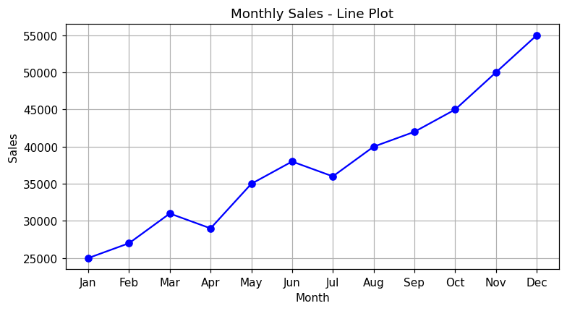
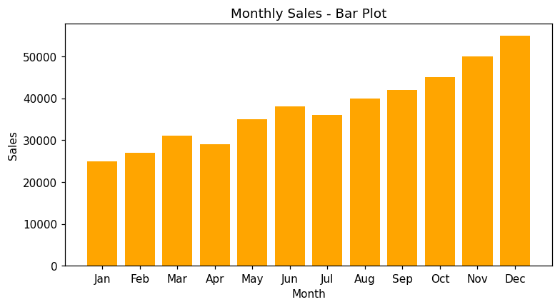
Conclusion: The line plot and the bar plot of the monthly sales data were created successfully. Sales show an increasing trend through the year.

