Experiment 11
Line, scatter and bar plots of sales in a month
Fundamentals of Data Science

Aim
To create a line plot, a scatter plot and a bar plot using Matplotlib to show the sales of a product over the days of a month.

Algorithm
- Import matplotlib.pyplot and NumPy.
- Create the day numbers (1 to 30) and the daily sales values.
- Draw a line plot of sales against days and label it.
- Draw a scatter plot of sales against days and label it.
- Draw a bar plot of sales against days and label it.
- Display each plot using plt.show().

Code
import numpy as np
import matplotlib.pyplot as plt

days = np.arange(1, 31)

np.random.seed(1)
sales = np.random.randint(20, 80, size=30) # daily sales of the product

# 1. Line plot
plt.figure(figsize=(8, 4))
plt.plot(days, sales, color="green")
plt.title("Daily Sales - Line Plot")
plt.xlabel("Day of the month")
plt.ylabel("Units sold")
plt.grid(True)
plt.show()

# 2. Scatter plot
plt.figure(figsize=(8, 4))
plt.scatter(days, sales, color="red")
plt.title("Daily Sales - Scatter Plot")
plt.xlabel("Day of the month")
plt.ylabel("Units sold")
plt.show()

# 3. Bar plot
plt.figure(figsize=(8, 4))
plt.bar(days, sales, color="purple")
plt.title("Daily Sales - Bar Plot")
plt.xlabel("Day of the month")
plt.ylabel("Units sold")
plt.show()

Input
Day numbers 1 to 30 and daily sales of a product (30 values).

Result
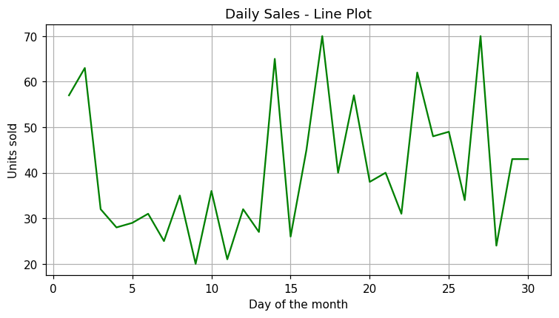
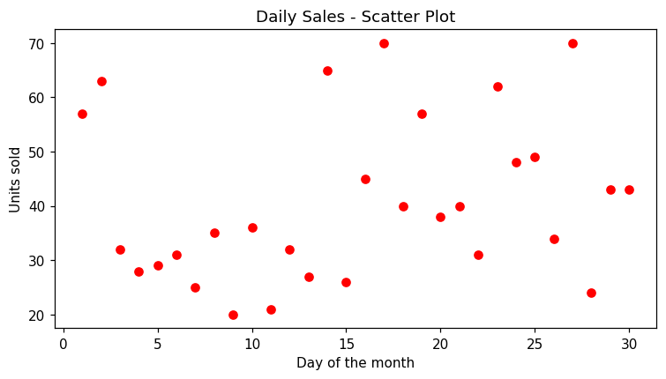
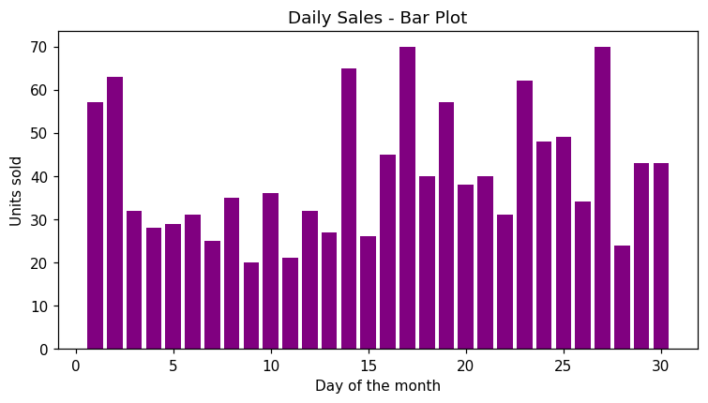
Conclusion: The line plot, scatter plot and bar plot of the daily sales of the month were created successfully.

