Experiment 12
Temperature line plot and rainfall scatter plot
Fundamentals of Data Science

Aim
To develop a Python program that creates a line plot of the monthly temperature and a scatter plot of the monthly rainfall of a city.

Algorithm
- Import matplotlib.pyplot.
- Create lists for the months, the monthly temperature (in degree Celsius) and the monthly rainfall (in mm).
- Line plot: plot temperature against months with markers, add title, labels and grid.
- Display the line plot using plt.show().
- Scatter plot: plot rainfall against months, add title and labels.
- Display the scatter plot using plt.show().

Code
import matplotlib.pyplot as plt

months = ["Jan", "Feb", "Mar", "Apr", "May", "Jun",
"Jul", "Aug", "Sep", "Oct", "Nov", "Dec"]
temperature = [25, 27, 29, 32, 34, 33, 32, 31, 30, 28, 26, 25] # degree Celsius
rainfall = [24, 7, 15, 25, 52, 53, 83, 124, 118, 267, 309, 139] # mm

# 1. Line plot of temperature
plt.figure(figsize=(8, 4))
plt.plot(months, temperature, marker="o", color="red")
plt.title("Monthly Temperature - Line Plot")
plt.xlabel("Month")
plt.ylabel("Temperature (°C)")
plt.grid(True)
plt.show()

# 2. Scatter plot of rainfall
plt.figure(figsize=(8, 4))
plt.scatter(months, rainfall, color="blue")
plt.title("Monthly Rainfall - Scatter Plot")
plt.xlabel("Month")
plt.ylabel("Rainfall (mm)")
plt.show()

Input
Months (Jan to Dec), monthly temperature in degree Celsius and monthly rainfall in mm of a city.

Result
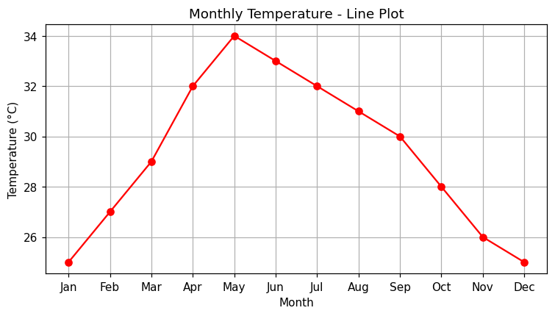
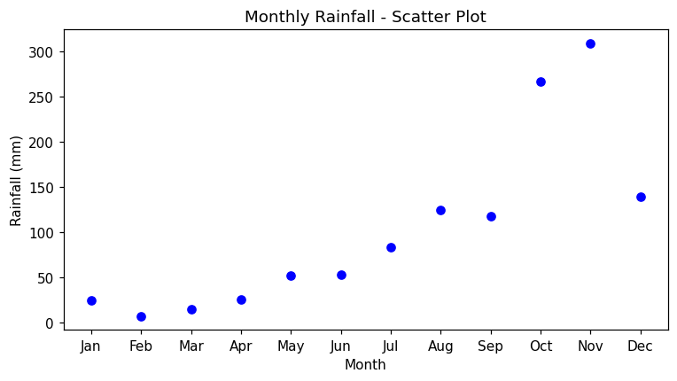
Conclusion: The line plot of the monthly temperature and the scatter plot of the monthly rainfall were created successfully.

