Experiment 17
Customer feedback word analysis with bar graph
Fundamentals of Data Science

Aim
To develop a Python program that loads customer feedback from a CSV file, preprocesses the text, finds the word frequency distribution, displays the top N words and plots them as a bar graph.

Algorithm
- Import pandas, re, Counter and matplotlib.pyplot.
- Load data.csv, which has a single column named feedback.
- Preprocess every comment: convert to lowercase and remove punctuation.
- Split the text into words and remove the stop words (the, and, is, etc.).
- Count the frequency of the remaining words using Counter.
- Read N (number of top words wanted) from the user.
- Print the top N words with their frequencies.
- Plot a bar graph of the top N words and their frequencies.

Code
import re
import pandas as pd
import matplotlib.pyplot as plt
from collections import Counter

# Common words that carry little meaning
stop_words = {"the", "and", "is", "a", "an", "to", "of", "in", "it", "i", "was",
"for", "on", "my", "this", "that", "with", "are", "but", "very",
"be", "at", "as", "so", "we", "you", "have", "has", "had", "not"}

# 1. Load the dataset
data = pd.read_csv("data.csv")

# 2. Preprocess: lowercase, remove punctuation, remove stop words
all_words = []
for comment in data["feedback"]:
comment = comment.lower()
comment = re.sub(r"[^a-z\s]", "", comment) # remove punctuation
for word in comment.split():
if word not in stop_words:
all_words.append(word)

# 3. Frequency distribution
frequency = Counter(all_words)

# 4. Top N words
n = int(input("Enter the number of top words (N): "))
top_n = frequency.most_common(n)

print(f"\nTop {n} most frequent words:")
for word, count in top_n:
print(f"{word:12} {count}")

# 5. Bar graph
words = [w for w, c in top_n]
counts = [c for w, c in top_n]

plt.figure(figsize=(8, 4))
plt.bar(words, counts, color="teal")
plt.title(f"Top {n} Most Frequent Words in Customer Feedback")
plt.xlabel("Word")
plt.ylabel("Frequency")
plt.show()

Input
data.csv with a single column named feedback (one customer comment per row). N is entered by the user (N = 5 in this run).

Result
Output:
Enter the number of top words (N): 5
Top 5 most frequent words:
great 6
delivery 5
service 4
fast 3
product 3
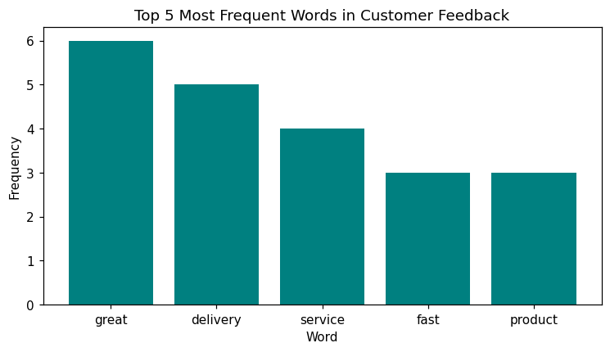
Conclusion: The top 5 most frequent words in the feedback are great (6), delivery (5), service (4), fast (3) and product (3), shown in the bar graph.

