Experiment 18
Age and %fat statistics, boxplots, scatter plot and Q-Q plot
Fundamentals of Data Science

Aim
To calculate the mean, median and standard deviation of age and %fat using Pandas, and to draw the boxplots, a scatter plot and a Q-Q plot of the two variables.

Algorithm
- Import pandas, numpy and matplotlib.pyplot.
- Create the DataFrame with the age and %fat of the 18 adults.
- Calculate the mean, median and standard deviation of both columns using mean(), median() and std().
- Draw boxplots of age and %fat using plt.boxplot().
- Draw a scatter plot of age (x-axis) against %fat (y-axis).
- Sort both variables and plot them against each other to get the Q-Q plot, with a reference line y = x.
- Display the plots using plt.show().

Code
import numpy as np
import pandas as pd
import matplotlib.pyplot as plt

data = pd.DataFrame({
"age": [23, 23, 27, 27, 39, 41, 47, 49, 50, 52, 54, 54, 56, 57, 58, 58, 60, 61],
"fat": [9.5, 26.5, 7.8, 17.8, 31.4, 25.9, 27.4, 27.2, 31.2,
34.6, 42.5, 28.8, 33.4, 30.2, 34.1, 32.9, 41.2, 35.7]
})

# 1. Mean, median and standard deviation
print(" age %fat")
print(f"Mean {data['age'].mean():7.2f} {data['fat'].mean():7.2f}")
print(f"Median {data['age'].median():7.2f} {data['fat'].median():7.2f}")
print(f"Std dev {data['age'].std():7.2f} {data['fat'].std():7.2f}")

# 2. Boxplots
plt.figure(figsize=(6, 4))
plt.boxplot([data["age"], data["fat"]])
plt.xticks([1, 2], ["Age", "%Fat"])
plt.title("Boxplots of Age and %Fat")
plt.show()

# 3. Scatter plot
plt.figure(figsize=(6, 4))
plt.scatter(data["age"], data["fat"], color="red")
plt.title("Scatter Plot: Age vs %Fat")
plt.xlabel("Age")
plt.ylabel("%Fat")
plt.show()

# 4. Q-Q plot (sorted values of one variable against the other)
age_sorted = np.sort(data["age"])
fat_sorted = np.sort(data["fat"])

plt.figure(figsize=(6, 4))
plt.scatter(age_sorted, fat_sorted, color="green")
low = min(age_sorted.min(), fat_sorted.min())
high = max(age_sorted.max(), fat_sorted.max())
plt.plot([low, high], [low, high], "k--") # reference line y = x
plt.title("Q-Q Plot: Age vs %Fat")
plt.xlabel("Age quantiles")
plt.ylabel("%Fat quantiles")
plt.show()

Input
Age and %fat of 18 randomly selected adults (Age: 23, 23, 27, 27, 39, 41, 47, 49, 50, 52, 54, 54, 56, 57, 58, 58, 60, 61). The %fat values are listed in the code.

Result
Output:
age %fat
Mean 46.44 28.78
Median 51.00 30.70
Std dev 13.22 9.25
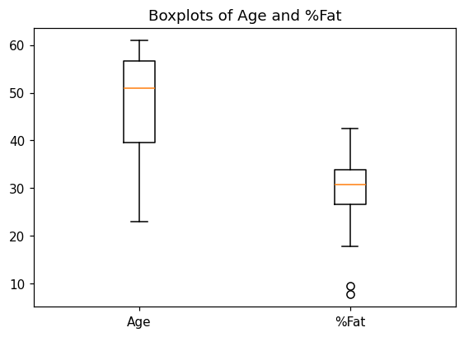
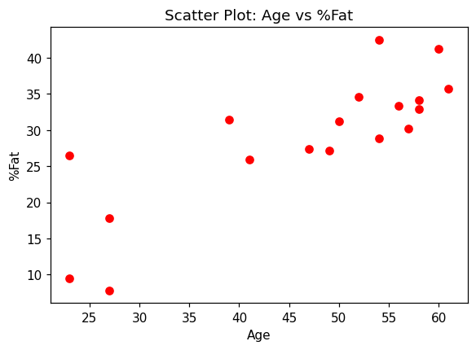
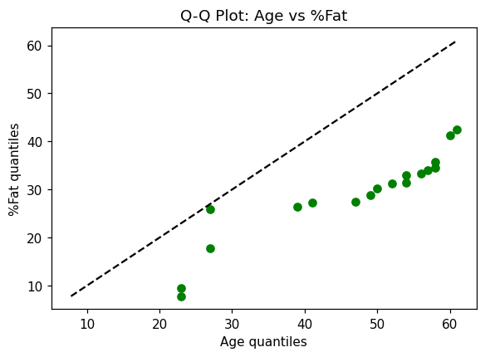
Conclusion: Age: mean 46.44, median 51.00, standard deviation 13.22. %Fat: mean 28.78, median 30.70, standard deviation 9.25. The boxplots, scatter plot and Q-Q plot were drawn. The scatter plot shows that %fat tends to increase with age.

