**Slide - 11**

**Scheduling and Sequencing**

**Sequencing *n* jobs on one machine**

**Sequencing *n* jobs on two machines**

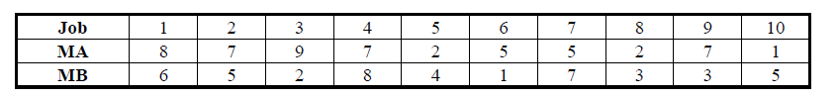

**Sequencing *n* jobs on three machines**

