**Slide - 8**

**Transportation in the Supply Chain**

**Role of transportation**: Transportation refers to movement of product from the beginning of supply chain to the customer Transportation adds to a significant amount of cost to most supply chain Transportation activity represent more than 10% of GDP Transportation accounts for about 20 million jobs (16% The role of transportation is even more significant in global supply Chains Success of a supply chain is closely linked to proper use o transportation

**Factors Affecting Transportation Decisions:** Shipper -Carrier

**Transportation Mode:** Truck-Rail-Air-Package-Water-Pipeline-Intermodal **Truckload (TL)** Low fixed and variable costs **Less Than Truckload (LTL)** Higher fixed costs (terminals) and low variable costs

**Design Options for a Transportation Network:** Here, the buyer structures his transportation network so that all shipments come directly from each supplier to each buyer location

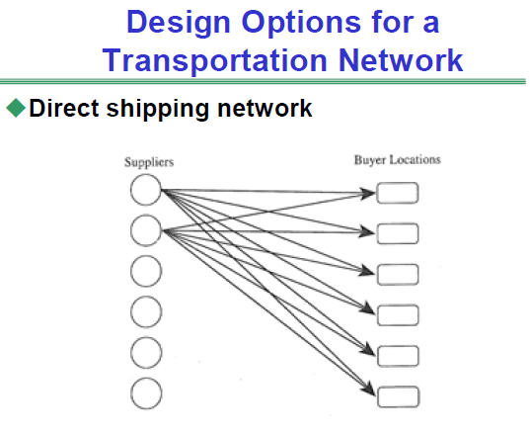

**Direct shipping with milk runs** A **milk run** is a route on which a truck either delivers product from a single supplier to multiple retailers or goes from multiple suppliers to a single buyer

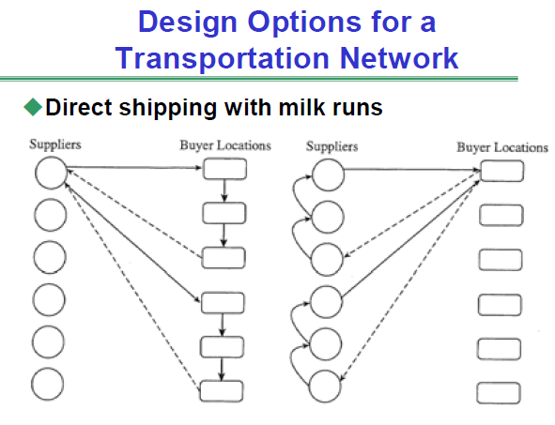

**All shipments via central DC** Here, suppliers send their shipments to a DC and the DC then forwards appropriate shipments to each buyer location DC store inventory and serve as a transfer location

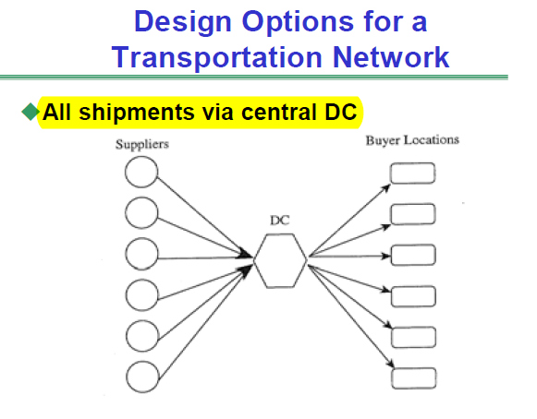

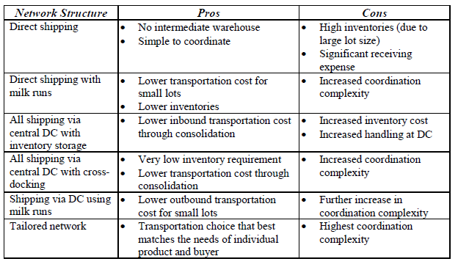

**Selecting a Transportation Network**

**Example – (Selecting a Transportation Network )**

A retail chain has eight stores in a region with four supply sources for four different products. Trucks have a capacity of40,000 units and cost $1,000 per load plus $100 per delivery. Thus, a truck making two deliveries charges $1,200. The cost of holding one unit of a product in inventory at a retail store fora year is $0.20. The manager of supply chain is considering whether to use direct shipping from suppliers to retail stores or setting up milk runs from suppliers to retail stores. (a) What network would you recommend if annual sales for each product at each retail store are 960,000 units? (b) What network would you recommend if sales for each product at each retail store are 120,000 units? (Assume that all trucks are full when they leave from the supplier.)

**Inventory Aggregation**

**Problem 2 - Inventory Aggregation – HW-2.2**

HighMed, a manufacturer of medical equipment used in heart procedures, is located in Madison, Wisconsin, and its products are used by cardiologists all over North America. The medical equipment is not sold through purchasing agents but directly to doctors. HighMed currently divides the United States into 24 territories, each with its own sales force. All product inventories are maintained locally and replenished from Madison every four weeks using UPS. The average replenishment lead-time using UPS is one week. UPS charges at a rate of $0.66+0.26*x*, where *x* is the quantity shipped in pounds. The products sold fall into two categories - Highval and Lowval. Highval products weigh 0.1 pounds and cost $200 each. Lowval products weigh 0.04 pounds and cost $30 each.

Weekly demand for Highval products in each territory is normally distributed, with a mean of μ*H*=2 with a standard deviation of σ*H*=5. Weekly demand for Lowval products in each territory is normally distributed, with a mean of μ*L*=20 with a standard deviation of σ*L*=5. HighMed maintains sufficient safety inventories in each territory to provide a cycle service level (CSL) of 0.997 for each product. Holding cost at HighMed is 25 percent.

In addition to the current approach, the management team at HighMed is considering two other options:

***Option A***. Keep the current structure but replenish once a week rather that once every four weeks.

***Option B***. Eliminate inventories in the territories, aggregate all inventories in a finished-goods warehouse at Madison, and replenish the warehouse once a week.

If inventories are aggregated at Madison, orders will be shipped using FedEx, which charges $5.53+0.53*x* per shipment, where *x* is the quantity shipped in pounds. The factory requires a one-week lead-time to replenish finished-goods inventories at the Madison warehouse. An average customer order is for one unit of Highval and 10 units of Lowval.

What should HighMed do? (In order to analyze this, you need to compare the current situation, Option A and Option B).

**Choice of Transportation Mode**

**Problem 2 - Choice of Transportation Mode – HW-2.1**

Eastern Electric (EE) is a major appliance manufacturer with a large plant in the Chicago area. EE purchases all the motors for its applications from Westview Motors, located near Dallas. EE currently purchases 120,000 motors each year from Westview at a price of $120 per motor. Demand has been relatively constant for several years and is expected to stay that way. Each motor averages about 10 pounds in weight, and EE has traditionally purchased lots of 3,000 motors. Westview ships each EE order within a day of receiving it. At its assembly plant, EE carries a safety inventory equal to 50 percent of the average demand for motors during the delivery lead time.

The plant manager at EE has received several proposals for transportation and must decide on one to accept. The details of various proposals are provided in the table below (one cwt = 100 pounds):

Golden’s pricing represents a marginal unit quantity discount. Golden’s representative has proposed lowering the marginal rate for the quantity over 250 cwt in a shipment from $4/cwt to $3/cwt and suggested that EE increase its batch size to 4,000 motors to take advantage of the lower transportation cost. Shipments by rail require a five-day transit time, whereas shipments by truck have a transit time of three days. If EE’s annual cost of holding inventory is 25 percent, what should the plant manager do? (In order to analyze this, you need to compare the total annual costs for the AM Railroad proposal, the Northeast Trucking proposal, and the Golden Freightways proposals (including the cases for 50 cwt, 150 cwt, 250 cwt, 300 cwt, 400 cwt using both the old proposal and the new proposal)).

