**Slide-9**

**Pricing and Revenue Management in the Supply Chain**

**The Role of Revenue Management in the Supply Chain** Revenue management is the use of pricing toincrease the profit generated from a limited supplyof supply chain assetsSupply assets exist in two forms: capacity(production, transportation and storage)an inventory Revenue management may also be defined as the use of differential pricing based on customer segment, time of use, and product or capacity availability to increase supply chain profits Most common example is probably in airline pricing

1. **Using equation:**

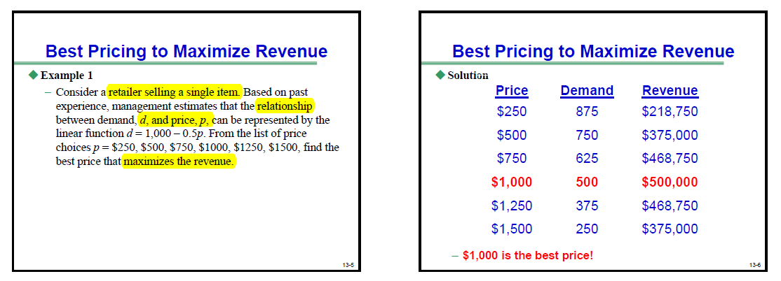

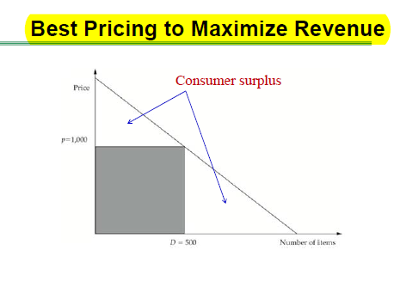

**Using a differential pricing strategy:**

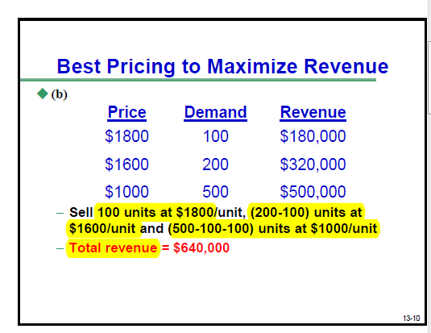

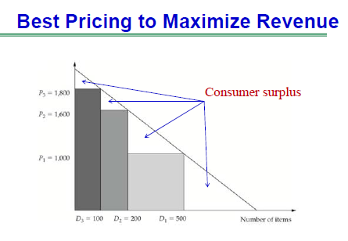

**Example 2 - Best Pricing to Maximize Revenue**

Consider the same product described in Example 1. The management has decided to use differential pricing strategy (i.e., differentiate between the customers who can pay the higher price and those who are willing to pay only the lower price). Find the total revenue with (a) a two-tier pricing strategy of $1000 and $1600 and (b) a three- tier pricing strategy of $1000, $1600 and $1800.

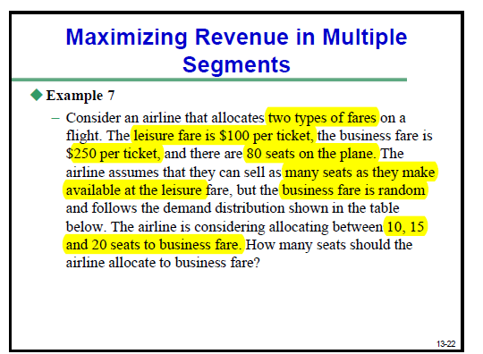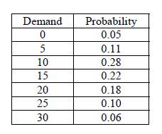

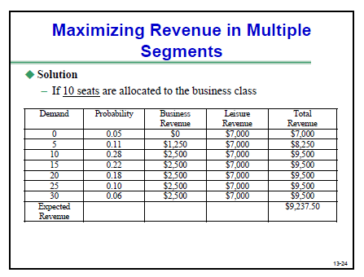

**Optimal Pricing to Maximize Profit**

**Problem 1. Optimal Pricing to Maximize Profit – HW-6.1** Two Wheels, a bike manufacturer, has identified two customer segments; one that prefers a customized bike and is willing to pay a higher price and another that is willing to take a standardized bike but is more prices sensitive. Assume that the cost of manufacturing either bike is $200. Demand from the customized segment has a demand relationship of *d*1 = 20,000 – 10*p*1 and demand from the price-sensitive segment is *d*2 = 40,000 – 30*p*2. What price should Two Wheels charge each segment if its goal is to maximize profits? What is the total profit? If Two Wheels were to charge a single price over both segments, what should it be? How much increase in profits does differential pricing provide?