MONAD ARENAX
Workflows &
Architecture
A complete visual design pack for the Monad-first prediction exchange
Hackathon testnet edition | Chain ID 10143 | May 31, 2026
DESIGN INTENT
Pastel translucent diagrams, operationally precise workflows, and one all-inclusive system map. Every value-moving path remains testnet-only and every AI action remains advisory until the user signs.

DOCUMENT MAP | COVERAGE
System map | Frontend, services, Monad contracts, events, safety modes, fallback
Product workflows | Discovery, trading, Pro Exchange, parlay NFTs, oracle, AI, LP, creator
Operations | Indexer reads, matcher health, runtime modes, verification

Prepared for hackathon judges, technical reviewers, and product walkthroughs.

1. Executive Architecture Map
The map below is the one inclusive reference for the complete ArenaX system. Read left to right: user-facing product surfaces, supporting application services, Monad testnet protocol modules, indexed reads, and the safety envelope.
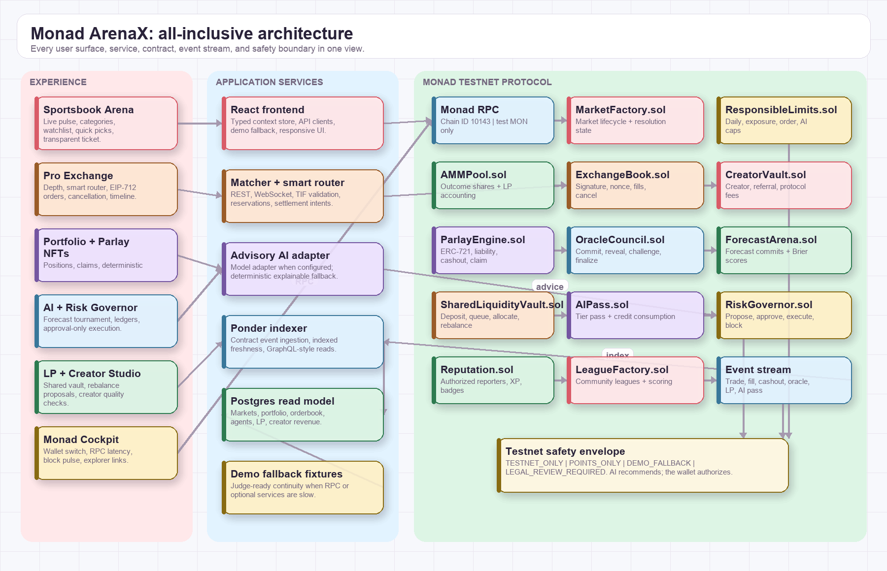
Figure 1. All-inclusive Monad ArenaX architecture.
NON-NEGOTIABLE BOUNDARY
The matcher never custodies user funds. AI never places an order. Deterministic contract math and explicit wallet approval remain authoritative.

2. End-to-End Product Journey
The product experience is structured as one continuous testnet journey. It begins with the branded Arena launch, then moves through discovery, review-first pricing, wallet approval, portfolio management, oracle resolution, and indexed confirmation.
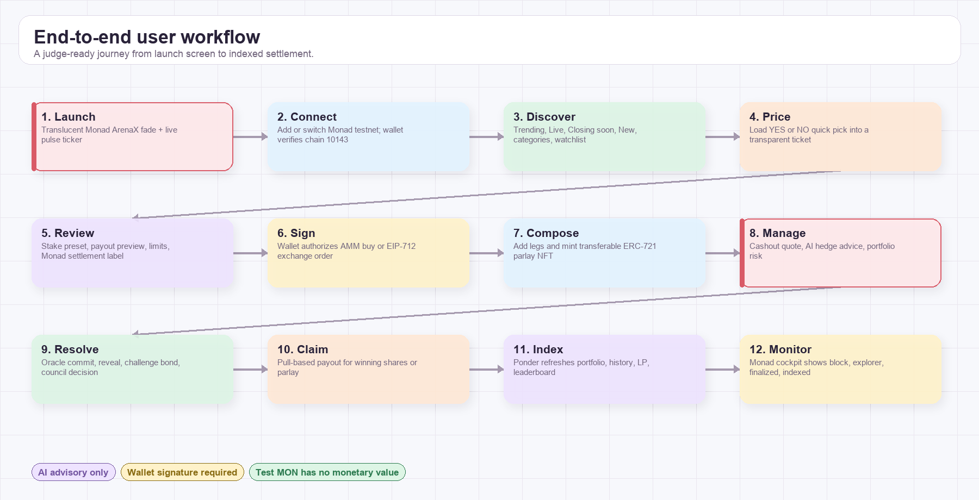
Figure 2. End-to-End Product Journey.
- The Arena view opens first so judges see the usable prediction exchange immediately.
- Quick picks prepare a transparent ticket; they do not submit a transaction.
- The finality timeline distinguishes submitted, proposed, finalized, and indexed states.

3. AMM and Pro Exchange Execution
ArenaX supports a simple AMM path and a professional signed-order path. Both are non-custodial, visible to the user, and settled on Monad testnet.
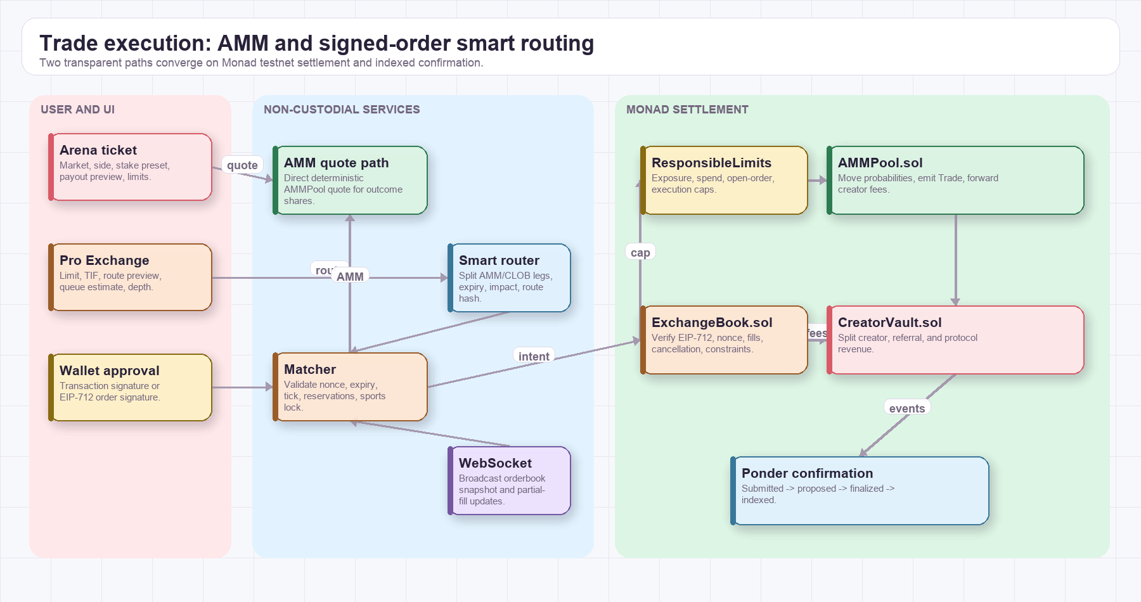
Figure 3. AMM and Pro Exchange Execution.
- AMM trades move outcome-share probabilities and forward creator-aware fees.
- The smart router can preview AMM/CLOB splits, impact, expiry, and route hash.
- The matcher validates time-in-force, nonce, tick size, reservations, and sports locks before it creates a settlement intent.

4. Parlay NFT Cashout and Hedge
Parlays are transferable ERC-721 positions. The contract reserves liability before minting and computes early exits from deterministic AMM probabilities.
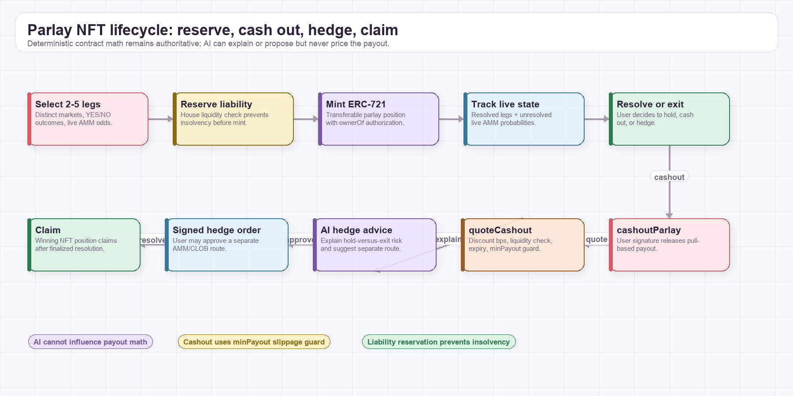
Figure 4. Parlay NFT Cashout and Hedge.
- Cashout math applies unresolved probabilities, resolved-leg state, discount basis points, available liquidity, and a minPayout guard.
- The AI layer can explain hold-versus-cashout risk and propose a hedge route, but cannot modify payout math.
- Claims remain pull-based after finalized resolution.

5. Oracle Court and Forecast Arena
Outcome integrity is visible: Oracle Court handles commit-reveal and bonded disputes, while Forecast Arena turns finalized outcomes into auditable Brier scores and reputation updates.
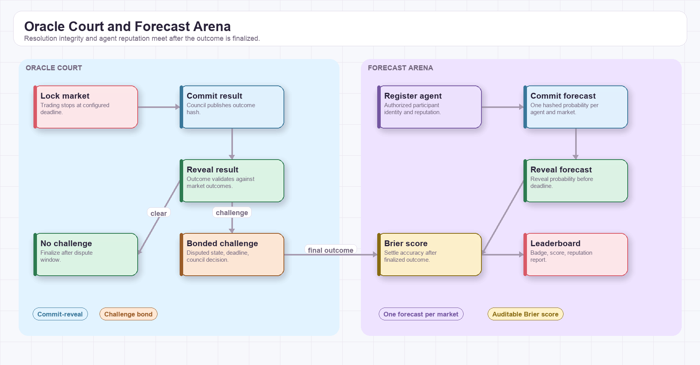
Figure 5. Oracle Court and Forecast Arena.
- Challenges carry a configured bond and place the market into a disputed state.
- Forecast agents reveal one probability per market before deadline.
- Finalized results drive leaderboards, badges, and authorized reputation reports.

6. Agentic AI Safety and Tier Gating
ArenaX exposes AI as a visible advisory layer rather than an invisible executor. Every task writes a ledger and every state-changing proposal routes back to the user.
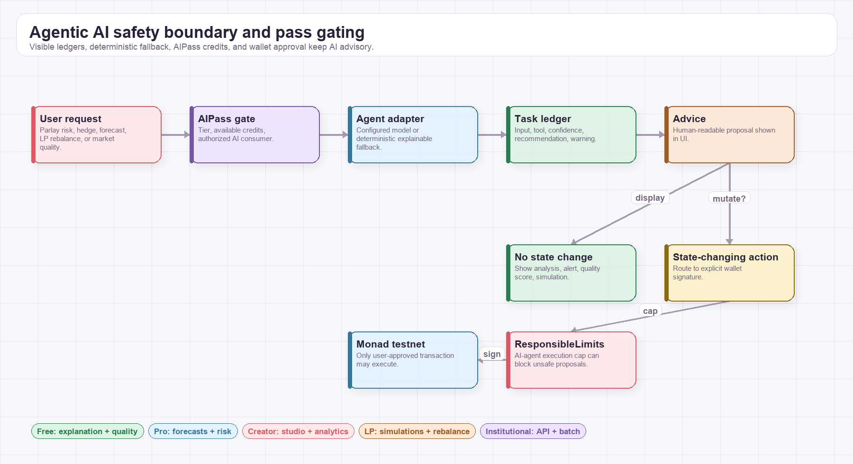
Figure 6. Agentic AI Safety and Tier Gating.
- AIPass tiers gate credits and feature access for Free, Pro, Creator, LP, and Institutional users.
- When a model key is unavailable, deterministic fallback analysis preserves an explainable demo.
- ResponsibleLimits can block unsafe AI execution proposals before wallet approval.

7. Shared LP Vault and Creator Economy
The liquidity workflow is designed for transparent deployment and safe recall. The creator economy is wired into trading rather than shown as a disconnected dashboard.
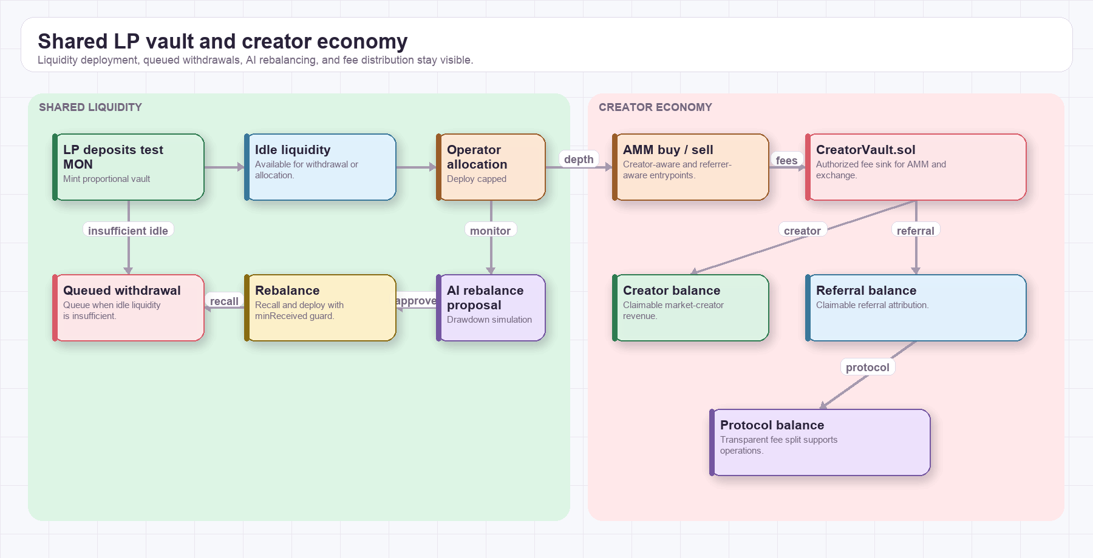
Figure 7. Shared LP Vault and Creator Economy.
- Vault shares represent proportional deposits; withdrawals queue when idle liquidity is insufficient.
- The LP agent proposes rebalances with drawdown context; the operator still approves execution.
- CreatorVault separates creator, referral, and protocol balances for pull-based claims.

8. Indexer, Runtime Modes, and Operations
Ponder converts Monad events into a queryable product read model. Typed frontend services read indexed APIs and retain local fallback fixtures for hackathon continuity.
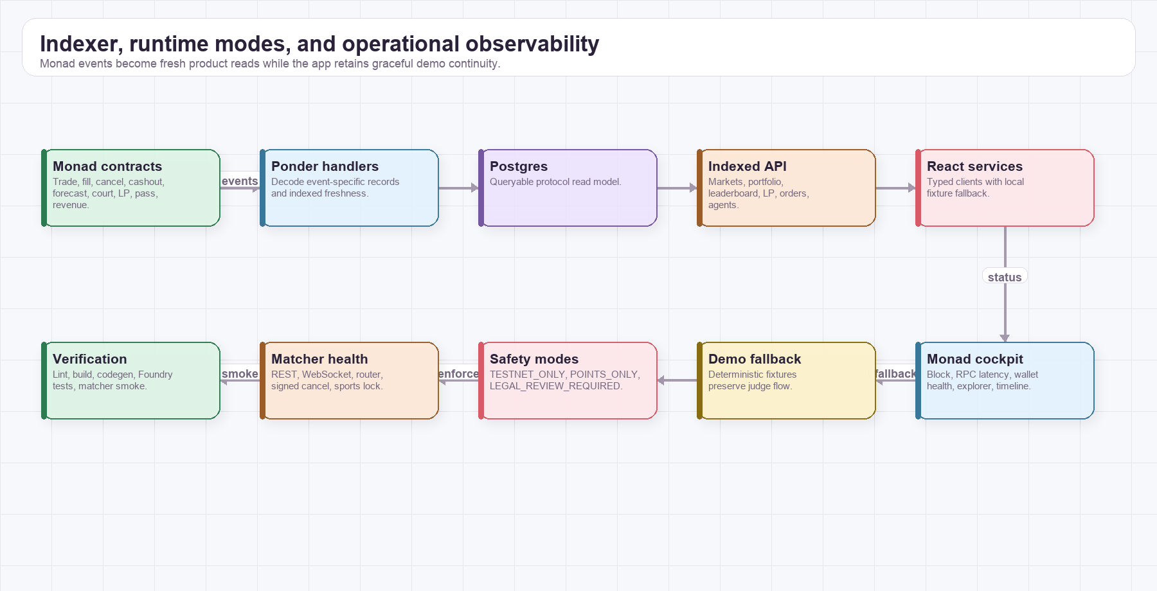
Figure 8. Indexer, Runtime Modes, and Operations.
- Indexed domains include markets, exchange, parlays, forecasts, oracle cases, LP vault activity, passes, leagues, badges, spend, creator revenue, and risk proposals.
- Runtime modes remain explicit: TESTNET_ONLY, POINTS_ONLY, DEMO_FALLBACK, and LEGAL_REVIEW_REQUIRED.
- The verification command covers frontend lint/build, matcher TypeScript build, Ponder codegen, and Foundry tests.

9. Contract and Event Completeness Matrix
This matrix confirms that the visual workflows cover each implemented protocol module and its most important emitted or indexed behavior.
MODULE | PRIMARY RESPONSIBILITY | INDEXED OR VISIBLE BEHAVIOR
MarketFactory | Market registry and lifecycle | MarketCreated, locked/disputed/finalized state
AMMPool | Outcome shares and LP accounting | Trade, quote movement, creator-aware fees
ExchangeBook | EIP-712 settlement | Fill, cancellation, nonce and partial-fill state
ParlayEngine | ERC-721 parlay positions | Mint, liability reserve, cashout, claim
OracleCouncil | Resolution integrity | Commit, reveal, challenge, council finalize
ForecastArena | Agent tournament | Agent registration, forecast commit/reveal, Brier score
SharedLiquidityVault | Shared LP capital | Deposit, allocation, queued withdrawal, rebalance
CreatorVault | Revenue accounting | Creator, referral, and protocol claimable balances
AIPass | Paid AI access | Tier mint, credit spend, authorized consumer
ResponsibleLimits | Usage controls | Exposure, daily usage, open order, execution caps
RiskGovernor | Approval-only risk automation | Proposal, approval, execution, block
Reputation + LeagueFactory | Community layer | League join, score, XP, badge issuance

Indexed Event Coverage
DOMAIN | EVENT COVERAGE
Markets | Market created, trade, result finalized
Exchange | Fill, cancellation, routed settlement
Parlays | NFT creation, liability reservation, cashout, claim
Forecast Arena | Registration, commit, reveal, score
Oracle Court | Commit, reveal, challenge, resolution
Shared LP vault | Deposit, allocation, queued withdrawal, rebalance
AI passes | Tier mint, spend record, credit consumption
Community | League join, badge issued, reputation report
Creator economy | Creator fee, referral credit, protocol balance

10. Judge Walkthrough and Verification
The strongest demo is short, linear, and visibly Monad-native. Use the built-in runbook as a backup, while presenting Arena as the primary product experience.
- Open ArenaX and let the translucent launch sequence fade into the live market board.
- Connect or switch the wallet to Monad testnet and point out chain ID 10143, RPC health, block pulse, and explorer links.
- Filter Live markets, load a YES or NO quick pick, review payout and responsible-limit status, then sign the testnet trade.
- Add two legs and mint the transferable parlay NFT. Open Portfolio and request deterministic cashout plus advisory hedge analysis.
- Open Pro Exchange, preview AMM/CLOB routing, create a signed-order preview, and show the settlement timeline.
- Run Forecast Arena, advance an Oracle Court challenge, approve an LP vault rebalance, and create an AI-reviewed market draft.
- Close on indexed freshness, the safety modes, and the fact that test MON has no monetary value.
ONE-COMMAND VERIFICATION
Run npm run verify for frontend lint/build, matcher TypeScript build, Ponder codegen, and all Foundry tests. Run npm run matcher:smoke while the matcher is live for router, advisory AI, order types, cancellation, sports lock, WebSocket, nonce, and rate-limit checks.

Runtime Safety Modes
MODE | PURPOSE
TESTNET_ONLY | Default hackathon mode. Transactions use Monad testnet only.
POINTS_ONLY | Disables wallet value flows while preserving the product walkthrough.
DEMO_FALLBACK | Uses deterministic fixtures when optional APIs are unavailable.
LEGAL_REVIEW_REQUIRED | Keeps any future real-money path disabled pending review.

End of visual architecture pack.

