TOC \t "Chapter Title, 1,Section Title, 2"

Preface PAGEREF _Toc \h 2

Credits PAGEREF _Toc1 \h 2

Conventions and Key PAGEREF _Toc2 \h 3

Building Blocks PAGEREF _Toc3 \h 3

Catalyst Card Layout PAGEREF _Toc4 \h 4

Class Card Layout PAGEREF _Toc5 \h 5

Unit Card Layout PAGEREF _Toc6 \h 6

Quest Card Layout PAGEREF _Toc7 \h 7

Location Card Layout PAGEREF _Toc8 \h 8

Scenario Card Layout PAGEREF _Toc9 \h 9

Equipment Card Layout PAGEREF _Toc10 \h 10

Contents of Box PAGEREF _Toc11 \h 11

Initial Game Setup PAGEREF _Toc12 \h 12

Turn Order PAGEREF _Toc13 \h 13

Combat PAGEREF _Toc14 \h 14

Formations PAGEREF _Toc15 \h 15

Example of play PAGEREF _Toc16 \h 16

Keywords / Appendix PAGEREF _Toc17 \h 18

Tips and tricks PAGEREF _Toc18 \h 19

Preface

Thanks for taking the time read this rulebook and play a game of Monad Wars!

I have defined Monad Wars as “Adventure Building Card Game”. Players travel from location to location completing quests. In doing so, they earn experience and gold. With these resources, players can purchase levels for their catalyst, and acquire equipment and units to help in their travels.

Each location that can be traveled to has something unique, a reason why you would choose that locale over another. Wether its to pay certain costs (use an Inn, safe passage through a location, etc) or its the safest route to or location to complete a quest. Through a chain of actions, wins and losses, players will create a narrative all of their own.

The core game content will be broken into Acts. This base game contains all of the act 1 content. In each act there are major events that the catalyst are involved in. The objective of the game is to gain 5 VP by completing these events called Scenarios.

Each scenario has an objective that must be met and is stated on the scenario card. Each scenario grants a certain amount of Victory Points. For a standard game, the first player to accumulate 5 Victory Points wins! Good luck, I hope you enjoy playing Monad Wars with your friends and adversaries alike.

Credits

Conventions and Key

**Abilities =** These represent the various actions you can take outside of and during combat. You cannot use an ability without paying its cost if it has one.

**Ability Key**

**(R)**ange #     = How many rows in front of the unit that this ability can find a valid target.

Ro**(W)**  = This ability effects an entire row of units within its listed range.

All **(X)**  = Targets any units that fit the criteria.

**(S)**ingle  = Targets only one unit.

**(F)**riendly  = Only effects friendly units

**(P)**assive  = Always active, always check if it applies to the current situation

**(A)**ggressive 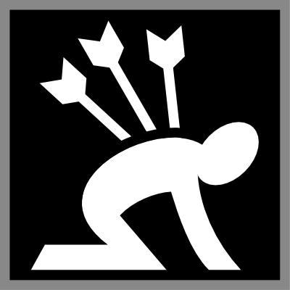   = Must have a valid target, pay the cost and then resolve any valid defensive action the defensive player chooses as a response. After the defensive action is resolved (if there is any at all) then resolve the Aggressive action.

**(D)**efensive  = Used in response to an Aggressive action. Resolve the Defensive action first and then the Aggressive action after.

Building Blocks

*What you need to know. This will all be used in context later in the Rulebook.*

**Hit Points (HP)  =** Represents how much damage a unit can take. When taking damage a player adds counters to their card that is effected. When restoring HP you remove the specified amount of HP counters from the effected Unit.

**Initiative (INI) 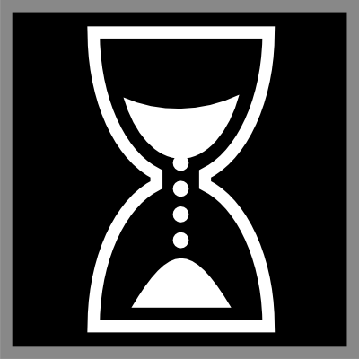 =** How fast a unit is. The higher the number, the great the likelihood of the Unit acting sooner in a combat sequence.

**Ability Points (AP)  =** Is the resource Units consume to use abilities. When Spending AP a player adds AP counters to their card that is effected. When restoring AP you remove the specified amount of AP counters from the effected Unit.

**Catalyst Card Layout**

At the start of the game you choose 1 of 11 catalysts. This unit serves as the backbone to your party. They can increase in level, gain new abilities, and switch classes (1 class per tier). You will also multiply its base including the class stats by its level (if Its base stats are 5HP 2INI 3AP and the catalyst is now level 3, then there current stats before modif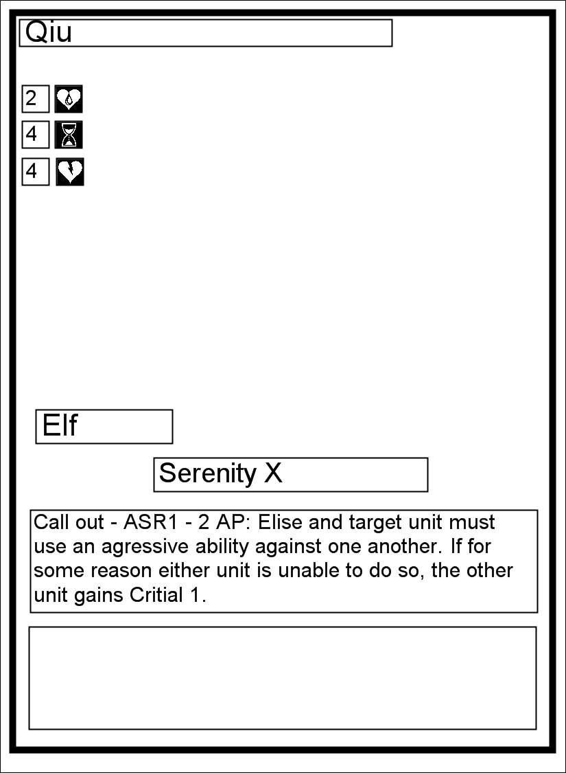iers is 15HP 6INI and 9AP. You then do the same for its class stats and add them together). If your catalyst is killed during combat (being reduced to 0 HP or otherwise) Place it at a starter location (marked with a star). Lose half your remaining gold rounded up. Shuffle your former party and their equipment back into the proper stacks. They have disbanded and ran through your pockets!

Ability 2

Ability 1

Racial Ability

Race

AP

INI

HP

Card Name

**Class Card Layout**

Choose one class at start of the game that you meet the requirements for. Dictates the abilities a catalyst has access to as well as the cost to purchase a level. When you purchase a level select an ability on the class card to obtain (place a marker on it denoting the abilities you have earned as well as your catalysts level).

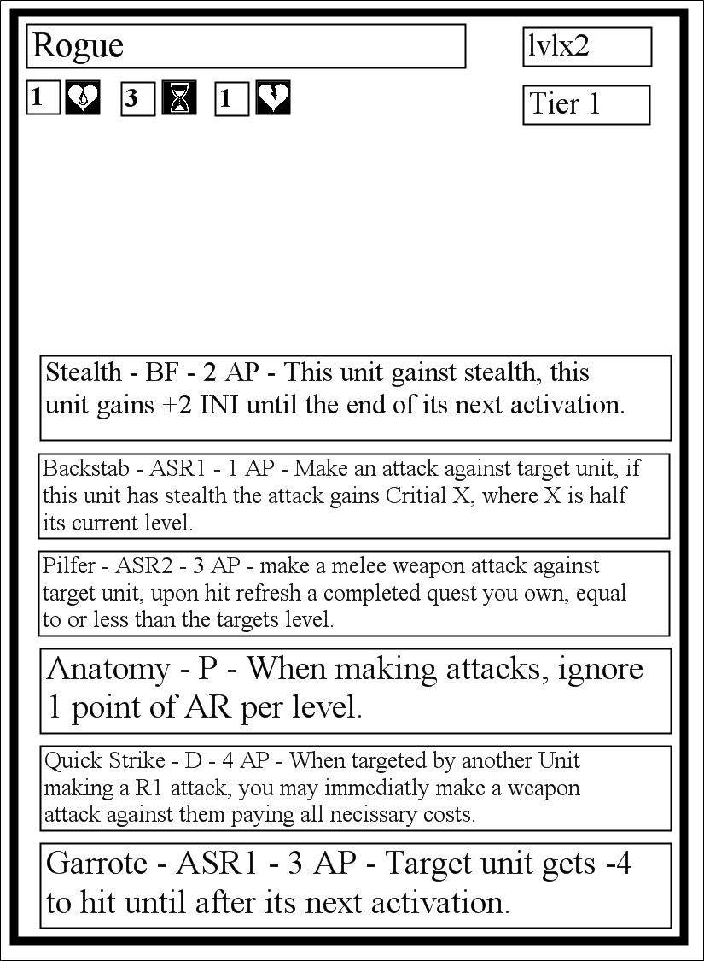

Ability 6

Ability 5

Ability 4

Ability 3

Ability 2

Ability 1

Class Tier

Cost to Level

AP

HP

Card Name

INI

**Unit Card Layout**

You can play additional Units by going to locations and paying the associated recruitment costs.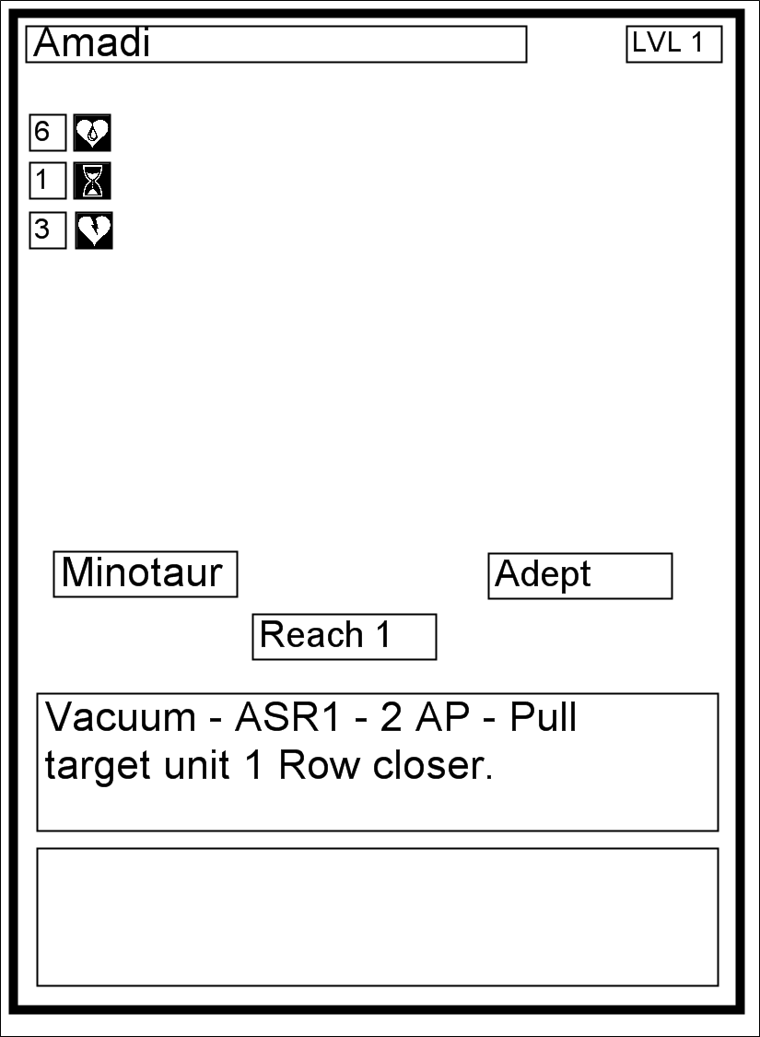 When a Unit is reduced to 0 HP put it into your discard pile along with any equipment attached to the unit.

Level

Ability 2

Ability 1

Class

Racial Ability

Race

AP

HP

Card Name

INI

**Quest Card Layout**

Your short term objectives. This is how you earn gold and XP. You travel to a location where you can play the quest and follow the terms and conditions listed on the card. Once y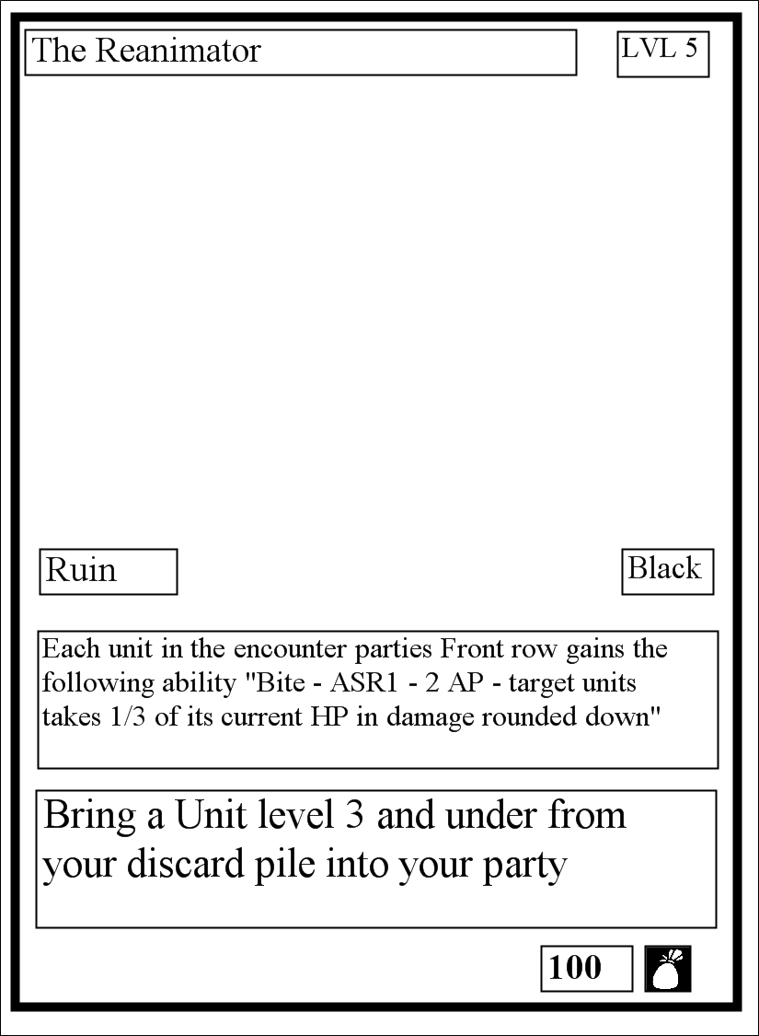ou complete a quest you move it to your completed quest pile. You may shuffle quests from your completed pile with xp of an equal or higher value than the printed level cost on your class card(s).

Gold Awarded

Quest Rewards

Quest Conditions

Quest

Type

Location Requirement

Level

Card Name

**Location Card Layout**

The places you travel to and from during gameplay. This is what dictates a lot of 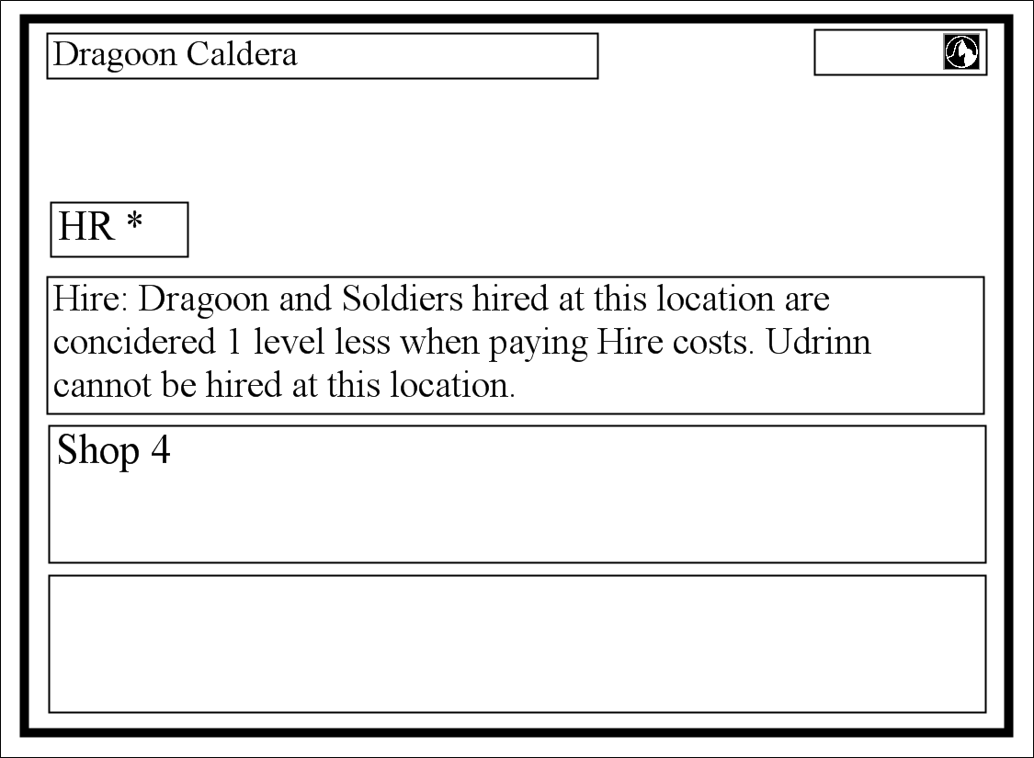gameplay (How much a unit costs to hire, buying equipment, where you can play a quest etc)

Region Markers

Hazard Level

Ability 3

Ability 2

Ability 1

Card Name

**Scenario Card Layout**

At the start of the game all scenarios and associated tokens are set aside. During setup each player chooses 1 scenario and places it face down. According to turn order, each player reveals their scenario and leaves it face up. Once the conditions stated on the Scenario are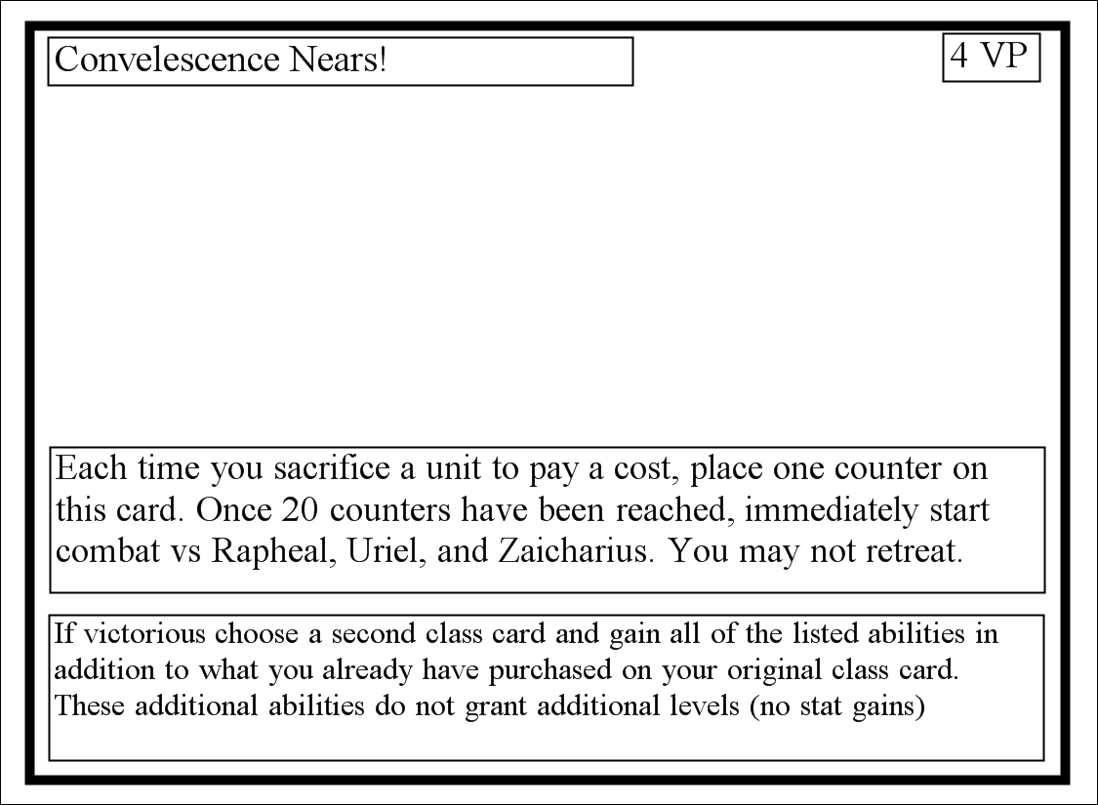 met, it is considered completed. Follow the instructions on the card and gain the Victory Points (VP) listed. Choose your next scenario and reveal it to all players (Next scenario can be any other aside from your most recently completed one). Scenario effects are always game changing.

Victory

Points

Earned

Scenario Rewards

Scenario Conditions

Card Name

**Equipment Card Layout**

Cards that you must attach to a valid target when played (Unit or catalyst). Improves the attache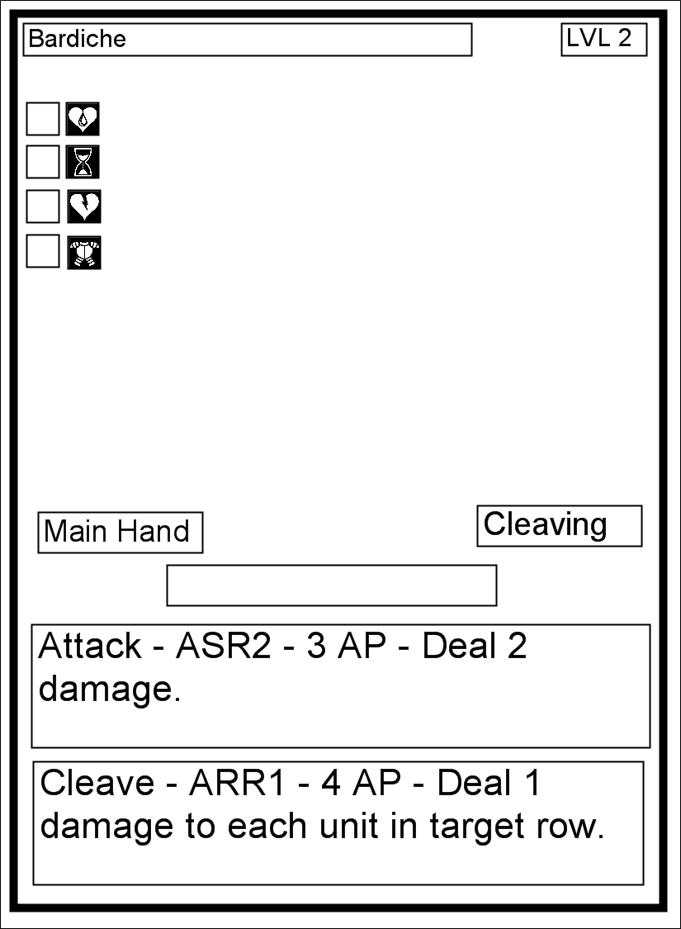d cards stats. Also has abilities with associated costs. Purchased at Locations or awarded by Quests and Scenarios.

Type Ability

Equipment Type

Equipment Slot

AR Bonus

Ability 2

Ability 1

Level

AP Bonus

HP Bonus

Card Name

INI Bonus

Contents of Box

* **Unit stack** = The Unit stack contains all the Units in Monad Wars you can recruit by standard means. During initial setup, 3 cards from the top of this stack will be flipped over into 3 different piles. If a Unit is removed (from recruitment or other means) the active player will flip over the top card of the Unit stack and place it in the same space that the removed Unit occupied.
* **Quest stack** = The Quest stack contains all the Quests in Monad Wars you can attempt to complete. During initial setup, 3 cards from the top of this stack will be flipped over into 3 different piles. If a Quest is removed (from completion or other means) the active player will flip over the top card of the Quest stack and place it in the same space that the removed Quest occupied.
* **Equipment stack** = The Equipment stack contains all the Equipment in Monad Wars you can Acquire by standard means. During initial setup, 3 cards from the top of this stack will be flipped over into 3 different piles. If a piece of Equipment is removed (from purchasing or other means) the active player will flip over the top card of the Equipment stack and place it in the same space that the removed Equipment occupied.
* **Location stack** = The Location stack contains all the Locations in Monad Wars you can travel to and from. During initial setup, players will choose a starting location starting with the player who goes last in turn order and ending with the player who goes first. No two players can start at the same starting location. A player may travel to any other location that shares a Region Marker with their current location. Players may freely browse this stack at any time. It is courtesy to give the current active player priority with the usage of the Location stack.
* **2x sets of 11 Catalysts** = Two sets of the 11 base set catalysts. Multiple players may choose the same catalyst.
* **4x sets of 6 classes** = Four sets of the 6 base set class cards. Multiple players may choose the same class for their catalyst.
* **Token stack** = Contains various Tokens that will be called into use by in game mechanics and other card text.
* **Hazard stack =** The Hazard stack has a mix of units and monsters and represents some of the random enemies one may encounter in this setting. The Encounter and Quest handlers flips over cards from the Hazard stack until they have met or exceeded the hazard rating (HR) of the encounter (factoring in location and quest text for calculating the HR rating of units).
* **2x sets of scenarios** = Two sets of base set scenarios. During setup players will choose a single scenario to track and complete. Upon completion they will follow the rewards text on the completed Scenario and then choose any other Scenario that does not share the same name as the one just completed and use that as their current Scenario.
* **Set of Gold cards** = These are used to keep visible track of how much Gold each player has (another player may ask you how much gold you currently have at any time). They come in Three increments 1 Gold, 3 Gold and 10 Gold. Upon using gold, you return it to the appropriate gold pile.
* **Set of VP markers** = These are used to keep visible track of how many Victory Points each player has earned so far (another player may ask you how many VP you currently have at any time).
* **8x six sided dice (d6)** = Each player receives a pair of D6’s. You roll them as needed (combat etc)
* **This Rulebook** = Your reading it.

Initial Game Setup

1. Players shuffle the Unit, Equipment, Quest and Hazard stacks and place them face down on the playing surface. Players will also make the Catalyst, Class, Scenario and Location cards available to all players in separate stacks.
2. Each player then chooses a Catalyst card, a Class card and one Scenario card. Place a marker on the class card to select your starting class ability. This represents your hero's level as well as the one ability of choice you gain per level. Each player also places their scenario card face down in front of them.
3. Now each Player rolls 2D6. The player with the highest roll plays first. Play moves clockwise.
4. Next, the player who is last in the turn order sequence chooses a location that is marked with the starter Icon "" and places it in front of their formation, which at this point should just be their catalyst (see formation section). This continues counter clockwise until the player who goes first does the same. Players cannot choose the same starting location.

|  |  |  |  |
| --- | --- | --- | --- |
| Quest Stack | Quest 1 | Quest 2 | Quest 3 |
| Equipment Stack | Equipment 1 | Equipment 2 | Equipment 3 |
| Unit Stack | Unit 1 | Unit 2 | Unit 3 |

1. All Players now flip over their face down scenario cards.
2. Each player then takes 4x 100 Gold , and 2x 300 Gold cards for a total of 1,000 Gold. This is used to pay costs at locations the player may travel to as well as anything else that might call for it.
3. Finally, The Player with the highest roll now flips over the top 3 cards of the Unit, Equipment and Quest stacks and lays them out individual in a 3x3 grid.
4. Play now starts with the player who had the highest roll. The active player now proceeds with the standard Turn Order.

Turn Order

**1.    Recovery Phase**

Each unit recovers 1HP and 1 AP. Token Units do not.

**2.    Travel Phase**

You may stay at your current location or travel to another location that shares the same region symbol as your current location.

**Source Location** - The location the player is traveling from.

**Destination** - The location the player is traveling to.

You may choose to “Run"; if so every opposing unit or monster gets to take a single combat action. After these actions are taken, you may move as normal. Since they were not defeated your opponent then shuffles any units or monsters that were played due to you moving (random encounter) or playing a quest back into the Hazard Stack.

**3.    Random Encounter Phase >**

After moving, The closest opponent to your right (Encounter Handler) flips over cards from the Hazard stack until the levels are equal to or greater than the hazard rating of your current location (Random Encounter). Resolve combat as you would normally.

Most locations will reduce the cost of certain types of units when played as hazards (random and quest).

Place all of the defeated Hazards used into the used Hazard pile.

**4.    Encounter and Quest phase <**

The active player may play a quest card that is equal to or less than the hazard rating of the current location in level. The closest opposing player on your left (Quest Handler) plays units and equipment equal to or less in level to the level printed on the quest card. Resolve combat as you would normally. If you chose to resolve your active scenario instead, then follow the directions printed on the Scenario card. If you are at the same location as a player controlled party, the active player may choose to initiate combat with any other player controlled combat; resolve the combat as usual.

Place all of the defeated Hazards used into the used Hazard pile.

**5.    Provision Phase**

During this phase, the active player can use non-combat unit abilities and abilities based on location. This includes abilities placed on location cards.

**6.    End phase**

Resolve any remaining effects in play.

Combat

Encounters are scaled based on the Hazard rating of the destination location As well as the current quest or scenario the player is attempting to complete. At the start of an encounter, the active player places his units into formation. The Hazard or Quest handler then generated the encounter and does the same.

Play goes in order of personal initiative (It works best to order your units in row based on initiative the encounter, mechanically a units position within the row has no bearing). The player chooses an action listed on the active Units card or attached Equipment and then follows the directions for the action. If an action would target one of your units, you may use a defensive ability in response (providing it is a valid target). Each Unit may only take 1 Aggressive action per combat round.

Melee Attack

To resolve a melee ability roll 2D6 and add the acting unit’s level as well as any additional modifiers. Compare this total to the targets total Armor Rating (AR) + the targets level. If the result is equal to or greater the attack is a success. Resolve the action as normal. Otherwise it is a miss, the unit with the next highest initiative acts next.

Ranged Attack

To resolve a ranged ability roll 2D6 and add the acting unit’s level as well as any additional modifiers. Compare this total to the targets total Armor Rating (AR) + the targets level. If the result is equal to or greater the attack is a success. Resolve the action as normal. Otherwise it is a miss, the unit with the next highest initiative acts next.

Magic Attack

To resolve a magic attack roll 2D6 and add the acting unit’s level as well as any additional modifiers. Compare this total to the targets remaining Action Points (AP) + the targets level. If the result is equal to or greater the attack is a success. Resolve the action as normal. Otherwise it is a miss, the unit with the next highest initiative acts next.

**Unit Death** – If a units is reduced to 0 HP and it has the unique tag, remove it from the game. Otherwise put it into your discard pile. Discard all its attached equipment as well.

If a player’s party can take no further actions from lack of resources, they **MUST** choose to run since they can no longer fight.

Play continues until there is no one on the opposite side left, or some other effect draws The conflict to a close. (loosing all VIPs etc).

Formations

There are 3 combat rows designated as:

Front

Mid

Back

These rows offer no in game effect by themselves. Locations, quests, scenarios, Units and equipment may have text that alters these to some extent.

The key features of utilizing the combat rows in your formation are:

* You may not have a unit in the mid row unless you have another unit in the front row.
* You may not have a unit in the back row unless you have a unit in the mid row and in turn another unit in the front row (allowing you to have that mid unit).
* Weapons, abilities and other effects have ranges associated with them. You may not target a Unit or equipment with that ability if they are outside of your range.
* Range is calculated starting with the row directly in front of the Unit or item in question. So if it has Range 1, it can target only the row directly in front of it. If it has Range 2 it can target the row in front of it and the row directly behind of the first row.
* If at any point in time your front or mid row no longer have units inside of them, after the current effect fully resolves, you must move the full mid row to the front, or the full back row to the mid. You may make one single movement for each row that has been fully moved.

Example of play

You've just bought the *Monad Wars* Box Set and you're ready to play! You should probably read through the rules first, and then come back to this page. Most of the basic information you need to play the game is right here. Page numbers in parentheses tell you where to go for more information on each topic.

Players shuffle the Unit, Equipment, Quest and Hazard stacks and place them down on the surface. They will also make the Catalyst, Class, Scenario and Location cards available to all players in separate stacks.

Game play starts with each player choosing 1 Catalyst card, 1 Class card and 1 Scenario card. Place a marker on the class card to select your starting class ability. This also represents your hero's level as well as the one ability of your choice you gain per level. Each player also places their scenario card face down in front of them.  
   
 Players each rolls 2D6. The player with the highest roll plays first. Play moves clockwise. The player who is last in the turn order sequence chooses a location that is marked with the starter Icon "star" and places it in front of their formation, which at this point should just be their catalyst (see formation section). This continues counter clockwise until the player who goes first does the same. Players cannot choose the same starting location. All Players now flip their scenario cards face up. Each player then takes 4x 100 Gold , and 2x 300 Gold cards for a total of 1,000 Gold. This is used to pay costs at locations the player may travel to as well as anything else that might call for it. The Player with the highest roll now flips over the top 3 cards of the Unit, Equipment and Quest stacks and lays them out individual in a 3x3 grid.

Play now starts with the player who had the highest roll.

Begin your turn by removing 1HP and 1AP counter from each non-token unit. Players will likely spend their first turn staying at their starting location until the provision phase and then buying units and equipment before moving on. On the following turns, you’ll want to look at all the face up quest on the surface. You will then choose a location card that shares at least one region symbol with your current location and set that as your destination. Put that card on the table in front of your party. After moving, the closest opponent to your right (Encounter Player) will flip over cards from the the Hazard stack equal to or greater in total level to the encounter rating of your destination location. Resolve combat as you would normally. If there are no enemy units at the active party’s current location, the active player may select a face up quest card that is equal to or less than the hazard rating of the location in level. The closest opposing player on your left (Quest Handler) flips over cards from the the Hazard stack equal to or greater in total level to the level printed on the quest card. Resolve combat as you would normally. You may also choose to resolve your active scenario instead, then follow the directions printed on the Scenario card. If the quest was worth the level up cost noted on the class card (the classes in the base game lists it as 2x current level) than gain a level. Upon the successful completion of a quest, follow the rewards text and gain the amount of gold listed on the quest card. Move the quest card into the completed quest pile.

You are now able to use non-combat unit, equipment and abilities marked on your current location. Finally, resolve any remaining effects in play. The next player clockwise begin their turn and you become the Encounter Handler.

Play proceeds this way until one player accumulates 5 VP.

Remember, *Monad Wars* is a game of action and reaction, planning and improvisation. But in the beginning, it's simply a matter of doing what you can. You will likely have to play through a game or two before you get the hang of it. Once you figure it out, though, you'll see that the rules are simple; it's the interactions between cards that are complex and interesting.

Keywords / Appendix

**Tough # -** subtract this number from damage after equipment modifiers are added. Soak. Damage Reduction. DR.

**Steady # -** If an ability would involuntarily move this unit, subtract its steady value and move it that many space according to that total.

**Serenity # -** While at a wilderness location this unit regains their serenity value in AP at the beginning of each round.

**Elusive # -** This unit counts as being # rows back for defensive purposes. With the maximum of the back row.

**Corrosion # -** On a successful attack, place # of corrosion tokens on a piece of equipment the target is carrying. If an item has >= corrosion tokens to its item level then destroy it. Remove the tokens after combat.

**Reach # -** This units can target units # spaces away.

**Regeneration # -** At the beginning of a round heal # damage from this unit.

**Mob mentality** # - Bonus for each unit with this skill to damage. This effect is cumulative.

**Mortal Coil # -** If a unit hit by mortal coil receives healing before this units next turn, subtract X from it.

**Arrogant # -** Subtract # levels from anyone defending against or attacking this unit for combat purposes.

**Resistant # -** For Magic checks this unit uses its Max AP instead of current.

**Hidden -** This unit cannot be targeted by a unit with lower INI. Ends if this unit moves or performs any action.

**Critical # -** Deal an additional # times the listed damage.

**Miss -** An attack that is not successful.

**Hit -** A successful attack.

**Enfeeble # -** Reduces dealt damage until after the targets next turn.

**Haze # -** Reduces targets range

**Pinned -** Don't move!

**Slow # -** Minus target’s INI until their next turn!

**Haste # -** Increases Targets INI!

**Push # -** Moves target away from user!

**Pull # -** Moves the target closer to the user!

**Daze # -** Increases the AP cost of the target’s abilities until after their next turn. !

**Debilitate #** - minus all stats

**Marker #** - + to hit

**Shield # -** Buffer against x type of damage

**Precision #** - Critical range

**Aura # -** grants this benefit/debuff to affected units

**Excavate # -** Roll 2d6, on the result of the number listed complete the effect.

**Native # -** Units of X type are considered **#** levels lower for meeting Hazard limits.

**Guts #** -Upon reaching 0 HP, turn this unit side ways and its current HP becomes #. This can happen once each combat.

**Soak #** - reduce incoming physical damage by #

**Hire #** - You may purchase a unit under these conditions.

Tips and tricks

Location types

**Town** - Safe Buy and Sell

**Ruin** - Excavation + Dangerous combat

**Hostile** - Dangerous Buy and Sell

**Wilderness** - Combat (danger by region)

**Crossroad** - Fast Travel / DANGER

**Dungeon** - Random encounters, good rewards