# *Assignment 1:*

**1.How internet works ?**

The Internet works by connecting networks together through a series of routers and switches. A router forwards packets of data between different networks while a switch links devices within a single network. This enables computers to communicate with each other and access content stored on remote servers.

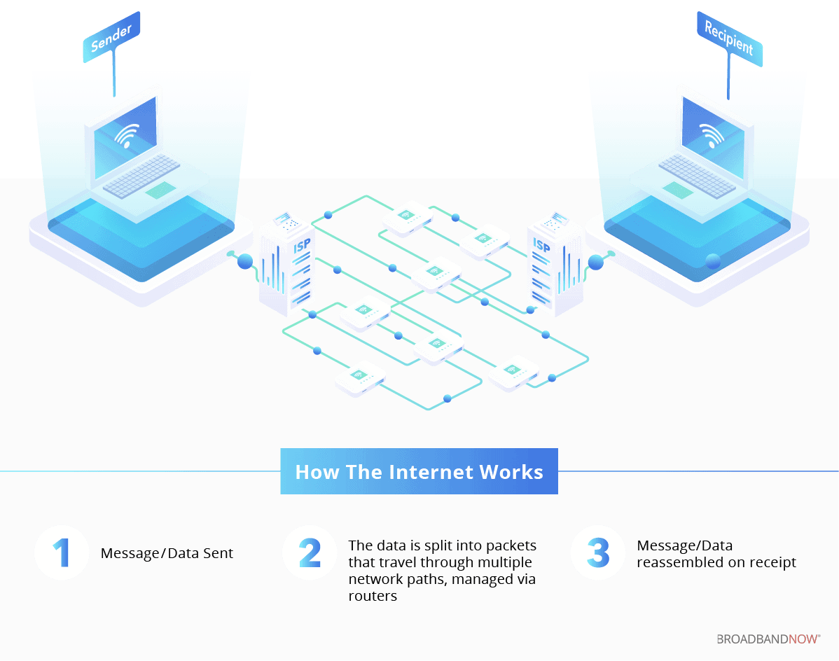

**2.How browser works?**

Browsers are responsible for retrieving and displaying web content to users. When a user enters a URL or clicks on a link, the browser initiates a complex series of actions to retrieve the web content from a server and display it on the user’s device.

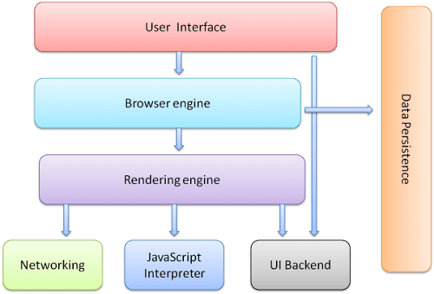

The process begins with Domain Name System (DNS) resolution, where the browser translates the domain name into an IP address to locate the server where the web page is stored. The browser then sends an HTTP request to the server, specifying the path and parameters of the requested resource.Once the server receives the request, it sends an HTTP response to the browser containing the requested resource in HTML, CSS, and JavaScript code. The browser’s rendering engine interprets and renders the code to display the web page on the user’s device. The CSS stylesheets are applied to format the web page’s content, including fonts, colours, and layout.The browser may also execute JavaScript code on the web page to add interactivity and dynamic behaviour.

**3. What is Server?**

A server is a computer program or device that provides a service to another computer program and its user, also known as the client. In a data center, the physical computer that a server program runs on is also frequently referred to as a server. That machine might be a dedicated server or it might be used for other purposes.In the client/server programming model, a server program awaits and fulfils requests from client programs, which might be running in the same, or other computers. A given application in a computer might function as a client with requests for services from other programs and as a server of requests from other programs.

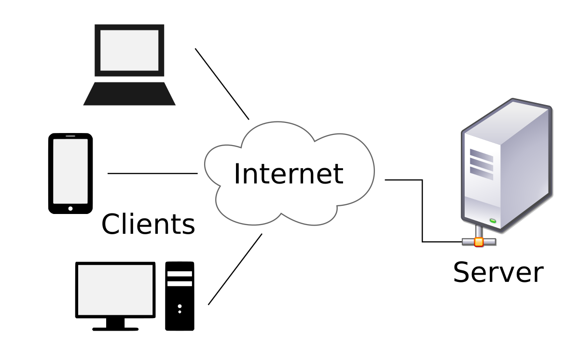

**4. what are the types of server available?**

1. Web Server
2. Database Server
3. Email Server
4. Web Proxy Server
5. DNS Server
6. FTP Server
7. File Server
8. DHCP Server
9. Cloud Server
10. Application Server
11. Print Server
12. NTP Server
13. Radius Server
14. Syslog Server
15. Physical Server

**5. What is SEO? Importance of SEO?**

SEO is the practice of increasing the quantity and quality of traffic to your website through organic search engine results. A higher rank when someone searches a term in your industry increases your brand’s visibility online. The increase in visibility will drive more organic traffic to your site, and this, in turn, gives you more opportunities to convert qualified prospects into customers. When done correctly, SEO can help your brand stand above others as a trustworthy company and further improve the user’s experience with your brand and website.

SEO is important for brands as it’s a highly effective way to improve your brand’s visibility through search, drive more traffic to your website, establish your brand as a trusted authority in your industry, sustainably and reliably grow your business, and much more. Here’s how each of these factors contributes to the importance of SEO for your brand.

**6. What is Accessibility?**

Accessibility refers to the design and creation of environments, products, and services that can be used by all people, regardless of their disabilities or impairments. It aims to ensure that everyone, including those with physical, sensory, cognitive, or other disabilities, can access, understand, and use various aspects of their environment and society.

Here are some key areas of accessibility:

1. **Physical Accessibility**: Ensuring buildings, transportation, and other physical spaces are navigable and usable by people with disabilities. This includes features like ramps, elevators, wide doorways, and accessible restrooms.
2. **Digital Accessibility**: Making websites, apps, and other digital content usable for people with disabilities. This includes screen reader compatibility, keyboard navigability, alternative text for images, and ensuring content is clear and understandable.
3. **Communication Accessibility**: Providing ways for people with communication disabilities to access information. This can involve sign language interpreters, captioning for videos, and easy-to-read materials.
4. **Cognitive Accessibility**: Designing products and services that are easy to understand and use for people with cognitive or learning disabilities. This might include simplified instructions, consistent navigation, and clear, concise language.
5. **Social and Attitudinal Accessibility**: Promoting inclusive attitudes and behaviours in society to ensure people with disabilities are treated with respect and dignity.

Accessibility is crucial for ensuring equal opportunities and participation in society for everyone, including those with disabilities. It is often guided by laws and standards, such as the Americans with Disabilities Act (ADA) in the United States or the Web Content Accessibility Guidelines (WCAG) for digital content.

**7. What is Markup Language?**

A markup language is a set of rules that defines how the layout and presentation of text and images should appear in a digital document. It allows structuring documents, adding formatting, and specifying how different elements should be displayed (or “rendered”) on webpages.

This structuring helps search engines like Google understand the information on websites better. If search engines know more about what a page is about, they are more likely to show it to people who are looking for its content. Which, in result, can bring more people to websites with the right markup.

**8. What is HTML?**

HTML is a standardised system for tagging text files that creates the structure for just about every page that we find and use on the web. It’s HTML that adds in page breaks, paragraphs, bold lettering, italics, and more. HTML works to build this structure by using tags that tell browsers what to do with text.

For example, to make a word appear bold, we put that word between the

following tags <strong>bold</strong>. The first tag indicates the

start of the word(s) that we want to bold, and the closing tag(/) indicates

where we want the bold to stop. It’s the basis for pretty much every page on

the web. If you are learning to code, this is the place to start.

**9. What is browser engine?**

A browser engine, also known as a rendering engine or layout engine, is a central [software](https://techterms.com/definition/software) component in a [web browser](https://techterms.com/definition/web_browser). It translates [HTML](https://techterms.com/definition/html) and [CSS](https://techterms.com/definition/css) from [plain text](https://techterms.com/definition/plaintext) marked up with [tags](https://techterms.com/definition/tag) into the content you see on the screen — setting up the [page layout](https://techterms.com/definition/page_layout), styling text, and placing images. The browser engine also handles navigation between pages using [hyperlinks](https://techterms.com/definition/hyperlink).

In addition to laying out the elements of a [web page](https://techterms.com/definition/webpage), the browser engine also creates a document object model (DOM) for each page, which organises each page into standard elements like its title, body, and [headers](https://techterms.com/definition/header). The browser engine is also closely integrated with the browser's [JavaScript](https://techterms.com/definition/javascript) engine, which executes a web page's JavaScript code. Updates to a browser engine can add support for new [file formats](https://techterms.com/definition/file_format), fix [bugs](https://techterms.com/definition/bug), or support new features added to the HTML and CSS specifications.

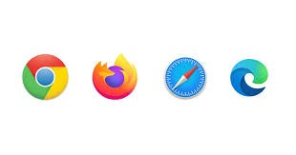

**10. What is rendering engine? share the available rendering engine?**

Rendering engine usually happens to be something like an “add-on” to the 3D software that helps compute the lighting and physical properties of the materials used in a more photorealistic way than the default renderer that comes with a given 3D software. Common rendering engines are Corona renderer, Vray, Redshift, Fstorm, Lumion, Octane or Cycles (proprietary of Blender).

There are two types of renderers: raytracing ones (mentioned above) that utilize actual calculations of lightrays hitting the surfaces and adjusting the look of the image based on physical properties of the materials (such as diffuse, bump, displacement, roughness etc.) and the other group – real time rendering engines such as Unreal Engine, Eevee in Blender or Unity.Those are most commonly found in game industry and rely primarily on quick approximations of shadows, pre-set (baked-in) lighting and other memory-saving procedures.

available rendering engine-

**WebKit**: Used by Safari and older versions of the default Android browser. It's an open-source engine known for its performance and standards compliance.

**Blink**: A fork of WebKit, used by Google Chrome, Microsoft Edge (recent versions), Opera, and other Chromium-based browsers. It's also open-source and emphasizes speed and efficiency.

**Gecko**: Developed by Mozilla, it's used in Firefox. Gecko is also open-source and focuses on standards compliance and flexibility.

**Trident**: Used in older versions of Internet Explorer. It's proprietary to Microsoft and has been largely replaced by the EdgeHTML engine in later versions of Internet Explorer and Edge.

**EdgeHTML**: A proprietary engine developed by Microsoft for use in Edge (before the switch to Chromium) and later versions of Internet Explorer.

**Presto**: Used by older versions of the Opera browser (before it switched to Blink). Presto is known for its performance but is no longer actively developed.

**11. What is JavaScript Engine? share the available JS engine? Purpose of JS Engine?**

JavaScript is a scripting language and is not directly understood by computer but the browsers have inbuilt JavaScript engine which help them to understand and interpret JavaScript codes. These engines help to convert our JavaScript program into computer-understandable language.

A JavaScript engine is a computer program that executes JavaScript code and converts it into computer understandable language.

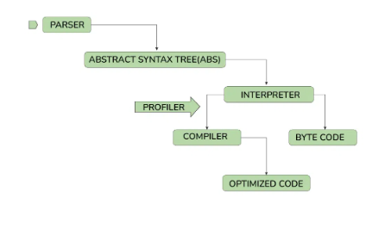

Available JavaScript Engines:

Several JavaScript engines are widely used across different browsers and platforms:

1. **V8 (used in Chrome and Node.js)**: Developed by Google, V8 is a high-performance JavaScript engine known for its speed and efficiency. It compiles JavaScript directly into native machine code before executing it.
2. **SpiderMonkey (used in Firefox)**: Developed by Mozilla, SpiderMonkey was one of the first JavaScript engines. It also uses JIT compilation for performance optimization.
3. **JavaScriptCore (used in Safari)**: Developed by Apple, JavaScriptCore (also known as Nitro) powers JavaScript execution in Safari. It includes both an interpreter and a JIT compiler.
4. **Chakra (used in older versions of Microsoft Edge)**: Developed by Microsoft, Chakra was the JavaScript engine used in older versions of Edge. It's now replaced by V8 in the newer Chromium-based Edge.
5. **RingoJS**: A JavaScript engine used in the RingoJS platform, designed for server-side JavaScript applications.

Purpose of a JavaScript Engine:

1. **Code Execution**: The main task of a JavaScript engine is to take JavaScript code, parse it (break it down into its components), compile it into machine code, and execute it.
2. **Optimization**: Modern JavaScript engines employ various optimization techniques to improve the performance of JavaScript code. This includes techniques like just-in-time (JIT) compilation, which dynamically optimizes frequently executed code segments for faster execution.
3. **Memory Management**: JavaScript engines handle memory allocation and garbage collection, ensuring efficient use of memory and cleaning up unused memory (garbage) to prevent memory leaks.

**12. How website works?**

All websites are identified by a unique address, which tells browsers where they are located.

Simply put, when you enter a web address into your browser, it goes to that specified location and retrieves the web page. The process of retrieving this information is carried out by a web service using technologies such as Hypertext Transfer Protocol (HTTP) and File Transfer Protocol (FTP), which essentially define how information and files are transmitted over the web.

The browser then displays the retrieved web page on your screen using technologies such as HyperText Markup Language (HTML) and Cascading Style Sheet (CSS[)](https://www.hostinger.in/tutorials/what-is-css). They structure and present the web page’s information to the visitor by telling the browser exactly where to put what on the screen.

Fortunately, you don’t need to know how to write computer code or have in-depth knowledge of these technologies to make a website. In fact, you can turn your website idea into a fully functional site in a matter of minutes using a website builder.

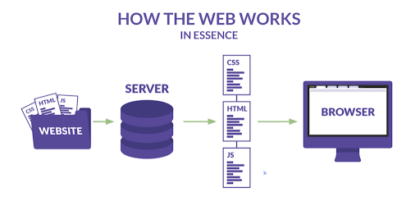

**13. What is Data Structure?**

A data structure is a storage that is used to store and organise data. It is a way of arranging data on a computer so that it can be accessed and updated efficiently.

A data structure is not only used for organising the data. It is also used for processing, retrieving, and storing data. There are different basic and advanced types of data structures that are used in almost every program or software system that has been developed. So we must have good knowledge about data structures.

**14. Explain Tree Data Structure?**

A tree is a non-linear abstract data type with a hierarchy-based structure. It consists of nodes (where the data is stored) that are connected via links. The tree data structure stems from a single node called a root node and has subtrees connected to the root.

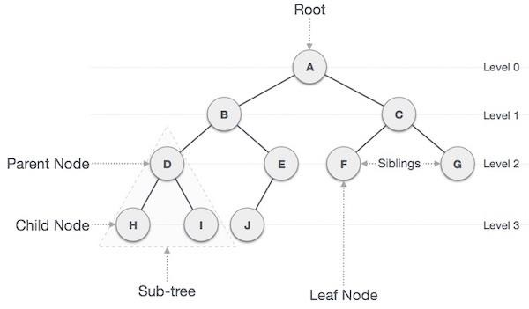

**15. What is a user agent? share the list and its purpose?**

The user-agent is an HTTP header field which can be used to transfer more or less detailed information regarding the device making a network request.

This is done through an HTTP header and this information can be used, for example, to deliver certain elements only to those browsers, which are capable of managing them.

Purpose of User Agent:

1. **Compatibility**: User agents help servers deliver content that is compatible with the client's browser and operating system. This includes ensuring that the content uses features supported by the client's browser version.
2. **Content Adaptation**: Websites can use user agent information to adapt their content, layout, or functionality based on the capabilities of the client device. For example, serving a mobile-friendly version of a website to users on smartphones.
3. **Analytics**: User agents provide valuable data for website analytics, helping website owners understand the distribution of browsers and devices accessing their site.
4. **Security**: Some security measures may use user agent information to detect potential threats or suspicious activity originating from certain browsers or devices.

**16. What is Hypertext?**

Hypertext is a method of organizing information in a digital format that uses traditional text structures (words, sentences, pages, articles or chapters, books, and libraries) as enhanced by the numerous linkages (words to words, words to sentences, sentences to pages, pages to pages, pages to chapters, and so on) that are possible in cyberspace.

The prefix “hyper” indicates that the text contains additional information than what the reader sees.

When hypertexts are supplemented with graphics, images, audio, and video, they are referred to as hypermedia or multimedia.

Hypertexts expand and create ethical issues related to access, the implications of linking choices, and more by both enhancing and subverting traditional assumptions about the linear reading of a text (i.e., word after word, sentence after sentence, page after page).

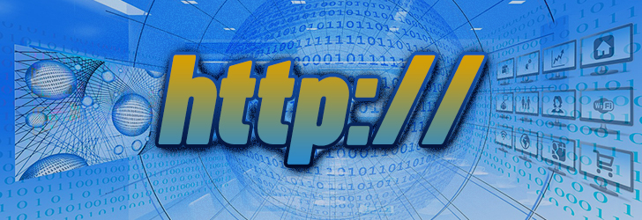

**17. What is HTML Tags?**

HTML tags are like keywords which defines that how web browser will format and display the content. With the help of tags, a web browser can distinguish between an HTML content and a simple content. HTML tags contain three main parts: opening tag, content and closing tag. But some HTML tags are unclosed tags.

When a web browser reads an HTML document, the browser reads it from top to bottom and left to right. HTML tags are used to create HTML documents and render their properties. Each HTML tag has different properties.

An HTML file must have some essential tags so that the web browser can differentiate between a simple text and HTML text. You can use as many tags you want as per your code requirement.

* All HTML tags must be enclosed within < > these brackets.
* Every tag in HTML performs different tasks.
* If you have used an open tag <tag>, then you must use a close tag </tag> (except some tags)Syntax

<tag> content </tag>

**18. What is HTML Attributes?**

HTML attributes are the modifier of the HTML elements or tags. Simply put, attributes are special words that provide additional information about the elements or attributes.

Key features of HTML Attributes

* Attributes are additional values that add meaning or adjust the behaviour of elements.
* Every element or tag can have attributes.
* They always come in pairs (atribute_name=“value”).
* The attribute’s names are case-insensitive, but W3C recommends lowercase attributes in HTML.
* Attributes should always be used with the start tag.
* We can add multiple attributes in one HTML element.

Syntax:

<tag attribute_name="attribute_value">Some content...</tag>

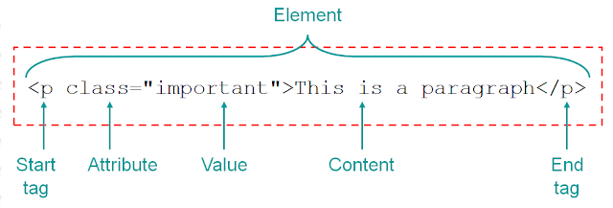

**19. What is HTML Elements?**

An HTML element is a component of an HTML document that tells a web browser how to structure and interpret a part of the HTML document. HTML elements can contain formatting instructions, semantic meaning, and content.

For example, HTML elements are used to denote document parts such as headers, paragraphs, and footers and to embed content such such as hyperlinks, text, and images. Although HTML can be used to provide formatting instructions, HTML standards strongly encourage using [CSS](https://www.digitalocean.com/community/tutorials/what-is-css) for this purpose instead.

An HTML element is often — but not always — created by opening and closing [HTML tags](https://www.digitalocean.com/community/tutorials/what-is-an-html-tag), which wrap around a piece of content. Below is an illustration that labels each of the parts of an HTML element:

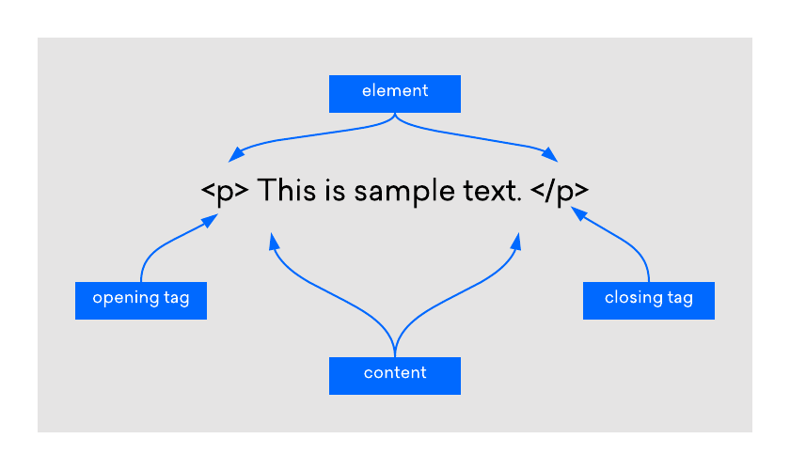

**20. How do convert elements to tree?**

Converting elements into a tree typically refers to organizing data or information in a hierarchical structure, similar to how a tree data structure organizes its nodes. Here’s a general approach to converting elements into a tree:

1. **Define the Tree Structure:** Decide on the structure of your tree, which includes understanding the relationships between parent and child nodes. Each element or node should have attributes that allow it to be placed correctly within this structure.
2. **Identify Elements:** Determine what your elements are and how they relate to each other. These could be items in a list, data points in a dataset, or any entities that can be organised hierarchically.
3. **Establish Relationships:** Establish relationships between elements based on criteria such as parent-child relationships, dependencies, or any other relevant connections.
4. **Construct the Tree:** Using the relationships identified, construct the tree data structure. This might involve creating nodes for each element and linking them according to their relationships.
5. **Traversal and Operations:** Once the tree is constructed, you can perform operations such as traversing the tree (e.g., depth-first or breadth-first), searching for specific elements, modifying the structure, or extracting information in a hierarchical manner.

**21. What is DOCTYPE?**

Doctype is an HTML declaration used to instruct the browser about the HTML version used. This is included in the head section of the HTML file.

This declaration appears on the first line of the HTML document. The doctype declaration stands for the HTML version that the document is written in. This ensures the document is rendered consistently across various web browsers.

Without doctype, browsers may interpret the code differently, messing up the page’s appearance. Also, without specifying the HTML version, the browser may enter quirks mode, displaying the page using outdated rules.  
Doctype declaration for HTML 4.01 was lengthy compared to HTML 5. Doctype declaration of HTML 4.01 requires the document type definition (DTD) that specifies the document’s legal elements and structural rules. DTD is required in HTML 4.01 as it is based on an older system called SGML (Standard Generalised Markup Language). Doctype declaration of HTML 5 does not require DTD as HTML 5 is not based on SGML.  
The Doctype declaration for HTML 5 is <!DOCTYPE html>

**22. What are the ways we can save html files?**

Saving an HTML file involves preserving the content and structure of a web page or HTML document. Here are several common ways to save an HTML file:

**Using a Text Editor:**

Open a text editor like Notepad (Windows), TextEdit (Mac), or any code editor (Visual Studio Code, Sublime Text, etc.).

Copy the HTML code from your browser or existing file.

Paste the code into the text editor.

Save the file with a .html extension. For example, index.html.

**Browser Save Functionality:**

Open the webpage in a browser (e.g., Chrome, Firefox, Safari).

Right-click on the webpage.

Select "Save As..." or a similar option from the context menu.

Choose the location on your computer where you want to save the file.

Specify the file name and ensure the file type is set to HTML.

Click "Save".

**Using Developer Tools:**

Open the webpage in a browser.

Right-click on the webpage and select "Inspect" or press Ctrl+Shift+I (Windows/Linux) or Cmd+Option+I (Mac) to open Developer Tools.

In the Elements or Sources panel, locate the <html> tag or the specific HTML code you want to save.

Right-click on the <html> tag or the code snippet.

Choose "Edit as HTML" if available, then copy the HTML code.

Paste the code into a text editor and save it as described in the first method.

**23. What is charset? why we need to use this?**

A charset, short for character set, refers to a standardised set of characters that are used in writing or displaying text. It defines how characters are represented in digital form, typically assigning a unique numeric code to each character.

Here's why charsets are important and why we need to use them:

1. Character Encoding: Charsets determine how characters are encoded into binary data for storage or transmission. Different charsets use different encoding schemes (like UTF-8, UTF-16, ISO-8859-1, etc.), which affect how characters are represented and interpreted by computers.
2. Multilingual Support: Charsets enable computers to handle text in multiple languages and scripts. For instance, Unicode (UTF-8) supports a vast range of characters from various languages worldwide.
3. Compatibility: Using a standardised charset ensures that text can be accurately interpreted and displayed across different systems, software, and platforms. It helps avoid issues like garbled text or misinterpretation of characters.
4. Web Development: In web development, specifying the charset in HTML (using <meta charset="...">) ensures that browsers render text correctly according to the chosen character encoding.

**24. What is meta data? what is the purpose of it?**

Metadata provides information about digital data. In other words, it’s the data about data. As an example, the metadata of a social media post would include information about the author of the post, the message type, post date and time, versions, links (un-shortened), location, likes, and comments.

**Description**: Metadata describes the characteristics of data, such as its title, creator, subject, keywords, and abstract. This descriptive metadata helps users identify and understand the content of the data.

**Discovery and Retrieval**: Metadata aids in the discovery of data by enabling efficient searching and indexing. Search engines, databases, and libraries use metadata to categorize and retrieve information based on user queries.

**Management**: Metadata supports data management activities such as version control, access control, and preservation. It helps in tracking changes, ensuring data integrity, and determining usage rights.

**Interoperability**: Metadata facilitates interoperability between different systems and platforms by providing standardised information about data structure, format, and semantics. This interoperability ensures that data can be exchanged and integrated seamlessly across diverse environments.

**Contextualization**: Metadata provides context and provenance information that enhances the interpretation and reliability of data. It helps users assess the quality, reliability, and relevance of the data for their purposes.

**Compliance and Governance**: Metadata supports compliance with regulations and standards related to data management, privacy, and security.

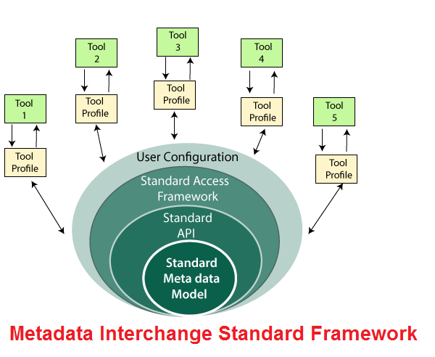

**25. Explain Web Application Architecture?**

Web application architecture defines the interactions between applications, middleware systems and databases to ensure multiple applications can work together. When a user types in a URL and taps “Go,” the browser will find the Internet-facing computer the website lives on and requests that particular page.

The server then responds by sending files over to the browser. After that action, the browser executes those files to show the requested page to the user. Now, the user gets to interact with the website. Of course, all of these actions are executed within a matter of seconds. Otherwise, users wouldn’t bother with websites.

What’s important here is the code, which has been parsed by the browser. This very code may or may not have specific instructions telling the browser how to react to a wide swath of inputs. As a result, web application architecture includes all sub-components and external applications interchanges for an entire software application.Of course, it is designed to function efficiently while meeting its specific needs and goals. Web application architecture is critical since the majority of global network traffic, and every single app and device uses web-based communication. It deals with scale, efficiency, robustness, and security.

