Machine Learning Streamlit Application

short line

|  |  |  |  |
| --- | --- | --- | --- |
| Team Member’s Last Name | Team Member’s First Name | ID | Streamlit Result Alias |
| Htun | Nyan Paing | 13053107 | Booking |
| Patil | Monali | 14370946 | Flight Center |
| Yaputra | Michael | 24619001 | Expedia |
| Vanderbilt | Charles | 11210325 | Kayak |

|  |  |
| --- | --- |
| GitHub | Project Repo: <https://github.com/monalippatil/MachineLearning-Domestic-Flight-Fare-Prediction-Streamlit-Application.git> |

36120 - Advanced Machine Learning Application

Master of Data Science and Innovation

University of Technology of Sydney

Table of Contents

**1. Executive Summary 2**

**2. Business Understanding 3**

a. Business Use Cases 3

**3. Data Understanding 4**

**4. Data Preparation 5**

**5. Modeling 6**

a. Approach 1 6

b. Approach 2 6

c. Approach 3 6

**6. Evaluation 8**

a. Evaluation Metrics 8

b. Results and Analysis 8

c. Business Impact and Benefits 8

d. Data Privacy and Ethical Concerns 9

**7. Deployment 10**

**8. Collaboration 11**

a. Individual Contributions 11

b. Group Dynamic 11

c. Ways of Working Together 11

d. Issues Faced 12

**9. Conclusion 13**

**10. References 14**

# 

# Executive Summary

This project aimed to develop a web-based application to estimate airfare for local travel within the USA. The application was designed to assist travelers, travel professionals, and budget-conscious individuals in making informed decisions regarding their travel expenses. Through the integration of multiple machine learning models, the application provides users with fare predictions based on their travel details.

**Relevance and Goals:**

The relevance of this project lies in addressing the need for accurate airfare estimation, which is a crucial aspect of travel planning. Travelers often face challenges in budgeting their trips, while travel professionals and businesses seek efficient ways to manage travel expenses. The project's primary goals included:

1. Developing a user-friendly web application for estimating airfare.
2. Integrating multiple machine learning models to provide diverse fare predictions.
3. Offering a UI tool that enhances user experience and decision-making in travel planning.

**Problem Statement:**

The problem at hand was to create an application that could take user-input travel details, including departure and destination airports, departure date and time, and cabin type, and provide accurate fare estimates. This involved addressing challenges related to dynamic pricing, data quality, and user expectations.

**Overall Context:**

In the travel industry, the ability to estimate airfare plays a pivotal role in the success of travel plans. This project served as a response to the dynamic and competitive nature of the travel sector, where travelers and professionals alike seek tools to streamline the planning process and optimize budgets. The application's outcome aimed to provide a valuable solution for users to better plan their trips, whether for personal travel, business purposes, or cost-conscious exploration. It strived to enhance user satisfaction, offer more accurate fare estimates, and contribute to the travel and transportation industry's innovation.

short dash

# Business Understanding

Covid-19 has caused an unprecedented drop in demand for air transportation in 2020 and airlines had no choice but to downsize their fleet and manage resources to stay afloat. Starting in 2022, the airline industry has been experiencing a significant rebound from the pandemic level but airline companies have yet to keep up. Figures from the first half of 2023 shows the population are eager to fly despite the rising cost of living and global economic slowdown (ING, 2023).

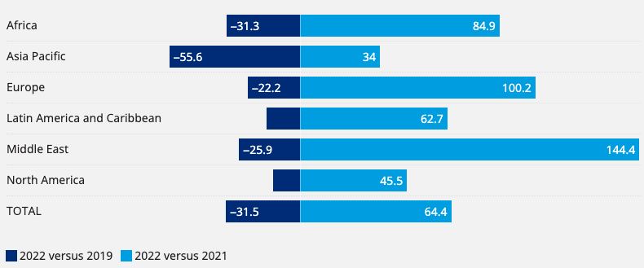**Figure 1:** Worldwide air passenger demand (Stalnaker et al, 2023)

Rising demand and limited supply has put pressure on ticket prices and flying has become more expensive. In the US, ticket fares in May 2023 were 30% more expensive compared to January 2022.

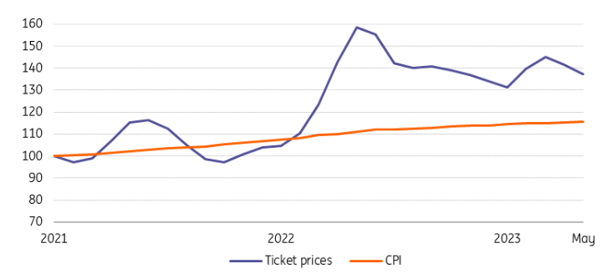

**Figure 2:** Index ticket price vs consumer price index in the US (ING, 2023)

With air transportation demand soaring, fares are through the roof and rising cost of living. It can be beneficial for organizations or governments to develop a web application to help consumers estimate airfares and better plan and manage their spendings on necessities and leisures.

## **Web Application**

In this project, we will develop a web application for estimating local travel airfare which can be applied to various business use cases and scenarios in the travel and transportation industry, including:

**1. Travel Planning Websites and Apps:**

* Travel planning websites and mobile apps can integrate the airfare estimation feature to help users plan and budget their trips more effectively.
* Users can estimate airfare costs when browsing for potential destinations and itineraries.

**2. Travel Agencies and Tour Operators:**

* Travel agencies and tour operators can use the application to provide quick fare estimates to clients when designing customized travel packages.
* The tool can help travel professionals offer more accurate pricing information.

**3. Travel Deal Aggregators:**

* Travel deal aggregators can integrate airfare estimation to enhance their deal listings.
* Users can see estimated total costs, including airfare, when browsing for travel deals.

**4. Hotel and Accommodation Booking Sites:**

* Hotel and accommodation booking sites can expand their services by providing airfare estimates along with room booking options.
* Users can get a comprehensive view of trip costs.

## **Challenges**

With different variables to consider, such as direct/indirect flights, budget/premium seats and multiple airline companies, estimating ticket fares can be challenging, including:

* **Dynamic Pricing:** Airlines use dynamic pricing strategies, which can make fare prediction challenging as prices change frequently based on demand, time, and other factors.
* **Data Quality:** Ensuring the accuracy and completeness of the historical airfare data used for training the models is a challenge.
* **Competition:** The travel industry is highly competitive, and providing accurate fare estimates can be a differentiator.

The web application has the potential to address the challenges in the travel industry by providing a valuable tool for users to estimate airfare costs. It facilitates better decision-making, and opens doors to potential revenue streams for businesses in the travel and transportation sector.

short dash

# Data Understanding

The dataset used for the project is a collection of purchasable flight tickets between April and July 2022, specifically for travel to and from various airports within the USA. It provides information on airfares, travel details, and flight characteristics.

## **Data Sources and Limitations**

While the specific source is not mentioned, it is assumed to be a publicly available dataset for research and analysis. The limitations of the dataset includes the following:

1. **Temporal Limitation:** The dataset covers a specific time frame between April and July 2022, which may not be representative of airfare dynamics throughout the year.
2. **Scope**: The dataset focuses on travel within the USA and includes a limited set of airports. This may not be suitable for estimating international travel costs.
3. **Data Completeness:** Data quality and completeness can be a limitation. Handling missing values and ensuring data accuracy are crucial steps in data preprocessing.

## **Total Rows and Columns**

There are 13,519,999 rows and 23 columns in the dataset

## **Columns**

Available columns include flight dates, departure/arrival airports, direct/indirect flights and search dates

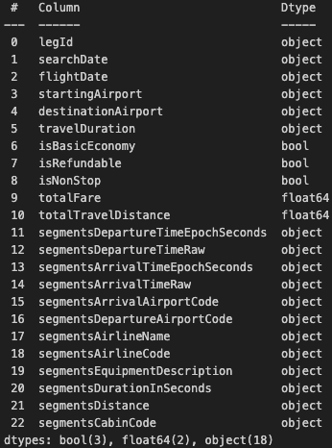

## **Number of Unique Flights**

In total there are only 1,721,518 unique flights, majority are duplicates due to multiple searches



## **Cabin Options**

There are 4 cabin options to choose from: coach, premium coach, business and first

## **Search date range**

Search date ranges from April 2022 to May 2022

## **Non-stop Flights**

Majority of flights are indirect flights but we would need to remove duplicates first in order to verify this information



## **Flight Fares**

Majority of the fares are between $1 and $1,000

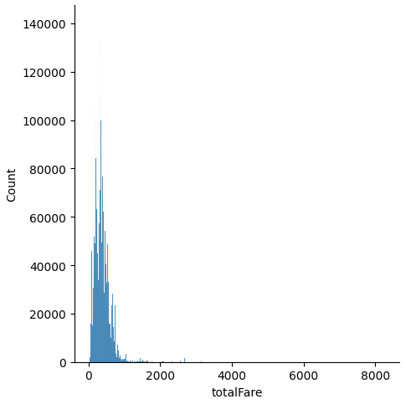

## **Total Searches Based on Flight Dates**

Number of searches peaked for May and June flights, this could be due to summer holiday season in the US

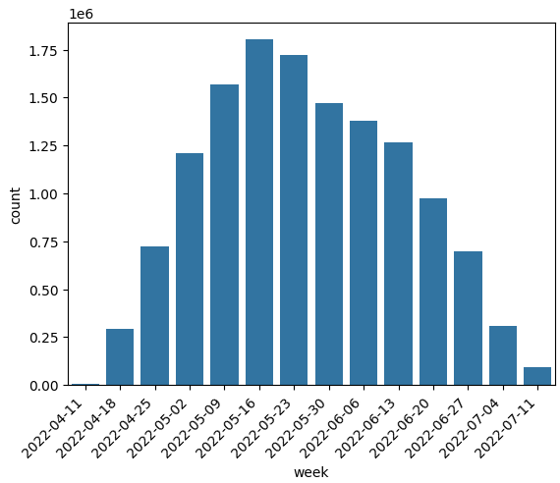

## **Flight Fares Variation Between Dates**

Average weekly price has been steady. Fares were high in early April followed by a drop in early May and then stayed around $350-$400 throughout June and July

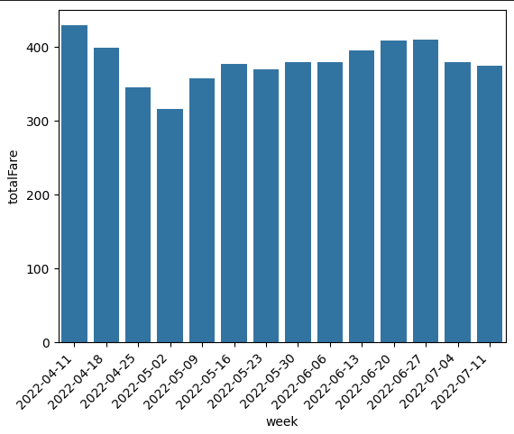

## **Number of Unique Pair of Departure and Arrival Airports**

There are 235 unique pairs of departure and arrival airports and all flights departure and arrival pairs have direct and indirect flight option

## **Maximum number of transits**

There are up to 4 transits per flight in the dataset

short dash

# Data Preparation

## **Data Cleaning**

**Missing Values**

There are no significant missing values in the dataset. But for the few columns that are missing values, we will use imputation methods to fill the gap, such as filling missing values with the mean for travel distance.

**Duplicate Rows**

Duplicate rows were detected since there are multiple searches for the same flight. Sometimes flight fare varies between searches for the same flight. To deal with this, we will calculate the average fares for the same flight.

## **Data Preprocessing**

**‘segmentsDepartureTimeRaw’ vs 'segmentsDepartureTimeEpochSeconds'**

Looks like 'segmentsDepartureTimeEpochSeconds' is based on UTC and 'segmentsDepartureTimeRaw' is based on departure airport timezone, which should be the case in real life, passengers will book departure flights based on departure airport timezone.

Also 'segmentsDepartureTimeRaw' looks more like scheduled departure time whereas 'segmentsDepartureTimeEpochSeconds' looks like actual depart time which is susceptible to changes due to delays

We will be using 'segmentsDepartureTimeRaw' instead of 'segmentsDepartureTimeEpochSeconds' to illustrate a real life scenario by converting ‘segmentsDepartureTimeRaw’ into readable format.

**Data Type Downcasting**

To save memory and improve processing speed, data types of numerical columns, objects columns, datetime columns were downcasted to their appropriate types. For example, converting integer columns to smaller integer types or using float32 instead of float64 for floating-point columns. Objects columns to category data types etc.

**Feature Engineering**

Creating 'Average Flight Fare' as a new target to train the model. With several variables such as number of transits and airline companies, it is difficult to determine ticket fare accurately, we will be using the average fares for the same flight and across airline companies as the target variable.

To calculate the average flight fare, the dataset was first grouped by 'legId' and 'flightDate'. The 'totalFare' values within each group were averaged to calculate the 'average flight fare' for each unique combination of 'legId' and 'flightDate'. This new feature provides insights into historical fare trends for specific flights on particular dates with uniform transformation for the historical data. Our models will be trained using this new feature as a target.

short dash

# Modeling

We will be using 4 different algorithms to develop the web application: AdaBoost, Neural Network (Tensorflow)

Different models to show how performance differ among models, details below

## **AdaBoostRegressor**

Algorithm: AdaBoost (Adaptive Boosting)

**Key Hyperparameters:**

* n_estimators: The number of weak learners (decision trees) to train in the ensemble. Start with a low value and increase until performance stabilizes. [50]
* base_estimator: default (decision tree)
* learning_rate: 0.05
* Loss Function: square
* Random State: 42

**Preprocessing and Feature Engineering:**

* Data Cleaning: Ensure dataset cleanliness and handle missing values.
* Feature Selection: 3 categorical values (departure airport, arrival airport and cabin code) and other relevant numerical features are selected ('isBasicEconomy', 'isRefundable', 'isNonStop', 'flightDepartureHour', 'flightDepartureMinute', 'flightDate_month', 'flightDate_day', 'flightDate_dow')
* Feature Scaling: To scale the numerical features for better model performance .
* Train-Test Split: Split data for model evaluation [Train 80%, Test 10%, Validation 10%].

**Model Evaluation:** Assess performance using regression metrics (e.g., MAE, MSE, R2).

**Additional Considerations:**

* AdaBoost adapts by sequentially assigning weights to misclassified data points.
* Base estimator is typically a shallow decision tree for weak learning.
* Learning rate affects step size in boosting.

Model 3 employs AdaBoost to iteratively improve the prediction of expected flight fares by boosting the performance of a base decision tree regressor.

## **TensorFlow Keras (Charles)**

**Model Summary**  
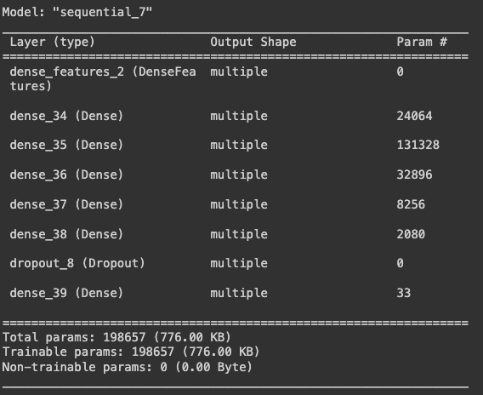

**Model Architecture:**

* Model type: Sequential
* Number of hidden layers: 11
  + Layer 1 - Output shape: 512
  + Layer 2 - Output shape: 512
  + Layer 3 - Output shape: 256
  + Layer 4 - Output shape: 256
  + Layer 5 - Output shape: 128
  + Layer 6 - Output shape: 128
  + Layer 7 - Output shape: 64
  + Layer 8 - Output shape: 64
  + Layer 9 - Output shape: 32
  + Layer 10 - Output shape: 32
  + Layer 11 - Dropout
* Optimiser: Adam
* Learning rate: 0.001
* Loss Function: MAE
* Metrics: MAE, RMSE
* Epoch: 50

**Preprocessing and Feature Engineering:**

* Data Cleaning: Ensure dataset cleanliness and handle missing values.
* Feature Selection: 3 categorical values (departure airport, arrival airport and cabin code) and other relevant numerical features are selected ('isBasicEconomy', 'isRefundable', 'isNonStop', 'flightDepartureHour', 'flightDepartureMinute', 'flightDate_month', 'flightDate_Day', 'flightDate_DayofWeek')
* Feature Encoding: Using Tensorflow one-hot encoding to convert categorical columns to numerical representation
* Train-Test Split: Split data for model evaluation [Train 64%, Validation 16%, Test 20%].

**Model Evaluation:** Assess performance using regression metrics (e.g., MAE and RMSE).

Model 4 employs deep neural network using Tensorflow, and Keras to iteratively improve the prediction of expected flight fares by boosting the performance of a base decision tree regressor.

## **TensorFlow Keras (Michael)**

Neural network can be beneficial and useful to predict average flight fare prices due to its ability to handle large amounts of data, recognize complex patterns and automate feature engineering.

**Preprocessing:**

* Transforming flight date into month, day, day of week, hour and minute
* Splitting dataset by stratifying using unique pairs of departure and arrival airport, to ensure every pair of departure and arrival airports are present and equally distributed in training and testing datasets
* Numerical columns scaling
* Categorical columns embedding

**Key Hyperparameters/architecture:**

* Number of neurons
* DenseFeatures
* Number of hidden layers
* Number of epochs
* Dropout layer
* L1 & L2 regularizers
* Keras optimizer
* EarlyStopping

**Model Evaluation:** RMSE

Neural network offers many advantages but it is important to consider the downsides such as overfitting. The aim is to train a neural network architecture that can learn accurately by employing enough neurons and hidden layers to detect patterns and stops when the model has seen and learn enough to be able to generalize and not overfit.

## **TensorFlow Keras (Monali)**

Utilizing Tensorflow and Keras, deep learning tools based on neural networks as they excel at capturing complex non-linear relationships, and patterns, and adapting to dynamic data changes.

**Preprocessing:**

* Selected relevant features and generated additional ones based on the departure date.
* Transformed Boolean features to string.
* The dataset is divided into training (60%), validation (20%), and testing (20%) sets, followed by transformation into TensorFlow datasets.
* Performed TensorFlow transformations for both numerical and categorical features.

**Tensorflow Architecture:**

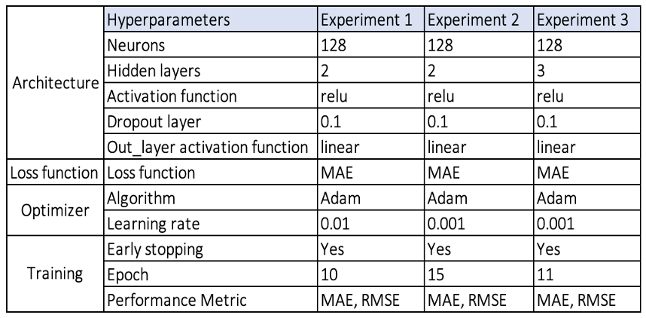

short dash

# Evaluation

## **Evaluation Metrics**

RMSE (Root Mean Squared Error): a common regression metric, measures the square root of the average squared differences between predicted and actual values. It's essential for these reasons:

* Project Alignment: It aligns with the project's core objective of precise airfare estimation.
* Outlier Sensitivity: RMSE detects the impact of outliers on predictions, crucial for extreme cases.
* User-Friendly: RMSE's unit (USD) makes it user-friendly, allowing easy error interpretation.

MAE (Mean Absolute Error): calculates the average of absolute differences between predicted and actual values. Its advantages include:

* Robustness: MAE is robust to outliers, making it valuable when extreme values are present.
* User Interpretation: MAE's USD unit offers user-friendly interpretation.
* Project Goal Consistency: MAE aligns with the project's objective of accurate airfare estimates.

Metric Selection:

Using RMSE and MAE offers a comprehensive performance assessment. RMSE gauges overall accuracy and outlier sensitivity, while MAE provides insights into the average prediction error magnitude. These metrics collectively ensure models provide accurate fare estimates, are robust to extreme cases, and meet user and professional needs.

## **Result and Analysis**

The evaluation metrics RMSE and MAE for the training and validation datasets are as follows:

### **Model 1: AdaboostRegressor (Tyler)**

RMSE and MAE metrics across the training, validation, and testing datasets are consistent:

|  |  |  |
| --- | --- | --- |
|  | RMSE | MAE |
| Training | 224.094 | 157 |
| Validation | 224.481 | 157.066 |
| Testing | 224.16 | 156.967 |

* Training and validation metrics align, indicating the model generalizes effectively.
* Model performance remains stable across different datasets, showcasing its ability to make accurate airfare estimates in real-world scenarios.
* While the models partially meet the project's goals, there is room for improvement. Further fine-tuning, exploring alternative algorithms, and feature engineering may enhance precision.

### **Model 2: Tensorflow Keras (Charles)**

Training loss, and validation loss improves drastically at the beginning, and the loss rate gets slower as the epochs goes. Both losses are consistent with training loss improvement smoother than validation as expected.

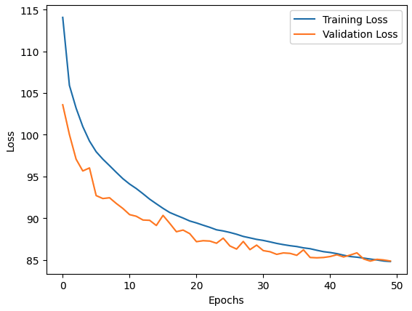

The behaviour of the improvement can also be seen in MAE, and RMSE for both Training, and Validation set.

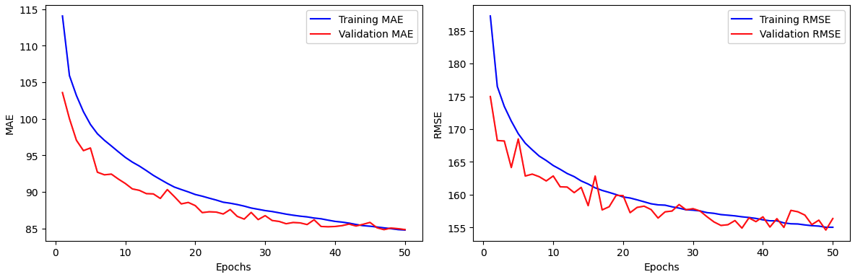

RMSE and MAE metrics across the training, validation, and testing datasets are comparable:

|  |  |  |
| --- | --- | --- |
|  | RMSE | MAE |
| Training | 155.0372 | 84.7970 |
| Validation | 156.3654 | 84.8590 |
| Testing | 155.3763 | 84.3071 |

* Training and validation metrics align, indicating the model generalizes effectively.
* The testing metrics are comparable with both training, and validation which indicates the model is not overfitting.
* Model performance remains stable across different datasets, showcasing its ability to make accurate airfare estimates in real-world scenarios.
* We have experimented with a reduced hidden layers, ie. a shallow network with various configuration of hidden layers, and as expected the performance aren't as good. However, we did try adding one extra layer for each output types (ie. one more 512 layer, 256 layer, etc.) making it a 16 layer networks and the result is not as good as the 11 layers network.
* Moreover, we also tried AdamW as our optimiser with the same 11 layer networks but it does not beat the best model with Adam as optimiser.

In conclusion, the project has made promising progress in developing airfare estimation models with consistent performance. Further optimization can address residual errors and align more closely with project objectives.

### **Model 3: Tensorflow Keras (Michael)**

Training result based on RMSE:

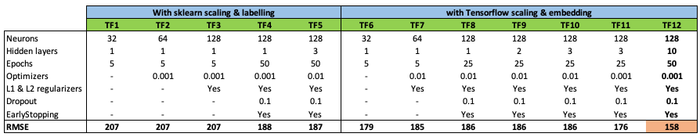

Our top performing model (TF 12) was able to perform 36% better than the baseline model (RMSE: 158 vs 249). This experiment shows Deep learning’s ability to recognize and learn from complex patterns. The web application will be able to benefit from this model’s prediction ability. Takeaways:

* Scaling numerical and embedding categorical features using Tensorflow yields better results than scaling and labeling using sklearn. Model TF1 vs TF6, both have identical hyperparameters but TF6 (scaled with Tensorflow) performed 14% better than TF1.
* Tuning optimizers from 0.01 to 0.001 yields better RMSE by allowing the model slowly and minimizing overshooting the optimal loss point; by plotting the learning process between the two optimizer values, we can see 0.001 optimizer allow the model to find loss point more smoothly:

**Optimizer: 0.01**

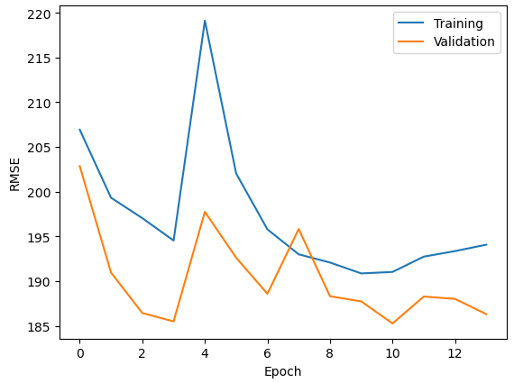

**Optimizer: 0.001**

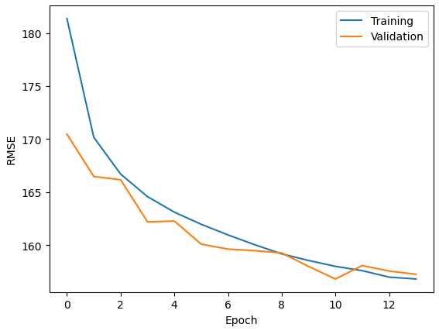

* Adding more neurons and layers does allow the model to perform better up to a certain point where EarlyStopping kicks in when it stops getting better
* Adding more neurons, layers and lowering the optimizer value significantly increases the computation time and power. We should weigh the cost and benefits of adding more complexity and time/power in future experiments.

### **Model 4: Tensorflow Keras (Monali)**

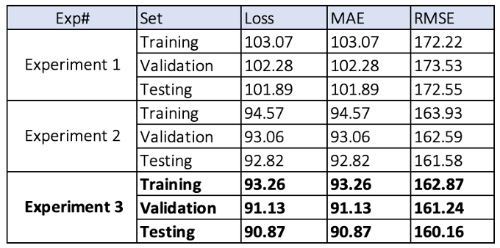

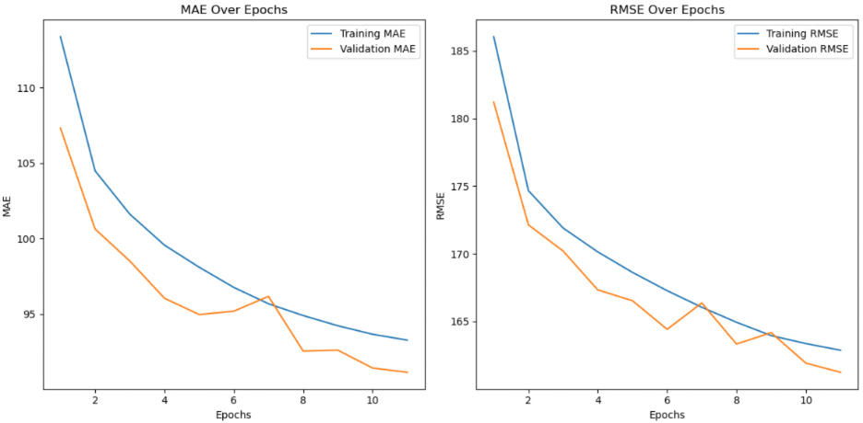

* The model from Experiment 3 performs well based on the above metrics. The decreasing trends in MAE, and RMSE across training, validation, and test sets suggest effective learning and generalization. The lower values of test metrics indicate the model's ability to make accurate predictions on unseen data.
* Reference to EarlyStopping in the insights suggests that models are designed to stop training when they cease to improve. This prevents overfitting and improves generalization.
* Experiment 3 uses an optimizer value of 0.001 as the learning rate, and it results in better performance, indicating that the magnitude of adjustments made to the model’s weight during the training process has a positive impact on model training. Thus, it helped the model acquire knowledge from the data and the ability to generalize effectively.
* The project benefits from the ability of deep learning models to capture complex patterns, as demonstrated by the performance improvements across experiments. Further analysis, such as feature importance, exploration of data patterns, and experimenting with hyperparameters and model architecture could be performed to enhance the model's performance.

## **Impacts and Benefits**

The final model for airfare estimation holds significant promise in addressing various business use cases within the travel and transportation industry. Here's an assessment of its impact and benefits:

**1. Travel Planning Websites and Apps:**

* Impact: Users can estimate airfare costs accurately when browsing for destinations and itineraries, enhancing their travel planning experience.
* Benefits: The final model contributes to more informed decision-making for travelers, potentially leading to higher booking rates and user satisfaction.

**2. Travel Agencies and Tour Operators:**

* Impact: Travel professionals can provide quick and accurate fare estimates when designing customized travel packages.
* Benefits: Improved pricing information enables travel agencies to offer competitive packages, attracting more clients and enhancing their reputation.

## **Data Privacy and Ethical Concerns**

The project involves data collection, usage, and model deployment, which raises several data privacy and ethical concerns. Following is an assessment of these implications and the steps taken to address them:

**Data Privacy:** The dataset may contain sensitive information about travelers, such as travel itineraries and pricing details. Unauthorized access to or misuse of this data could lead to privacy violations and potential harm to individuals.

**Bias and Fairness:** Models may unintentionally incorporate bias, leading to unfair treatment or pricing discrimination.

**Transparency:** Lack of model transparency may raise concerns about how predictions are made and whether they are fair and unbiased.

short dash

# Deployment

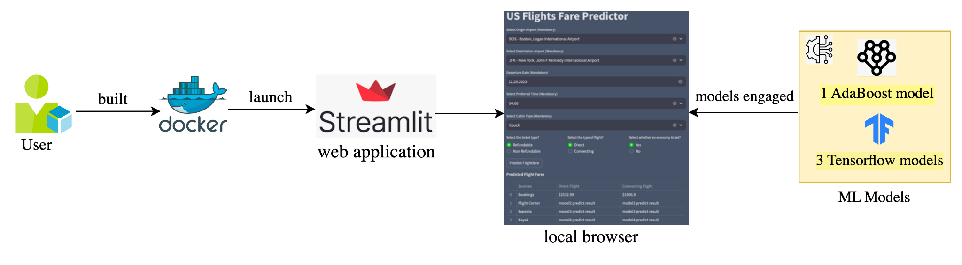

## Model Serving

**The process of deploying the trained models:** Deploying a trained machine learning model involves making the model available for use in a production environment so that it can generate predictions on new data. Following steps are performed for this purpose.

1. Prepare Model for Deployment: Once the model is trained and evaluated for desired prediction result, the models are saved as separate files for later integration.

2. Streamlit Application Development:

* Created a Streamlit application that collects the user input with user-friendly interface for fare prediction.
* Implemented input validation and integrated trained models into the application.
* Implemented input processing and with the four models, provided fare predictions in a table.

3. Choose a Deployment Platform:

* Streamlit: Used streamlit to deploy our model as a web application service for end users to use.
* Containerization: Built Docker image and containers that packages machine learning models and their dependencies.

4.. Documentation: With this report documenting the process to help other developers and users understand how to use it.

**Challenges for deployment:**

It was difficult to maintain consistent environment setups and package versions among team members for validating model predictions on the Streamlit application. To address this issue, we implemented a Docker image and containerization, providing a streamlined and reproducible solution for a uniform deployment environment across the team.

**Purpose of the Application:**

The purpose of this application is to provide users in the USA with a tool to estimate the airfare for local travel. Users can input details of their trip, including the origin and destination airports, departure date, departure time, and cabin type.

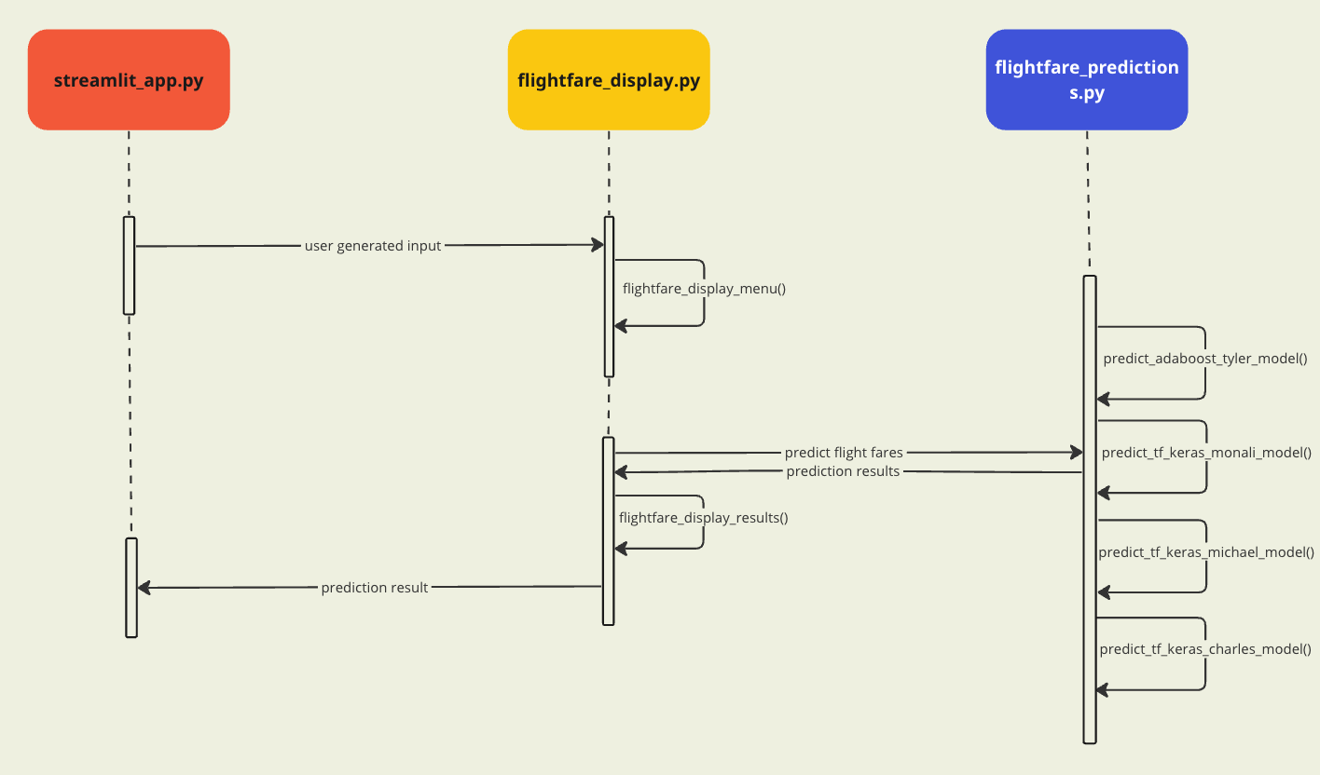

**The Main functionalities and Key features**:

1. Input Collection: Users need to provide trip details, such as the airport of departure, destination, travel date, departure time, and cabin type and (optional whether ticket should be refundable and basic-economy)
2. Validation and Input store: Validate if the user has provided all the mandatory information in their inputs before getting fare predictions to ensure the correctness of the provided information. Additionally, store the input values into session state variables.
3. Model Integration: The application integrates four different machine learning models, each trained by a different student. When users click a "Predict Fare" button, the application calls these models to predict the expected flight fare based on the user's inputs.
4. Display Predictions: The application displays fare predictions from each of the four models, offering users multiple predictions for better decision-making.

**Instructions to Set Up and Launch the Web Application:**

* To set up environment for the web application, follow below steps:

1. Install Python and Docker on your system if not already installed.
2. Create a new local directory and clone the streamlit git repository using:

“git clone [git@github.com](mailto:git@github.com):tyler737/adv_mla_at3_steamlit.git”

* To launch the web application, follow these steps:

1. From the CLI execute: “docker compose up”
2. Ensure the docker image is built followed by container launch successfully.
3. From local browser launch streamlit web app using URL: http://localhost:8502
4. Enter the necessary flight details and click to receive fare predictions.
5. To terminate the web application, execute “docker compose down”

short dash

# Collaboration

## **Team Interaction and Communication**

* **Regular Meetings:** We made it a point to have regular virtual meetings. These sessions were invaluable for discussing project progress, tackling challenges, and making collective decisions.
* **Clear Roles and Responsibilities:** To maintain focus and clarity, we defined specific roles and responsibilities for each team member. This structure ensured that everyone had a well-defined purpose.
* **Communication channel:** In addition to formal meetings, our WhatsApp group and Teams became our go-to space for quick updates, casual discussions, and urgent communication.
* **Github:** We utilize Github and cookie cutter template to manage our project and version control.
* **Roles and Responsibility:** Below table shows how we divide tasks for our individual contribution:

|  |  |
| --- | --- |
| **Tasks** | **Designated Team Member** |
| Exploratory Data Analysis | Monali and Tyler |
| Data Preprocessing | Charles and Michael |
| Model Training and Evaluation | All |
| Streamlit App Creation and Input Validation | Monali |
| Streamlit Functions | Monali, Charles & Michael |
| Report Writing | All |

## **Issues Faced**

During the initial project stages, our team faced Python environment, package discrepancies, and data wrangling challenges due to the complex dataset. Here's how we tackled them and key takeaways for future collaborations:

1. Package Discrepancy Issues:

* Challenge: Package version discrepancies could disrupt code execution and model reproducibility.
* Resolution: Managed package versions using Docker

1. Data Wrangling Challenges:

* Challenge: Cleaning and preprocessing the extensive dataset with missing values and outliers was a demanding task.
* Resolution: Collaboratively designed a data preprocessing plan, assigned specific tasks, and documented processes. Utilized pandas for data wrangling.

**Lessons Learned:**

* Emphasized clear communication, providing updates on Python environments, packages, and data preprocessing to prevent issues or utilize Docker to manage dependencies.
* Documented data preprocessing comprehensively for team understanding and future reference.
* Leveraged collaboration tools like GitHub for version control and issue tracking.

short dash

# Conclusion

The developed application serves as a valuable tool for users in the USA, enabling them to estimate airfare costs and make informed travel decisions. It streamlines travel planning, enhances user experience, and offers efficiency to travel professionals. However, it's important to acknowledge limitations related to data quality and dynamic pricing. The application's potential benefits extend to a wide range of users, including individual travelers, travel agencies, corporate travel planners, and budget-conscious travelers. By addressing these limitations and maintaining data accuracy, the application can further optimize its utility in the travel and transportation industry.

short dash

# References

1. ING. (2023, July 10). *Global aviation outlook: Air fares climb higher amid the unprecedented recovery of travel*

<https://www.ing.com/Newsroom/News/Global-aviation-outlook-Air-fares-climb-higher-amid-the-unprecedented-recovery-of-travel.htm#:~:text=US%20airline%20tickets%20were%20more,%25%20of%20total%20operational%20costs>).

1. Stalnaker, T., Usman, K., Alport, G., Buchanan, A. (2023). *AIRLINE ECONOMIC ANALYSIS 2022-2023.*

https://www.oliverwyman.com/our-expertise/insights/2023/may/airline-economic-analysis-2022-2023.html

short dash