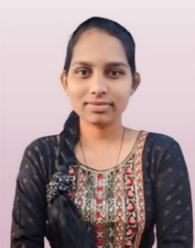**MONALI VINOD UMALE**

**Phone**: +91 9529133766

**Email:** monaliumale58@gmail.com

**Linkdin:** [www.linkedin.com/in/](http://www.linkedin.com/in/)monali-umale-8b0530338

**Location:** Nandura,Maharatra

**OBJECTIVE**

I am self-motivated and quick learner with a strong analytical mindset and passion for technology . Adept at problem.

**SKILLS**

**Technical Competencies:**

Languages- Java ,javascript,HTML,CSS

Database -SQL,MySQL

Web Technologies

**Behavioral Skills:**

Decision Making |Leadership |Adaptability |Problem-solving|Time Management

**EDUCATION**

**Bachelar of Engineering in Computer Science And Engineering** **November 2022 - June 2026**

Padm.Dr,V.B.Kolte College of Engineering Malkapur

**SGPA:8.25**

**Higher Secondary Education(Class XII)** **June 2020 - March 2022**

Rastrapita Indira gandi junior College Shegaon

**Percentage: 67.40%**

**Secondary Education(Class X) June 2018 - March 2020**

Shri Sant Gadge Maharaj Vidhyalaya Dahigaon

**Percentage: 88.40%**

**WORK EXPERIENCE**

Fresher

**PROJECTS**

**Hospital Management System** (2025): Developed a Java-based application with a MySQL backend to manage the Accuracy for Patient.

**CERTIFICATIONS**

• College project exhibition certificate

**HOBBIES & INTEREST**

* Listen to music
* Inhance New Things
* Other Activities (NSS, SPORTS Etc.)