

**HTML Project**

**Monaliza Dasig**

**Milan Destura**

**Arvee Flores**

CSIS 1280 - Multimedia Web Development

# 

# Introduction

Our group created a website about organizing hiking events in British Columbia. We built this website to allow individuals to go hiking through organized groups. The creators are interested in building this kind of website as we, newcomers in British Columbia, are interested in exploring the province. This would also allow newcomers to meet other people by joining our organized group hiking activities.

# Website Layout

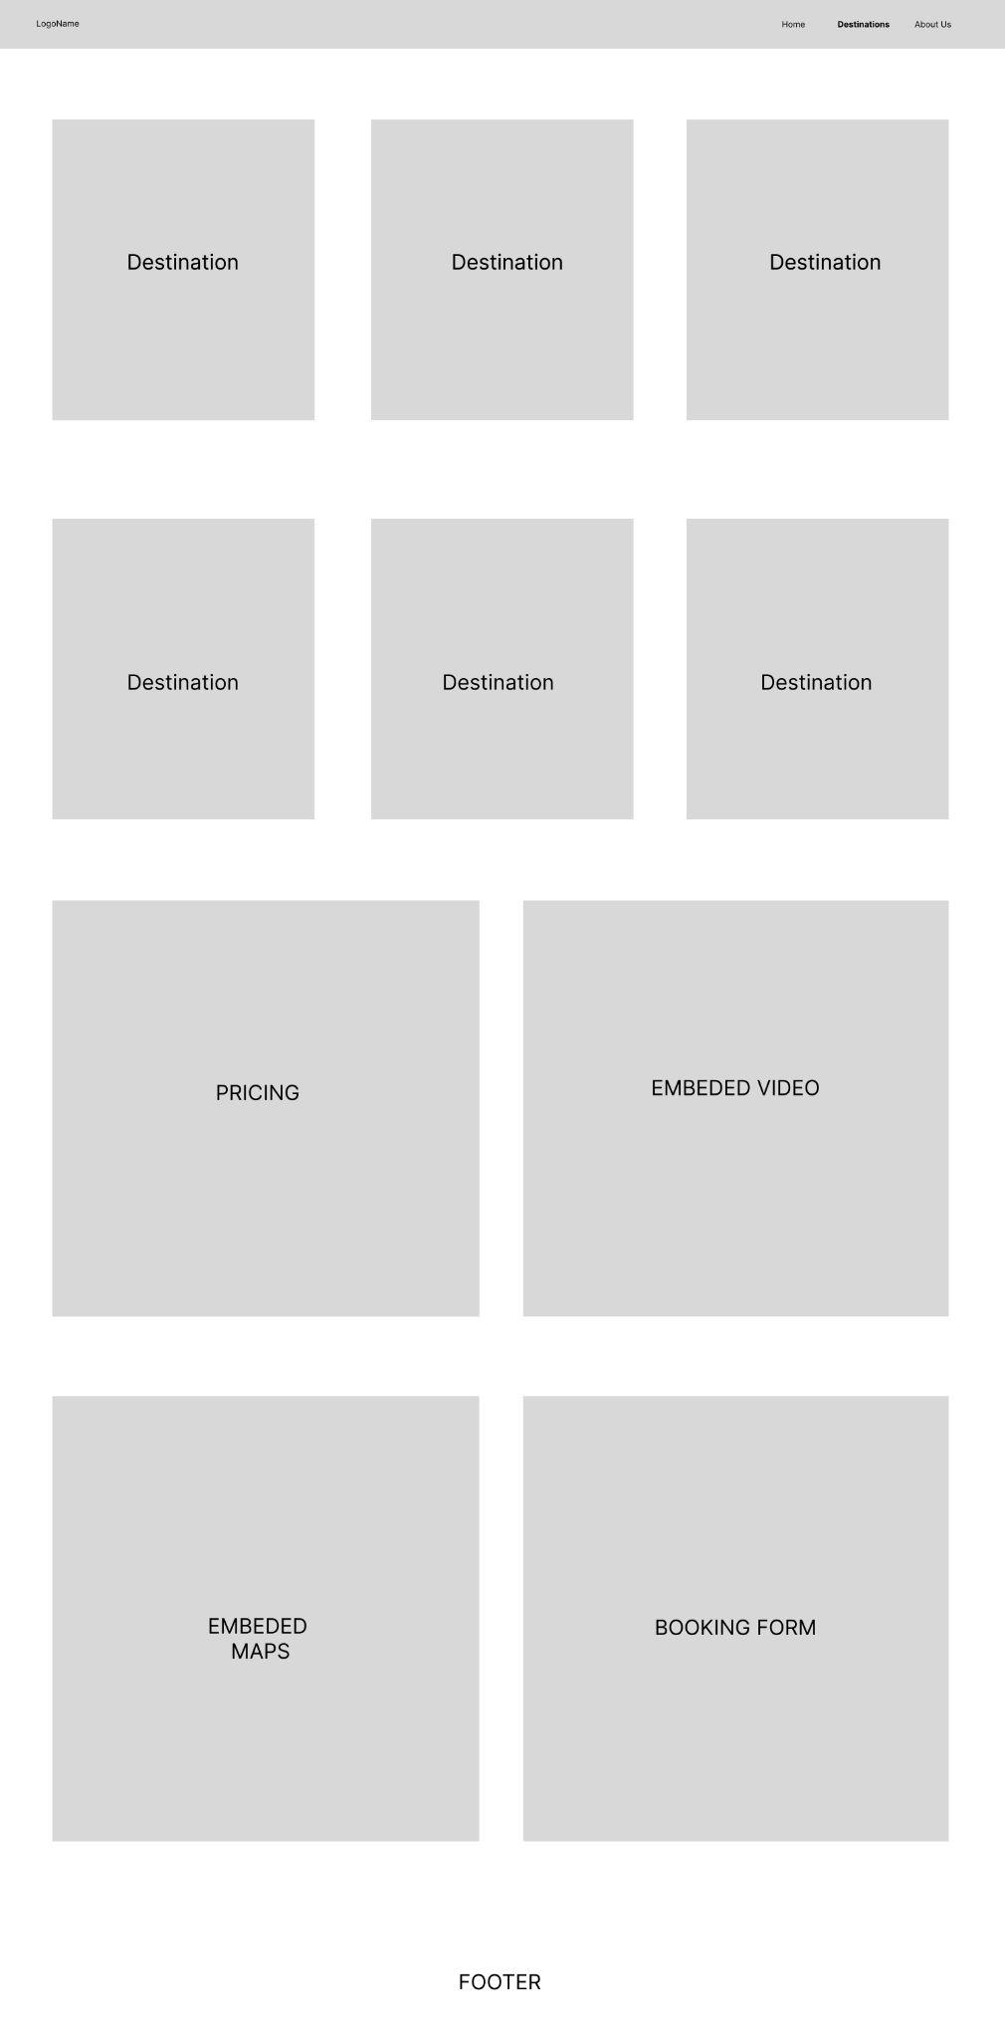

We used a combination of ***flexbox and CSS grid*** to position and layout the elements on our website. We mostly utilized flexbox to position the components such as the header, services/reviews section, forms, footer and others. For the destination section, where we display the details and photos of each destination, we used CSS grid to create a grid-based layout.

# Website Organization

Home Page (index.html)

* Header Section - contains our **personalized** logo (**Happy Hikers**), navigation buttons, and other important information that can be easily accessible to the visitors
* Image Slider Banner (Dynamic Content) - features a rotating set of images or dynamic content made through Javascript that showcases some of the highlights of our packages
* What We Offer Section - provides a summary of the products or services that our website offers to the visitors
* Reviews Section - testimonials or reviews from previous customers, giving potential customers an idea of the quality of our services or products
* Footer Section - contains links to important pages such as About Us, Privacy Policy, Terms of Use, and Disclaimer. It also features social media links

Destination Page (page2_HappyHikers.html)

* Features information on six hiking destinations, embedded video, pricing table, embedded map, and booking form. It provides visitors with detailed information on the different hiking destinations available, along with the tools they need to book their trip. By including features such as embedded videos, pricing tables, and interactive maps, it can help visitors make informed decisions about their trip and provide them with a more engaging user experience.
* Book Button (Destinations) - all book button navigates to the below booking form but each book button has designated map updates that dynamically changes the map presented depending on the destination button selected
* Embedded Video - placed a link of a video to an iframe via HTML to provide a sample video of what awaits their hiking journey
* Pricing Table - a static table that provides information of the prices per destination
* Embedded Maps (Dynamic Content) - provides a Google Map view of the destination selected. It changes depending on the location selected in the booking form. Was made through importing Google Map sources, showing it in an iframe via HTML and then used Javascript to dynamically update the Google Map source
* Booking Form (Dynamic Content) - a form the provides dates of available hiking activities as well as dynamic pricing changes depending on the number of pax being reserved with the use of Javascript

About Us Page (page3_HappyHikers.html)

* This page allows visitors to learn more about the members of the group. It also provides visitors to reach out with questions, comments, or feedback through a contact form that sends an email to us via SMTP

# Content Declaration

All the images used on our website came from *Unsplash.com* aside from our personal image (Group Photo). Icons used came from Fontawesome library. With regards to destinations, we picked the destinations personally but the information and details provided were gathered from *Alltrails.com* and *Vancouvertrails.com*.

# Highlight

Image Slider

* An automatic image slider with three images and corresponding content, displayed through CSS classes. The *active class* is used to determine the current image and content displayed and is updated dynamically with JavaScript every 6 seconds.

Embedded Maps

* Used iframe to showcase the Google Map source of each destination. Provides dynamically changing content through source changing via Javascript and *onchange* method from the *select* input

SMTP

* An open-source javascript library was used to send email messages on the ‘contact us ‘ form of the ‘about us’ page.

# References

Unsplash - <https://unsplash.com/>

Stackoverflow - <https://stackoverflow.com/>

W3Schools - <https://www.w3schools.com/>

Youtube - <https://www.youtube.com/>

MDN Web Docs - <https://developer.mozilla.org/>

Figma - ​​<https://www.figma.com/>

Google fonts - <https://fonts.google.com/>

Fontawesome - <https://fontawesome.com/>

Smtpjs - <https://smtpjs.com/>

AllTrails - <https://www.alltrails.com/>

Vancouvertrails - <https://www.vancouvertrails.com/>