Financial Loan Data Analysis
Objective:
The objective of this project is to analyze loan application data to uncover trends, patterns, and borrower characteristics that influence lending decisions. The goal is to help stakeholders understand how lending activities vary across time, regions, loan types, employment backgrounds, and homeownership statuses.
Through interactive dashboards, this analysis highlights key performance metrics such as Total Loan Applications, Total Funded Amount, and Total Amount Received, enabling data-driven insights into borrower behavior and overall performance.

Dataset Summary:
The Financial Loan Dataset contains 38,576 loan records with 24 key attributes capturing borrower details, loan characteristics, credit factors, and repayment information. This dataset is ideal for performing financial analysis, loan performance tracking, and risk assessment.
- Key Features Covered in the Dataset

- Borrower Information:
address_state, grade, purpose
- Loan Details:
loan_amount, loan_status, int_rate, term
- Credit Profile:
emp_length, annual_income, total_acc, dti
- Financial Metrics:
total_payment, loan_amount, recoveries, installments

Tech Stack Used:
- Data cleaning – Microsoft Excel
- Data Analysis – SQL
- Dashboard Development - PowerBI

SQL Analysis:
MySQL
All core transformations and calculations were executed in MySQL, including:
- Data type conversions (especially issue date)
- Cleaning inconsistent text fields
- Creating new calculated columns
- Monthly & yearly aggregations
- State-wise and demographic grouping
- Risk categorization for Good vs Bad loans
1. Total Loan Application
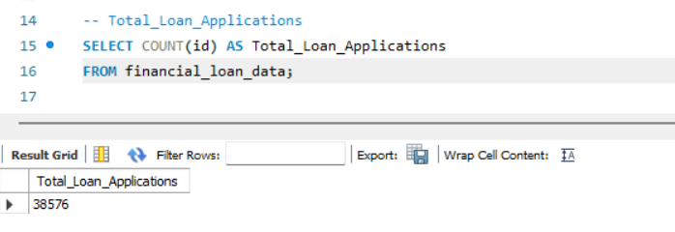

2. Month To Date Total Loan Application
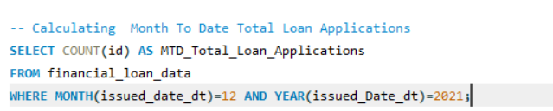

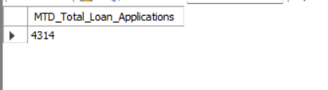

3. Previous Month To Date Total Loan Application
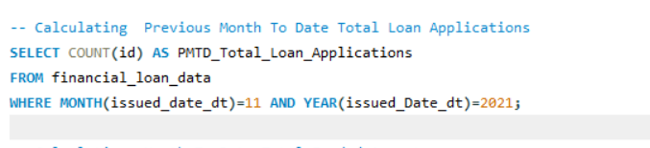
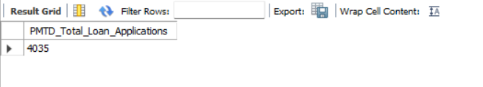
4.Percentage changed between current and Previous month

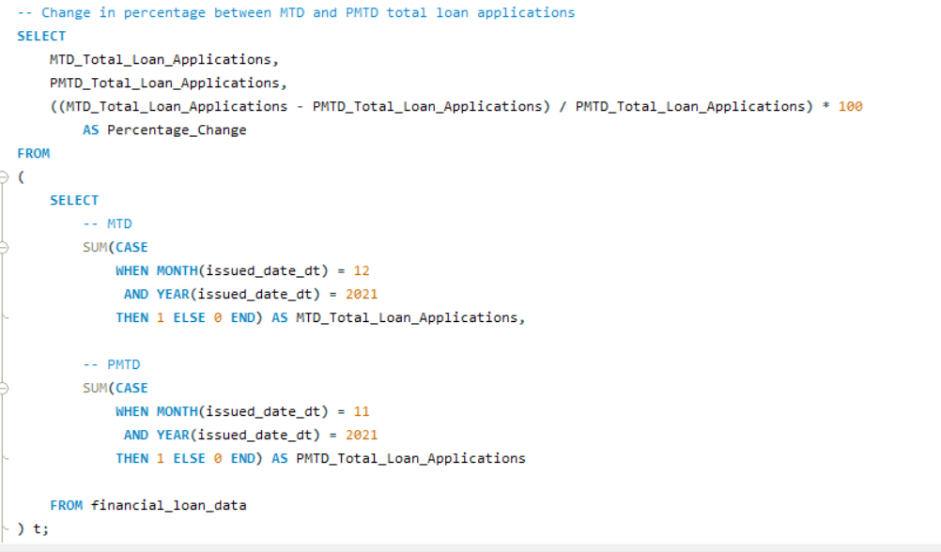

5.Month To Date Total Funded Amount
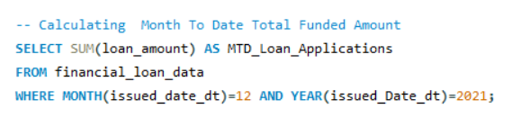
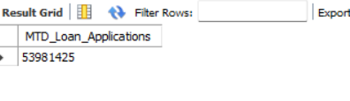
6.Previous Month To Date Total Funded Amount
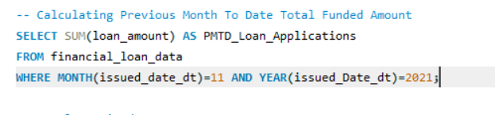
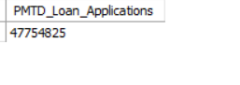
7. Total Amount Received

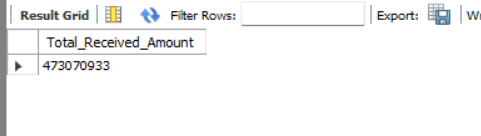
8.Month To Date Total Received Amount
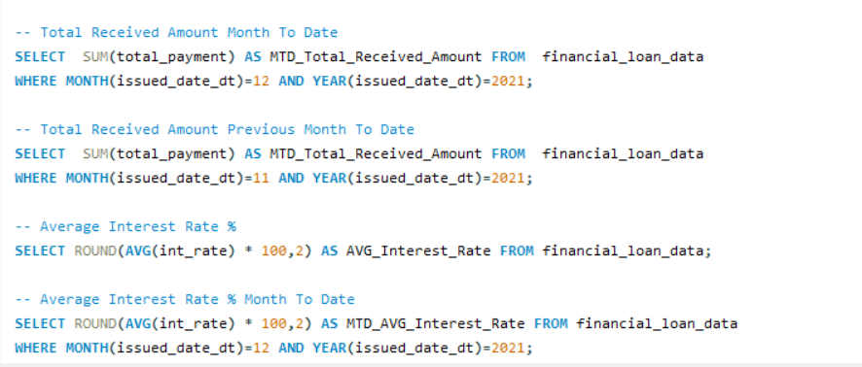
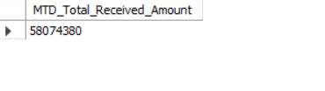
9.Previous Month To Date Total Funded Amount
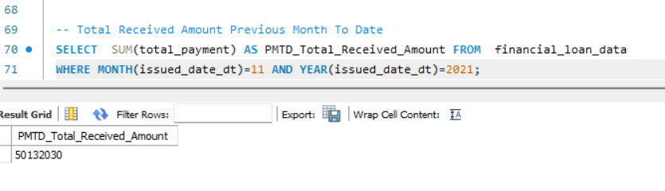


10.Average Interest rate %

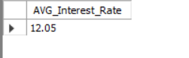
11.Average Interest rate % Month To Date

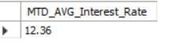
12.Average Interest rate % Previous Month To Date
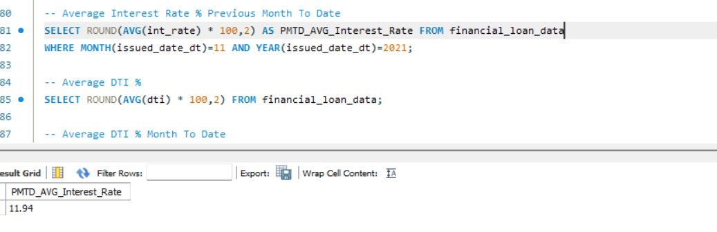


13.Average DTI %
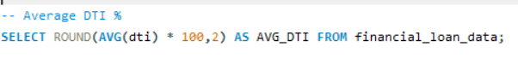
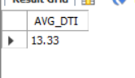
14.Average DTI % Month To Date
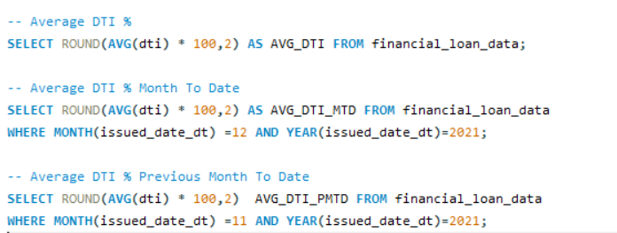


15.Average DTI % Previous Month To Date

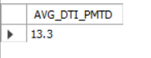

16.Good Loan Application Percentage
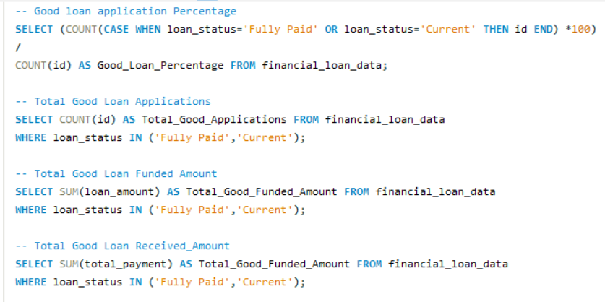
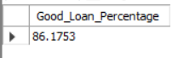
17.Total Good Loan Applications

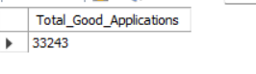
18. Total Good Loan Funded Amount
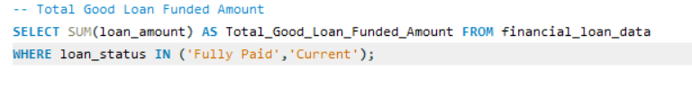
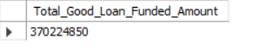
19. Total Good Loan Received Amount

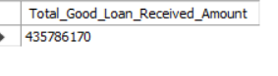
20.Bad Loan Application Percentage
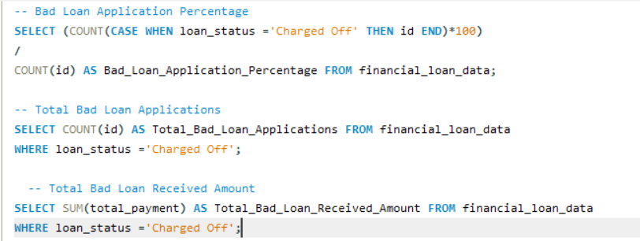
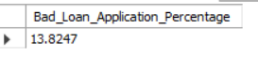

21.Total Bad Loan Applications

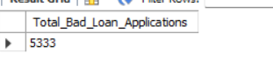
22.Total Bad Loan Funded Amount
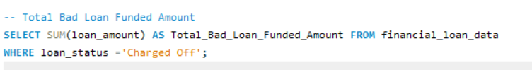
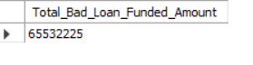
23.Total Bad Loan Received Amount

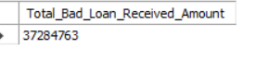
24. Loan Status Analysis
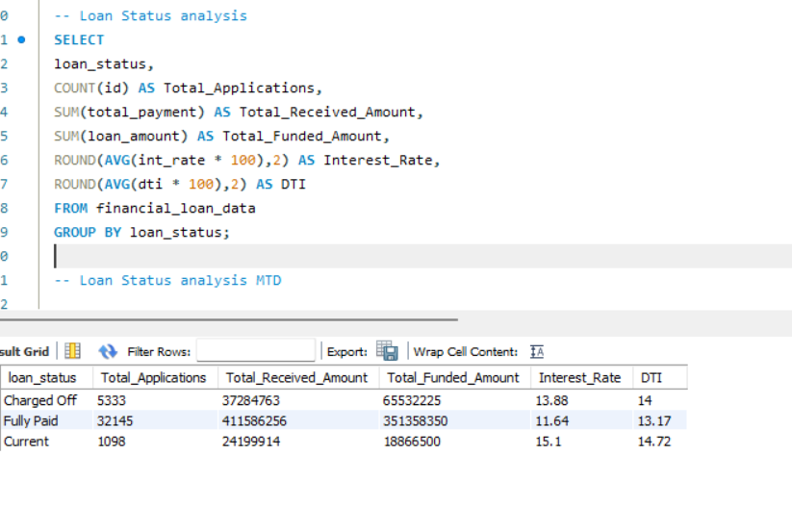

25. Loan Status Month To Date Analysis
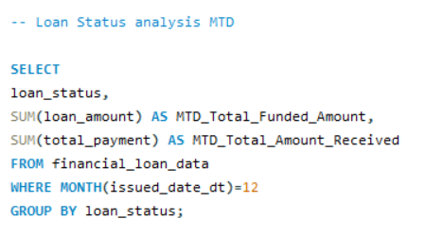
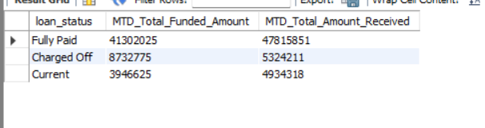

26. Monthly Trend Analysis
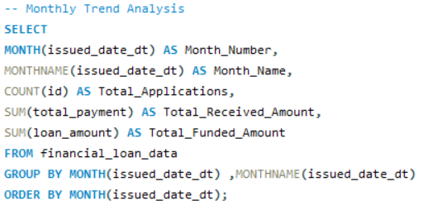
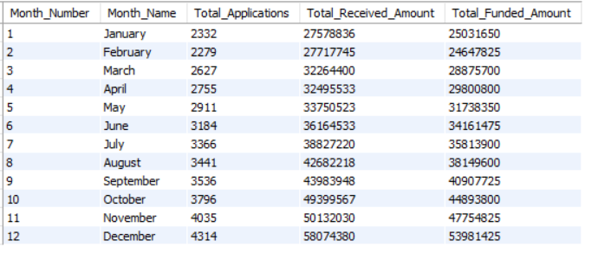

27. Regional Analysis
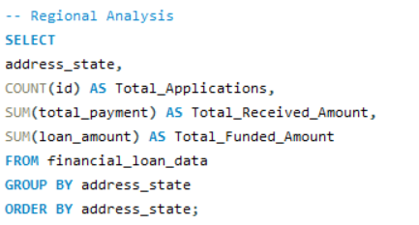
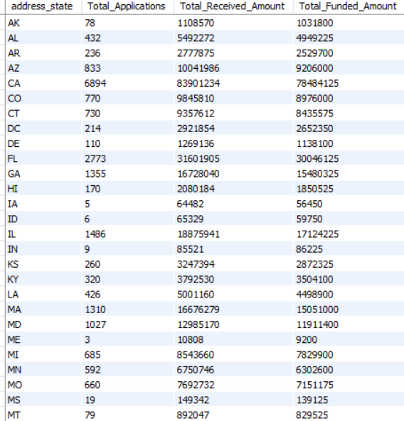

28. Top 10 States with the Highest Loan Applications
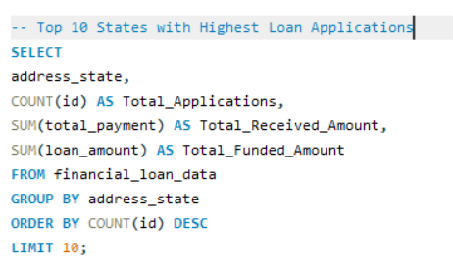
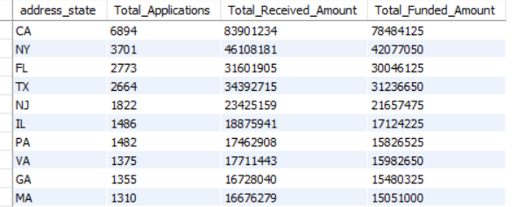
29. Analysis by Term
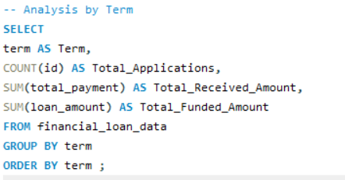
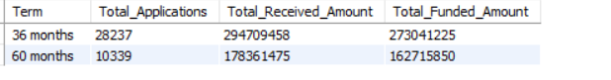

31. Analysis by Employee Length
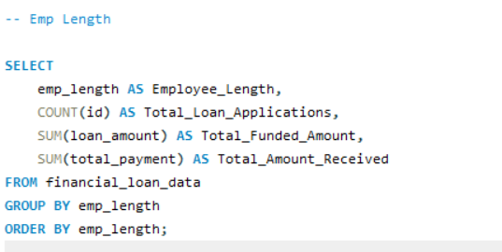
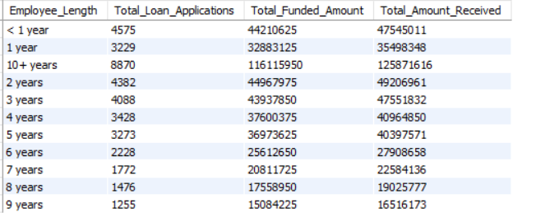
32. Analysis by Purpose
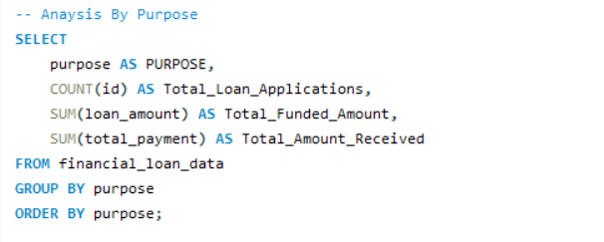
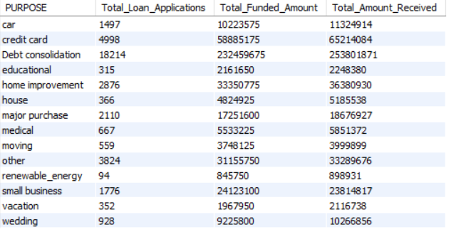
33. Analysis by Home Ownership
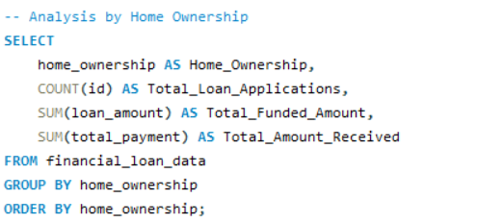
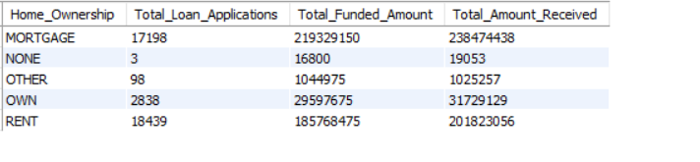

Dashboard 1 -KPI Overview :
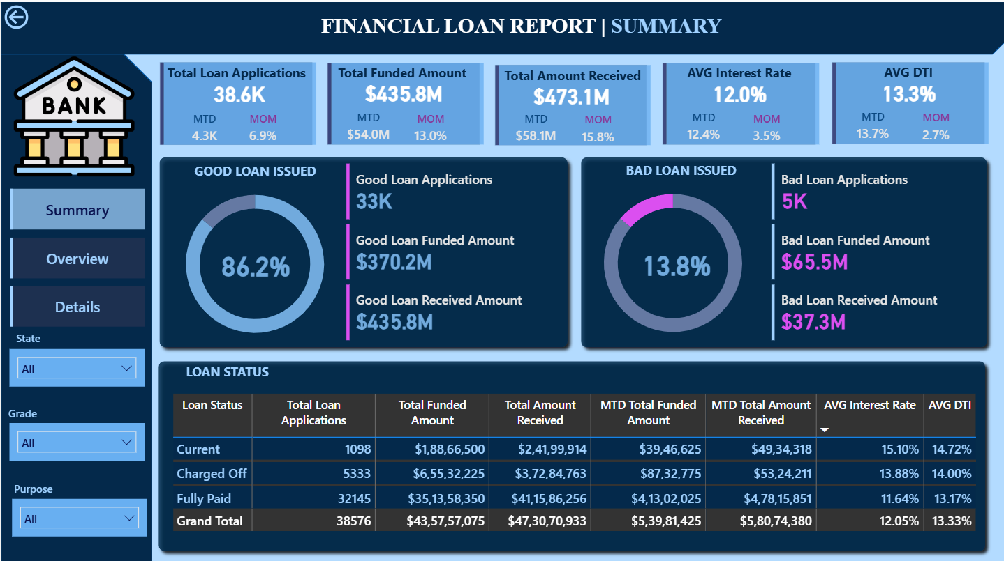

Key Metrics Displayed
- Total Loan Applications
- Total Funded Amount
- Total Amount Received
- Average Interest Rate
- Average Debt-to-Income (DTI)

Charts Included
- Loan Status Distribution
- Good Loan vs Bad Loan Segmentation

Dashboard 2 - Borrower & Trend Analysis
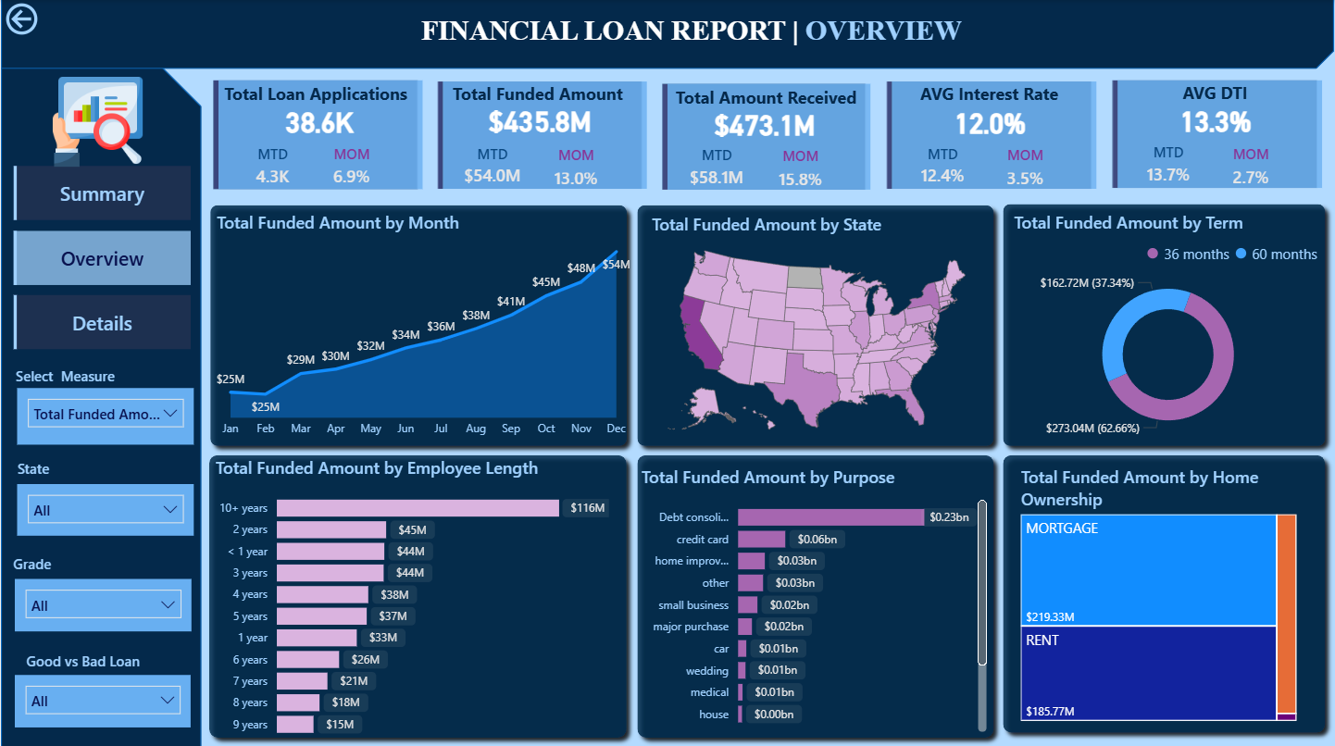
This page focused on time-based trends and borrower demographic patterns.
Charts Included
- Monthly Trends by Issue Date (Line Chart) – Showed seasonality and long-term lending movement.
- State-Level Regional Map (Filled Map) – Highlighted states with the highest loan activity.
- Loan Term Distribution (Donut Chart) – Compared 36-month vs 60-month loans.
- Employment Length Analysis (Bar Chart) – Displayed how work experience impacted loan approvals.
- Loan Purpose Breakdown (Bar Chart) – Showed borrower intentions behind loan requests.
- Home Ownership Analysis (Tree Map) – Demonstrated how housing status influenced loan amounts and applications.

Dashboard 3 - Loan Status Deep Dive
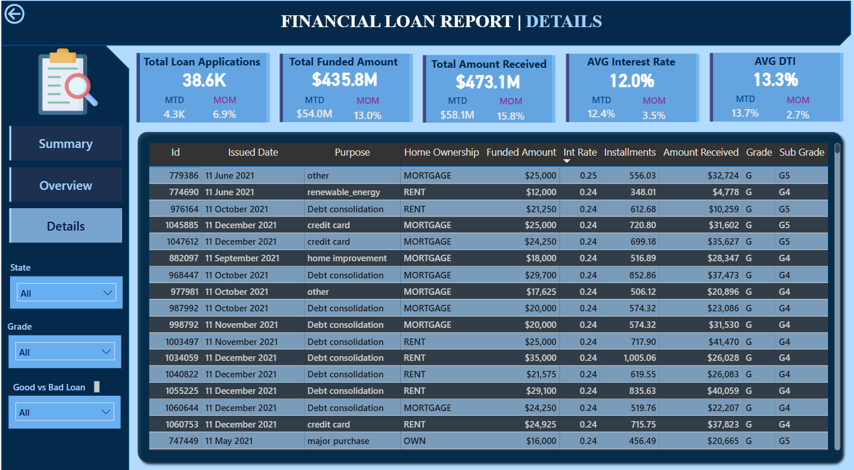
This dashboard provided an in-depth performance analysis of loan repayment.
Charts Included
- Id
- Issued Date
- Purpose of Loan
- Interest Rate vs Loan Grade Relationship
- Loan Amount vs Amount Received Comparison
- Interest rate
- Installments

Key Insights
1. Borrowing Increased Over Time:
Monthly loan trends showed steady growth, indicating rising borrowing demand and seasonality patterns.

2. Certain States Dominated Loan Applications:
A limited number of states contributed the most applications, helping lenders focus on priority regions.

3. Employment Length Impacted Funding:
Borrowers with 5+ years of employment history showed higher approval and funding rates.

5. Debt Consolidation Was the Top Purpose:
This indicated rising financial pressure and dependency on credit restructuring.

6. Portfolio Was Mostly Stable:
A majority of loans fell under Fully Paid or Current, but Charged Off loans highlighted risk pockets that required attention

Conclusion:
Together, the dashboards narrated a clear story:
Borrowers across the country showed strong repayment behavior, with most loans classified as good. However, specific states, loan purposes, and employment categories showed higher risk — highlighting where lenders should focus attention to strengthen performance.

