Marketing Campaign ROI & Conversion Analysis

Project Overview :
This project focuses on analyzing the performance of digital marketing campaigns across multiple channels to evaluate their effectiveness and profitability. The goal is to provide a comprehensive view of how marketing investments translate into customer engagement, conversions, and revenue generation.
Data Description :
Dataset : marketing_campaign_dataset from Kaggle.
The dataset contains approximately 200,000 records with 16 columns representing various marketing campaign metrics.
Columns: 16
Rows: 200k
The dataset contains marketing campaign performance data including:
- Campaign ID
- Company
- Campaign type
- Targeted audience
- Duration
- Channel used
- Conversion rate
- Acquisition cost
- ROI
- Location
- Language
- Clicks
- Impressions
- Engagement score
- Customer segment
- Date
Tools & Technologies Used

This project was developed using PostgreSQL for data cleaning, transformation, and analysis, and Microsoft Power BI for data modeling and dashboard visualization.

SQL (Data Processing & Analysis):

- Created and structured tables for the dataset
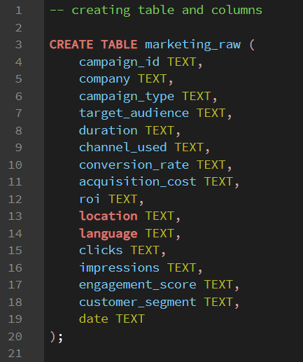

- Cleaned and transformed raw marketing data

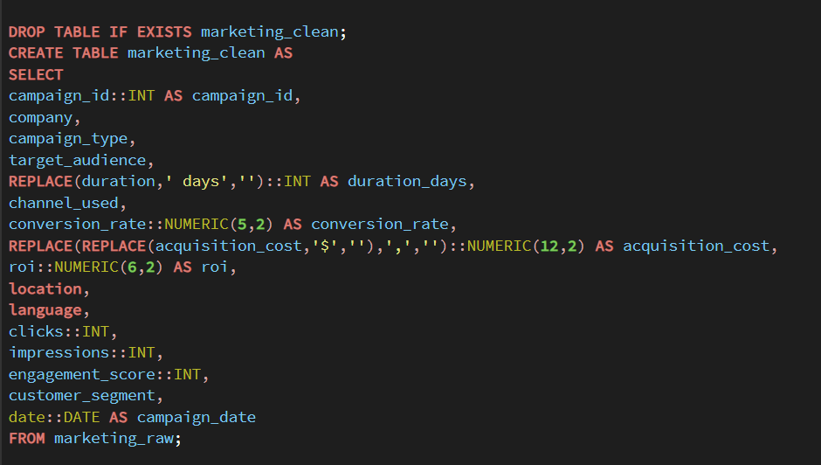

- Calculated derived metrics, including revenue and profit, using ROI and acquisition cost.

-Added revenue column

-Calculated Total revenue
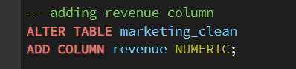
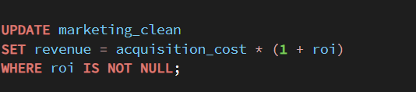
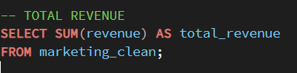
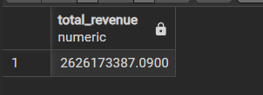

-Total marketing cost

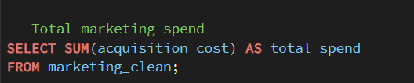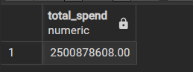

-Profit:

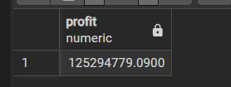

-Overall ROI in percentage:
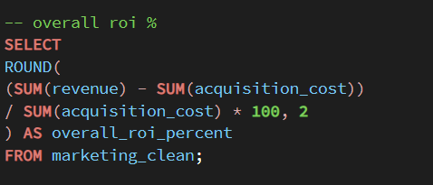
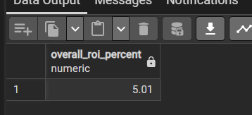

Designed SQL tables to create fact and dimension tables for efficient data modeling in Power BI.

-Created fact table:
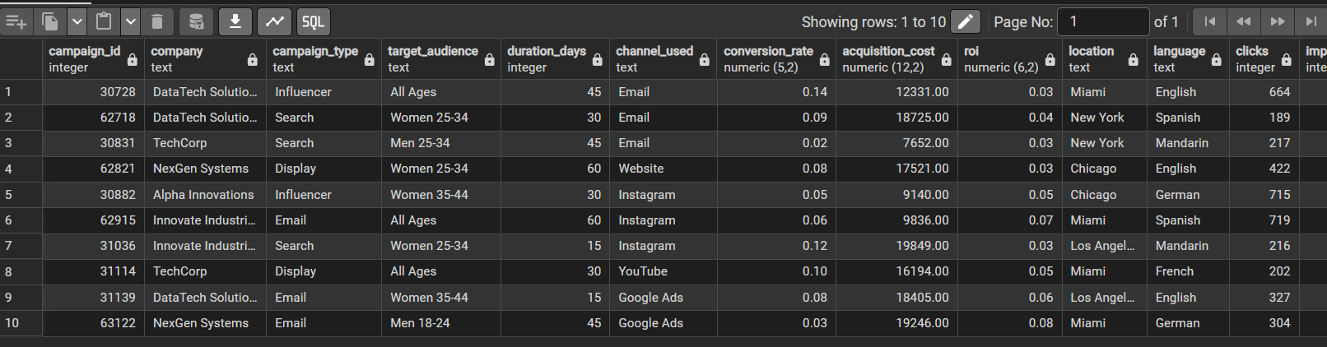
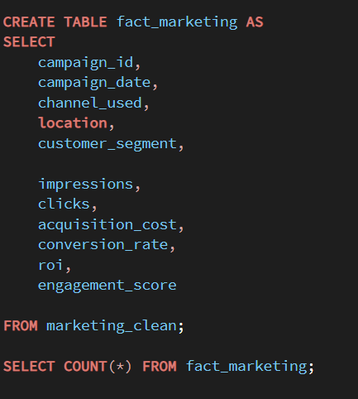

-Created Dimension tables

-Campaign dimension table:
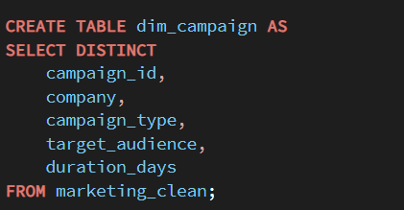
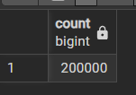

-Channel dimension table:
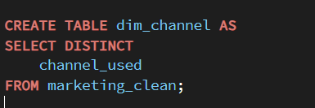
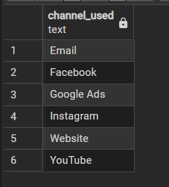

-Channel dimension table:
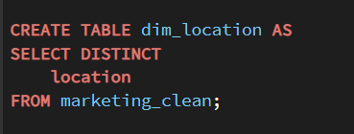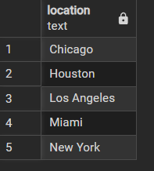

-Customer segment dimension table:
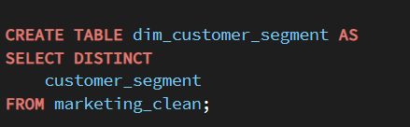
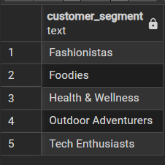

-Date dimension table:
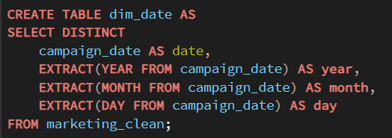
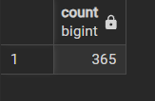

Data Analysis(SQL):

- Analyzed campaign performance across channels and locations to identify revenue trends and high-performing marketing segments.

-Channel performance :
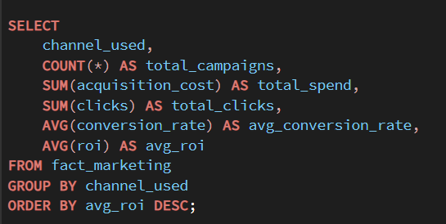
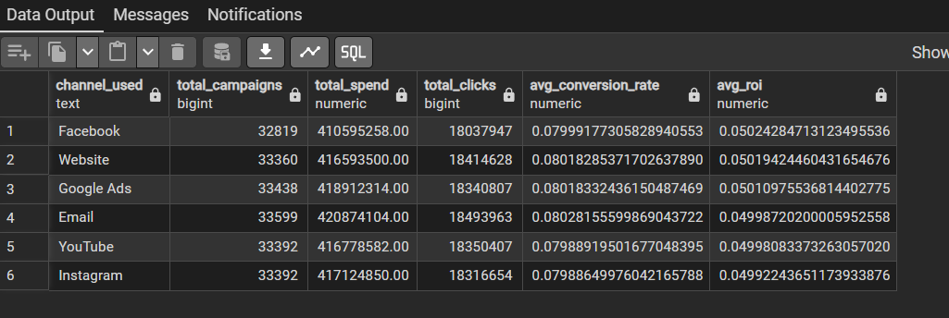

-Best performing channel:
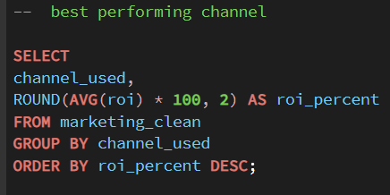
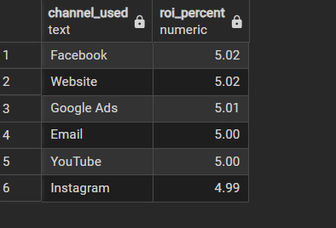
-Monthly trend analysis:
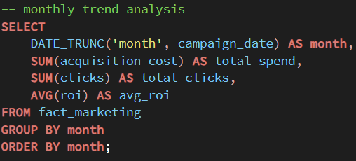
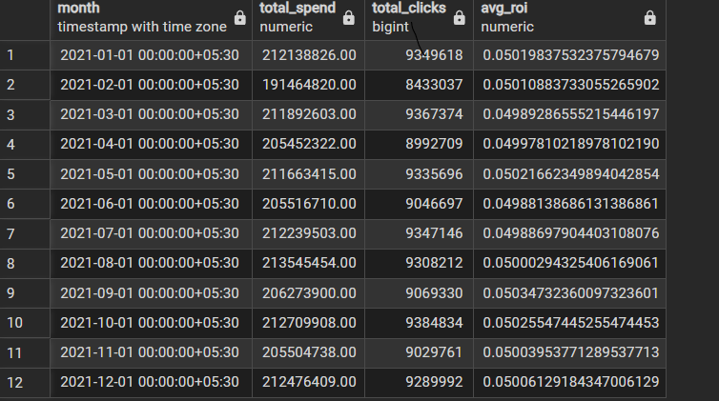

-Campaign performance by location
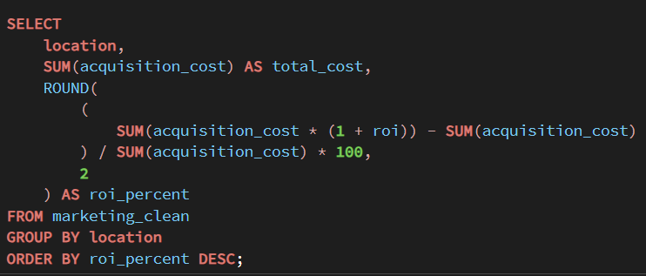
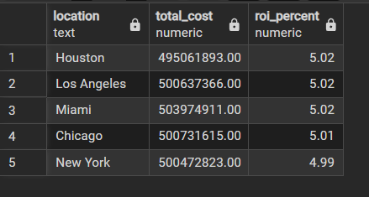

Data Modeling & Dashboard development in PowerBI:

- Developed a data model in Power BI by creating relationships between dimension and fact tables.

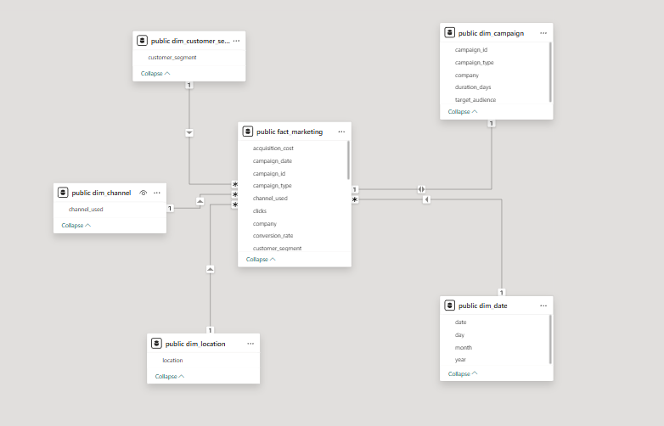
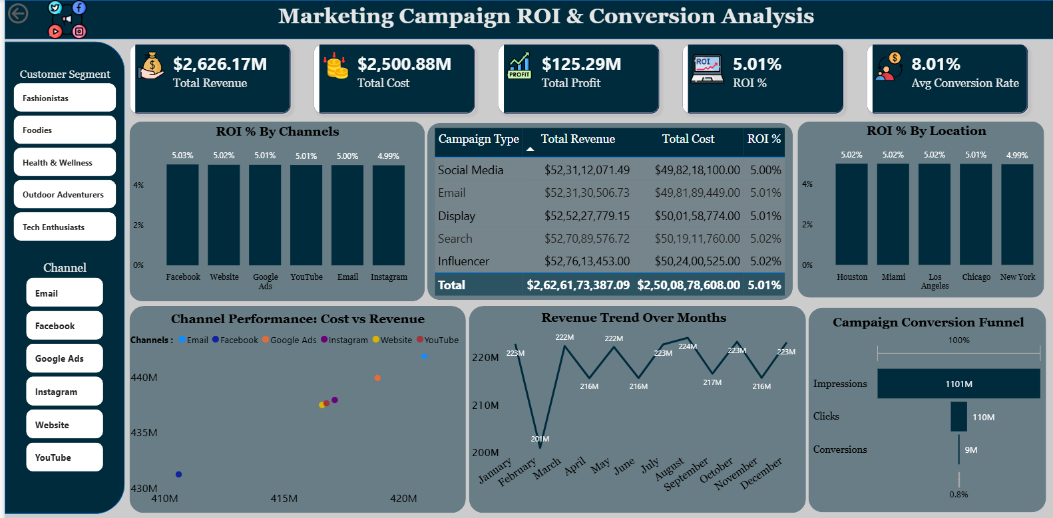
- Dashboard
Key Insights:
- The campaigns generated 110M+ clicks and about 9M conversions, showing strong reach but some drop-off before the final conversion stage.
- Performance varies by channel — some channels bring more traffic, while others generate better ROI.
- Locations like New York and Los Angeles show higher revenue and ROI compared to other cities.
- The campaigns achieved an average ROI of around 5x, meaning marketing investments are generating strong returns.
- Revenue trends over time show some ups and downs, helping identify the best periods for running campaigns.

Recommendations
- Increase investment in high-performing marketing channels that generate better ROI.
- Focus more on top-performing locations such as New York and Los Angeles to maximize returns.
- Work on improving the conversion stage of the funnel to reduce drop-off between clicks and conversions.
- Monitor campaign performance regularly to identify high-performing time periods and optimize marketing strategy.

