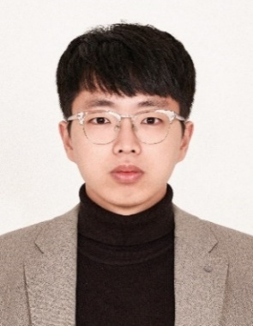  Personal Information  Nationality  South Korea  Address  307, 12 Rue du Dr Jean d'Argelos, 13100 Aix-en-Provence, France  Phone  (KR) +82-10-2991-8510  Email  yhs0365@gmail.com  Skills & Experience  Programming Language  - MATLAB, C++, CUDA  - Python  Research Expertise  - SPH, PD, DEM, FEM  - Multiphysics coupling  - HPC, GPU  Commercial Tools  - ANSYS Fluent  - COMSOL  System code  - MARS  - CATHARE  Open-source  - Basilisk (CFD)  - OpenFOAM (CFD)  - Modelica (system)  - C3PO (code coupling)  Others  - Paraview (visualization)  - Linux  Language  Korean (Native)  English (Advanced)  French (Basic) |  |   Heesang Yoo, Ph.D.  EDUCATION    Ph.D. Seoul National University (SNU), Korea 2024  Dept. of Nuclear Engineering (Thermal-Hydraulics)  Advisor Prof. Eung Soo Kim  Dissertation Multiphase ALE-SPH for Versatile Approaches on Highly Viscous Corium Simulation    B.E. Seoul National University (SNU), Korea 2017  Dept. of Nuclear Engineering  WORK EXPERIENCE    Postdoc. French Alternative Energies 2024.11 ~ present  and Atomic Energy Commission (CEA) Cadarache, France  Aff. CEA/DES/IRESNE/SESI/LEMS  (Laboratory of Systems Studies and Modeling)  Advisor. Dr. Claire Vaglio-Gaudard  - Multiphysics Coupling of APOLLO3 and CATHARE3 via the C3PO Platform for Analysis of CABRI Power Transients    Postdoc. Seoul National University (SNU), Korea 2024.3 ~ 2024.10  Aff. Nuclear Research Institute for Future Technology and Policy.  Advisor Prof. Eung Soo Kim  RESEARCH INTERESTS  - Development of High-Fidelity Multiphysics Simulation Tools  Development and application of GPU-accelerated particle-based solvers (SPH/PD/DEM) for large-scale multiphysics and multiphase thermal-fluid phenomena.  - Advanced Computational Methods for Coupled Multiphysics Systems  Development of hybrid meshless–mesh-based numerical methods and scalable HPC frameworks for strongly coupled fluid–structure–thermal interactions.  - Multi-Scale and System-Level Energy Systems Analysis  Multi-scale modeling and integrated system-level analysis of advanced energy infrastructures, including SMR systems and high-density data center cooling.  - Advanced Thermal Management for High-Power Applications  Design and optimization of next-generation two-phase cooling technologies using high-fidelity simulations and thermos-economic assessment.
HONORS
- Songwon–Kim Young-Hwan Scholarship (2014–2018), Seoul National University, Korea.
- Best Poster Award (First Author, Presenter), Transactions of the Korean Nuclear Society (KNS) Autumn Meeting, Yeosu, Korea, 2018.
- Best Paper Award (Co-author), Transactions of the Korean Nuclear Society (KNS) Autumn Meeting, Gyeongju, Korea, 2023.
- Best Paper Award (First Author, Presenter), Transactions of the Korean Nuclear Society (KNS) Spring Meeting, Jeju, Korea, 2024.
- Best Paper Award (Co-author), 21st International Topical Meeting on Nuclear Reactor Thermal Hydraulics (NURETH-21), Busan, Korea, 2025.

MAJOR RESEARCH ACHEIVEMENTS
- [Journal Paper] Yoo, H. S, & Kim, E. S.* (2024). Numerical investigation of Spreading Phenomena of Molten Corium using EISPH method. Nuclear Engineering and Technology, 57(4), 103301. (2023-JCR-IF: 2.6, Nuclear Science & Technology Q1(7/41))
- Role: First author; Developed and applied the EISPH framework for severe accident analysis, performed large-scale simulations of corium spreading, and wrote the manuscript.

- [Journal Paper] Yoo, H. S,, et al. (2024). Comparative study of WCSPH, EISPH and Explicit Incompressible-Compressible SPH (EICSPH) for Multi-Phase Flow with High Density Difference. Journal of Computational Physics, 112930. (2024-JCR-IF: 3.8, Physics & Mathematical Q1(2/61))
- Role: First author; Designed comparative framework, implemented three SPH solvers, evaluated multiphase benchmarks with high density ratios, and led manuscript writing.

- [Journal Paper] Yoo, H. S, & Kim, E. S.* (2025). Coupled EISPH–OSPD Framework for Modeling Hydroelastic Response and Brittle Fracture. Computational Mechanics, 1-35. (2024-JCR-IF: 3.8, Interdisciplinary Applications & Mathematical Q1(16/136))
- Role: First author; Developed EISPH-OSPD scheme, optimized GPU parallelization, and demonstrated efficiency for various hydrodynamic problems with elastic-brittle deformation.

- [Journal Paper] Yoo, H. S, et al. (2023). A simple Eulerian–Lagrangian weakly compressible smoothed particle hydrodynamics method for fluid flow and heat transfer. International Journal for Numerical Methods in Engineering, 124(4), 928-958. (2024-JCR-IF: 2.9, Interdisciplinary Applications & Mathematical Q1(26/136)) (*Cover)
- Role: First author; Proposed a new Eulerian–Lagrangian WCSPH scheme, implemented the solver, conducted benchmark validations, and prepared the manuscript.

- [Journal Paper] Kim, S. J, Yong, H, J., Yoo, H. S.* & Park, I. W,* (2026). From Water to Dielectric Fluids: Pool Boiling Research under Pressure and Subcooling for Next-Generation Cooling. Renewable and Sustainable Energy Reviews (Accepted) (2024-JCR-IF: 16.3, Green & Sustainable Science & Technology Q1(26/136))
- Role: Corresponding author (led scientific direction); Conceptualization, methodological framework design, supervision, original draft preparation, and final manuscript revision
Research Focus Areas
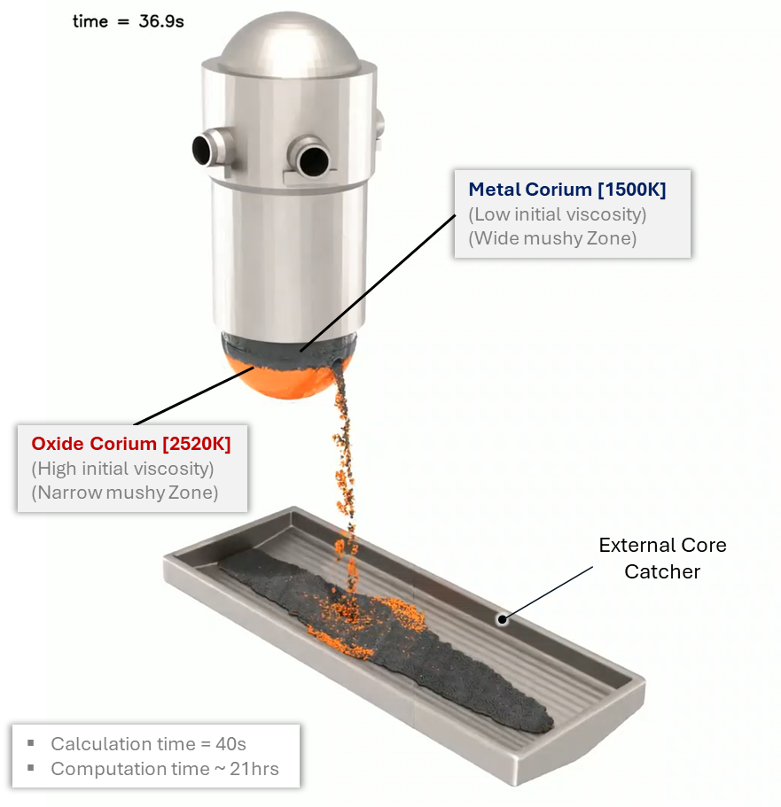 | High-Fidelity Multiphysics Thermal-Fluid Modeling  - Development of high-fidelity particle-based CFD methodologies for multiphase flow, phase-change phenomena, and conjugate heat transfer under extreme thermal-fluid conditions.  - Development of large-scale multiphysics simulation platforms for high-resolution transient analysis of strongly coupled nonlinear systems.  - Application of scalable computational frameworks to complex industrial and energy systems.  Related Publications: (J14) ~ (J2)
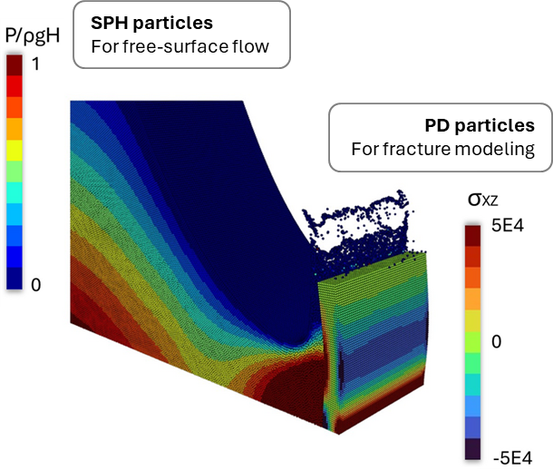 | Advanced Computational Methods for Multiphysics Problem  - Development of coupled meshless/meshless and meshless/mesh-based numerical methods for fluid–structure–thermal interaction and strongly coupled multiphysics simulations.  - Design and implementation of GPU-accelerated high-performance computing (HPC) strategies for scalable large-scale transient analysis.  - Development of reduced-order modeling (ROM) and data-driven acceleration techniques for particle-based multiphysics simulations.  Related Publications: (J14), (J12), (J4)
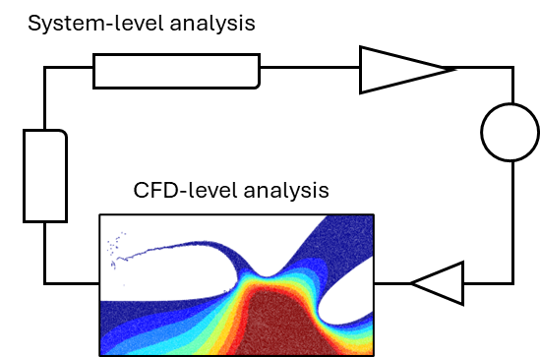 | Multi-Scale and System-Level Energy Systems Analysis  - System-level thermal-fluid analysis of large-scale energy infrastructures, including advanced nuclear reactor concepts and high-efficiency power cycles.  - Safety analysis and performance evaluation of nuclear reactors under steady-state and transient conditions  - Development of multi-scale simulation frameworks through coupling of system-level transient codes with three-dimensional CFD tools for integrated system analysis  Related Publications: (J18), (C15), (C9), (C8)
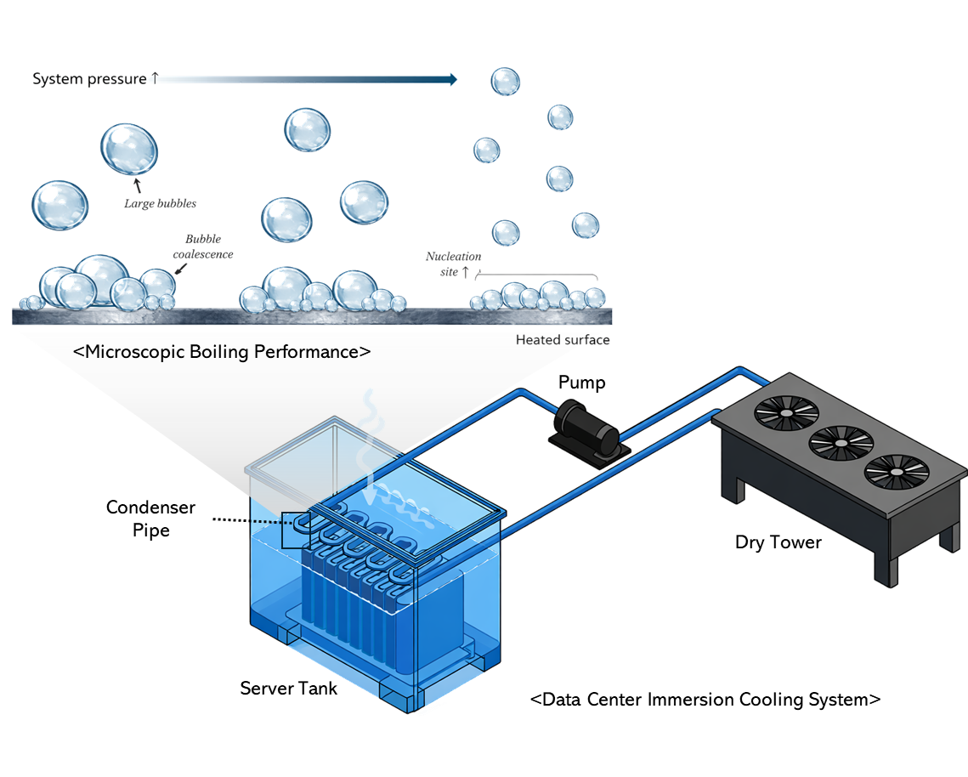 | Advanced Thermal Management for High-Power Systems  - Development of next-generation two-phase cooling technologies for AI-driven data centers and high-power computing systems.  - Integration of high-fidelity numerical simulations, critical review of heat transfer performance, and thermos-economic analysis to enable optimized system-level thermal design.  Related Publications: (J15), (J16), (C14)

JOURNAL PUBLICATIONS
(J15) | Kim, S. J, Yong, H, J., Yoo, H. S.* & Park, I. W,* (2026). From Water to Dielectric Fluids: Pool Boiling Research under Pressure and Subcooling for Next-Generation Cooling. Renewable and Sustainable Energy Reviews (Accepted) (2024-JCR (2.4%, IF: 16.3))
(J14) | Ahn, Y. L., Choi, N. J., Yoo, H. S., & Kim, E. S. (2026). Dynamic Load Balancing for Multi-GPU Smoothed Particle Hydrodynamics Using Two-Dimensional Staggered Domain Decomposition. advanced in engineering software (Accepted) (2024-JCR (8.9%))
(J13) | Kim, T. H., Yoo, H. S., Kim, J. W., & Kim, E. S. (2026). A Steady‐State Eulerian Smoothed Particle Hydrodynamics (SPH) Approach for Incompressible Flow and Heat Transfer Using the Semi‐Implicit Method for Pressure‐Linked Equations (SIMPLE) Algorithm. International Journal for Numerical Methods in Engineering, 127(1), e70255.
(J12) | Yoo, H. S., & Kim, E. S.* (2025). Coupled EISPH–OSPD framework for modeling hydroelastic response and brittle fracture. Computational Mechanics, 1-35. (2024-JCR (11.4%))
(J11) | Yoo, H. S. & Kim, E. S.* (2025). Comparative Evaluation of Matrix-Free Implicit Viscosity Solvers for GPU-Accelerated SPH Simulation of Highly Viscous Fluids. Computational Particle Mechanics, 1-24.
(J10) | Kim, J. H, Yoo, H. S, Jo, Y. B, Park, S. S, & Kim, E. S.* (2025). GPU-Parallelized SPH Solver for Accurate Simulation of Shaped Charge Jet Penetration in Concrete Structures. International Journal of Fracture , 249(3), 52,
(J9) | Yoo, H. S. & Kim, E. S.* (2024). Numerical investigation of Spreading Phenomena of Molten Corium using EISPH method. Nuclear Engineering and Technology, 57(4), 103301.
(J8) | Kim, J., Yoo, H. S., Jo, Y. B., & Kim, E. S.* (2024). Simulation of Shockwave Propagation Characteristics in Nuclear Reactor Cavity during External Steam Explosion using Unified SPH. Nuclear Engineering and Technology 57.4 (2025): 103274.
(J7) | Ahn, Y. L., Yoo, H. S., Choi, N. J., & Kim, E. S.* (2024). Dynamic Load Balancing of Multi-GPU Parallelization for VULCANO VE-U7 Corium Spreading Analysis using SOPHIA. Nuclear Technology, 1-21,
(J6) | Yoo, H. S., Jo, Y. B., & Kim, E. S.* (2024). Comparative study of WCSPH, EISPH and Explicit Incompressible-Compressible SPH (EICSPH) for Multi-Phase Flow with High Density Difference. Journal of Computational Physics, 112930. (2024-JCR (2.5%))
(J5) | Yoo, H. S., Jo, Y. B., Kim, J. W., Kim, E. S.*, & Choi, T. S. (2023). A simple Eulerian–Lagrangian weakly compressible smoothed particle hydrodynamics method for fluid flow and heat transfer. International Journal for Numerical Methods in Engineering, 124(4), 928-958. (*Cover)
(J4) | Jo, Y. B., Park, S. H., Yoo, H. S., & Kim, E. S.* (2022). GPU-based SPH-DEM Method to Examine the Three-Phase Hydrodynamic Interactions between Multiphase Flow and Solid Particles. International Journal of Multiphase Flow, 153, 104125.
(J3) | Yoo, H. S., Choi, H. Y., Kim, T. H., & Kim, E. S.* (2022). Effect of wettability on the water entry of spherical projectiles: Numerical analysis using smoothed particle hydrodynamics. AIP Advances, 12(3).
(J2) | Park, S. H., Jo, Y. B., Ahn, Y., Choi, H. Y., Choi, T. S., Park, S. S., Yoo, H. S., Kim, J.H. & Kim, E. S.* (2020). Development of multi-GPU–based smoothed particle hydrodynamics code for nuclear thermal hydraulics and safety: potential and challenges. Frontiers in Energy Research, 8, 86.
(J1) | Yoo, H. S., Yoo, S. H., & Kim, E. S.* (2019). Heat transfer enhancement in dry cask storage for nuclear spent fuel using additive high density inert gas. Annals of Nuclear Energy, 132, 108-118.

- In Preparation & Under Review
(J18) | Yoo, H.S., Debove, J., Vaglio-Gaudard. C*., Garcia-Cervantes. E.-Y., Jaboulay. J.-C., & Labit. J.-M.. (2026). Implementation of APOLLO3–CATHARE3 Multiphysics Coupling on the C3PO Platform for CABRI Power Transient Studies. Annals of Nuclear Energy (In preparation)
(J17) | Kim, J.W, Yoo, H. S, & Kim, E. S.* (2026). A coupled EISPH-TLSPH method for the fluid-structure interaction of hydroelasticity with quasi-brittle fracturee. (Under Review)
(J16) | Kim, S. J, Song, S, M., Park, H, S., Yoo, H, S. & Park, I. W,* (2026). Effects of Surface Characteristics of Oxidized Zircaloy-4 on Pool Boiling Heat Transfer. International Communications in Heat and Mass Transfer (Under Review – Major Revision)

CONFEREENCE PRESENTATIONS
(C15) | Yoo, H. S., Debove, J., Vaglio-Gaudard. C*., Garcia-Cervantes. E.-Y., Jaboulay. J.-C., & Labit. J.-M.. (2026). Multiphysics Coupling of APOLLO3 and CATHARE3 via the C3PO Platform for Analysis of CABRI Power Transients, International Conference on the Physics of Reactors (PHYSOR 2026), Turin, Italy, April 19-23, 2026. (Accepted)
(C14) | Kim, M. H., Yoo, H. S., & Park, I. W. (2025) Numerical Analysis of Melting and Interfacial Flow in a Direct-Contact Latent Heat Storage System Reflecting the Marangoni Effect, Korean Society for Fluid Machinery (KSFM), Jeju, Korea, December 4-5, 2025 (in Korean)
(C13) | Kim, E. S.*, Ahn, Y., Kim, J.-W., Kim, J. H., Park, J., Jo, Y. B., & Yoo, H. S. (2025). Particle-Based Approaches to Multiphysics Simulation in Nuclear Safety, 21th International Topical Meeting on Nuclear Reactor Thermal Hydraulics (NURETH 21), Busan, Korea, August 31 - September 5, 2025.
(C12) | Kim, J. W., Yoo, H. S., Lee, T. H., Ahn, Y., Kwon, M. C., & Kim, E. S.* (2025) A Smoothed Particle Hydrodynamics Model for Safety Assessment of the Ex-vessel Core Catcher under Reactor Vessel Failure, 21th International Topical Meeting on Nuclear Reactor Thermal Hydraulics (NURETH 21), Busan, Korea, August 31 - September 5, 2025. (Best Paper)
(C11) | Kim, J. W., Yoo, H. S., Lee, T. H., Ahn, Y., Kwon, M. C., & Kim, E. S.* (2024) Numerical Investigation on the Safety Assessment of an Ex-vessel Core Catcher under Large-break Reactor Vessel Failures Using Smoothed Particle Hydrodynamics, The Eleventh Korea-Japan Symposium on Nuclear Thermal Hydraulics and Safety, Seoul, Korea, November 10-13, 2024
(C10) | Yoo, H. S., & Kim, E. S.* (2024). Numerical Investigation of Corium Spreading Phenomena using Smoothed Particle Hydrodynamics, Transactions of the Korean Nuclear Society Spring Meeting, Jeju, Korea, May 9-10, 2024 (in Korean) (Best Paper)
(C9) | Park, K. J., Kim, T. H., Yoo, H. S., Jo, Y. B., & Kim, E. S.* (2024). Dynamic Modeling for 20 kWe Heat Pipe Fission Battery with Dual Power Conversion System, Transactions of the Korean Nuclear Society Spring Meeting, Jeju, Korea, May 9-10, 2024 (in Korean)
(C8) | Park, K. J., Kim, T. H., Yoo, H. S., Kim, E. S.*, & Jo, Y. B (2023). Dynamic Modeling of Free Piston Stirling Generator for Micro Nuclear Reactors, Transactions of the Korean Nuclear Society Autumn Meeting Gyeong-Ju, Korea, October 25-27, 2023 (in Korean) (Best Paper)
(C7) | Yoo, H. S., Jo, Y. B., & Kim, E. S.* (2022) GPU-accelerated Explicit Incompressible-Compressible SPH for multi-phase flow with large density difference, Proceedings of the SPHERIC Workshop, Piazza Roma, Catania. Italy
(C6) | Yoo, H. S., & Kim, E. S.* (2021) Development of an Eulerian–Lagrangian Coupling Method Using SPH, Proceedings of the KSCFE Conference, Seoul National University Siheung Campus, Korea. (in Korean)
(C5) | Yoo, H. S., & Kim, E. S.* (2021) Comparative Analysis of Recent Pressure-Noise Reduction Methods for Free-Surface Flow and Fluid–Structure Interaction Using SPH, Proceedings of the KSOE Conference, Busan, Korea. (in Korean)
(C4) | Yoo, H. S., Kim, T. H., & Kim, E. S.* (2021). Numerical Simulation on Spreading and Impact Behavior of a Single Droplet Using Smoothed Particle Hydrodynamics. Transactions of the Korean Nuclear Society Virtual Autumn Meeting, October 21-22, 2021 (in Korean)
(C3) | Yoo, H. S., Yoo, S. H., & Kim, E. S.* (2018) Heat Transfer Enhancement of Dry Cask Storage System Using Binary Helium and Heavy Inert Gas Mixture, The Eleventh Korea-Japan Symposium on Nuclear Thermal Hydraulics and Safety, Busan, Korea, November 18-21, 2018
(C2) | Yoo, H. S., Kim, E. S.*, & Yoo, S. H. (2018). Thermal Performance Enhancement of Dry Cask Storage System Using Helium-Based Binary Gaseous Mixture. Transactions of the Korean Nuclear Society Autumn Meeting, Yeosu, Korea, October 25-26, 2018 (in Korean) (Best Poster)
(C1) | Song, M. S., Yoo, H. S., Kim, J. H., & Kim, E. S.* (2017). The investigation of flow characteristics in 3-pin wire-wrapped fuel bundle using laser-based measurement techniques. 17th International Topical Meeting on Nuclear Reactor Thermal Hydraulics (NURETH 17), Xi'an, China, September 3–8, 2017

SOFTWARE DEVELOPMENT
- SOPHIA. a Lagrangian-based HPC-CFD code for versatile thermal-hydraulics and nuclear safety application
, NEA-1911 (https://www.oecd-nea.org/tools/abstract/detail/nea-1911/) PI: Kim, E. S.
Co-Developers: Jo, Y. B., Park, S. H., Choi, H. Y., Choi, T. S., Park, S. S., Yoo, H. S., Ahn, Y. L., Kim, J. H, Lee., T. H, Chae, H., Kim, J. W., Park, J. R., Kim, D. H.

PROFESSIONAL SERVICE
- Technical Review:
The Korean Hydrogen & New Energy Society, Korean Nuclear Society,
Ocean Engineering, Nuclear Engineering and Technology,
Physics of Fluids

LEADERSHIP & EXTRACURRICULAR ACTIVITIES
- President, SNU Global Outreaching & Education Club (2015)
Organized academic exchange events and coordinated volunteer programs with international students.
TEACHING & SUPERVISION EXPERIENCE
- Undergraduate Thesis Supervision Tae Hwan Kim (B.S. thesis, 2020) – awarded Best Thesis Prize
- Teaching Assistant
  - Engineering of Energy Systems (2017)
  - High-Performance Particle Methods for Thermal–Hydraulic Analysis (2021)

LIST OF REFERENCES
- Prof. Eung Soo Kim 🎓 (Dissertation Supervisor)
Professor, Department of Nuclear Engineering, Seoul National University
Gwanak-gu, Gwanak-ro, Seoul, Republic of Korea
✉︎ Email: kes7741@snu.ac.kr
- Dr. Claire Vaglio-Gaudard 🔬 (Current Advisor)
Senior Expert & Research Engineer, CEA Cadarache
Cadarache, 13108 Saint-Paul-lès-Durance, France
✉︎ Email: claire.vaglio-gaudard@cea.fr
- Prof. Il-Woong Park 🔬 (Collaborator)
Multiphase Flow and Thermal Engineering
Department of Mechanical Engineering, Inha University
✉︎ Email: ilwoongpark@inha.ac.kr
- Prof. Qiao Wu 🎓 (Collaborator)
Director of NuScale Integral System Testing program
School of Nuclear Science and Engineering, Oregon State University
Corvallis, OR 97441, USA
✉︎ Email: Qiao.Wu@oregonstate.edu
- Dr. Nam-il Tak 🔬 (Dissertation Committee)
Principal Research, Department of High Temperature Reactor, KAERI
111, Daedeok-daero 989beon-gil, Yuseong-gu, Daejeon, Republic of Korea
✉︎ Email: takni@kaeri.re.kr

