BUJUMBURA INTERNATIONAL UNIVERSITY
Faculty of BST — Software Engineering
Bachelor 2 — Course: Vue.js — Academic year 2025–2026

PROJECT REPORT
Restaurant Management Web Application
Frontend Implementation
Vue 3 · Options API · Pinia · Vue Router · Axios · Vue I18n

Student: Jerome CIRHULWIRE AJuwa
Level: Bachelor 2
Frontend repository: github.com/monamijer/restaurant-frontend
Submission date: November 6, 2026
Acknowledgements
I would like to thank my Vue.js lecturer for the course and for the guidance that made this project possible, and Bujumbura International University and the Faculty of Software Engineering (BST) for the learning environment in which it was carried out. I also thank my classmates for their feedback during the development of the application.
Abstract
This report presents the frontend of a restaurant management web application, developed as the project for the Vue.js course of the Bachelor 2 programme in Software Engineering. The application covers the journey of a restaurant customer (menu, cart, table scan, waiting queue, reservations, checkout, invoices and notifications) and provides interfaces for restaurant staff (order board, walk-in orders, reservations, queue, tables) and administrators (dashboard, categories, menu, settings, users, reports). It is a single-page application that communicates with a Django REST API.
The frontend is built with Vue 3.5 and the Options API, Vite 8, Vue Router 5, Pinia 4, Axios 1.20 and Vue I18n 11. No UI framework is used: the interface relies on custom CSS design tokens, scoped component styles, self-hosted fonts and light and dark themes. Authentication keeps the short-lived access token in memory and the refresh token in the browser storage, and a single Axios interceptor renews expired sessions once for all concurrent requests. Route guards control access by role, and the interface is available in English and French.
The code base contains 80 Vue single-file components, 8 Pinia stores and 22 API service modules. It is verified by 735 automated tests in 85 files (Vitest, Vue Test Utils and jsdom), all passing at the time of writing, with a clean ESLint run and a successful production build. Card and mobile-money payments are simulated, and the application has not been deployed to a production environment. The report describes the architecture, the implementation of each module, the testing strategy, the limitations and the possible improvements.
Keywords: Vue.js, Options API, Pinia, Vue Router, Axios, JWT, internationalisation, single-page application, restaurant.
Table of Contents
Chapter 1 — General Introduction 1
1.1 Background 1
1.2 Problem statement 1
1.3 Project objectives 1
1.4 General objective 1
1.5 Specific objectives 1
1.6 Scope of the project 2
1.7 Methodology 2
1.8 Organisation of the report 2
Chapter 2 — Project Overview and Requirements 3
2.1 Project description 3
2.2 Business context 3
2.3 Identified problems 3
2.4 Functional requirements 3
2.5 Non-functional requirements 4
2.6 User roles 4
2.7 Main application features 4
2.8 User workflows 5
Chapter 3 — Technologies and Development Environment 6
3.1 JavaScript 6
3.2 Vue.js 3 6
3.3 The Options API 6
3.4 Vite 7
3.5 Vue Router 7
3.6 Pinia 7
3.7 Axios 7
3.8 Vue I18n 7
3.9 Vitest and Vue Test Utils 8
3.10 CSS architecture 8
3.11 Development environment 8
Chapter 4 — Frontend Architecture and Design 9
4.1 Frontend architecture overview 9
4.2 Project directory structure 9
4.3 Component-based architecture 10
4.4 Vue Options API implementation 10
4.5 Component communication 11
4.6 Vue Router configuration 12
4.7 Route protection and navigation guards 13
4.8 Pinia state management 14
4.9 API service architecture 15
4.10 Authentication and token management 16
4.11 Internationalisation architecture 17
4.12 Styling and design system 18
4.13 Error handling and notifications 18
Chapter 5 — Implementation of the Application 20
5.1 Customer interface 20
5.1.1 Home page 20
5.1.2 Menu and dish details 20
5.1.3 Shopping cart 20
5.1.4 Table scanning 21
5.1.5 Queue management 21
5.1.6 Reservations 21
5.1.7 Checkout and simulated payment 21
5.1.8 Orders, tracking, invoices and notifications 22
5.1.9 Accounts and authentication pages 22
5.2 Staff interface 22
5.3 Administration interface 23
5.4 Cross-cutting implementation aspects 24
Chapter 6 — Testing and Quality Assurance 25
6.1 Testing strategy 25
6.2 Unit testing 25
6.3 Component testing 25
6.4 Store testing 25
6.5 Service testing 25
6.6 Integration testing 26
6.7 Test execution results 26
6.8 Code quality and linting 26
6.9 Known limitations of the quality process 27
Chapter 7 — Results, Limitations and Future Improvements 28
7.1 Achieved objectives 28
7.2 Implemented functionality 28
7.3 Technical achievements 28
7.4 Current limitations 28
7.5 Future improvements 29
7.6 Lessons learned 29
General Conclusion 30
References 31
Appendices 32
Appendix A — Configuration excerpts 32
A.1 ESLint rules enforcing the architecture (eslint.config.js) 32
A.2 Environment and scripts 32
Appendix B — Test helper 32
Appendix C — Verified project statistics 32
Appendix D — Screenshots to capture 33

List of Figures
Figure 1. Home page of the application (English, light theme) 5
Figure 2. Overall frontend architecture 9
Figure 3. Component interaction (example of the menu page) 12
Figure 4. Decision flow of the global navigation guard 13
Figure 5. Pinia stores and their main consumers 15
Figure 6. API request and authentication flow 17
Figure 7. Menu page with category filter and search 20
Figure 8. Checkout page with the simulated payment panel 22
Figure 9. Order tracking page with the status timeline 22
Figure 10. Staff order board 23
Figure 11. Administration dashboard 24
List of Tables
Table 1. Functional requirements 3
Table 2. Non-functional requirements 4
Table 3. User roles and their areas 4
Table 4. Frontend technology stack (resolved versions) 6
Table 5. Directory structure of the frontend repository 9
Table 6. Route organisation 12
Table 7. Pinia stores and responsibilities 14
Table 8. Staff views 23
Table 9. Administration modules 24
Table 10. Verified quality results 26
Table 11. Test files by group 26
Table 12. Assessment of the specific objectives 28
Table 13. Environment variable and scripts 32
Table 14. Verified statistics of the frontend repository 32
List of Abbreviations
Abbreviation | Meaning
ADR | Architecture Decision Record
API | Application Programming Interface
CORS | Cross-Origin Resource Sharing
CRUD | Create, Read, Update, Delete
CSS | Cascading Style Sheets
CSV | Comma-Separated Values
DOM | Document Object Model
HTTP | Hypertext Transfer Protocol
i18n | Internationalisation
JSON | JavaScript Object Notation
JWT | JSON Web Token
QR | Quick Response (code)
REST | Representational State Transfer
SPA | Single-Page Application
UI | User Interface
URL | Uniform Resource Locator
WCAG | Web Content Accessibility Guidelines
XSS | Cross-Site Scripting

Chapter 1 — General Introduction

1.1 Background
Restaurants handle several flows at the same time: customers waiting for a table, tables to be assigned, orders passing from the dining room to the kitchen, payments, and the daily figures that the manager needs. When these flows are managed on paper or through informal communication, information is lost, customers wait without knowing for how long, and staff duplicate work.
A web application can bring these flows together. A customer can browse the menu on a phone, join the waiting queue, reserve a table, place an order and follow its progress. Staff see incoming orders in real time, and the manager reads reports. The project described in this report is the frontend of such a system. It runs in the browser and communicates with a separate backend through a REST API.
The project was carried out for the Vue.js examination of the Bachelor 2 programme at Bujumbura International University. The course requires Vue 3 and prohibits the use of a UI framework, so the project is also an exercise in building a complete, coherent interface from first principles.

1.2 Problem statement
Restaurant operations suffer from the following problems, which a software system can reduce:
- Customers do not know how long they will wait for a table and cannot reserve in advance without a telephone call.
- Orders are taken verbally or on paper, which causes errors and delays between the dining room and the kitchen.
- Staff cannot see the state of all orders and tables on a single screen.
- Managers have no immediate access to sales figures, popular dishes or user management.
- Customers and staff use different languages, and an interface that is difficult to use on a phone excludes many customers.
The question addressed by this report is: how can a Vue.js single-page application, built without a UI framework, provide a maintainable, accessible and tested interface for these three groups of users?

1.3 Project objectives

1.4 General objective
To design and implement the frontend of a restaurant management application with Vue 3 and the Options API, connected to a REST backend, covering customer, staff and administration needs.

1.5 Specific objectives
- Organise the interface as reusable components and lazily loaded views.
- Manage shared state with Pinia and keep request-specific state local to components.
- Control navigation and access with Vue Router, navigation guards and role metadata.
- Communicate with the API through a single Axios instance with automatic token renewal.
- Provide the interface in English and French with Vue I18n.
- Build a consistent, accessible, responsive design system with custom CSS, without any UI framework.
- Verify the application with automated unit, component, service and routing tests.

1.6 Scope of the project
The work covers the frontend repository (restaurant-frontend). The backend repository (restaurant-backend, Django REST Framework) is the data and business-rule provider; it is discussed only where required to explain the API contract, authentication and data exchange. It is not the subject of this report.
The scope has deliberate limits. Payments by card and mobile money are simulated by the backend; no real payment gateway is connected. The application has not been deployed to a public production server and is run locally. The in-app scanning of QR codes with the camera is not implemented: a table QR code opens the application through a URL. These limits are repeated where they matter in the following chapters.

1.7 Methodology
The application was developed incrementally, one feature at a time, from the foundation (configuration, router, API layer, design tokens) towards the customer features, and then the staff and administration modules. The repository history contains 92 commits between 14 October and 5 November 2026. Several rules were fixed early and applied throughout:
- Architecture decisions were recorded and enforced where possible: the Options API and the absence of v-html are enforced by ESLint rules, and the equality of the English and French translation keys is enforced by a test.
- Every feature comes with tests. The checks npm run lint, npm test and npm run build are run before a change is committed.
- The backend is the authority. The frontend never computes or sends a price and never decides on its own who may perform an action; it only improves the experience.
- Mobile-first design with CSS design tokens shared by all components.
For this report, the source code was examined directly: the router, stores, services, views and tests were read, and the test suite, the linter and the production build were executed. Where the project documentation and the code differed, the code was taken as the reference.

1.8 Organisation of the report
Chapter 2 describes the project and its requirements. Chapter 3 presents the technologies used and their role in the application. Chapter 4, the central chapter, explains the frontend architecture: components, routing, state, API access, authentication, internationalisation and styling. Chapter 5 describes the implemented modules. Chapter 6 presents the testing strategy and the verified results. Chapter 7 discusses the results, the limitations and future improvements. A general conclusion, the references and the appendices follow.

Chapter 2 — Project Overview and Requirements

2.1 Project description
The application is a restaurant table, queue and online ordering system. Its frontend is a Vue 3 single-page application that gives each type of user a dedicated set of pages. Customers can consult the menu without an account; creating an account unlocks ordering, reservations, invoices and notifications. Staff and administrators sign in with accounts that carry a role, and they reach protected areas under the /staff and /admin paths.

2.2 Business context
The system models a single restaurant. The restaurant's name, currency, time zone and opening rules are stored as settings on the backend and displayed by the frontend (the restaurant store). Customers may dine in, take away or request delivery. A dine-in customer may be linked to a table by scanning the QR code placed on it. Staff receive orders and move them through preparation, and the administrator manages the catalogue, the users and the settings.

2.3 Identified problems
From the problem statement, the following needs were derived: a public, searchable menu; an ordering flow that works on a phone; a visible queue with a position and an estimated wait; reservations by date, party size and time slot; order tracking for customers; an order board for staff; and management and reporting tools for administrators.

2.4 Functional requirements
Table 1. Functional requirements
Id | Requirement | Actor
FR1 | Browse and filter the menu by category, search text and page. | Visitor
FR2 | Manage a cart (quantities, notes) that survives a page reload. | Visitor
FR3 | Register, sign in, sign out, recover a forgotten password, change the password and edit the profile. | Visitor, client
FR4 | Link a table through a QR-code URL and place dine-in orders for it. | Client
FR5 | Join and leave the waiting queue; view queue length and estimated wait. | Visitor, client
FR6 | Search free time slots, create and cancel reservations. | Client
FR7 | Check out an order (dine-in, takeaway, delivery) and pay it with a simulated gateway. | Client
FR8 | Follow an order in real time and read invoices and notifications. | Client
FR9 | Receive and advance orders, take walk-in orders, confirm cash payments. | Staff
FR10 | Manage reservations, queue entries and tables, and download table QR codes. | Staff
FR11 | Manage categories, menu items with images, settings and users. | Administrator
FR12 | Read a dashboard and sales reports, and export them to CSV. | Administrator

2.5 Non-functional requirements
Table 2. Non-functional requirements
Quality | Requirement | How it is addressed
Maintainability | Predictable structure, one coding model. | Options API only (ESLint-enforced), one service file per backend area, shared base components.
Security | Limit the impact of stolen tokens and XSS. | Access token in memory, rotating refresh token, safeRedirect, no v-html, validated cart storage.
Accessibility | Usable by keyboard and assistive technologies. | Real buttons and links, labels, aria-live regions, focus moved on navigation, 44 px targets, contrast tests.
Responsiveness | Usable on a phone. | Mobile-first CSS with min-width media queries.
Internationalisation | English and French. | Vue I18n with 16 namespaces and a parity test.
Performance | Fast first load. | All views lazy-loaded; main bundle 275 kB (95 kB gzip).
Testability | Automated verification. | 735 tests; the network is replaced by a fake adapter.

2.6 User roles
The backend defines three roles, mirrored in src/utils/roles.js: client, staff and admin. Visitors who are not signed in have no role. The frontend uses the role to decide which links to display and which routes to allow; the backend remains the authority and checks every request again.
Table 3. User roles and their areas
Role | Landing page | Main areas
Visitor | / | Menu, cart, queue summary, scan page, sign in, register, legal pages.
Client | /client/account | Orders, reservations, invoices, notifications, profile, checkout.
Staff | /staff | Order board, walk-in order, reservations, queue, tables; also client pages.
Admin | /admin | Dashboard, categories, menu, settings, users, reports; also staff pages.

2.7 Main application features
The application has 43 route declarations, of which 28 require a signed-in user. The customer area is the largest, followed by the administration area (13 files) and the staff area (7 views). The features are described module by module in Chapter 5.

2.8 User workflows
Three workflows summarise the use of the application.
Dine-in order. The customer scans the QR code on a table; the application stores the table token for the browser session and shows a banner. The customer fills the cart from the menu and checks out; the order is created for the table. The customer follows its status on a timeline that is refreshed every ten seconds, then pays online (simulated) or at the counter.
Reservation. The signed-in customer chooses a date and a party size, the application asks the backend for free slots, the customer selects a time, and the reservation is created. It appears in the reservation list, where it can be cancelled, and staff see it in their own list.
Order processing. A staff member opens the order board, filters by status, opens an order and advances it through the sequence pending → confirmed → preparing → ready → completed. For a cash payment, the staff member confirms the receipt of the money.

SCREENSHOT PLACEHOLDER
To capture: the home page at /, signed out, showing the restaurant name and the main call to action
Figure 1. Home page of the application (English, light theme)

Chapter 3 — Technologies and Development Environment
This chapter presents the technologies of the frontend. For each one, it states what it is, why it is useful and how it is used in this project. The versions are those resolved in package-lock.json.
Table 4. Frontend technology stack (resolved versions)
Technology | Installed version | Role
Vue | 3.5.44 | Component framework
Vite (with @vitejs/plugin-vue 6.0.10) | 8.3.4 | Development server and production build
Vue Router | 5.4.0 | Client-side routing
Pinia | 4.1.0 | Shared state
Axios | 1.20.0 | HTTP client
Vue I18n | 11.4.14 | Translations
Vitest | 5.0.4 | Test runner
@vue/test-utils | 2.5.1 | Component mounting in tests
jsdom | 29.1.1 | Browser simulation for tests
ESLint (with eslint-plugin-vue 10.11.1) | 10.12.0 | Static analysis
@fontsource-variable/fraunces, /inter | 5.3.0 | Self-hosted fonts

3.1 JavaScript
JavaScript is the language of the browser and of Vue. The project uses modern JavaScript (ES modules, async/await, optional chaining) and no TypeScript. The language is used for components, stores, services and pure helpers in src/utils (money, dates, errors, roles, redirect handling). Keeping business-neutral logic in small pure functions makes it easy to test: for example, src/utils/money.js converts amounts to integer cents to avoid floating-point errors in cart totals.

3.2 Vue.js 3
Vue is a progressive framework for building user interfaces from components. Its reactivity system updates the DOM automatically when data changes, so the code describes the state and the template describes how the state is displayed. In this project Vue renders the whole interface: 80 single-file components (.vue) combine a template, a script and scoped styles. Directives such as v-if, v-for, v-model and :class express the interface declaratively, and a custom directive, v-reveal, adds a reveal-on-scroll effect. v-html is forbidden by the linter, which removes a common XSS vector.

3.3 The Options API
Vue 3 offers two ways of writing components. The Composition API organises code in functions (setup() and <script setup>); the Options API organises it in a component object with named sections: data, computed, watch, methods and lifecycle hooks such as created. This project uses the Options API exclusively. The choice is enforced by three ESLint rules (Appendix A.1), so a component written in the Composition style fails the lint check.
The reasons are practical. A component reads as a single object whose shape is predictable and searchable; Pinia stores and router helpers are connected in the same way in every file (mapState, mapActions); and tests read wrapper.vm directly. The consequence is that logic shared between components cannot be a composable function: it becomes a Pinia store, a mixin (formErrors, cartMoney) or a pure helper in src/utils.

3.4 Vite
Vite is a build tool that serves source modules directly during development and bundles them with a production build. In the project it provides the development server on port 5173 (strictPort, because the backend accepts only that origin through CORS), the @ alias for src/, hot module replacement, and the production bundle. The verified production build succeeds, splits each view into its own chunk through dynamic imports, and produces a main chunk of about 275 kB (95 kB compressed). The API address is injected at build time through the VITE_API_BASE_URL environment variable.

3.5 Vue Router
Vue Router maps URLs to views, supports nested and parameterised routes, and exposes navigation guards. The project declares 43 routes in src/router/routes.js; every view is loaded lazily, and route meta fields (layout, title key, authentication, roles) drive the page shell and the guards. Section 4.6 and 4.7 describe the configuration.

3.6 Pinia
Pinia is the official state-management library for Vue. A store holds state, getters (derived values) and actions (operations, including asynchronous ones). The project defines eight stores in the options style and consumes them with mapState and mapActions. Pinia is used only for state that is read by several routes and must remain consistent between them (Section 4.8).

3.7 Axios
Axios is an HTTP client with interceptors, request configuration and automatic JSON handling. A single configured instance (src/services/api.js) carries the base URL, the timeout, the authentication header, the transparent renewal of expired sessions and the conversion of every failure into a uniform ApiError. Twenty-two service modules build on this instance.

3.8 Vue I18n
Vue I18n provides translation functions, pluralisation and number and date formatting. The application supports English and French through 16 namespaces of messages per language, with the language switcher stored in the ui store (Section 4.11).

3.9 Vitest and Vue Test Utils
Vitest is a test runner designed for Vite projects; Vue Test Utils mounts components so that tests can interact with them; jsdom simulates a browser in Node.js. Together they run 735 tests in 85 files. Tests replace the network by a fake Axios adapter (fakeServer in tests/helpers/http.js) and mount components with the real Pinia and translations through a mountWithApp helper. Chapter 6 reports the results.

3.10 CSS architecture
The specification forbids UI frameworks, so styling is written in plain CSS: custom properties in src/assets/styles/tokens.css (typography, spacing on a 4 px grid, colours, radii, motion, target size), a small base.css with global utility classes (container, stack, cluster, muted, eyebrow, visually-hidden) and scoped styles in each component. The light and dark themes are two sets of colour values selected by a data-theme attribute on the root element. Section 4.12 details the system.

3.11 Development environment
The project requires Node.js 22.13 or later and npm. The commands npm run dev, npm run build, npm run preview, npm test and npm run lint start the development server, build and preview the production bundle, run the tests and run ESLint. The report's verification used Node.js 22 with a clean npm ci. The repository has no continuous-integration pipeline; the three checks are run manually before each commit.

Chapter 4 — Frontend Architecture and Design

4.1 Frontend architecture overview
The frontend is organised in four layers. The presentation layer (layouts, views and components) renders the interface. The routing layer decides which view is shown and whether the visitor may see it. The state layer (Pinia) holds the data that several pages share. The data access layer (services, the Axios instance and the session module) communicates with the backend. Vue I18n and the design tokens are transversal: every view uses them. Figure 2 summarises these relations as they exist in the code.
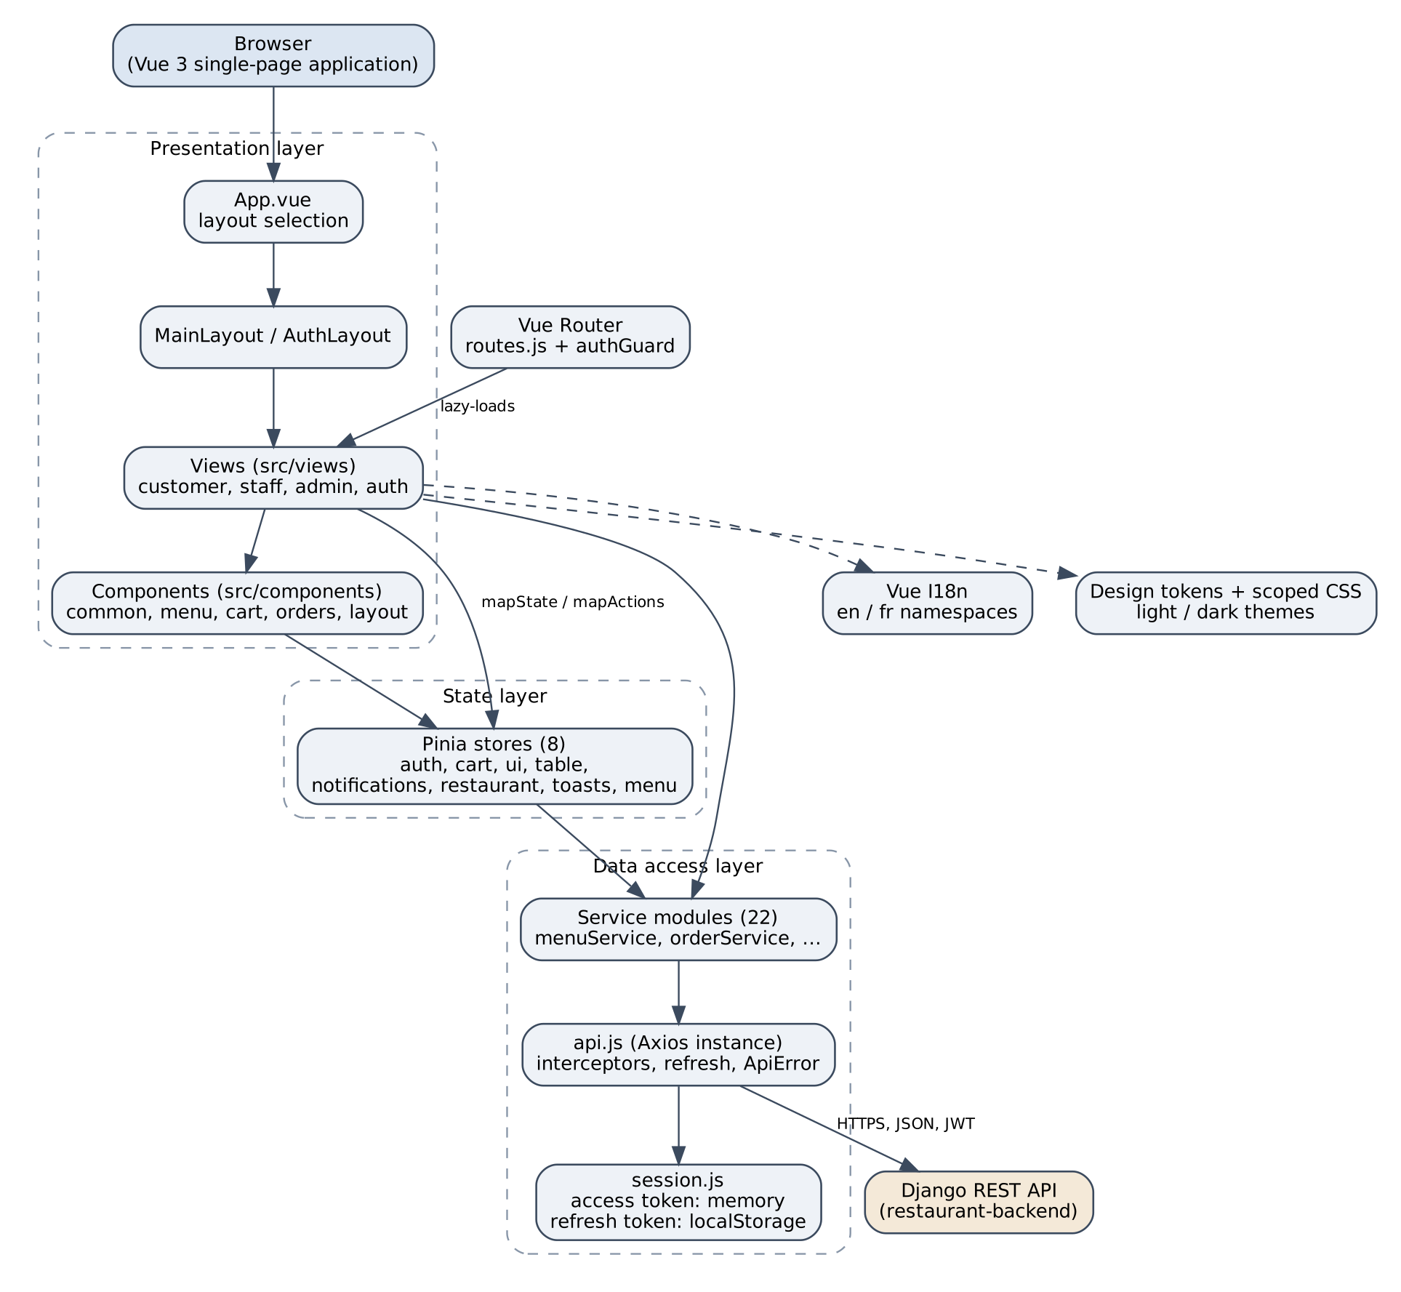
Figure 2. Overall frontend architecture
The entry point src/main.js creates the application, installs Pinia, the i18n instance and the router, and registers the session-expiry handler and the synchronisation of the cart between browser tabs. App.vue reads route.meta.layout to choose between MainLayout (header, table banner, footer) and AuthLayout (a centred card for sign-in pages), and loads the restaurant settings and the notifications when a user is signed in.

4.2 Project directory structure
Table 5. Directory structure of the frontend repository
Path | Content
src/main.js, App.vue, config.js | Entry point, root component, constants (API URL, timeouts, currency, limits, locales).
src/router/ | routes.js, guards.js, title.js (document title and focus), expiry.js.
src/store/ | Eight Pinia stores.
src/services/ | api.js, session.js and 22 service modules, one per backend area.
src/views/ | Customer pages, plus staff/, admin/, account/, auth/, errors/, legal/.
src/components/ | common (14 shared base components), layout, menu, cart, orders, home, account, staff, admin.
src/layouts/ | MainLayout.vue and AuthLayout.vue.
src/mixins/, src/directives/ | Two mixins (formErrors, cartMoney) and the v-reveal directive.
src/i18n/ | i18n setup and locales/{en,fr}/<namespace>.json.
src/utils/ | Pure helpers: money, dates, errors, roles, redirect, menu query, orders.
src/assets/styles/ | tokens.css and base.css.
tests/ | unit/ (27 files), components/ (26), views/ (25), services/ (7), helpers/, setup.js.

The folders separate responsibilities rather than technical file types alone: a view never calls Axios directly, it calls a service; a service never touches the DOM; a utility never imports a store. This rule keeps each layer testable in isolation.

4.3 Component-based architecture
The interface is composed of three kinds of components. Views correspond to routes and orchestrate a page: they read the route, call services and pass data down. Feature components (MenuFilters, MenuItemCard, OrderTimeline, PaymentPanel, QuantityStepper, and others) implement a part of a page. Base components in components/common (for example BaseButton, BaseInput, BaseModal, BaseBadge, BaseSkeleton, BasePagination, EmptyState, ConfirmDialog, ToastHost) implement the visual vocabulary of the design system and are reused by all areas. Because the base components accept props and emit events only, replacing a button style or a modal behaviour is done in one place.

4.4 Vue Options API implementation
Every component is a default-exported object. The MenuView component, abbreviated below, shows the typical structure: local state in data, derived values in computed, a watch on the route, a lifecycle hook, and methods that call the store actions and services.
Listing 4.1 — Structure of src/views/MenuView.vue (abridged)
export default {
name: 'MenuView',
data() {
return { items: [], count: 0, loading: false, failed: false,
requestId: 0 } // Only the latest request may update the page.
},
computed: {
...mapState(useMenuStore, ['categories']),
filters() { return parseMenuQuery(this.$route.query) },
},
watch: {
'$route.fullPath'() { if (this.$route.name === 'menu') this.fetchItems() },
},
created() { this.loadCategories(); this.fetchItems() },
methods: {
...mapActions(useMenuStore, ['loadCategories']),
async fetchItems() { /* see below */ },
},
}

The method fetchItems illustrates a pattern used by every list page. Each call increments requestId and compares it with the value captured at the start; an answer that arrives after a newer request was issued is ignored. This prevents an old, slow response from overwriting a newer result when the visitor changes filters quickly.
Listing 4.2 — Stale-response guard (abridged from MenuView.vue)
async fetchItems() {
const id = ++this.requestId
this.loading = true
this.failed = false
try {
const page = await menuService.items(toApiParams(this.filters))
if (id !== this.requestId) return
this.items = page.results
this.count = page.count
} catch (error) {
if (id !== this.requestId) return
this.failed = true
} finally {
if (id === this.requestId) this.loading = false
}
}

The address of the page is the source of truth for the filters: filters is a computed property derived from $route.query, and any change of the filters updates the URL, which triggers the watcher. As a result, a filtered menu page can be bookmarked, shared and navigated with the browser's back button.

4.5 Component communication
Communication follows three mechanisms. Props down, events up is used between a parent and its children: MenuView passes filters and categories to MenuFilters, which emits an update event. Pinia connects distant components, such as the header, the cart page and the checkout, which all read the cart store. The router carries state that must survive reloads and sharing (filters, page number, redirect target). Events are declared with emits, and the rule vue/require-explicit-emits makes the linter reject undeclared events; vue/require-default-prop requires defaults for optional props. Figure 3 shows the relations.
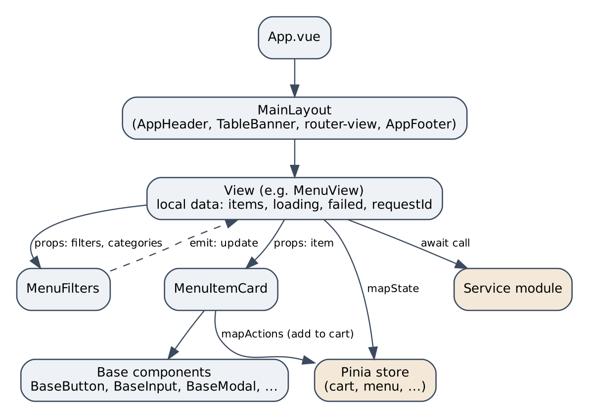
Figure 3. Component interaction (example of the menu page)

4.6 Vue Router configuration
Routes are declared as an array in src/router/routes.js. Each route has a name, a lazily imported view and a meta object that drives the application shell and the guards. The meta fields are documented in the file itself: layout (main or auth), titleKey, requiresAuth, roles and guestOnly.
Listing 4.3 — A public route in src/router/routes.js
{
path: '/menu',
name: 'menu',
component: () => import('@/views/MenuView.vue'),
meta: { layout: 'main', titleKey: 'menu.title' },
},

Table 6. Route organisation
Area | Examples of paths | Access
Public | /, /menu, /menu/:id, /cart, /queue, /scan, /privacy, /terms | Everybody
Authentication | /login, /register, forgot- and reset-password pages | guestOnly for sign-in pages
Client | /checkout, /orders, /orders/:id, /reservations, /client/account | requiresAuth
Staff | /staff, order board, walk-in order, reservations, queue, tables | roles: staff, admin
Admin | /admin, dashboard, categories, menu, settings, users, reports | roles: admin
Errors | forbidden, unknown address page | Everybody

The development-only /styleguide route is registered only when import.meta.env.DEV is true. After each navigation, title.js sets the document title from the translated titleKey and moves the keyboard focus to the main region, except when only the query string changed; this helps screen-reader and keyboard users to notice that the page changed. Page titles also follow the current language.

4.7 Route protection and navigation guards
A single global guard, authGuard, runs before every navigation. It first waits for the stored session to be restored (once, and shared by concurrent callers), then applies three rules in order. Figure 4 shows the decision flow; Listing 4.4 shows the code.
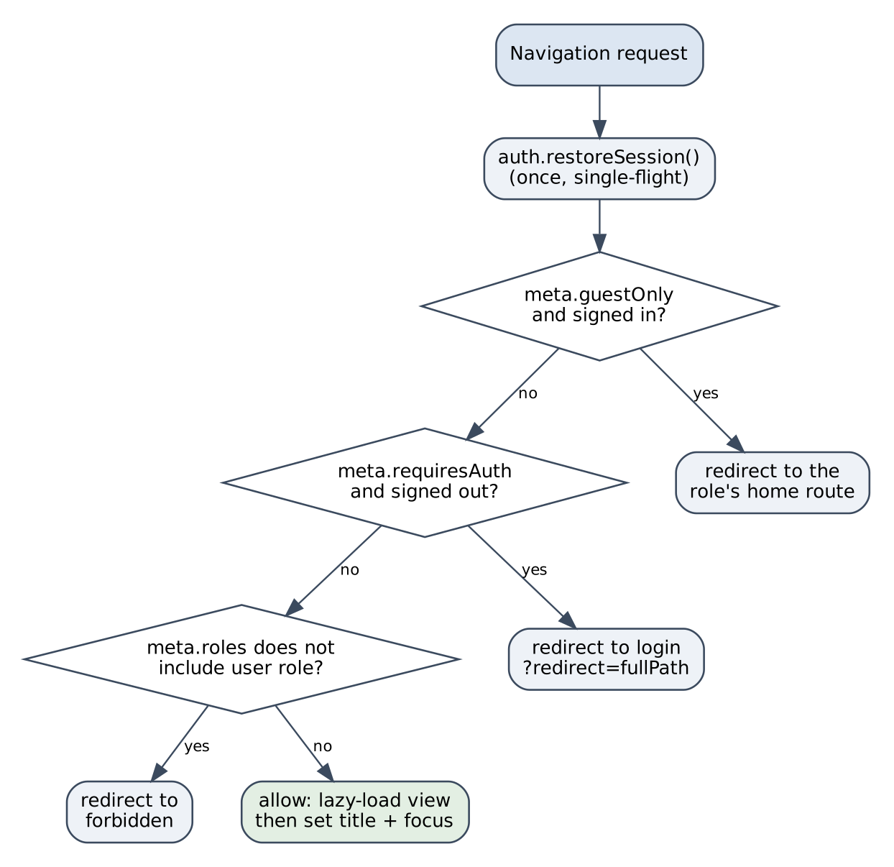
Figure 4. Decision flow of the global navigation guard
Listing 4.4 — src/router/guards.js
export async function authGuard(to) {
const auth = useAuthStore()
await auth.restoreSession()
if (to.meta.guestOnly && auth.isAuthenticated) {
return { name: homeRouteFor(auth.role) }
}
if (to.meta.requiresAuth && !auth.isAuthenticated) {
return { name: 'login', query: { redirect: to.fullPath } }
}
if (to.meta.roles && !to.meta.roles.includes(auth.role)) {
return { name: 'forbidden' }
}
return true
}

The comment in the source states the design principle: the guard improves the experience, because the visitor never sees a page that cannot be used, but it is not security. Every API request is checked again by the backend, so modifying the frontend cannot grant access to data. The role information (meta.roles) mirrors permissions that exist on the backend. After a successful sign-in, the visitor is sent back to the page requested, through the redirect query parameter, which is validated (Section 4.10).

4.8 Pinia state management
The project applies one criterion to decide whether a piece of state becomes a store: it must be read by more than one route and stay consistent across them. Everything else remains local to a component. Table 7 lists the eight stores with their responsibilities. All stores are written in the options style (state, getters, actions).
Table 7. Pinia stores and responsibilities
Store | State | Responsibilities and notable behaviour
auth | user, restored | Getters isAuthenticated, role, isStaff, isAdmin, fullName. Actions restoreSession (single-flight), login, register, logout, expireSession.
cart | lines | Persisted in localStorage; each stored line is validated on reading; totals are display estimates in integer cents; the order payload is built by a getter.
ui | theme, locale | Theme (follows the system on the first visit) and language; persisted; only the switcher applies a locale.
table | scanned table | Kept in sessionStorage so that the scanned table survives a reload of the menu page.
notifications | items, unread count | Polled every 30 seconds by the header; polling is skipped when the tab is hidden.
restaurant | settings | Name, currency and time zone read by the header, home page, reservation form and checkout.
toasts | queue | One queue and one host (ToastHost); any page can push a message.
menu | categories | Cached for the filters and the cart.

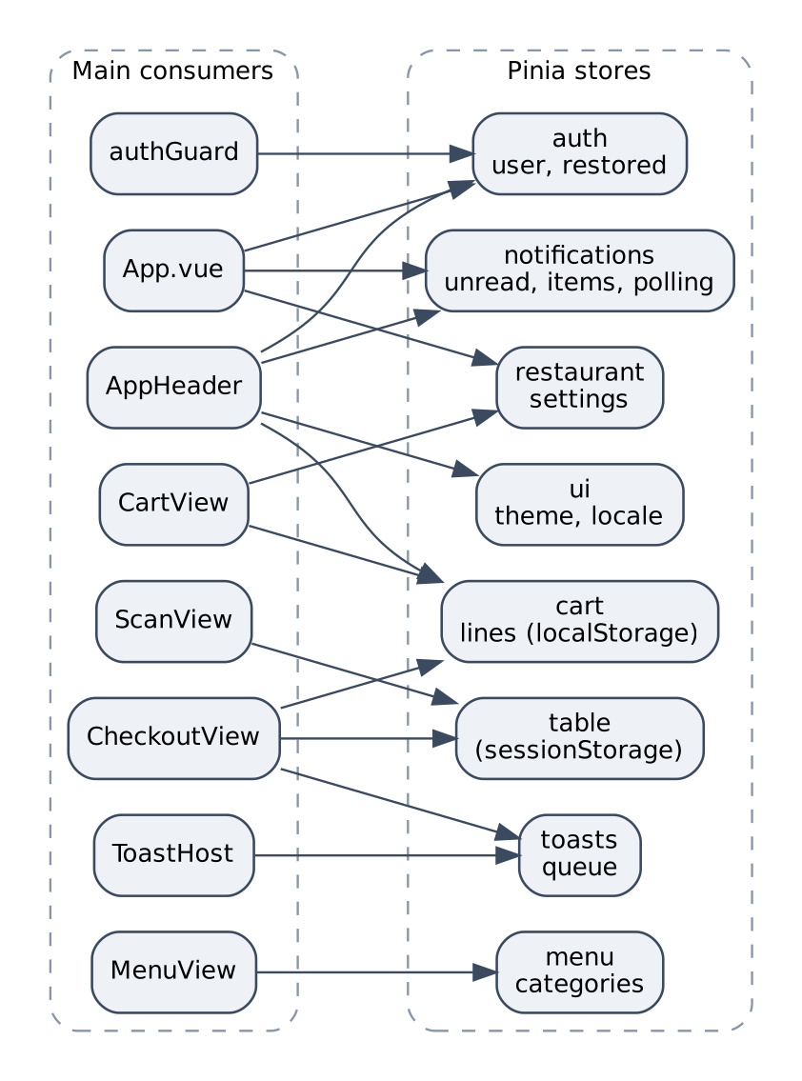
Figure 5. Pinia stores and their main consumers
List pages deliberately do not use a store: each keeps its own items, loading, failed and requestId. The request lifecycle and the stale-response guard are then visible next to the template that uses them, and a list page can be copied to a new route without dragging a store along. For the same reason, stores are not used as a data cache: two pages that need the same list (the administrator's and the staff's lists of orders) call their own service. The cart store illustrates defensive design: since localStorage can be edited by hand, every stored line is checked (identifier, name length, price pattern, quantity bounds) before it is trusted, and the cart is truncated to a maximum number of lines.

4.9 API service architecture
All backend access goes through one Axios instance defined in src/services/api.js. Twenty-two service modules (for example menuService, queueService, authService, staffOrderService, adminUserService) export plain objects whose methods wrap one endpoint each and return the data. A service handles URLs, parameters and request bodies; it contains no interface logic. Two request options control the interceptors: skipAuth (public endpoints and sign-in) and skipRefresh (a 401 must not trigger a renewal, for example after a wrong password).
Listing 4.5 — Excerpt of src/services/queueService.js
export const queueService = {
async summary() {
const { data } = await api.get('/queue/summary/', PUBLIC)
return data
},
async join({ partySize, phone }) {
const body = { party_size: partySize }
if (phone) body.phone = phone
const { data } = await api.post('/queue/', body)
return data
},
}

The backend returns errors in a common envelope containing a success flag, a message, field errors and a code. The helper toApiError converts any Axios failure (including the absence of a network answer) into an ApiError that carries these fields; the application maps backend codes to translated messages. A mixin, formErrors, applies field errors to forms.

4.10 Authentication and token management
The backend issues JSON Web Tokens: a short-lived access token (15 minutes) and a refresh token (7 days) that is rotated on each use, the previous one being blacklisted. These values were verified in the backend settings. The frontend stores them differently:
- The access token lives in a module-level variable in session.js; it is never written to storage, and a page reload loses it.
- The refresh token is kept in localStorage under restaurant.refresh (with an in-memory fallback when storage is unavailable). At startup the guard calls restoreSession, which exchanges it for a new pair and loads the user.
Listing 4.6 — Excerpt of src/services/session.js
let accessToken = null
let fallbackRefreshToken = null // Used when localStorage is unavailable.

export const session = {
getAccessToken() { return accessToken },
setTokens({ access, refresh }) { /* memory + localStorage */ },
clear() { /* forget both tokens */ },
}

The request interceptor adds the Authorization: Bearer header unless skipAuth is set. The response interceptor handles a 401 answer in a controlled way. If a refresh token exists, and the request was not already retried and does not opt out, the interceptor calls refreshTokens() and replays the request once with the new token. refreshTokens stores the pending promise in a module variable, so requests that fail at the same time share a single renewal; this matters because the backend rotates refresh tokens and two parallel renewals would invalidate each other. If the renewal fails, the session is cleared and the application is told once (a WeakSet remembers the announced failure), which displays a message and sends the visitor to the sign-in page.
Listing 4.7 — Single-flight refresh (abridged from src/services/api.js)
let refreshInFlight = null
export function refreshTokens() {
if (!refreshInFlight) {
const refresh = session.getRefreshToken()
if (!refresh) return Promise.reject(toApiError(new Error('No refresh token')))
refreshInFlight = api
.post('/auth/refresh/', { refresh }, { skipAuth: true, skipRefresh: true })
.then(({ data }) => {
session.setTokens({ access: data.access, refresh: data.refresh })
return data.access
})
.catch((error) => { session.clear(); throw toApiError(error) })
.finally(() => { refreshInFlight = null })
}
return refreshInFlight
}

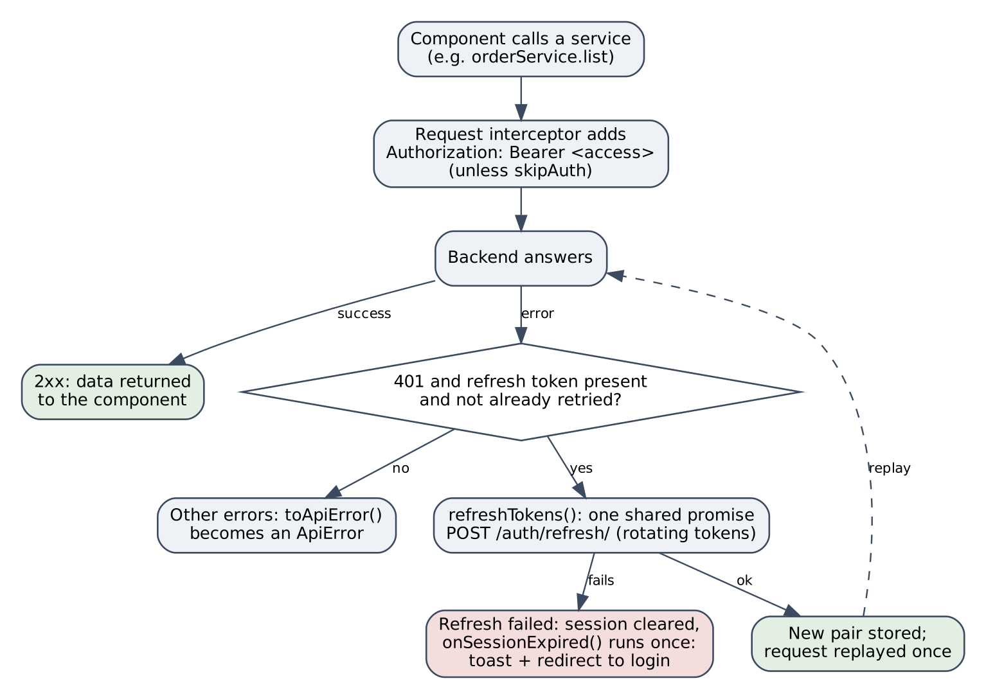
Figure 6. API request and authentication flow
Redirection after sign-in is protected against open redirects: the redirect query value is passed through safeRedirect (src/utils/redirect.js), which accepts only internal paths and rejects absolute URLs, protocol-relative addresses (//) and backslashes. Signing out calls the logout endpoint to blacklist the refresh token and clears the local session even if the call fails.
The combination limits the damage of token theft. A stolen access token stops working after 15 minutes; a stolen refresh token works only once because of rotation. The cost is one extra request when the page is reloaded. The trade-off is acknowledged: localStorage remains readable by any script running in the page, which is why the project avoids v-html and validates stored data.

4.11 Internationalisation architecture
Translations are stored in src/i18n/locales/{en,fr}/<namespace>.json, with 16 namespaces per language (for example menu, orders, billing, staff, admin). They are merged in src/i18n/index.js and exposed through $t. Several decisions are worth noting.
- Default language. English is the default for everybody; the browser language is deliberately not consulted, so two visitors see the same language until one of them opens the switcher. The choice is stored in localStorage under restaurant.locale.
- Mode. createI18n is called with legacy: false (the current mode of Vue I18n 11) and globalInjection: true, which exposes $t, $n and $d on this and in templates. The components remain in the Options API.
- Parity. A unit test (tests/unit/i18n.test.js) requires both languages to define exactly the same keys, with the same placeholders and no empty string, so a missing translation fails the build before reaching users.
- Plurals use the pipe syntax and are called with a count, for example $t('queue.waiting', { count: n }, n).
Listing 4.8 — Vue I18n configuration (src/i18n/index.js)
export const i18n = createI18n({
legacy: false,
globalInjection: true,
locale: detectLocale(),
fallbackLocale: DEFAULT_LOCALE,
messages: { en, fr },
})

Limitation. The interface text is translated, but the content that comes from the backend (menu item names and descriptions, and notification messages) is stored in a single language by the backend and is not translated.

4.12 Styling and design system
The project avoids UI frameworks and Tailwind CSS, as required, and still needs a coherent appearance. The solution is a set of design tokens: CSS custom properties declared in tokens.css and used by every component. Components never hard-code a colour, size or motion value. The file defines typography (Fraunces for headings and Inter for text, both self-hosted so that no external font request is made), a fluid type scale with clamp(), spacing on a 4 px grid, and the colours of two themes selected by :root[data-theme='light'] and :root[data-theme='dark']. The theme follows the system preference on the first visit and is then stored; a small script in public/theme-init.js applies it before the first paint to avoid a flash.
Component styles are scoped, so selectors stay local to the component; the few cross-cutting rules live in base.css. Media queries use min-width only, in a mobile-first approach, and interactive targets use a minimum size of 44 px (--target-size). Quality is protected by tests: tests/unit/tokens-contrast.test.js walks the colour tokens and checks that text and surface combinations meet the WCAG contrast ratios in both themes. The page transition and the modal animation are disabled for users who request reduced motion, and status changes never rely on colour alone: a badge carries a text label, an icon or an aria-live announcement.

4.13 Error handling and notifications
Errors are handled at four levels. Network and server failures are normalised into ApiError by the interceptor. Views catch errors in their own methods and set a failed flag that displays an error state with a retry action, or apply field errors to a form (formErrors mixin). The expiry of a session produces one message and one redirect. Finally, user feedback uses the toasts store and the ToastHost component (an aria-live region) for transient messages, and ConfirmDialog for destructive or financial actions such as leaving the queue or confirming a cash payment. Loading states use BaseSkeleton, and empty lists use EmptyState, so that the three states (loading, empty, failed) are explicit on every list page.

Chapter 5 — Implementation of the Application
This chapter describes the modules that exist in the repository. Each module was verified in the source code and is covered by tests. For each module, the relevant views and components, the main logic, the state management, the data exchange and the validation are presented. Screenshot placeholders mark the screens that should be captured to complete the report.

5.1 Customer interface

5.1.1 Home page
HomeView presents the restaurant through the restaurant store (name and settings) and a HeroCarousel component in components/home, with scroll-reveal animations provided by the v-reveal directive, which respects the reduced-motion preference. The page is public, and its text is fully translated.

5.1.2 Menu and dish details
Views and components: MenuView, MenuItemView, MenuFilters, MenuItemCard, BasePagination, BaseSkeleton, EmptyState. State: the filters (category, search text, page) live in the URL query; the categories are cached in the menu store; the items are local to the view. Data: menuService.items receives parameters built by toApiParams. Validation: parseMenuQuery in src/utils/menuQuery.js whitelists the values read from the URL, so a manipulated address cannot send arbitrary parameters. Behaviour: the stale-response guard (Listing 4.2), an explicit loading, empty and failed state, a status line announced to assistive technologies (statusText), and a return to page 1 when the requested page no longer exists.

SCREENSHOT PLACEHOLDER
To capture: the /menu page with several dishes, one category selected and a search term entered
Figure 7. Menu page with category filter and search

5.1.3 Shopping cart
Views and components: CartView, AddToCartButton, QuantityStepper, CartLink (in the header). State: the cart store (Section 4.8). Lines contain a menu item identifier, a name and a price snapshot, a quantity and an optional note, bounded by MAX_CART_LINES, MAX_LINE_QUANTITY and MAX_NOTE_LENGTH from config.js. The cart is persisted in localStorage under restaurant.cart, and main.js keeps several tabs synchronised. Money: amounts are decimal strings from the API; the cart computes totals in integer cents through src/utils/money.js and the cartMoney mixin, and labels them as estimates, because the backend recomputes every price when it creates the order. The client never sends a price: orderItems produces only a menu item identifier, a quantity and a note.

5.1.4 Table scanning
Each table of the restaurant has a QR code that encodes a URL of the form /scan?t=<token>. ScanView reads the token from the query, asks the backend to resolve it (tableService), and stores the table in the table store, which uses sessionStorage so that the table survives a reload of the menu page. TableBanner, part of MainLayout, then displays the linked table on every page. The checkout uses the stored table for dine-in orders. This is a URL-based scan: the application itself does not access the camera; the visitor uses the phone's camera application or any QR reader.

5.1.5 Queue management
QueueView displays a public summary (number of waiting parties and the estimated wait, fetched with skipAuth) and, for a signed-in customer, the current ticket with its position and the number of parties ahead (a pluralised message). A customer who is not in the queue can join with a party size (a select bound with v-model.number) and an optional phone number; a customer who is in the queue can leave it after a ConfirmDialog. A visitor who is not signed in is invited to sign in. Staff manage the same queue from StaffQueueView (Section 5.2).

5.1.6 Reservations
ReservationNewView implements a two-step flow: the customer chooses a date and a party size, the application asks the backend for the free slots, and the customer selects a time and confirms. The default date is computed in the restaurant's time zone (todayIn(settings.timezone)), not the browser's. A watcher forgets the slots whenever the date or party size changes, so a displayed time always corresponds to the current search. The party size is limited to MAX_PARTY_SIZE. ReservationsView lists the customer's reservations and allows cancellation.

5.1.7 Checkout and simulated payment
CheckoutView converts the cart into an order. The customer chooses dine-in, takeaway or delivery; a dine-in order uses the scanned table. The view reads the cart through mapState, sends orderItems to orderService, and clears the cart once the order is created. Errors are shown with the form-error mixin and toasts.
Payment is handled by PaymentPanel (components/orders) with paymentService. The customer may choose card, mobile money or cash. Card and mobile-money payments are simulated: the interface displays a demonstration notice, no real gateway is contacted, and a special test token (tok_declined) produces a declined payment so that the failure path can be tested. Cash payments are confirmed by a staff member. The legal pages state that no real money is handled. The backend only accepts simulated payments when it is configured to do so.

SCREENSHOT PLACEHOLDER
To capture: the /checkout page with a filled cart, showing the payment method choice and the demonstration notice
Figure 8. Checkout page with the simulated payment panel

5.1.8 Orders, tracking, invoices and notifications
OrdersView lists the customer's orders, and OrderView tracks one order. OrderTimeline shows the status sequence (pending, confirmed, preparing, ready, completed), with a distinct state for cancelled; a BaseBadge carries the status as text and a tone, so colour is never the only signal. The view refreshes the order every 10 seconds (POLL_INTERVAL_MS), but not when the tab is hidden or the order is settled, and a 404 answer displays a not-found state. Cancellation is offered only while the order is pending and unpaid. InvoicesView and InvoiceCard display the invoices, and NotificationsView displays the messages that the notifications store polls for the header bell (NotificationBell).

SCREENSHOT PLACEHOLDER
To capture: an order page (/orders/:id) in the "preparing" state
Figure 9. Order tracking page with the status timeline

5.1.9 Accounts and authentication pages
LoginView, RegisterView, ForgotPasswordView and ResetPasswordView use AuthLayout and are guestOnly. AccountView, AccountProfileView and AccountPasswordView let a signed-in user edit the profile and change the password. Forms use BaseInput with labels tied to inputs and error messages, validate on submission, and display the field errors returned by the backend. After registration, the new customer is signed in directly.

5.2 Staff interface
The staff area (/staff) is restricted to the staff and admin roles and has its own navigation component, StaffNav. Seven views were implemented:
Table 8. Staff views
View | Purpose | Main data and logic
StaffHomeView | Landing page of the area. | Entry points to the tools.
StaffOrdersView | Order board. | Lists orders with status filters; refreshed periodically through staffOrderService.
StaffOrderView | Order detail. | Advances the order through SEQUENCE = [pending, confirmed, preparing, ready, completed]; confirms a cash payment after a ConfirmDialog (staffPaymentService).
StaffOrderNewView | Walk-in order. | Creates an order for a customer without an account.
StaffReservationsView | Reservations. | Lists and manages reservations.
StaffQueueView | Waiting queue. | Lists and manages queue tickets.
StaffTablesView | Tables and QR codes. | Lists tables; downloads the QR code of a table (PNG) and a printable sheet (PDF), both produced by the backend and received as binary data.

The frontend displays only the next step of an order, but the legal transitions are decided by the backend (utils/orders.js states that the backend owns the rules); an illegal transition is therefore rejected by the server and reported by the interface.

SCREENSHOT PLACEHOLDER
To capture: the /staff orders page, signed in as server@demo.example, with several orders and status filters
Figure 10. Staff order board

5.3 Administration interface
The administration area (/admin) is restricted to the admin role and has AdminNav. It contains eleven views and two shared components:
Table 9. Administration modules
Module | Views and components | Description
Dashboard | AdminHomeView, AdminDashboardView, BarsChart | Key indicators (value and change with an arrow and a text label) and a revenue bar chart drawn by the project's own BarsChart component, without a charting library.
Categories | AdminCategoriesView | Creation, editing and deletion of menu categories.
Menu | AdminMenuView, AdminMenuItemNewView, AdminMenuItemEditView, MenuItemForm | Menu item management with image upload; one shared form for creation and edition.
Settings | AdminSettingsView | Restaurant settings used by the whole application (name, currency, time zone).
Users | AdminUsersView, AdminUserNewView, AdminUserEditView | User list filtered by role and activity, creation and edition with roles client, staff and admin.
Reports | AdminReportsView | Sales reports with a CSV download.

These pages follow the same pattern as the customer lists: local state, a request counter, loading, empty and failed states, and service modules (adminDashboardService, adminMenuService, adminUserService, adminReportService, settingsService). Roles are checked by the guard for navigation and by the backend for every request.

SCREENSHOT PLACEHOLDER
To capture: the /admin dashboard signed in as admin@demo.example, showing the key indicators and the revenue chart
Figure 11. Administration dashboard

5.4 Cross-cutting implementation aspects
- Accessibility. Real buttons and links, labels tied to inputs, visible focus, aria-live regions for status messages, focus moved to the main region after navigation, and a skip to content through the layout.
- Security. No v-html; the whitelist of query values; safeRedirect; validated cart storage; tokens as described in Section 4.10.
- Dead code. AreaPlaceholderView.vue is not referenced by any route; it is a remnant of an earlier development step and does not affect the application.

Chapter 6 — Testing and Quality Assurance

6.1 Testing strategy
Tests are written together with the features, in four groups that follow the architecture: unit tests for pure helpers, stores, the router and the API layer; component tests for base and feature components; view tests for pages; and service tests for the staff and administration services. All tests run in Vitest with jsdom. Two helpers keep them uniform. mountWithApp mounts a component with a fresh Pinia, the real translations and the English locale. fakeServer replaces the Axios adapter with a function, records every request (method, URL, authorisation header, body) and lets the test answer like a real server, including error envelopes. Components are therefore tested with their real stores and translations but without any network.

6.2 Unit testing
Twenty-seven files in tests/unit cover the foundations. Examples include money.test.js (cent arithmetic), menu-query.test.js (URL whitelisting), errors.test.js, session.test.js, i18n.test.js (key parity) and tokens-contrast.test.js (WCAG contrast of the colour tokens in both themes).

6.3 Component testing
Twenty-six files in tests/components cover base components (BaseButton, BaseInput, BaseModal, ConfirmDialog, ToastHost), layout components (AppHeader, AppFooter), and the feature parts of the cart, menu, billing, queue and reservation pages. These tests check rendering, props, emitted events and accessibility attributes.

6.4 Store testing
Each store has a test file: auth-store, cart-store, ui-store, notifications-store, restaurant-store and toasts-store. They verify, for example, that the cart rejects tampered stored lines and computes totals in cents, that the authentication store restores a session once, and that the ui store persists the theme and the language.

6.5 Service testing
tests/unit/api.test.js verifies the Axios layer, and seven files in tests/services verify the staff and administration services. The API tests check, among other behaviours: that the access token is sent when present and left out of public requests; that failures become ApiError objects carrying the backend envelope; that a missing network is reported clearly; that an expired token is renewed and the request replayed with the new token; that several simultaneous failures trigger a single renewal; that the session ends, with one announcement, when the renewal fails; that requests which opt out are not renewed; and that a request is replayed only once, so that a rejection after renewal cannot loop.

6.6 Integration testing
Several test files cross layer boundaries and act as integration tests: router-guards.test.js (the guard with the real store and routes), integration-nav.test.js, session-expiry.test.js, router-focus.test.js, staff-routes.test.js and cart-routes.test.js. They verify that a visitor is sent to sign in with the way back remembered; that each role enters its own area; that an administrator may enter the staff area; that a stored session is re-opened before the page is decided; that a dead session does not trap the visitor; and that titles and focus follow the language and the navigation. The tests of the view groups (tests/views) also combine router, stores, services and templates. There are no browser-based end-to-end tests.

6.7 Test execution results
The suite was executed on a clean installation (npm ci, Node.js 22) for this report. The historical figures in the project documentation were not used; Table 10 gives the verified results.
Table 10. Verified quality results
Check | Command | Result
Automated tests | npx vitest run | 85 test files, 735 tests passed, 0 failed, 0 skipped
Static analysis | npx eslint . | 0 errors, 0 warnings
Production build | npx vite build | Successful; main chunk about 275 kB (95 kB gzip); views split into lazy chunks

Table 11. Test files by group
Test group | Files
tests/unit | 27
tests/components | 26
tests/views | 25
tests/services | 7
Total | 85

The result shows that the main behaviours of the application are protected against regression, especially authentication, routing, the cart and the staff and administration services. It does not show that the interface is free of visual defects or that it works against the live backend: the tests use a simulated network and jsdom, not a real browser.

6.8 Code quality and linting
ESLint 10 runs with the recommended rules and the essential rules of eslint-plugin-vue. The configuration adds project rules (Appendix A.1): Options API only, restricted imports of the Composition API, explicit emits, required prop defaults, multi-word component names and no v-html. The architecture decisions therefore remain true as the code evolves, because a violation fails the check. The size of the code (about 13,600 lines in the Vue components, 2,300 lines of JavaScript in src and 7,800 lines of tests) shows that the tests are of the same order as the application code.

6.9 Known limitations of the quality process
- No code-coverage report is configured, so the percentage of code exercised by the tests is not measured.
- No browser end-to-end tests and no visual regression tests; the tests do not run in a real browser.
- The tests use mocked HTTP; compatibility with the live backend depends on the API contract being respected.
- No continuous-integration pipeline: the three checks are executed manually.
- Some staff services (staffOrderService, staffPaymentService) use a code style (semicolons, default export) different from the other services. It is cosmetic and does not affect behaviour.

Chapter 7 — Results, Limitations and Future Improvements

7.1 Achieved objectives
Table 12. Assessment of the specific objectives
Specific objective | Result
Components and lazy views | Achieved: 80 components, 43 routes, every view lazy-loaded.
Shared state with Pinia | Achieved: 8 stores, with a documented criterion separating shared and local state.
Navigation and access control | Achieved: global guard, role metadata, safe redirect, focus management.
API communication with token renewal | Achieved: one Axios instance, single-flight refresh, uniform error type.
English and French | Achieved for the interface; backend content is not translated.
Custom accessible design system | Achieved: tokens, scoped CSS, light and dark themes, contrast tests.
Automated verification | Achieved: 735 passing tests, clean lint, successful build.

7.2 Implemented functionality
The customer journey is implemented from the menu to invoices and notifications. The staff area provides seven views, and the administration area provides eleven views and two shared components. These features were verified in the source code and exercised by the tests; they were not taken from the planning documents. The project documentation described the staff and administration modules inconsistently (planned in one section, complete in another); the code shows that they are implemented.

7.3 Technical achievements
- A strict Options API code base enforced by the linter, with Pinia stores in the options style.
- A session design that keeps the access token out of persistent storage and renews it once for concurrent requests.
- A stale-response guard on every list page and a URL-driven filter state.
- A complete custom design system without a UI framework, with a tested contrast policy.
- A translation process that fails the build when a key is missing in one language.
- A test infrastructure that replaces the network and gives fast, deterministic tests.

7.4 Current limitations
- Payments are simulated. Card and mobile-money payments do not use a real payment gateway.
- No production deployment. The application is run locally with the backend; no public deployment exists at the time of writing.
- Table scanning by URL only. There is no camera-based scanner in the application.
- Partial translation. Menu content and notification messages come from the backend in a single language.
- Test scope. jsdom and mocked HTTP only; no coverage measurement, no end-to-end tests, no CI.
- Token storage trade-off. The refresh token remains readable by scripts in the page (localStorage).
- No TypeScript. Types of API data are documented by usage and tests rather than checked by the compiler.
- Polling. Order and notification updates use periodic requests instead of server-push channels, which is simple but adds traffic.
- Dead code. An unused placeholder view remains in the repository.

7.5 Future improvements
- Integrate a real payment provider behind the existing payment service interface.
- Deploy the frontend as a static site and the backend on a hosting service, with the API address set at build time and the frontend origin added to the backend CORS settings.
- Add a continuous-integration workflow running lint, tests and build, and a coverage report.
- Add end-to-end tests with a browser automation tool for the main journeys.
- Replace polling with WebSockets or server-sent events for orders, the queue and notifications.
- Translate menu content and notifications on the backend, for example by returning content per language.
- Add an in-app camera scanner for table QR codes.
- Consider TypeScript for the service layer and a progressive web application mode for offline resilience.

7.6 Lessons learned
Several lessons emerged. First, a restrictive architectural rule enforced by tooling (the Options API rule) is more reliable than a rule written in documentation. Second, the separation between shared and local state keeps stores small and pages easy to copy and test. Third, a single Axios layer concentrates the difficult parts of authentication (concurrency, rotation, expiry) in one place that can be tested thoroughly. Fourth, the project documentation must be checked against the code: the number of tests and the status of features differed between documents, which is why the figures of this report were obtained by running the project. Finally, designing without a UI framework requires discipline, and design tokens and shared base components provide that discipline.

General Conclusion
This project addressed the lack of integrated digital tools in restaurant operations: customers lack visibility on queues and orders, and staff and managers lack a shared view of orders, tables and figures. The solution is the frontend of a restaurant management application, written as a Vue 3 single-page application that connects to a Django REST API.
The main Vue.js technologies were used in a deliberate way. The Options API structures every component and is enforced by ESLint. Vue Router, with lazy views and a global guard, organises 43 routes and the access of each role. Pinia holds the eight stores that represent state shared between pages, while list pages keep their own state. Axios, configured once, provides authentication with an in-memory access token, a stored refresh token, a single-flight renewal and normalised errors. Vue I18n provides English and French with a test that guarantees equal keys. A custom CSS design system with tokens, scoped styles and two themes replaces a UI framework.
The objectives were achieved: the customer, staff and administration modules exist, and the application is verified by 735 passing tests, a clean lint run and a successful production build. The limitations are clear: payments are simulated, the application has not been deployed, backend content is not translated, and the tests do not cover real browsers or the live backend. The improvements listed in Chapter 7 (real payments, deployment, continuous integration, end-to-end tests and real-time updates) form a realistic next stage. The project demonstrates that a well-structured Vue application can be built with the framework's core tools alone, and that its quality can be protected by automation.

References
References follow the Harvard author–date style. The list contains only official documentation and standards that were used to understand the technologies of the project; no other source is cited. The project repositories are listed first.
CIRHULWIRE AJUWA, J. (2026) restaurant-frontend [source code]. Available at: https://github.com/monamijer/restaurant-frontend.
CIRHULWIRE AJUWA, J. (2026) restaurant-backend [source code]. Available at: https://github.com/monamijer/restaurant-backend.
Axios (n.d.) Axios documentation. Available at: https://axios-http.com/docs/intro.
ESLint (n.d.) ESLint documentation. Available at: https://eslint.org/docs/latest/.
eslint-plugin-vue (n.d.) eslint-plugin-vue documentation. Available at: https://eslint.vuejs.org/.
Fontsource (n.d.) Fontsource documentation. Available at: https://fontsource.org/docs/getting-started/introduction.
MDN Web Docs (n.d.) Web Storage API. Mozilla. Available at: https://developer.mozilla.org/en-US/docs/Web/API/Web_Storage_API.
MDN Web Docs (n.d.) CSS custom properties for cascading variables. Mozilla. Available at: https://developer.mozilla.org/en-US/docs/Web/CSS/Using_CSS_custom_properties.
Pinia (n.d.) Pinia documentation. Available at: https://pinia.vuejs.org/.
Vite (n.d.) Vite documentation. Available at: https://vite.dev/guide/.
Vitest (n.d.) Vitest documentation. Available at: https://vitest.dev/guide/.
Vue I18n (n.d.) Vue I18n documentation. Available at: https://vue-i18n.intlify.dev/.
Vue Router (n.d.) Vue Router documentation. Available at: https://router.vuejs.org/.
Vue Test Utils (n.d.) Vue Test Utils documentation. Available at: https://test-utils.vuejs.org/.
Vue.js (n.d.) Vue.js documentation. Available at: https://vuejs.org/guide/introduction.html.
W3C (2023) Web Content Accessibility Guidelines (WCAG) 2.2. Available at: https://www.w3.org/TR/WCAG22/.

Appendices

Appendix A — Configuration excerpts

A.1 ESLint rules enforcing the architecture (eslint.config.js)
COMPOSITION_API lists ref, reactive, computed, watch, onMounted, provide, inject, etc.
'vue/component-api-style': ['error', ['options']],
'no-restricted-imports': ['error', { paths: [{ name: 'vue',
importNames: COMPOSITION_API, message: 'Options API only.' }] }],
'vue/multi-word-component-names': ['error', { ignores: ['App'] }],
'vue/require-default-prop': 'error',
'vue/require-explicit-emits': 'error',
'vue/no-v-html': 'error',

A.2 Environment and scripts
Table 13. Environment variable and scripts
Item | Value
VITE_API_BASE_URL | Base URL of the Django API (default http://localhost:8000/api)
npm run dev | Development server on port 5173 (strictPort)
npm run build / preview | Production build in dist/ / local preview
npm test / npm run lint | Vitest suite / ESLint

Appendix B — Test helper
tests/helpers/http.js — replaces the network and records requests (abridged)
export function fakeServer(handler) {
const requests = []
api.defaults.adapter = async (config) => {
requests.push({ method: config.method, url: config.url,
auth: config.headers.Authorization, body: config.data })
return handler(config)
}
return requests
}

Appendix C — Verified project statistics
Table 14. Verified statistics of the frontend repository
Measure | Value
Vue single-file components | 80 (about 13,600 lines)
JavaScript in src (non-Vue) | about 2,300 lines
Routes (declared paths) | 43 (28 require authentication)
Pinia stores / service modules / mixins / directives | 8 / 22 / 2 / 1
Translation namespaces | 16 per language (en, fr)
Test files / tests | 85 / 735 (0 failed, 0 skipped)
Lines of test code | about 7,800
Commits in the repository | 92 (14 October – 5 November 2026)
Production main chunk | about 275 kB (95 kB gzip)

Appendix D — Screenshots to capture
The following screens should replace the placeholders. Sign in with the demo accounts created by the backend command seed_demo (admin@demo.example, server@demo.example, client1@demo.example), use a desktop width of about 1280 px, and capture both themes where a placeholder says so.
- Home page (Figure 1).
- Menu page with filters.
- Checkout with the simulated payment panel.
- Order tracking timeline.
- Staff order board.
- Administration dashboard.

