Title: Early progression proportion

Type: proportion

Distribution: beta_full_range

Estimate: 0.125

Spread: 0.0145

Limits: No additional limits applied

Implementation: Numerator is latent_early to active and denominator is latent_early to latent_late

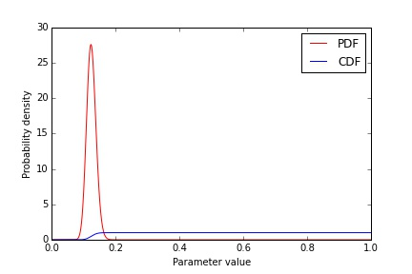

Title: Early progression proportion in children

Type: proportion

Distribution: beta_full_range

Estimate: 0.42

Spread: 0.056

Limits: No additional limits applied

Implementation: Numerator is latent_early to active (children) and denominator is latent_early to latent_late (children)

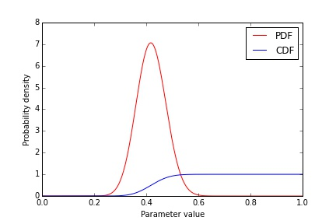

Title: Early progression proportion in adults

Type: proportion

Distribution: beta_full_range

Estimate: 0.024

Spread: 0.007575

Limits: No additional limits applied

Implementation: Numerator is latent_early to active (adults) and denominator is latent_early to latent_late (adults)

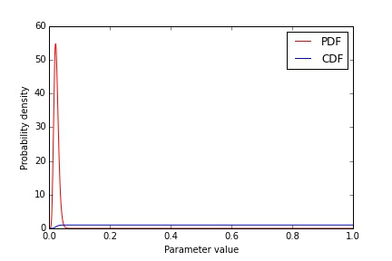

Title: Time spent in early latency

Type: timeperiod

Distribution: gamma

Estimate: 0.416666666667

Spread: 0.208333333333

Limits: No additional limits applied

Implementation: Time spent in early_latent (if not reinfected)

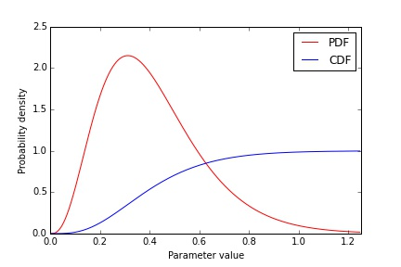

Title: Time spent in early latency - children

Type: timeperiod

Distribution: gamma

Estimate: 0.397260273973

Spread: 0.198630136986

Limits: No additional limits applied

Implementation: Time spent in early_latent (children, if not reinfected)

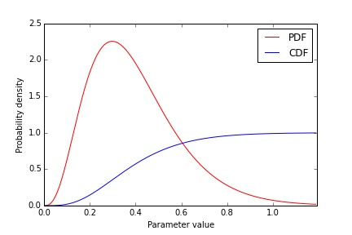

Title: Time spent in early latency - adults

Type: timeperiod

Distribution: gamma

Estimate: 0.621917808219

Spread: 0.31095890411

Limits: No additional limits applied

Implementation: Time spent in early_latent (adults, if not reinfected)

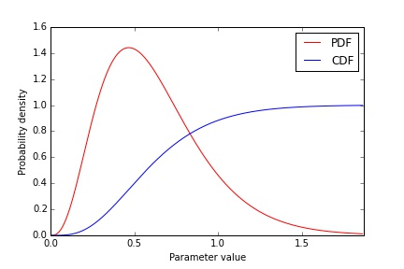

Title: Late progression rate

Type: rate

Distribution: gamma

Estimate: 0.00058

Spread: 0.0001275

Limits: No additional limits applied

Implementation: From compartment late_latent to compartment active

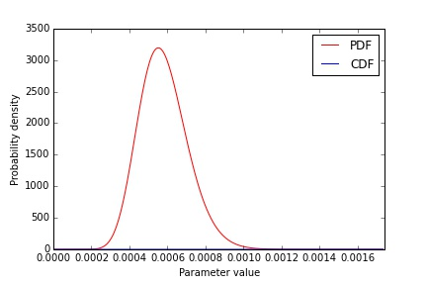

Title: Untreated duration

Type: timeperiod

Distribution: gamma

Estimate: 3

Spread: 1.5

Limits: No additional limits applied

Implementation: Time spent in active disease (if not detected)

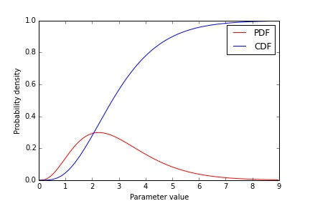

Title: Untreated case fatality

Type: proportion

Distribution: beta_full_range

Estimate: 0.7

Spread: 0.15

Limits: No additional limits applied

Implementation: Numerator is death and denominator is death and spontaneous recovery (if not detected)

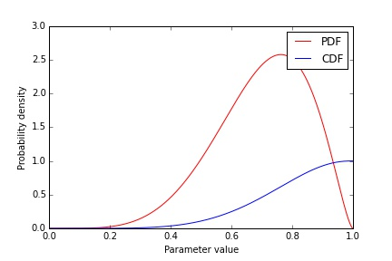

Title: Relative fitness

Type: multiplier

Distribution: beta_full_range

Estimate: 0.6

Spread: 0.25

Limits: No additional limits applied

Implementation: Parameter to be multiplied is force of infection

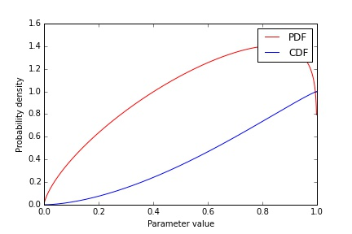

Title: BCG protection

Type: multiplier

Distribution: beta_full_range

Estimate: 0.49

Spread: 0.09

Limits: No additional limits applied

Implementation: Parameter to be multiplied is force of infection parameter

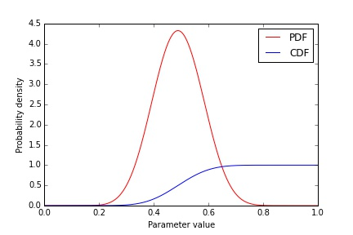

Title: Time under treatment for DS-TB

Type: timeperiod

Distribution: normal_truncated

Estimate: 6.0

Spread: 0.5

Limits: Two additional limits set at 6.0 and 1000.0

Implementation: Time spent in time under treatment for DS-TB (may span multiple compartments)

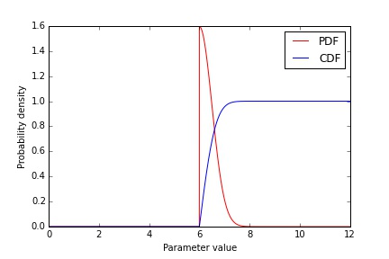

Title: Time under treatment for MDR-TB

Type: timeperiod

Distribution: normal_truncated

Estimate: 20.0

Spread: 6.0

Limits: Two additional limits set at 20.0 and 1000.0

Implementation: Time spent in time under treatment for MDR-TB (may span multiple compartments)

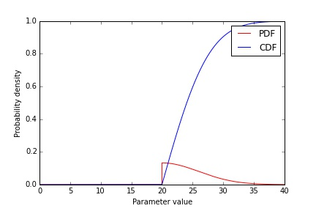

Title: Relative infectiouness of smear negative disease

Type: multiplier

Distribution: beta_full_range

Estimate: 0.24

Spread: 0.025

Limits: No additional limits applied

Implementation: Parameter to be multiplied is force of infection parameter

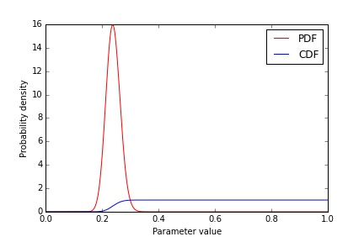

Title: Relative infectiousness of patients under treatment (DS-TB)

Type: multiplier

Distribution: beta_full_range

Estimate: 0.02

Spread: 0.01

Limits: No additional limits applied

Implementation: Parameter to be multiplied is force of infection parameter

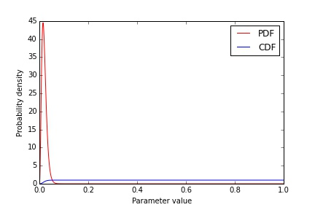

Title: Relative infectiousness of patients under treatment (MDR-TB)

Type: multiplier

Distribution: beta_full_range

Estimate: 0.0714285714286

Spread: 0.0357142857143

Limits: No additional limits applied

Implementation: Parameter to be multiplied is force of infection parameter

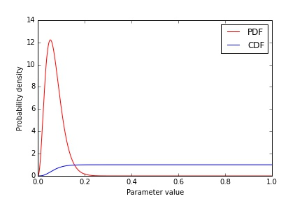

Title: Proportion of DS-TB defaults amplifying to new MDR-TB

Type: proportion

Distribution: beta_full_range

Estimate: 0.133333333333

Spread: 0.0666666666667

Limits: No additional limits applied

Implementation: Numerator is defaults to active MDR-TB and denominator is all defaults from DS regimens

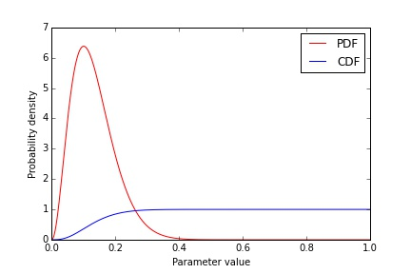

Title: Relative greater proportion with poor treatment outcomes for retreatment cases compared to new in DS-TB

Type: multiplier

Distribution: gamma

Estimate: 2.2

Spread: 1.1

Limits: No additional limits applied

Implementation: Parameter to be multiplied is defaults and deaths in retreatment DS-TB patients

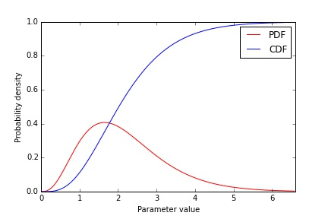

Title: Treatment success for inappropriately treated new MDR cases

Type: proportion

Distribution: beta_full_range

Estimate: 0.52

Spread: 0.24

Limits: No additional limits applied

Implementation: Numerator is successful outcome and denominator is all new MDR patients treated with inappropriate first line regimen

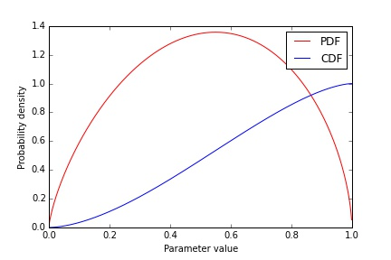

Title: Treatment success for inappropriately treated retreatment MDR cases

Type: proportion

Distribution: beta_full_range

Estimate: 0.29

Spread: 0.145

Limits: No additional limits applied

Implementation: Numerator is successful outcome and denominator is all new MDR patients treated with inappropriate first line regimen

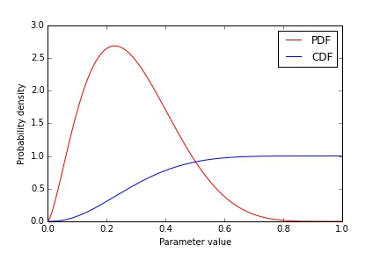

Title: Early progression proportion

Type: proportion

Distribution: beta_full_range

Estimate: 0.125

Spread: 0.0145

Limits: No additional limits applied

Implementation: Numerator is latent_early to active and denominator is latent_early to latent_late



Title: Early progression proportion in children

Type: proportion

Distribution: beta_full_range

Estimate: 0.42

Spread: 0.056

Limits: No additional limits applied

Implementation: Numerator is latent_early to active (children) and denominator is latent_early to latent_late (children)



Title: Early progression proportion in adults

Type: proportion

Distribution: beta_full_range

Estimate: 0.024

Spread: 0.007575

Limits: No additional limits applied

Implementation: Numerator is latent_early to active (adults) and denominator is latent_early to latent_late (adults)



Title: Time spent in early latency

Type: timeperiod

Distribution: gamma

Estimate: 0.416666666667

Spread: 0.208333333333

Limits: No additional limits applied

Implementation: Time spent in early_latent (if not reinfected)



Title: Time spent in early latency - children

Type: timeperiod

Distribution: gamma

Estimate: 0.397260273973

Spread: 0.198630136986

Limits: No additional limits applied

Implementation: Time spent in early_latent (children, if not reinfected)



Title: Time spent in early latency - adults

Type: timeperiod

Distribution: gamma

Estimate: 0.621917808219

Spread: 0.31095890411

Limits: No additional limits applied

Implementation: Time spent in early_latent (adults, if not reinfected)



Title: Late progression rate

Type: rate

Distribution: gamma

Estimate: 0.00058

Spread: 0.0001275

Limits: No additional limits applied

Implementation: From compartment late_latent to compartment active



Title: Untreated duration

Type: timeperiod

Distribution: gamma

Estimate: 3

Spread: 1.5

Limits: No additional limits applied

Implementation: Time spent in active disease (if not detected)



Title: Untreated case fatality

Type: proportion

Distribution: beta_full_range

Estimate: 0.7

Spread: 0.15

Limits: No additional limits applied

Implementation: Numerator is death and denominator is death and spontaneous recovery (if not detected)



Title: Relative fitness

Type: multiplier

Distribution: beta_full_range

Estimate: 0.6

Spread: 0.25

Limits: No additional limits applied

Implementation: Parameter to be multiplied is force of infection



Title: BCG protection

Type: multiplier

Distribution: beta_full_range

Estimate: 0.49

Spread: 0.09

Limits: No additional limits applied

Implementation: Parameter to be multiplied is force of infection parameter



Title: Time under treatment for DS-TB

Type: timeperiod

Distribution: normal_truncated

Estimate: 6.0

Spread: 0.5

Limits: Two additional limits set at 6.0 and 1000.0

Implementation: Time spent in time under treatment for DS-TB (may span multiple compartments)



Title: Time under treatment for MDR-TB

Type: timeperiod

Distribution: normal_truncated

Estimate: 20.0

Spread: 6.0

Limits: Two additional limits set at 20.0 and 1000.0

Implementation: Time spent in time under treatment for MDR-TB (may span multiple compartments)



Title: Relative infectiouness of smear negative disease

Type: multiplier

Distribution: beta_full_range

Estimate: 0.24

Spread: 0.025

Limits: No additional limits applied

Implementation: Parameter to be multiplied is force of infection parameter



Title: Relative infectiousness of patients under treatment (DS-TB)

Type: multiplier

Distribution: beta_full_range

Estimate: 0.02

Spread: 0.01

Limits: No additional limits applied

Implementation: Parameter to be multiplied is force of infection parameter



Title: Relative infectiousness of patients under treatment (MDR-TB)

Type: multiplier

Distribution: beta_full_range

Estimate: 0.0714285714286

Spread: 0.0357142857143

Limits: No additional limits applied

Implementation: Parameter to be multiplied is force of infection parameter



Title: Proportion of DS-TB defaults amplifying to new MDR-TB

Type: proportion

Distribution: beta_full_range

Estimate: 0.133333333333

Spread: 0.0666666666667

Limits: No additional limits applied

Implementation: Numerator is defaults to active MDR-TB and denominator is all defaults from DS regimens



Title: Relative greater proportion with poor treatment outcomes for retreatment cases compared to new in DS-TB

Type: multiplier

Distribution: gamma

Estimate: 2.2

Spread: 1.1

Limits: No additional limits applied

Implementation: Parameter to be multiplied is defaults and deaths in retreatment DS-TB patients



Title: Treatment success for inappropriately treated new MDR cases

Type: proportion

Distribution: beta_full_range

Estimate: 0.52

Spread: 0.24

Limits: No additional limits applied

Implementation: Numerator is successful outcome and denominator is all new MDR patients treated with inappropriate first line regimen



Title: Treatment success for inappropriately treated retreatment MDR cases

Type: proportion

Distribution: beta_full_range

Estimate: 0.29

Spread: 0.145

Limits: No additional limits applied

Implementation: Numerator is successful outcome and denominator is all new MDR patients treated with inappropriate first line regimen

