Possible Solution 1:
These guys sell a plug-in for importing Sketchup files. 7-day license for this add-in is USD 20.00:
http://www.sycode.com/products/skp_import_iv/

Possible Solution 2:
http://forums.autodesk.com/t5/inventor-general-discussion/converting-from-sketchup-to-inventor/td-p/3021246

You can import a .dwg directly. Make sure you set Options to Import
Then see attached...
....
you can transfer to the Repair or Construction Environment after opening if needed.

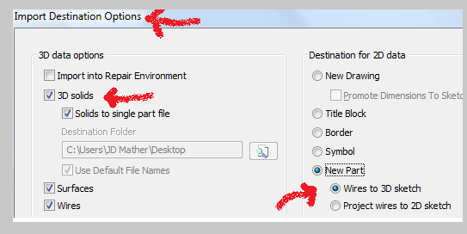

DXF or DWG?
Why DXF Is Best. Essentially, the main difference between the two files is that DWG files is proprietary to AutoCAD, while DXF is an exchange file created for non-AutoCAD applications to write a similar file type.

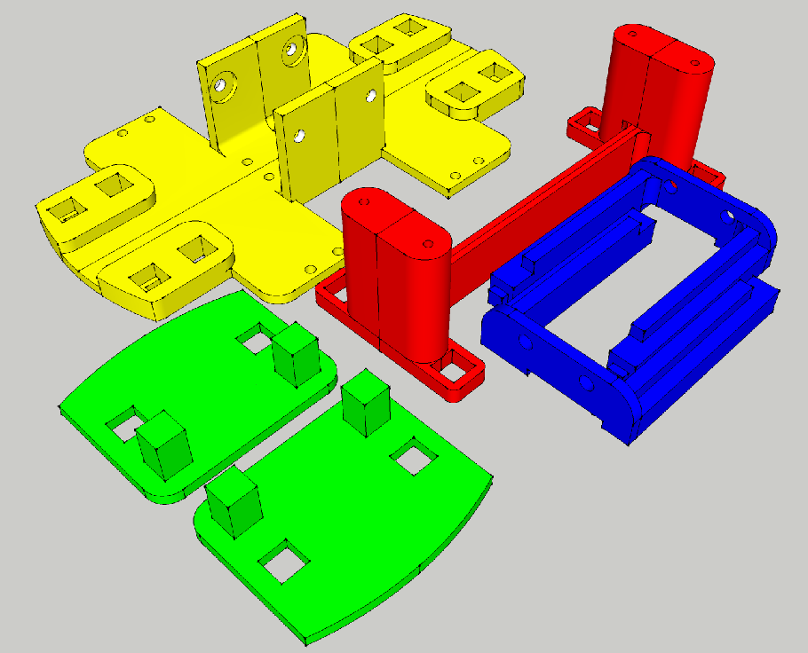

Blue --- Part 1
Yellow -- Part 2
Green -- Part 3
Red -- Part 4

Export from Sketchup:
(default export options appear with “construction geometry” unticked).

