**Step1**

**Step2**

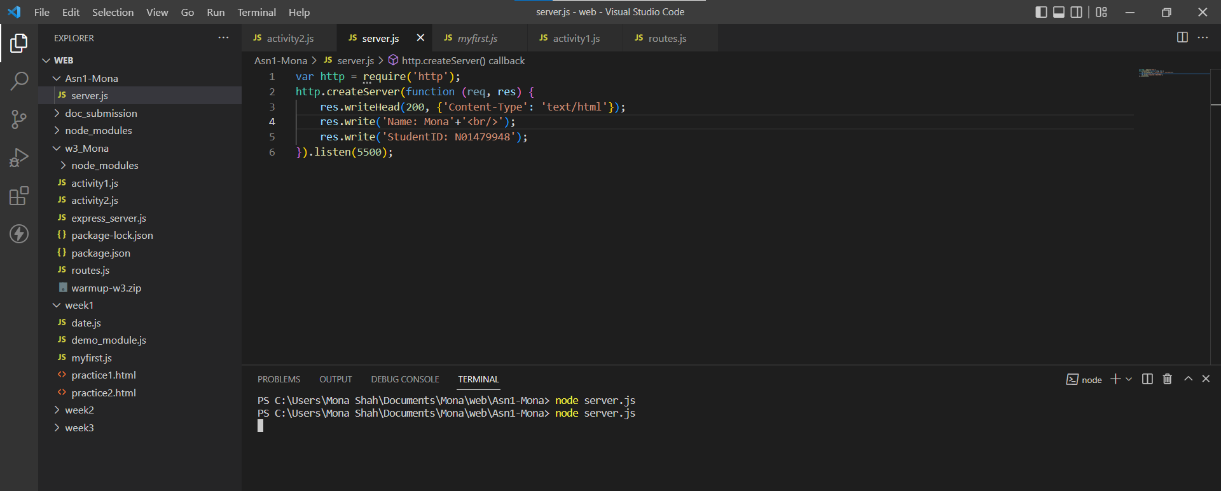

**Step3**

**Step4**

**Step5**

**Step6**

**Step7**

**Step8**

req.query

In case multiple search fields are available, it allows to send params in any order. Also it is comparatively easy to use one same route path for multiple fields. Whereas for optional fields, its not necessary to include them in query param list.

req.params

In case multiple search fields are available, all params must be sent in proper with respect to url path in order to avoid errors. Also we need to have different routes for different fields. For optional fields, we have to send empty value.