**Step1:-**

npm init

npm install express --save

npm install express-handlebars --save

Project structure

**Step:2**

Style.css

Main.hbs

Index.hbs

Error.hbs

App.js

**Step:3**

http://localhost:3000/

http://localhost:3000/users

http://localhost:3000/notExist

Step:4

1. What is the role of “main.hbs”? How does it being used/called in the app?
2. “main.hbs”  is used to store the layout of website which can be easily applied on different web pages.  In other words the core of the HTML code we want to be rendered is contained by main.hbs file
3. What is the role of “index.hbs” and “error.hbs”? How do these files being used/called in the app?
4. Index.hbs is kind of a static template file inside the layouts folder. It is being called as the root level page.

Error.hbs is being used in case of errors i.e. it is being rendered when any error occurs.

1. In “app.js”, what is the role of the following line? What happen if you commend it out?

app.use(express.static(path.join(__dirname, 'public')));

1. App.use is loading a function as middleware. express.static(path.join(__dirname, 'public')) is  a function that express understands as a middleware. In other words express.static() function returns a middleware that serves all the files in the given path.

If we comment this line, the function won’t serve all the files and therefore all the attributes and files under the public directory (including the style.css under the stylesheets) will stop reflecting.

1. Try to add proper comments to each line/block in app.js and explain its purpose.

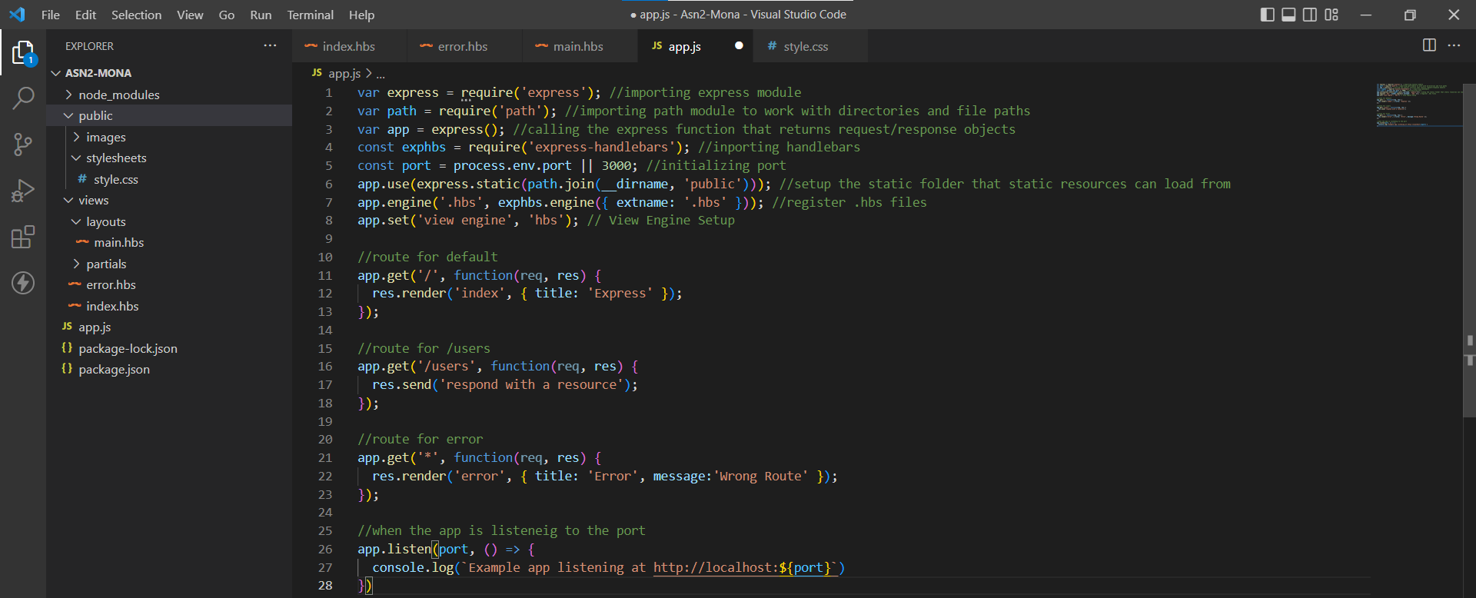

Step:5

Main.hbs

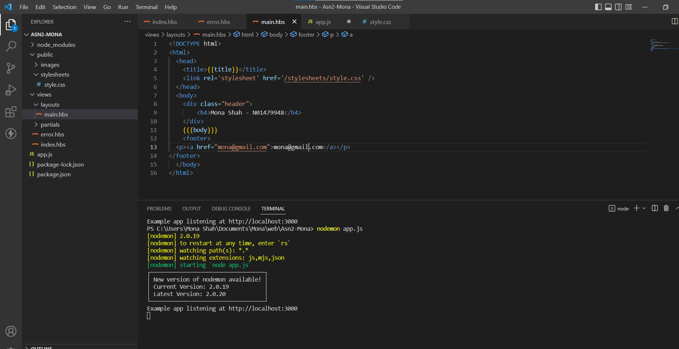

Style.css

Output:

Step:6

App.js

Isbn.hbs

Title.hbs

Output:

Isbn

Incorrect isbn

Title:

Wrong Title:

Step:7

App.js

allData.hbs

Step:8

Step:9

Step:10

a)

b)

Yes “Partial” Templates can be used in headers and footers