/****************************************************************************** *** * **ITE5315 – Assignment 3** * I declare that this assignment is my own work in accordance with Humber Academic Policy. * No part of this assignment has been copied manually or electronically from any other source * (including web sites) or distributed to other students. * * **Name:** Mona Shah **Student ID:** N01479948 **Date:** 11/15/2022 * * ****************************************************************************** **/

1)

2)

3)



4)

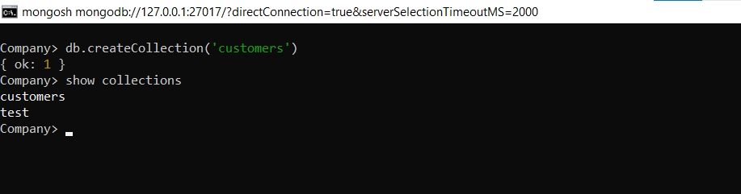

6)

7)

8)

9)

11)



12)



