1)

2)

Activity1:

Activity2:

Activity3:

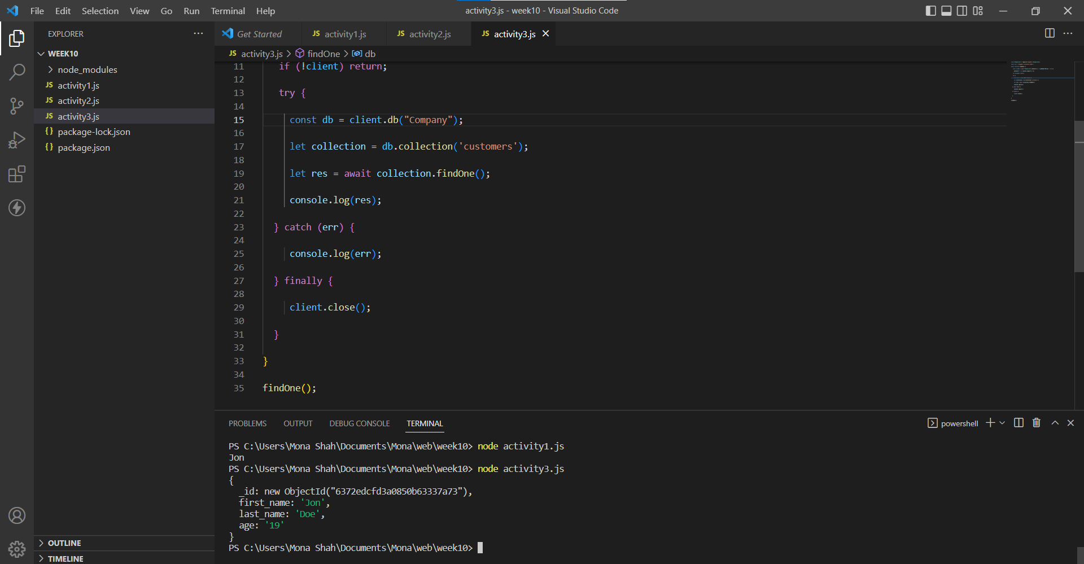

Activity4:

Mongoose Activity:

Step:5

