Warmup Activity:-

The following code firstly helps us to establish connection to the server and request the index.html page with respect to its path and directory. The later part of code consists of pages that we can route through by verifying the url and then demonstrates various node features.

Activity 1:-

Activity 2:-

Activity 3:-

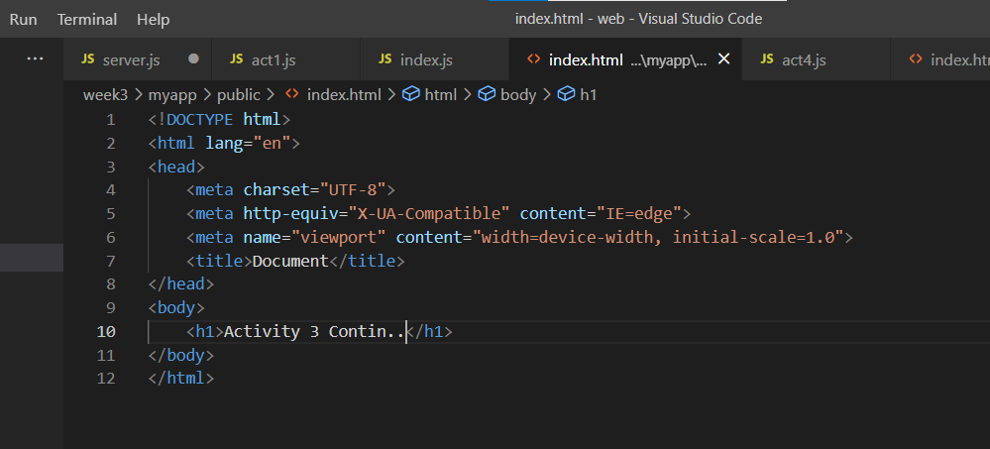

Activity 4:-

