Warm Up activity:

Activity Conti…

Activity1

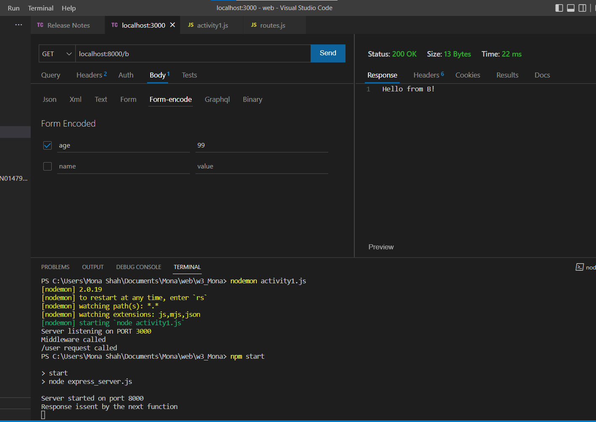

For the Above activity, when the url has address ‘/b’ , the code will route to the next request/response and ‘Hello from B’ will be displayed as output.

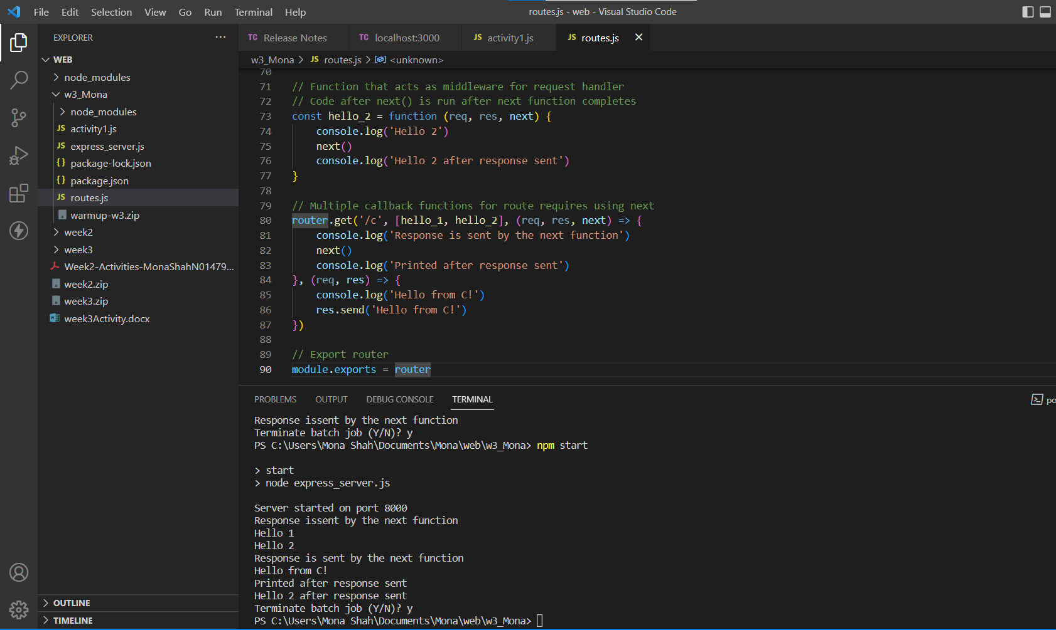

A Middleware is a function that has access to the request/response object. It also enables moving to the next middleware function in the application in the request-response cycle.

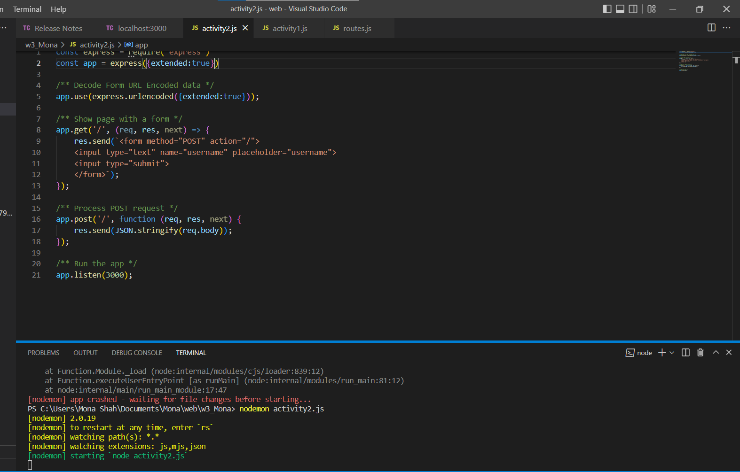

In the below code the ‘express.urlencoded’ is the built in middleware and enables to parse the request/response. The body-parser error was removed by adding ‘extended:true’ to the parameter of the express.urlencoded’

This error occurs because of rich objects and arrays. They need to be encoded into the URL-encoded format

The role of the following commands:

app. Use allows us to include the built in middleware

app.post will take the post request and will route to the next request/response object.

Res.send will send the response by converting the json body into string

