Getting name from someData:

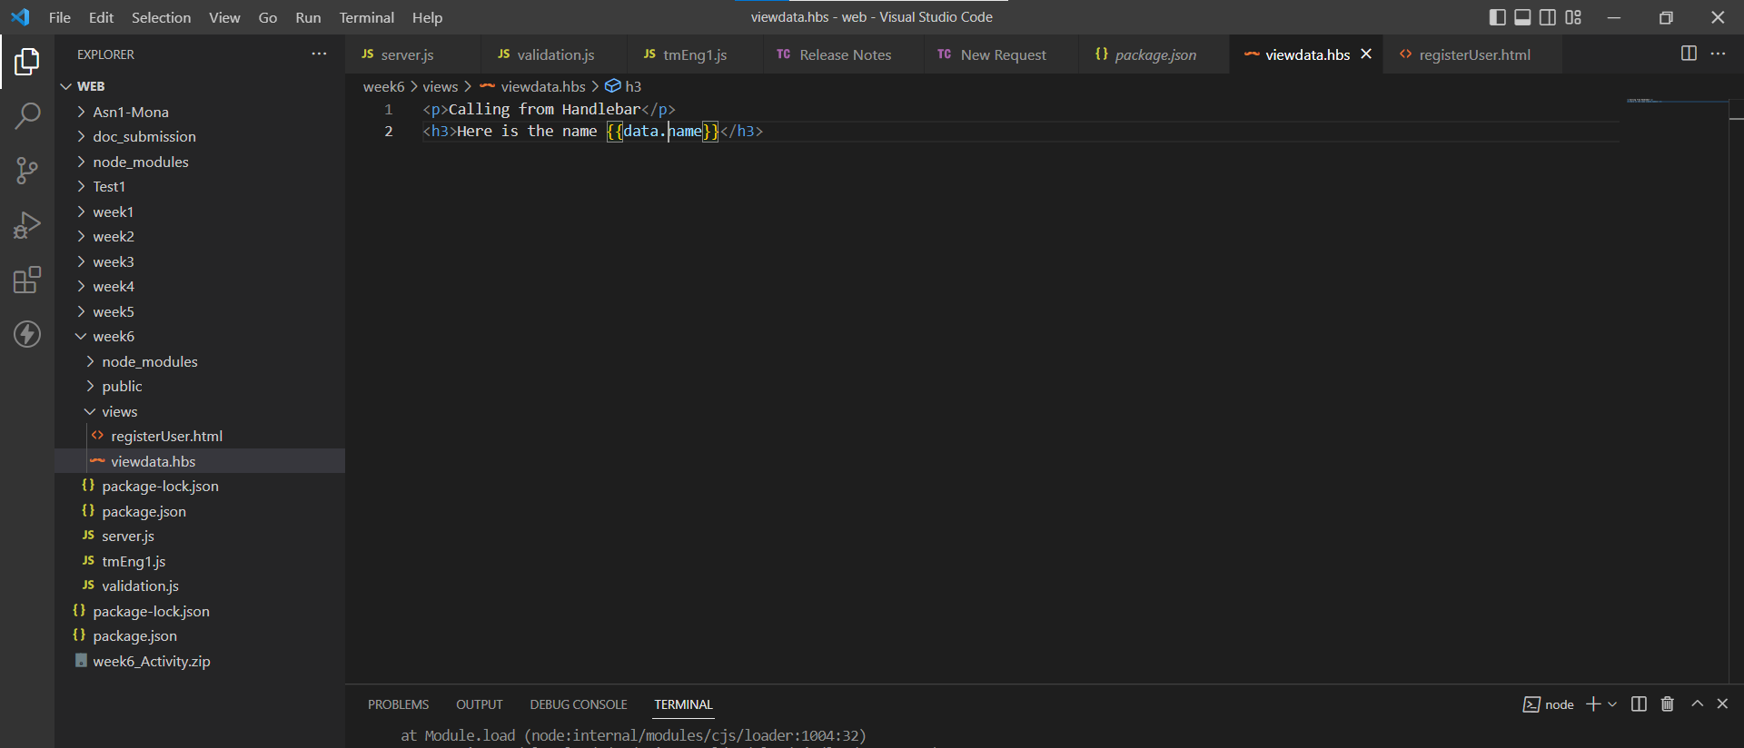

Using array in someData:

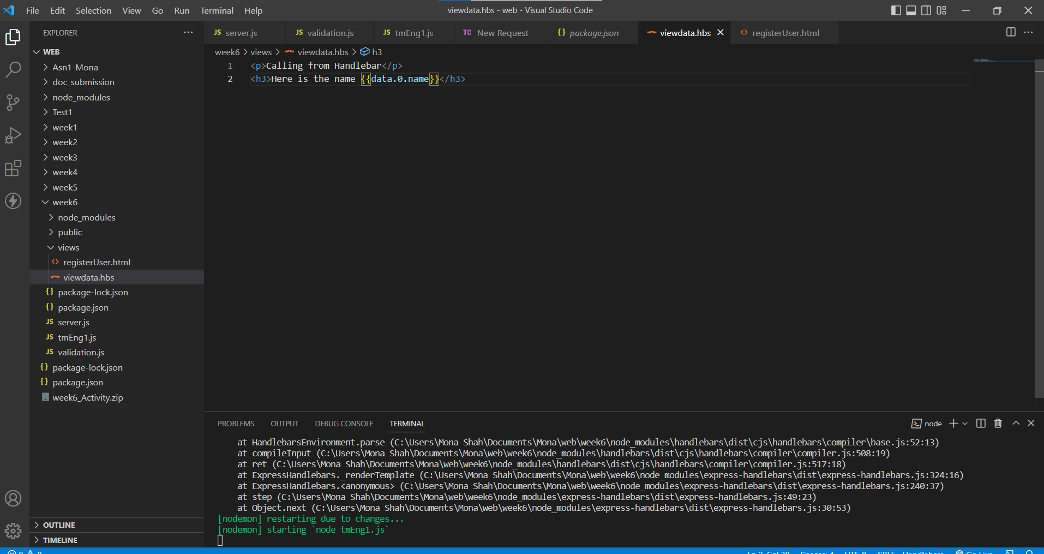

Another way using for-each:

Add two more data to JSON data and display in table format:

Using if:

Custom Helpers:

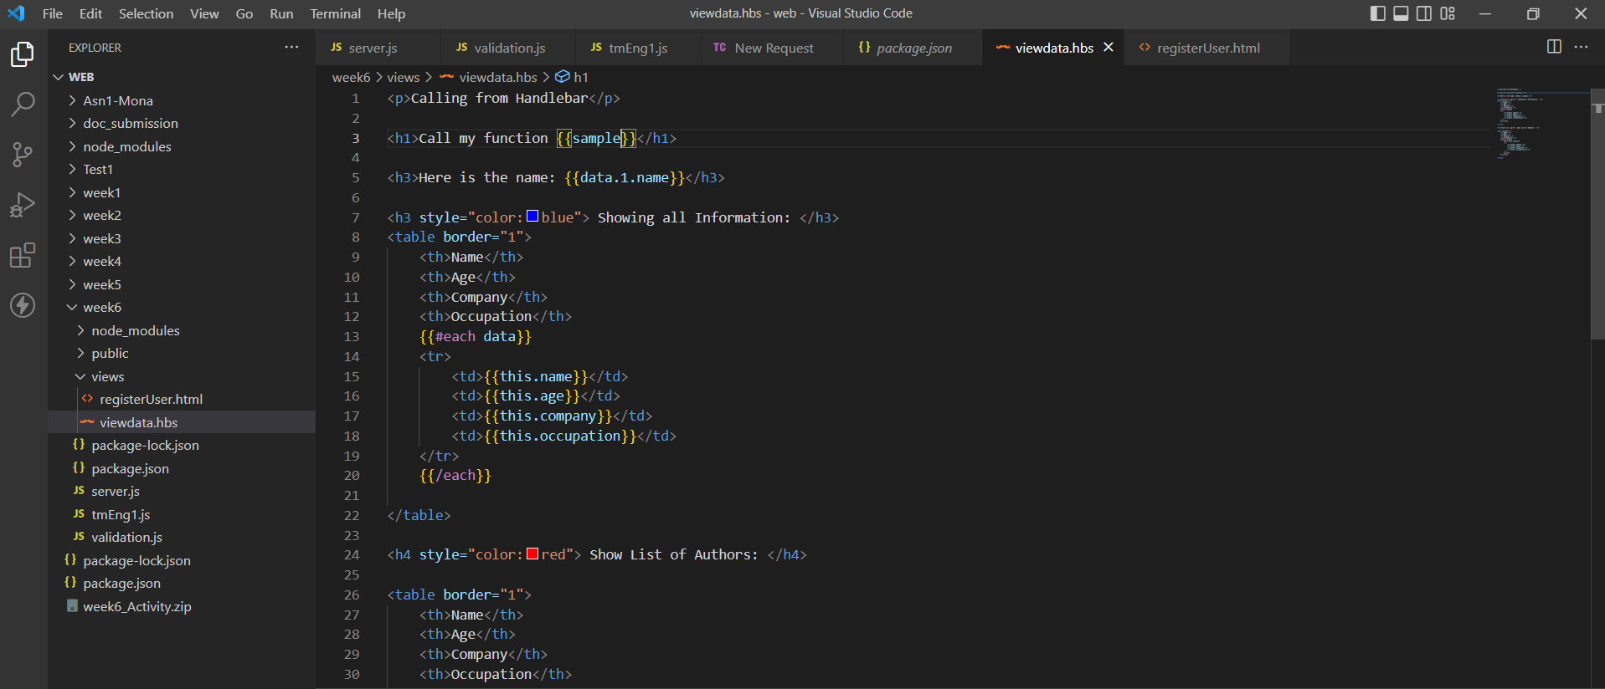

Calculator function:

Using strong:



