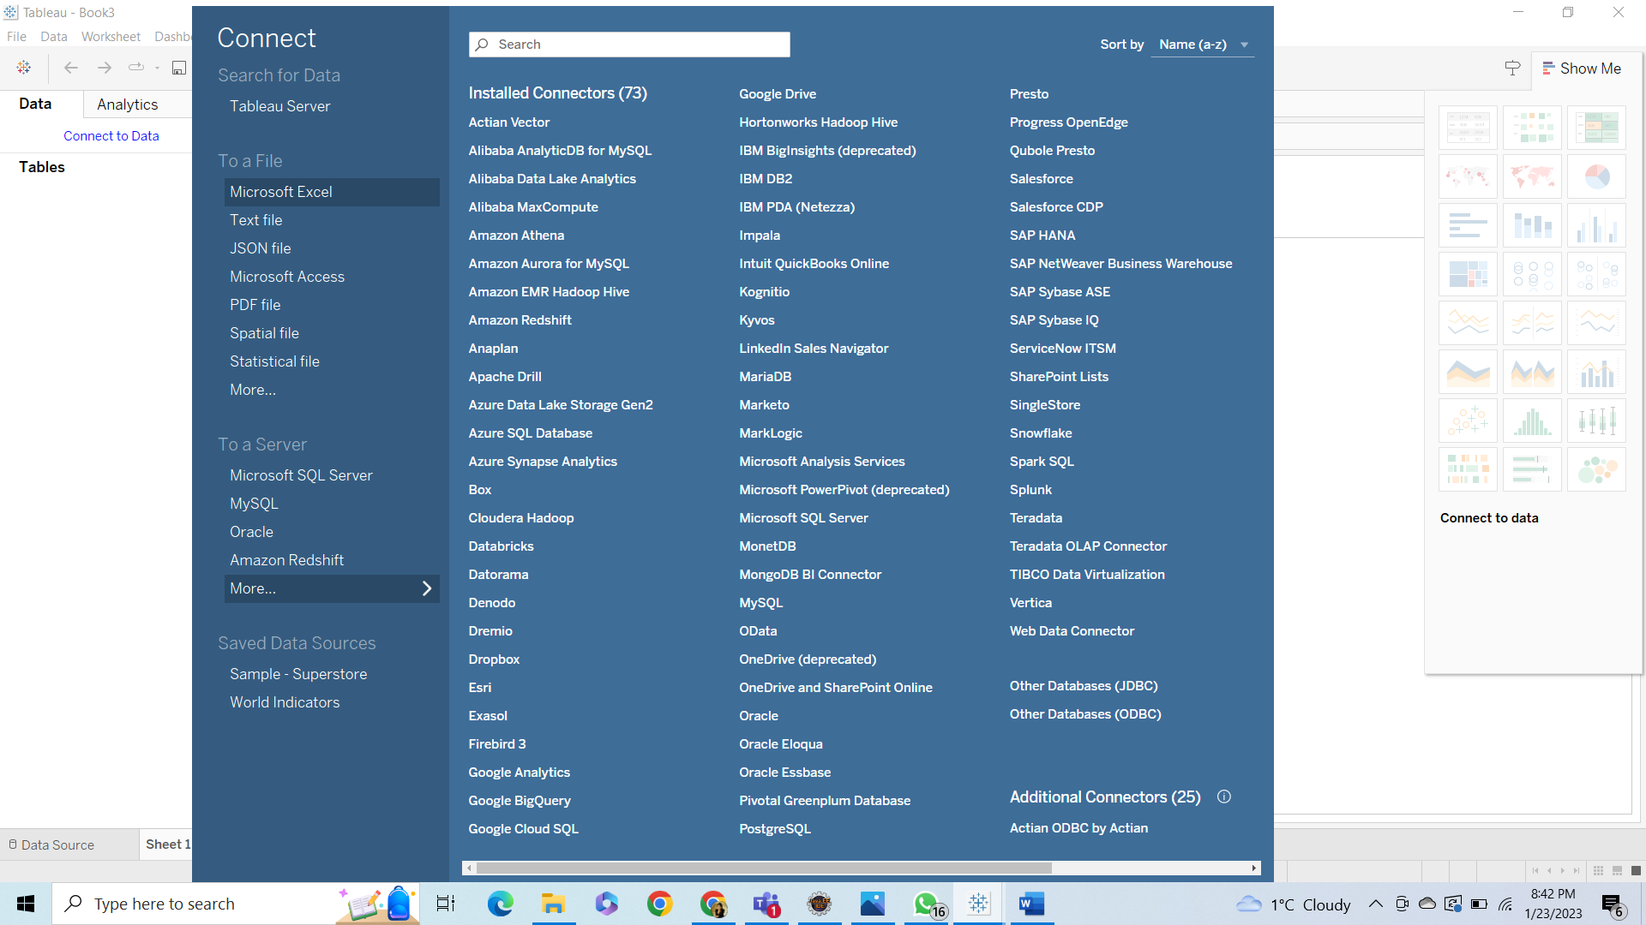

Split Employee

Date Renaming and Data Type

Visualization:

Here we display sum of resolved incidents with respect to employee_id and location.

Viz-2

From the above graph we can determine Maximum resolved incidents as per location for each quarter.