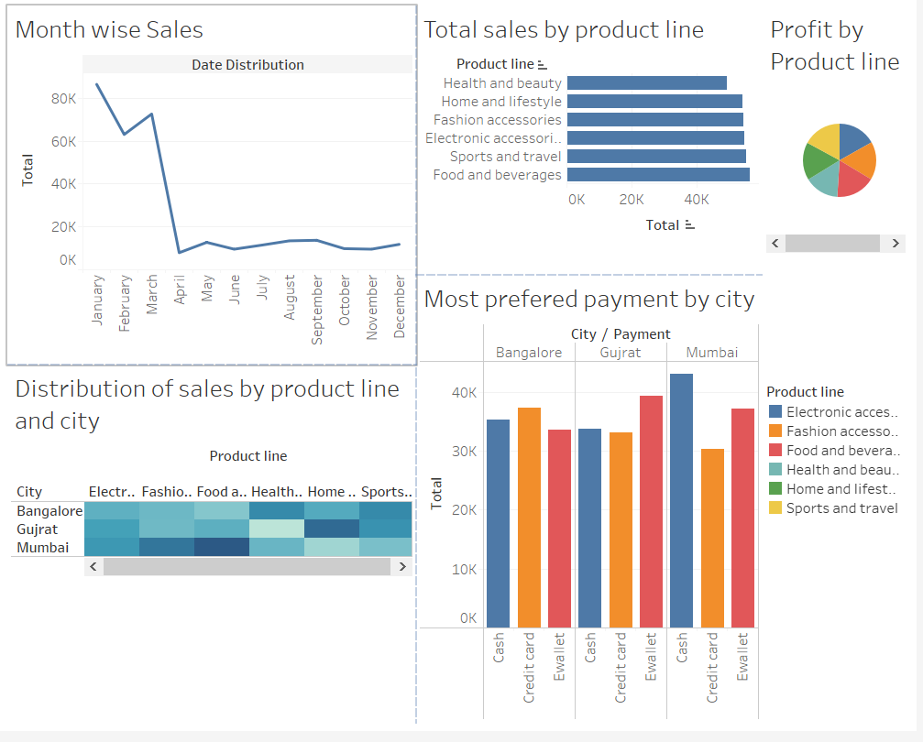

* The above dashboard has 5 visualizations:
* The Line chart depicts total sales with respect to Month.
* The Bar chart depicts total sales with respect to product line.
* For getting into more detailed analysis, we have another visualization of sales with respect to product line and city.
* The Pie Chart gives the Profit that we earned with respect to each Product line.

Profit is a Calculated Field.

* Last but not least we have a visualization for knowing what are the widely used payment methods across the cities.