# http://www.monash.eblib.com.au.ezproxy.lib.monash.edu.au/patron/FullRecord.aspx?p=1659162

# Nomenclature

-Chord symbols

-chords (triads)

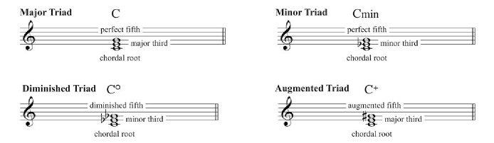

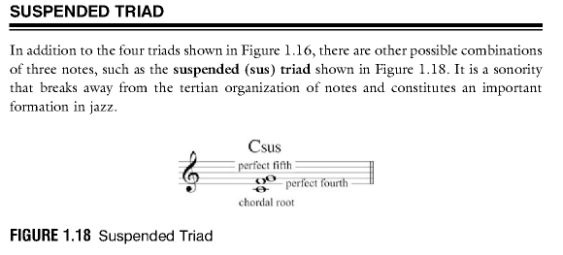

-notation

# Diatonic Principles

-basic terms

-7th chords

-introduction to chord extensions.

# Chord Structures

-Chord structures and functions:

-simple chord movement

-the basic principles of functional harmony

-the ii-V-I progression.

# Harmonic Fundamentals

-Voice leading

-guide tones

-basic chord voicing

# Chord Scales

-Chord Scale relationships

-Modes of the major scale

# Functional Harmony

-Tonal functional harmony

-the cycle of fourths

-simple chord movement

-secondary dominants

# Rhythmic Principles

-basic subdivisions

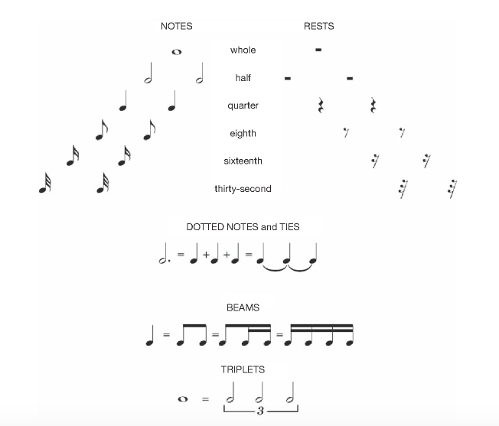

-8th notes

-syncopation and rhythmic tension/release devices.

# Song forms

Song forms and chord progressions:

-Blues - combining melody, harmony and rhythm in improvisation.

# Melody

-contour

-construction

-phrasing.