Modeling and Simulation of a Banded Vegetation with Cadmium

Mohamed Nasr
Student #101377844
mohamednasr@cmail.carleton.ca

Introduction
The Banded Vegetation Model is a cellular automata model used to study the emergence of spatial vegetation patterns in semi-arid and arid environments. The model is based on the work of Dunkerley, who demonstrated that vegetation banding can arise from simple local interactions driven by water redistribution under uniform rainfall conditions between neighboring plants [1].

In this model, the land is represented as a grid of cells, where each cell can either have a plant or be empty (no plant). At each step of the simulation water is shared between neighboring cells based on rules described in the conceptual model section. Whether a plant grows or dies depends on how much water the cell receives. Over time, these simple interactions between cells lead to the formation of vegetation bands.

Conceptual Model

The implemented model consists of a 50 × 50 grid of cells, where each cell represents a single piece of land.

Each cell can exist in one of two states:
- 0: Empty (no vegetation)
- 1: Vegetated (plant present)

The initial configuration of the system is either randomly generated or hardcoded depending on the test case, assigning each cell either state 0 or 1.

Instead of explicitly adding rainfall at each step, rainfall is represented indirectly through interactions between neighboring cells.
- Empty cells absorb 10% of the rainfall, and the remaining water flows downhill to neighboring cells. These cells do not absorb any additional runoff water.
- Vegetated cells absorb 100% of the water they receive. This water is then shared with neighboring cells: 10% is distributed to adjacent and downhill diagonal neighbors, and 5% is sent to cells that are two positions away.
Cell state transitions depend on the accumulated water:
- If a cell receives sufficient water depending on the rule defined in the model specification, vegetation can grow.
- If water levels fall below a threshold depending on the rule defined in the model specification and the cell is vegetated, vegetation dies.

Model Specification
The formal specifications < X, Y, S, N, d, τ, δint, δext, λ, D> for the atomic models are defined as follows:
X = {Ø}
Y = {Ø}
S = {0 : empty cell , 1: plant cell}
N = S^13 => { (-1,1) , (0,1), (1,1), (-1,0),(1,0), (0,-1),(-1,2),(0,2),(1,2),(-2,1),(-2,0),(2,1),(2,0) }
d = transport delay, 1 time unit
τ = “update_rule” pseudo code
Case 1: If the cell is empty (S is 0) and
- The value of primary neighborhood cells: (-1,1) + (0,1) + (1,1) + (-1,0) + (0,-1) + (1,0)
- plus the value of secondary neighborhood cells [ (-1,2) + (0 , 2) + (1,2) + (-2 ,1) + (-2,0) + (2,1) + (2,0) ] / 2
- is greater than or equal to 5 then the cell can grow a plant (S = 1)
Case 2: If the cell is not empty (S is 1) and
- The value of primary neighborhood cells: (-1,1) + (0,1) + (1,1) + (-1,0) + (0,-1) + (1,0)
- plus the value of secondary neighborhood cells [ (-1,2) + (0 , 2) + (1,2) + (-2 ,1) + (-2,0) + (2,1) + (2,0) ] / 2
- plus 9 – [ ((-1 ,1) + (0,1) + (1,1)) × 3] is less than 9.5 then the cell can no longer sustain a plant (S = 0)
Case 3:
- the state remains the same if neither case 1 or case 2 are valid

δint, δext, λ, D are implicitly defined following Cell-DEVS Specification

Note:
- Though in the original CD++ report, for Case 2 of the update rule threshold in the Model Specification was mentioned as 10 not 9.5. However, in the actual implementation of the CD++ source code, 9.5 is used. After further review the value 9.5 produces more refined results.
- In the original CD++ implementation, the Model Specification included 25 neighbors. However, only 13 of these neighbors’ actual have any effect on the state of the cell. To optimize the Cadmium implementation, we set the neighbor size to 13. This has no adverse effect on the model; it produces the same output as the CD++ implementation.

Simulation Results Analysis
Note: The simulation viewer shows the downhill direction going upwards instead of downwards.

Test 1 - Random
In this test scenario we are following the same experimentation done by the referenced paper [1]. The initial state of the grid was randomly generated with a set seed of 47.
Simulation time: 50 units
Initial State:
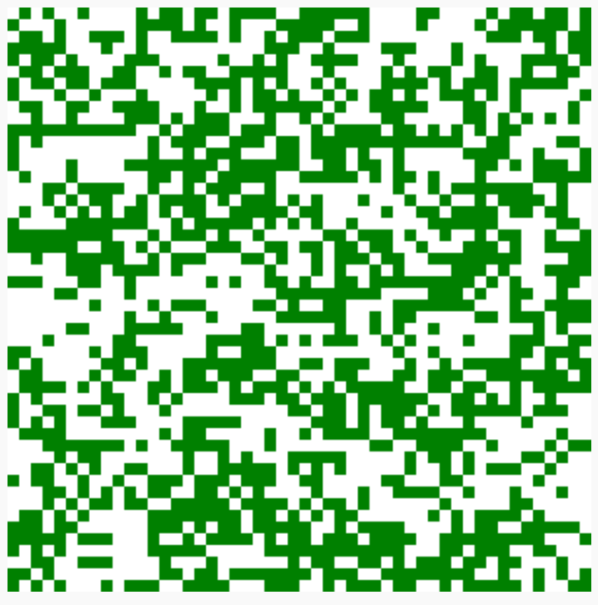
Final State:
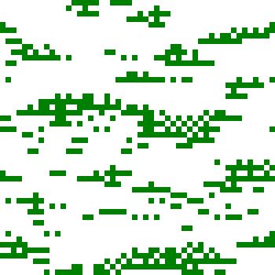
While the banding effect is clearly visible in the final state, the bands are not perfectly continuous and appear somewhat fragmented. This is partly due to the simplifying assumptions made in the model. The thresholds defined for plant growth and death may not capture the full range of environmental conditions. These assumptions, along with the discrete grid structure, result in less uniform bands. Despite this, the overall banding pattern still emerges clearly. The simulation can be found in file “Simulation_Result_Random.webm”

Test 2 - Clusters
In this test scenario, we set two clusters with plants and had a diagonal set of plants connected to them to see if the two clusters merge or remain isolated.
Initial State:
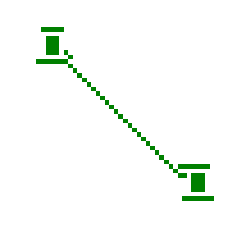
Final State:
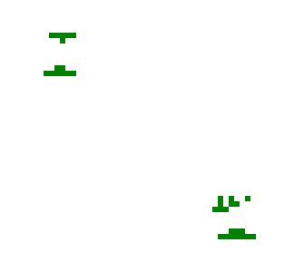
We can see from the final state that the diagonal plants did not survive, and the two clusters remain isolated. The banding effect is still maintained, however it’s small due to initial size of the clusters. The simulation can be found in file “Simulation_Result_Clusters .webm”

Test 3 - Diagonal
In this example we set 3 fully vegetated lines on the grid and connected a set of plants diagonally to see if this will allow them to spread.
Simulation time: 50 Units
Initial State:
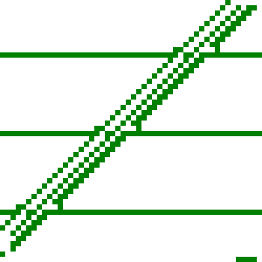

Final State:
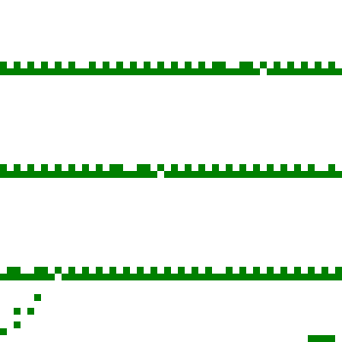
We can see from the simulation “Simulation_Result_Diagonal.webm” that the banding effect is maintained and only the 3 fully vegetated lines survived. This leads us to believe that diagonal cluster of vegetated cells doesn’t help spread the vegetation in the grid, in the next test scenario we will be sitting a third of the grid with plants to see if this will have a spreading effect.

Test 4 - Middle
In this example we set a third of the grid in the middle with plants and let the simulation run.
Simulation time: 35 Units
Initial State:
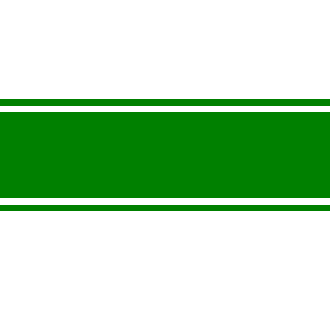
Final State:
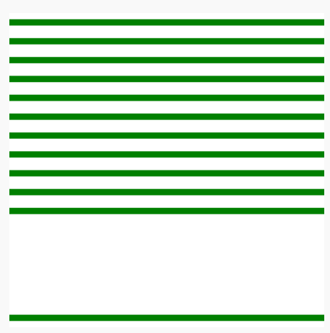
From the video “Simulation_Result_Middle.webm” we see that banding effect is still maintained and the vegetation spread downwards. Due to the wrapped nature of the grid, the spread of vegetation looped to the other side of the grid until it stopped at 35 units of simulation time where the water can no longer spread any further due to the small amount of runoff water available to the other plants which are empty. The empty plants can only absorb 10% which isn’t sufficient enough for them to grow.

References
[1] D. Dunkerley, “Banded vegetation: Development under uniform rainfall from a simple cellular automaton model,” Plant Ecology, vol. 129, no. 2, pp. 103–111, Apr. 1997, doi: 10.1023/A:1009725732740.

