Modeling and Simulation of a Load Balancing System with Cadmium

Mohamed Nasr
Student #101377844
mohamednasr@cmail.carleton.ca

System Overview and Model Structure

System overview
A simplified load-balancing system consists of one balancer, three servers, and one database server. Jobs arrive from clients (generator) are dispatched by the balancer using a round-robin algorithm to be processed by a server (processing time which is exponentially distributed), and then sent to a DB server (fixed processing time) to be returned to the originating server. Once the server receives the DB response, the job is considered finished and is sent out. Jobs are queued when components are busy, and servers may also queue jobs while waiting for DB responses.

Model structure
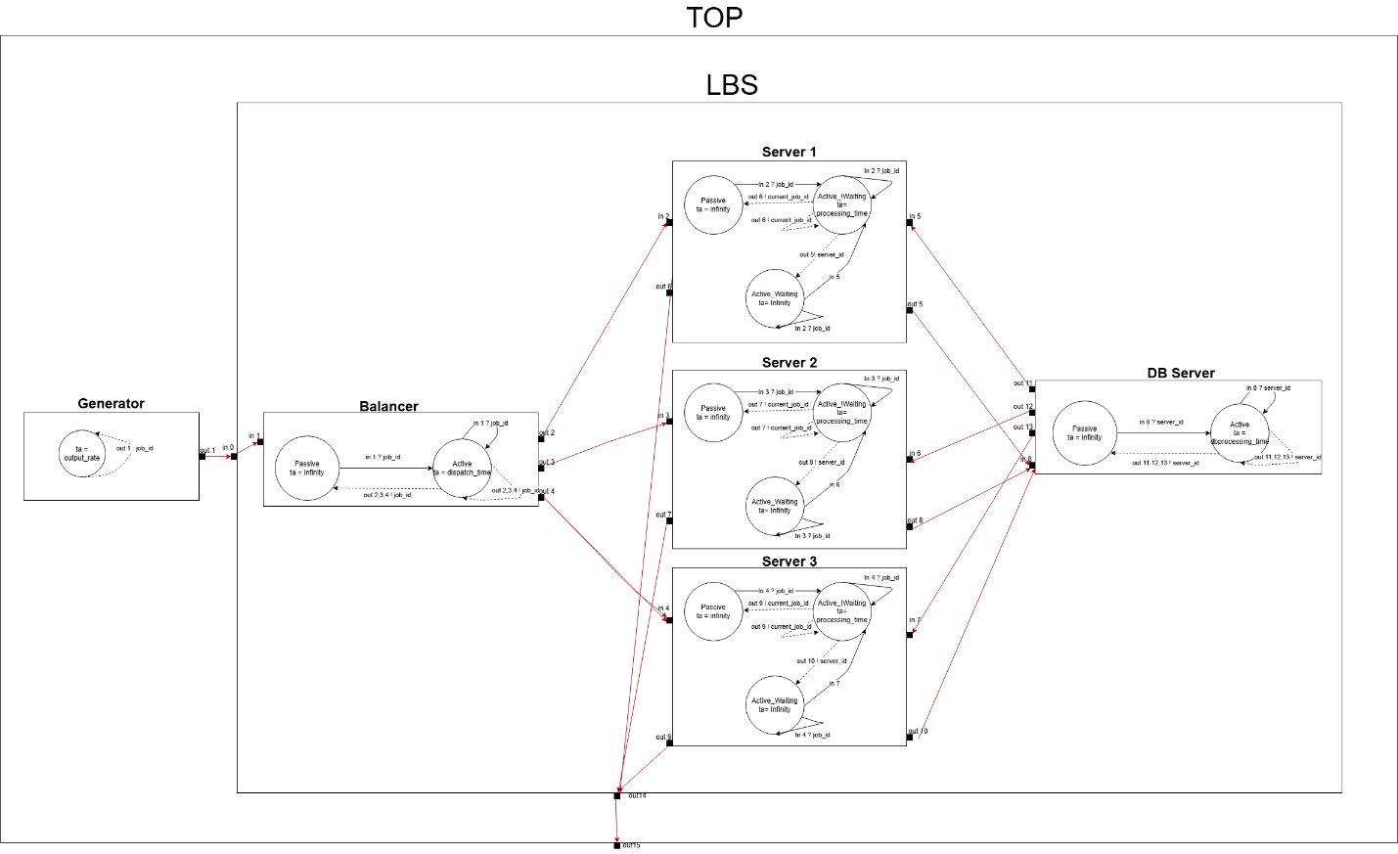

Model Specification & Test Framework
The formal specifications < X, Y, S, δint, δext, λ, ta> for the atomic models are defined as follows:

Model Specification

Atomic Model: Generator
The original implementation of this load-balancing system utilized the built it generator of CD++. However, when adapting it to cadmium the new implementation requires that we formally define the generator as it’s no longer built in.
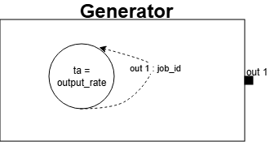

Parameters: output_rate \\ rate of jobs generated
State variables: job_id
X = ∅
Y = { out1 }
S = {job_id)
ta(job_id) = ouput_rate
λ(next_job_id)
{
next_job_id on out1
}

δint(next_job_id)
{
Set job_id = job_id + 1
}

Atomic Model: Balancer
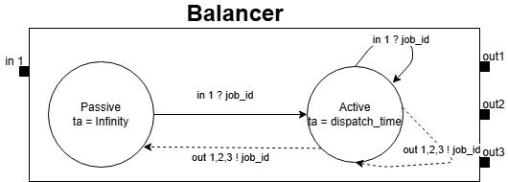

Parameters: dispatch_time
State variables: phase ∈ {active, passive}, sigma, job_queue
X = {in1}
Y = {out1, out2, out3 }
S = {phase, sigma, job_queue}

ta(passive) = INFINITY, ta(active) = dispatch_time

δext (s, e, x)
{
enqueue x into job_queue
if queue size becomes 1: \\ was empty
phase=active, sigma=dispatch_time
else:
remain in current phase \\ still dispatching/queued
}

λ(active)
{
let j = front(job_queue)
if j mod 3 = 0
output j on out1
else if j mod 3 = 1
output j on out2
else
output j on out3
pop job from the queue
}

δint(active):
{
if queue non-empty
phase = active, sigma=dispatch_time
else
phase = passive, sigma=∞
}

Atomic Model: Server
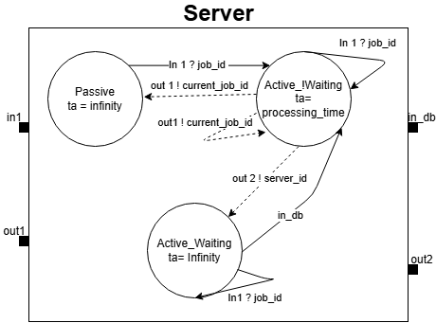

Parameters: mean
State variables: phase ∈ {active, passive}, sigma, job_queue, waiting
X = {in1, in_db}
Y = {out1, out2}
S = {phase, sigma, job_queue}

ta(passive) = INFINITY, ta(active, waiting) = INFINITY
ta(active) = processing_time

δext (s, e, x)
{
If input arrives on in1:
enqueue job_id
if queue size becomes 1 and waiting=false
phase = active, sigma = processing_time
Else if input arrives on in_db AND waiting=true:
Phase = actice, sigma = 0
}

λ(active)
{
If waiting== true:
output current_job_id on out \\ job finished
Else waiting== false:
set current_job_id = front(job_queue)
output server_id on out2 \\send to DB server
pop job from the queue
}

δint(active):
{
Toggle waiting
If job_queue non-empty and waiting==false
Phase = active, sigma = processing_time
Else
Phase = passive, sigma = infinity
}

Atomic Model: DB Server
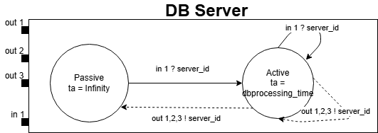

Parameters: dbprocessing_time
State variables: phase ∈ {active, passive}, sigma, job_queue,
X = {in1}
Y = {out1, out2, out3}
S = {phase, sigma, job_queue}

ta(passive) = INFINITY, ta(active) = dbprocessing_time

δext (s, e, x)
{
enqueue server_id
if queue size becomes 1
phase = active, sigma = dbprocessing_time
}

λ(active)
{
current_server = front(queue)
if current_server == 1 then
send current_server through out1
else if current_server == 2 then
send current_server through out2
else
send current_server through out3
pop job from the queue
}

δint(active):
{
If queue not empty
Phase = active, sigma = DBprocessing_time
Else
Phase = passive, sigma - infinity
}

Coupled Model: LBS
The formal specifications <X, Y, D, {Mi}, EIC, EOC, IC, SELECT > for the coupled model LBS and TOP models are defined as follows:
The LBS coupled model is a full load balancing system without the integration of the generator.
X = { in }
Y = { out }
M = {balancer, server1, server2, server 3, db server}
EIC = { (in, balancer.in) }
EOC = { (server1.out1, LBS.out), (server2.out1, LBS.out), (server3.out1, LBS.out) }
IC = { (balancer.out1, server1.in1), (balancer.out2, server2.in1), (balancer.out3, server3.in1), (server1.out2, dbserver.in), (server2.out2, dbserver.in), (server3.out3, dbserver.in), (dbserver.out1, server1.in_db), (dbserver.out2, server2.in_db), (dbserver.out3, server3.in_db) }
SELECT : ({balancer, server1, dbserver}) = dbserver
({balancer, server2, dbserver}) = dbserver
({balancer, server3, dbserver}) = dbserver
({balancer, server1}) = server1
({balancer, server2}) = server2
({balancer, server3}) = server3

Coupled Model: TOP
The top model is the integration of the LBS with the generator
X = { }
Y = { out }
EIC = { }
EOC = { (LBS.out, out) }
IC = { (generator.out, LBS.in) }
SELECT : ({generator, LBS}) = LBS

Test Framework
For the testing framework, we will test each atomic model individually and verify specific set of functionalities. Once all atomic models are tested, we will test coupled models and verify that the behavior (outputs) is correct.

Generator Tests
- Verify that new Job IDs are outputted based on the output rate.

Balancer tests
- Verify outputs go to out1/out2/out3 according to the correct round robin algorithm and that it only releases the jobs after the set dispatch time.

Server tests
- Verify the server finishes jobs following the order of jobs in the queue
- Verify the server finishes jobs as soon as it receives an acknowledgement from db server
- Verify the server stays in active and waiting state until it receives an acknowledgement from db server

DBServer tests
- Verify FIFO queueing and correct routing to out1/out2/out3.

Coupled tests (LBS)
- Verify end-to-end traces, each job eventually produces exactly one completion on the output ports of each server.

Coupled tests (TOP)
- Test 1
  - In this test, all parameters remain fixed except the server mean processing time, which is gradually reduced from 5 to 0.1 seconds. Since a smaller server processing mean time should lead to faster processing time, we expect an increase in system job throughput. The objective is to verify that improving server processing speed leads to a higher rate of completed jobs.
- Test 2
  - This test is to mimic a system architect that is checking for the maximum workload the system can handle while maintaining acceptable performance (99% of jobs being processed). With fixed parameters for the balancer, servers, and DB server, the generator output is gradually increased. The goal is to find the threshold at which the system can successfully complete at least 99% of incoming job requests in a span of 1 hour.

Simulation Results Analysis
The atomic models (Generator, Balancer, Server, and DB Server) are first tested individually and then integrated into coupled models (LBS and Top) for further testing.
Note:
It should be noted that in the actual implementation include, there are two additional parameters that can be found in some of the models
- Parameter 1: log_path
- Parameter 2: current_time
- Parameter 3: Jobs_done
These additional parameters were introduced in the implementation to produce readable logs that are used in this report, they were not mentioned in the formal definitions of the models as they are only used for logging purposes. Each model tested produced two output logs, one with .txt extension and another with .csv extension, both .txt and .csv logs are equivalent. The .txt refers to the human readable logs produced utilizing the mentioned parameters and the .csv refers to the logs produced by Cadmium built in logger. For sake of readability and debugging this report utilizes the .txt logs.
The two parameters can be removed, and they will not affect the intended behavior of the models, and the .csv files for each test can be found in the Github repo under “simulation_results”.

Atomic Model: Generator Test
To test the generator, we only need to provide one input parameter:
- output_rate
In the following example, we set the output_rate to 1, which produces a new job every second.
Simulation runtime: 4 seconds
Input parameter:
- output_rate = 1 // generate a job every 1 second
Model Output:
Time Output
1 Generator outputs Job# 1 at generator_out1
2 Generator outputs Job# 2 at generator_out1
3 Generator outputs Job# 3 at generator_out1
4 Generator outputs Job# 4 at generator_out1
Simulation Ended
The generator model test passed, and it works as we expected, a job is generated every second.

Atomic Model: Balancer Test
To test the balancer, we will need to provide the following inputs:
- Input parameter: dispatch_time (balancer dispatch time)
- Input tests to in1 (balancer input from generator)
  - Since we are testing the balancer model on its own, we have utilized Cadmium IEStream to provide inputs to the balancer based on a csv file with set time and input values.
Simulation runtime: INFINITY
Input parameter:
- dispatch_time = 1 // dispatch a job to the server cluster every second
Input file (in1):
Time Value
5 1
6 2
7.1 3
7.2 4
7.3 5
Model Output:
Time Output
5 Balancer receives Job# 1 at balancer_in
6 Balancer sends job# 1 to server 2 at balancer_out2
6 Balancer receives Job# 2 at balancer_in
7 Balancer sends job# 2 to server 3 at balancer_out3
7.1 Balancer receives Job# 3 at balancer_in
7.2 Balancer receives Job# 4 at balancer_in
7.3 Balancer receives Job# 5 at balancer_in
8.1 Balancer sends job# 3 to server 1 at balancer_out1
9.1 Balancer sends job# 4 to server 2 at balancer_out2
10.1 Balancer sends job# 5 to server 3 at balancer_out3
Simulation Ended
The model outputs show that the balancer is functioning correctly as per the specification defined. It assigns job IDs in a repeating cycle, sending each job to server 2, then server 3, then server 1, before starting the sequence again following the round-robin scheduling defined.
The balancer also only dispatched the jobs after 1 second of processing it. Even in the scenario where it receives 3 jobs at time 7.1, 7.2, 7.3 (highlighted in yellow). it only dispatched job#3 at time 8.1 (one second later after receiving the job with an empty), job# 4 at time 9.1 (one second later after dispatching the previous job), job# 5 at time 10.1 (one second later after dispatching the previous job).

Atomic Model: Server Test
To test the balancer, we will need to provide the following inputs:
- Input parameter: mean (the mean for the exponentially distributed processing time of the server)
- Input tests to in1 (server input from balancer)
  - Since we are testing the server model on its own, we have utilized Cadmium IEStream to provide inputs to the server based on a csv file with set time and input values.
- Input tests to in_db (server input from dbserver)
  - Since we are testing the server model on its own, we have utilized Cadmium IEStream to provide inputs to the server based on a csv file with set time and input values.

Simulation runtime: INFINITY
Input parameter:
- mean = 0.5 // mean processing time of 0.5 seconds

Input file (in1):
Time Value
0.1 1
0.2 2
0.3 3
Input file (in_db):
Time Value
2.0 1
5.0 2
Model Output:
Time Output
0.1 Server 1 receives job# 1 at server_in1
0.1 Server 1 starts processing job# 1
0.2 Server 1 receives job# 2 at server_in1
0.3 Server 1 receives job# 3 at server_in1
1.95786 Server 1 sends job# 1 to database server at server_out2
2 Server 1 receives DB acknowledgment for job# 1 at server_in_db
2 Server 1 finishes job# 1 at server_out1
2 Server 1 starts processing job# 2
2.04618 Server 1 sends job# 2 to database server at server_out2
5 Server 1 receives DB acknowledgment for job# 2 at server_in_db
5 Server 1 finishes job# 2 at server_out1
5 Server 1 starts processing job# 3
5.29452 Server 1 sends job# 3 to database server at server_out2
Simulation Ended
The server model output shows that it behaves as per the specification defined. The average processing time was 0.3 seconds, which is expected as it’s only tested on 3 jobs. We can expect the average processing time to reach 0.5 on a larger set of jobs.
The server finishes the jobs as soon as it receives the acknowledgement from the DB server as expected. And in this test case, we are also testing for a specific behavior, which is that once the server reaches a state of active and waiting (awaiting acknowledgement from the db server), It should stay in that state for infinity until it receives an input from in_db. In the test input file for in_db, we never included an acknowledgement for Job #3, so the model should never finish job #3. The simulation ends even with a set time of infinity, and the server never finishes job #3, as anticipated.

Atomic Model: DB Server Test

To test the balancer, we will need to provide the following inputs:
- Input parameter: dbprocessing_time (processing time for each request received from the servers)
- Input tests to in1 (dbserver input from the servers)
  - Since we are testing the dbserver model on its own, we have utilized Cadmium IEStream to provide inputs to the dbserver based on a csv file with set time and input values.
Simulation runtime: INFINITY
Input parameter:
- dbprocessing_time = 0.5 // takes 0.5 seconds to process a request from the server

Input file (in1):
Time Value
2.0 1
2.0 2
2.0 3

Model Output:
Time Output
2 DBServer receives job from server#1 at dbserver_in1
2 DBServer receives job from server#2 at dbserver_in1
2 DBServer receives job from server#3 at dbserver_in1
2.5 DBServer sends job back to server#1 at dbserver_out1
2.5 Jobs done by DB Server: 1
3 DBServer sends job back to server#2 at dbserver_out2
3 Jobs done by DB Server: 2
3.5 DBServer sends job back to server#3 at dbserver_out3
3.5 Jobs done by DB Server: 3
Simulation Ended
The output from the dbserver model shows that it behaves correctly as per the specification defined. In this test scenario, the dbserve receives 3 inputs at the same time showcasing a scenario where it receives a request from all 3 servers at the same time. We can see from the output that it only processes the requests following the same sequence in which the requests were received (FIFO), and that it takes 0.5 seconds to process each request.

Coupled Model: LBS Test
To test the LBS, we will need to provide the following inputs:
- Input parameters
  - dispatch_time (balancer dispatch time)
  - mean (the mean for the exponentially distributed processing time of the server cluster)
  - dbprocessing_time ( db server processing time for each request received from the servers)
- Input tests to in (LBS input from the generator)
  - Since we are testing the LBS model on its own, we have utilized Cadmium IEStream to provide inputs to the LBS based on a csv file with set time and input values.
Simulation runtime: INFINITY
Input parameter:
- dispatch_time = 1 // balancer takes 1 second to dispatch each job once it processes it
- dbprocessing_time = 1 // db server takes 1 seconds to process a request from the server
- mean = 0.5 // server mean processing time of 0.5 seconds

Input file (in):
Time Value
1 1
2 2
3 3
4 4
Model Output:
Time Output
1 Balancer receives Job# 1 at balancer_in
2 Balancer sends job# 1 to server 2 at balancer_out2
2 Server 2 receives job# 1 at server_in1
2 Server 2 starts processing job# 1
2 Balancer receives Job# 2 at balancer_in
2.89079 Server 2 sends job# 1 to database server at server_out2
2.89079 DBServer receives job from server#2 at dbserver_in1
3 Balancer sends job# 2 to server 3 at balancer_out3
3 Server 3 receives job# 2 at server_in1
3 Server 3 starts processing job# 2
3 Balancer receives Job# 3 at balancer_in
3.0587 Server 3 sends job# 2 to database server at server_out2
3.0587 DBServer receives job from server#3 at dbserver_in1
3.89079 DBServer sends job back to server#2 at dbserver_out2
3.89079 Jobs done by DB Server: 1
3.89079 Server 2 receives DB acknowledgment for job# 1 at server_in_db
3.89079 Server 2 finishes job# 1 at server_out1
4 Balancer sends job# 3 to server 1 at balancer_out1
4 Server 1 receives job# 3 at server_in1
4 Server 1 starts processing job# 3
4 Balancer receives Job# 4 at balancer_in
4.0461 Server 1 sends job# 3 to database server at server_out2
4.0461 DBServer receives job from server#1 at dbserver_in1
4.89079 DBServer sends job back to server#3 at dbserver_out3
4.89079 Jobs done by DB Server: 2
4.89079 Server 3 receives DB acknowledgment for job# 2 at server_in_db
4.89079 Server 3 finishes job# 2 at server_out1
5 Balancer sends job# 4 to server 2 at balancer_out2
5 Server 2 receives job# 4 at server_in1
5 Server 2 starts processing job# 4
5.00878 Server 2 sends job# 4 to database server at server_out2
5.00878 DBServer receives job from server#2 at dbserver_in1
5.89079 DBServer sends job back to server#1 at dbserver_out1
5.89079 Jobs done by DB Server: 3
5.89079 Server 1 receives DB acknowledgment for job# 3 at server_in_db
5.89079 Server 1 finishes job# 3 at server_out1
6.89079 DBServer sends job back to server#2 at dbserver_out2
6.89079 Jobs done by DB Server: 4
6.89079 Server 2 receives DB acknowledgment for job# 4 at server_in_db
6.89079 Server 2 finishes job# 4 at server_out1
Simulation Ended
The output shows that the load balancing system works as specified. Each job is executed once, and the jobs are distributed from the load balancing follow the round-robin scheduling (Job #1 is sent to server 2, Job#2 is sent to server 3, Job#3 is sent to server 1, Job#4 is sent to server 2 – Highlighted in green). Both the Balancer and DB server execute jobs following the specified parameters (1 second for dispatching, and 1 second for db processing), we can see this from the output highlighted in yellow.

Coupled Model: TOP Test

Test 1
To test the TOP model, we will need to provide the following inputs:
- Input parameters
  - output_rate (generator job output rate)
  - dispatch_time (balancer dispatch time)
  - mean (the mean for the exponentially distributed processing time of the server cluster)
  - dbprocessing_time ( db server processing time for each request received from the servers)

Simulation runtime: 1 Hour (3600 seconds)
Input parameter:
- output_rate = 0.5 // generator produces a job every 0.5 seconds
- dispatch_time = 1 // balancer takes 1 second to dispatch each job once it processes it
- dbprocessing_time = 1 // db server takes 1 seconds to process a request from the server
- mean = [5 , 3 , 1, 0.5 , 0.1] // list of server mean processing times

Since the output logs for this test are long and unfeasible to include in the report, please refer to the table below showcasing the results collected when running the Top model with different server processing mean time:

Generator output_rate | Balanacer dispatch time | dbserver processing time | Server processing time Mean | Jobs Finished
0.5 | 1 | 1 | 5 | 1762
0.5 | 1 | 1 | 3 | 2438
0.5 | 1 | 1 | 1 | 3519
0.5 | 1 | 1 | 0.5 | 3595
0.5 | 1 | 1 | 0.1 | 3599

The results show that the number of completed jobs increases as the server mean processing time decreases, which is the expected behavior of the system. However, when the server processing time mean is further reduced from 0.5 to 0.1 seconds, no additional improvement in completed jobs is observed. This indicates that the servers are no longer the performance bottleneck; instead, the limiting factors become the balancer’s dispatch time and the DB server’s processing time.

Test 2
To test the TOP model, we will need to provide the following inputs:
- Input parameters
  - output_rate (generator job output rate)
  - dispatch_time (balancer dispatch time)
  - mean (the mean for the exponentially distributed processing time of the server cluster)
  - dbprocessing_time (db server processing time for each request received from the servers)
Simulation runtime: 1 Hour (3600 seconds)
Input parameter:
- output_rate = [5 , 3 , 1, 0.5, 0.1] // list of generator output rates
- dispatch_time = 0.5 // balancer takes 0.5 second to dispatch each job once it processes it
- dbprocessing_time = 0.5 // db server takes 0.5 seconds to process a request from the server
- mean = 0.1 // mean processing time of 0.1 seconds

Since the output logs for this test are long and unfeasible to include in the report, please refer to the table below showcasing the results collected when running the Top model with different generator output_rate:
Generator output_rate | Balanacer dispatch time | dbserver processing time | Server processing time Mean | Jobs Produced | Jobs Finished | % of Jobs finished
5 | 0.5 | 0.5 | 0.1 | 720 | 719 | 99.86%
3 | 0.5 | 0.5 | 0.1 | 1200 | 1199 | 99.92%
1 | 0.5 | 0.5 | 0.1 | 3600 | 3599 | 99.97%
0.5 | 0.5 | 0.5 | 0.1 | 7200 | 7197 | 99.94%
0.3 | 0.5 | 0.5 | 0.1 | 12000 | 7197 | 59.98%

The results show that for generator output rates of 5, 3, 1, and 0.5, the system maintains a finished job % of 99, meaning almost all produced jobs are successfully finished. As the generator rate increases the number of jobs produced also increases, and the number of jobs finished rises proportionally. This indicates correct system behavior and shows that no bottleneck is present. However, when the generator begins producing a job every 0.3 seconds, the percentage of completed jobs drops significantly, indicating that the system has reached its processing limit.

Conclusion
All test outputs confirm that the load balancing system behaves according to the specification defined.
The model can be used to help system architects evaluate performance under different constraints (dbprocessing time, server processing time, balancer dispatch time) by specifying a desired % of jobs finished and running simulations to observe system behavior and check for bottlenecks.

