

**The Arab American University**

**Faculty of Engineering and Information Technology**

**Computer System Engineering Department**

**Senior Project 1**

**Smart Mobile Application for A Health Care Requests**

Prepared by:

**Marah Nairat**

**Hiba Shalabi**

**Deema Almasri**

Supervisor:

Prof. Dr. Mohammad Awad

Jenin 2020

# **Acknowledgments**

We would like to extend our sincere thanks to our supervisor Prof. Dr. Mohammed Awad, who has been greatly credited for our support and assistance in completing this project, we thank the Faculty of Engineering and Information Technology for its Dean and its lecturers, and we do not forget our Families, who are sacrificing their most precious possessions for us, to become good engineers and able to assume the responsibilities and support our beloved country Palestine.

# **Abstract**

With the acceleration of technology and in recent years especially the use of mobile applications. The use of health mobile application technology will help physicians and patients simultaneously. The proposed Mobile application system depends on the analysis of disease symptoms and provides the patients with the best, suitable, and accurate medical services depending on the most influential variables in this field. When the patient suffers from pain it is not easy to go directly to the health centers, especially if they are alone at home and the employees who are always busy. For these reasons the proposed smart mobile application system can determine the type of the illness in its general field by using smart data mining tools depends on the symptoms that the patient suffering. Also, it can send alerts, advice to choose appropriate appointments, and manage treatment processes in general.

The project supports the design of the smartphone application that can be used by the patient and the physician, which uses data analysis technology. The system includes a knowledge base (database) to analyze and clustering disease symptoms and suppose a suitable physician. The application can be downloaded on the mobile phone so that the patient will select the most important symptoms of which are suffering from the symptoms option list, and then compared to data of disease symptoms stored in the knowledge base (database) depends on a smart clustering method, the system will propose the nearest physician in the determine field and help the patient to visit the appropriate physician. Also, the patient can ask for a home treatment service, he can make an appointment, and request an ambulance, home laboratory analysis, medical imaging service and, ....etc. This system will provide time, effort, and cost for the patient, reducing the pressure on physicians in hospitals, with the ability to select the most convenient physicians in the interesting geographical area using artificial intelligence algorithms. On another hand, this smart mobile application can use to facilitate and observing the patient treatment by sending notifications to the patient to remind him to take medication on time and helps to organize the treatment dates between the patient and his physicians, laboratory and medical imaging departments, furthermore, the system can suggest some suitable medical articles related to his illness for patient review.

The project will be a mobile application that will be used from the renter and renter out, the application includes Database to store the data and analyze search results, the renter can specify his

Table of Contents

**Acknowledgments** 1

**Abstract** 2

**List of Figures** 5

**Chapter one** 6

**Introduction** 6

**1.1 Background and Motivation** 6

**1.2 Aims and objectives** 6

**1.3 Problem Statement** 7

**1.4 Contributions** 8

**1.5 Overview** 8

**Chapter Two** 9

**Literature Review** 9

**2.1 Overview** 9

**2.2 Existing Systems** 9

**2.2.1** **Vezeeta** 9

2.2.2 **MyMedicNow** 10

2.2.3 **Zocdoc** 11

2.2.4 **Doctor on Demand** 12

2.2.5 **WebTeb** 12

2.2.6 **Care Zone** 13

**2.3 Summary** 13

**Chapter Three** 15

**System Design** 15

**3.1 Introduction** 15

**3.2 Hardware** 15

**3.3 Architectural Design** 15

**3.4 System Design** 16

**3.5 Clustering Algorithm** 18

**3.6 Use case diagram** 23

**3.7 Class diagram** 25

**3.8 System Database (entity diagram)** 27

**Chapter Four** 30

**Conclusion and Future Work** 30

**4.1 Conclusions** 30

**4.2 Future work** 30

**References** 31

# **List of Figures**

Fig 2.1 Vezeeta……………………………….…………………….……….….8

Fig 2.2 MyMedicNow ……………………….…………………….……….….9

Fig 2.3 Zocdoc ……………………………….…………………….……….….10

Fig 2.4 Doctor On Demand ...……………….…………………….…..…….….11

Fig 2.5 WebTeb …………......……………….…………………….……….….11

Fig 2.6 Care Zone …………...……………….…………………….……….….12

Fig 3.1 System Architectural design ……….…………………….……….….15

Fig 3.2 System Design ……………………………………….…………..….…16

Fig 3.3 Specialization Selection algorithm …. …………………………..…….17

Fig 3.4 Clustering Algorithm …………………………………………….….…19

Fig 3.5 k-means algorithm ….…………………………………………….……21

Fig 3.6 Nearest physician algorithm ... …………………………………..…….21

Fig 3.7: K-NN Algorithm Applied on location on patient and locations of doctors…22

Fig 3.8 K –NN algorithm …………………………………………………….…23

Fig 3.9 use case diagram ……………………………...……………...………...25

Fig 3.10 Class diagram…….……………………….………………………….26

Fig 3.11 ER diagram…….………………………….………………………….27

# **Chapter one**

# **Introduction**

## **1.1 Background and Motivation**

Access to sound health care is one of the most important areas in the world because it cares about human life and survival, with great interest at the global level, but some regions lack the appropriate health care and facilities available in some developed regions. Since technology is covering all areas and providing services to all sectors, and its contribution also to the development of the health sector, so we find that technology has a major role in this sector, starting from the different medical devices (such as medical imaging devices, smart beds, ... etc.). The medical applications that aim to facilitate the work of this sector and enable people to obtain the largest amount of its services via it. However, there are problems that it faces and most of which revolve around people's awareness of confidence in the device. Also, many applications are not available for our country, which leads to the need to develop applications that serve the health sector and citizens in Palestine.

## **1.2 Aims and objectives**

The proposed smart mobile application aims to achieve many goals. To give all aspects benefits and save health. The stated objective is as follows:

* Maintain the health of the individual in the best condition.
* Increase personal and public awareness of modern medical developments and modern medicine, including benefiting from symptomatic relief, accreditation of the appropriate specialist, and the suggestion of the nearest physician.
* Be the main voice of some medical assistance and remote consulting services.
* Take advantage of time and provide treatment as soon as possible, especially in emergencies, because the symptoms presented through the application will have been analyzed beforehand, and accordingly, the patient’s condition will be quickly understood to save his life.
* Support and represent the rapid home treatment request for the benefit of all individuals in society.
* Reduce the pressure on physicians in public medical centers, such as hospitals, because some patients take refuge in nearby clinics or the nearest physician, instead of going to the central hospital.
* Organizing networking and social fellowship activities to improve communication between individuals and physicians.
* Provide an effective and supportive voice for modern medicine and telemedicine services in Palestinian society.
* Provide comfort and assistance to individuals, especially some groups, such as the elderly and people with special needs, because it is difficult to transport them to hospitals.

## **1.3 Problem Statement**

Palestinian society lacks awareness of the importance of technology in organizing and facilitating access to health care, and for that, the health system suffers from some delay from other systems, and there are many applications related to health care in the region, but most of them are Western-made, which weakens the confidence of Palestinian users in it, due to lack of comprehensive health information, lack of living with the status quo, and insufficient knowledge of the culture. One of the most important aspects of weakness in the health sector is a poor organization of patients and visitors to government and private health centers.

So sometimes access to health centers is a source of disease, not treatment. For example, if a patient has symptoms related to bone and a patient has a viral or infectious disease, the patient is exposed to the adjacent patients, so the hospital becomes a place to acquire the disease instead of treatment. The private clinic appointments system needs a lot of effort to improve it, and it suffers from some weakness and chaos, as the long waiting in the clinics negatively affects the progress of the health process. On the other hand, there is sometimes difficulty in identifying the appropriate physician through the symptoms that we suffer from without reviewing emergency centers and public health centers, so it is possible to go to a physician and refer us to the correct physician because the symptoms are closer to a disease whose treatment is with another physician, that is It takes time and effort of the patient and may endanger his health in case of delay to reach the appropriate

physician. One of the problems that patients can face, especially the elderly who suffer from chronic diseases and need to take medications continuously, is forgetting to take medications and sometimes taking the medication at an unscheduled time, or along with another medicine, which may lead to complications, and sometimes It could endanger the patient's life.

## **1.4 Contributions**

We have proposed a mobile phone application to solve these problems, so anyone can easily install this application. This application solves the problem of the difficulty in determining the competence of the physician, which is necessary to go to him according to the symptoms experienced by the person. Also, this application solves the problem of accessing medical centers and clinics and waiting for long hours in it by enabling them to book an appointment with the physician electronically in addition to booking an appointment, the patient can also request the physician to come to his home. Not only that, but this application also makes it easier for the patient to determine the closest pharmacy from him and know if the drug is available. Also, it helps to organize medication intake by reminding them of their appointments and the possibility of requesting an ambulance through it. All of these aim to increase awareness and confidence in the importance of technology in facilitating and organizing our lives.

## **1.5 Overview**

In chapter 2 we will give a literature review and all projects that are closest to the project. Then in chapter 3, we will show the system design (software). Finally, in chapter 4 we will present conclusion

# **Chapter Two**

# **Literature Review**

## **2.1 Overview**

In this chapter, we will talk about existing systems that are partially similar to our system. These systems aimed to make a special function or mainly one function, our mobile application will include several functions to be taken into consideration. It is worth mentioning that some of these systems do not take their place to operate, but they are categorized as theoretical researchers.

## **2.2 Existing Systems**

There are many existing health care systems, different in services, functions, and locations covered. To view these systems, we select some apps with different characteristics.

### **2.2.1** **Vezeeta**

Egyptian application helps to: Get more patients, through Vezeeta, the biggest online booking platform for clinics, used by more than 500,000 patients. Manage your clinic appointments better using the Vezeeta schedule. Decrease the no show appointments through appointment confirmation message. Enhance the patient experience when messages reach the patient by the clinic/physician name. Increase patient compliance and get better medical outcomes by sending treatment plans. View

Fig 2.1: Vezeeta [10].

Manage your patient’s database through our application. View, Edit, and adjust your appointments from anywhere and anytime. Manage multiple clinics. Vezeeta the Online Physician Finder enables patients to make choices that are more informed with easier access to better healthcare.

### 2.2.2 **MyMedicNow**

MyMedicNow is a smart app that provides healthcare services for patients. It is developed and operated by the Pulse FZ LLC company. Its main approach is connected between patients and physicians and allows patients to search for the appropriate physician, location, and acceptable insurance. It provides book appointments service and gets immediate confirmation from physicians and hospitals.

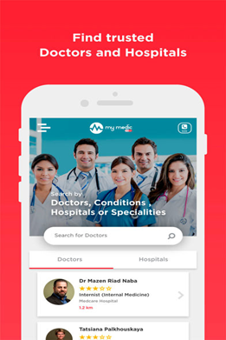

Fig 2.2: MyMedicNow

### 2.2.3 **Zocdoc**

It was designed in New York City, United States… this app is the start of a better healthcare journey for you. Find and book top-rated local physicians, on-demand. Visit them in their offices, or video chat with them from home. Compare medical professionals near you and instantly book appointments that work with your schedule. Worried about whether a physician takes your insurance? Use the Zocdoc insurance checker and filter for providers who accept your health care plan. Keep track of your annual checkups and manage all of your health care needs in one, user-friendly place.

3 reasons you’ll love using the award-winning Zocdoc app:

• Find and book the best local physicians based on reviews from other patients.

• Scan your insurance card and find physicians that match.

• Choose between an online video visit or heading to a convenient, local physician’s office to get the care you need.

Zocdoc makes it easy to get the right care when you need it the most.



Fig 2.3: Zocdoc [11].

### 2.2.4 **Doctor on Demand**

This application allows people to make a video call with the doctor with the possibility to book an appointment with the doctor [9].

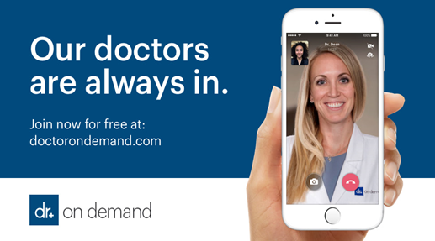

Fig 2.4: Doctoron Demand [9].

### 2.2.5 **WebTeb**

WebTeb is a smart application that provides information about healthcare. It provides a symptom diagnostic service, a guide of doctors to choose your doctor by entering the specialty you want and your location and platform of medical information

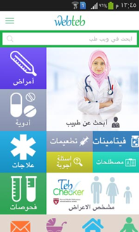

Fig 2.5: WebTeb

### 2.2.6 **Care Zone**

This application enables the user to enter his medications, the number of daily doses to remind him to take it, as well as remind him to record his measurement such as blood pressure, glucose levels, etc.

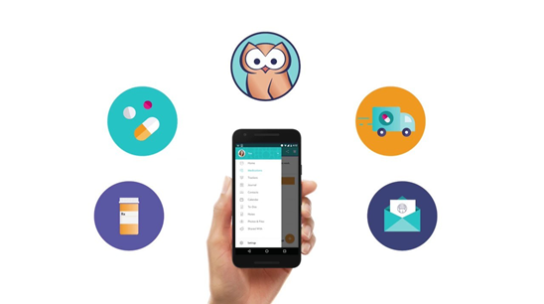

Fig 2.6: Care Zone [1].

## **2.3 Summary**

The previous systems are based on managing clinic appointments, searching for physicians, video chat with physicians on the world, and symptom diagnostic service. These systems give services separated from healthcare. And they may not be applicable in our country cause they are weastern-made and not comprehensive all data and details in our country.

Our system will give all services mentioned and connect them to give new intelligent services, which means analyze symptoms presented to specify the closest fitting physician and new features like warning the patients with the times of his medications and the possibility of calling an ambulance automatically if he sets the emergency. It will affect the culture because it will facilitate patients to get health care service easily and quickly this will change the community culture. Our project will be used by all the community members, not just a specific group. Our project will use intelligent algorithms and architecture to improve getting healthcare services on time. We will use the AI in our project. It is good to mention that our system will contain features that will make our system more reliable, the mobile application will be able to use neural network and clustering algorithms to predict the illness and specify closest fitting physician. Our project will be comprehensive for all clinics in Palestine

# **Chapter Three**

# **System Design**

## **3.1 Introduction**

In this chapter, we will talk about the software and hardware components that we will use in our system. Moreover, we are going to discuss the algorithms and the flowcharts that our system will follow to implement its functions.

## **3.2 Hardware**

We don't have a hardware part in our project, it's a software application.

## **3.3 Architectural Design**

MVC is a good pattern for developing mobile application in android. It is a common approach to building mobile app architecture. This pattern has three main components:

The model is responsible for holding data and has rules to operate data.

The view is the visual part for users and shows the data that was extracted from the model and presents it on the user interface.

a controller is a communication ring between model and view. It controls the model, changes it, and passes the result of processed data to the view part [2].

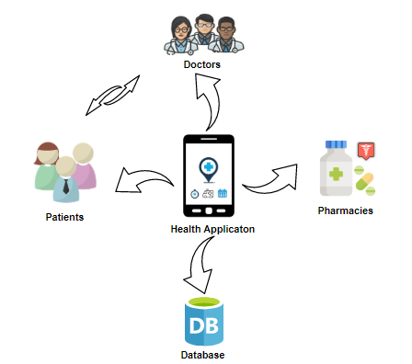

Fig 3.1: System Architectural design

## **3.4 System Design**

The motivation behind this system is to enable people to obtain some medical services easier and with less effort and time through its available services. Since our system is an intelligent system that uses a set of algorithms, such as an algorithm to classify symptoms under a specific jurisdiction and an algorithm to identify specialist physicians who are close to the patient and determine the closest three pharmacies on the patient have the prescription, so we need to develop an algorithm ‘flowchart ‘to explain how the system should work. First, we have the main algorithm which contains many parts: main clustering algorithm and the nearest neighbor search algorithm ..etc.

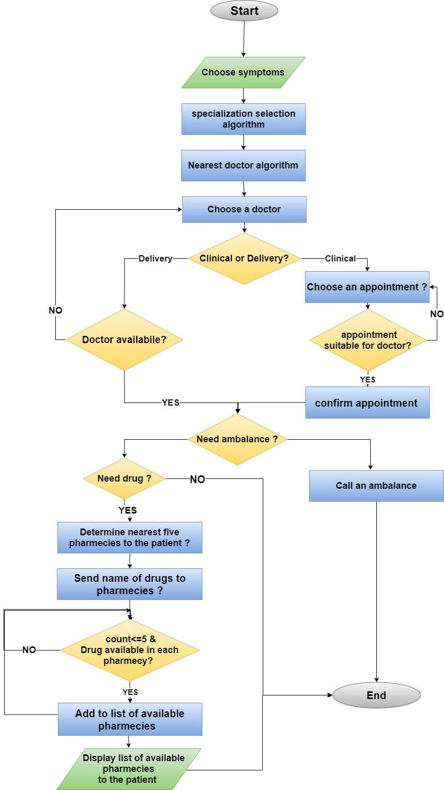

**Fig** 3.2: System Design

In fig 3.2 we present the main flowchart for the system , First of all, the patient chooses the symptoms he suffers from several symptoms then system will determines these symptoms for any specialty that belongs, then displays a group of specialized physicians close to the patient when choosing a physician there are two options for either getting an appointment or requesting the physician to come to the house after examining the patient by the physician the physician can add medicine for patient to the system, and he will send this medicine to the five nearest pharmacies close to the patient, so the system will determine three pharmacies the drug available in it .

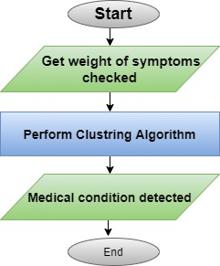

**Fig** 3.3: Specialization Selection Algorithm

## **3.5 Clustering Algorithm**

Clustering is an attractive and smart technique for controlling the user’s distribution over wireless networks, yielding to a better distribution of clients to the available wireless nodes. But we will use the clustering algorithm to divide the pathological symptoms into clusters that will be processed separately for each cluster. This clustering algorithm contains Data extraction then will take the extract data to be processed at the Data

processing stage. Then the processed data will be clustered by using the k-means algorithm. Then the data will be fed to the system, as shown in fig 3.4. [7]

***K-Means Clustering Algorithm pseudocode:***

***K-Means Clustering***

1. Choose the number of clusters (K) which present the number of medical specialization and obtain the data points, which represent symptoms.

2. Place the centroids c_1, c_2 ,..... c_k randomly.

3. Repeat steps 4 and 5 until convergence or until the end of a fixed number of iterations

4. for each data point x_i:

- find the nearest centroid (c_1, c_2 .. c_k)

- assign the point to that cluster

5. For each cluster j = 1..k

- New centroid = mean of all points assigned to that cluster

6. End [8],[7]

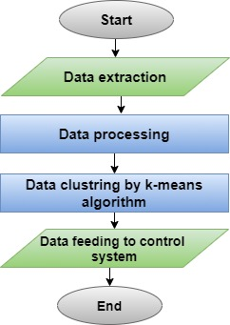

Fig 3.4 Clustering algorithm [7]

As shown in the following figures 3.5, here is how the k-means algorithm work on a row data to separate it into clusters depending on the gathering of the point it will create the clusters then append the data to the closest cluster area.

Here in the picture, we have seven groups. These groups represent the seven clusters that will contain the specialists, then the algorithm will take one of the clusters and put all the symptoms in its group, then the algorithm will take the symptom and append the closer requests to it.

Then the redpoint will change its origin to fit all the points that are close to it.

Then the algorithm will start to change the origins of the cluster to fit the maximum number of points in the cluster, so each cluster will contain the closets points (symptoms) to it.

Finally, after specifying the specialist, it is provided to a system for identifying physicians according to the nearest of the air distance to the patient, as shown in fig 3.6.

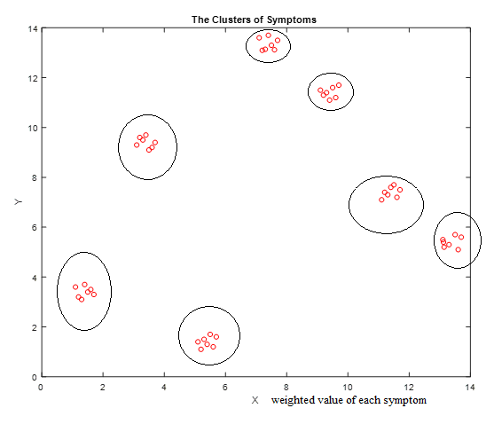

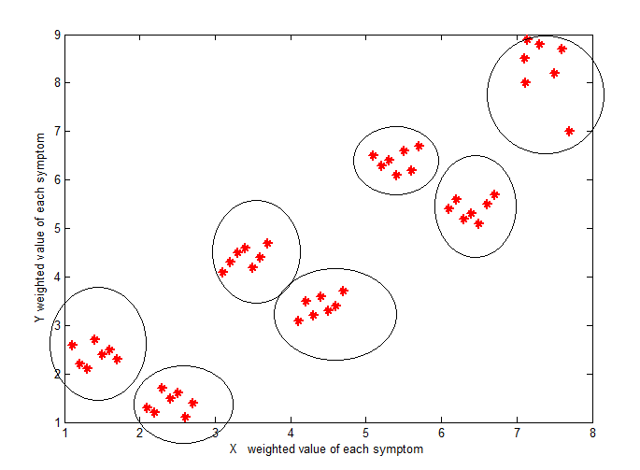

Fig 3.5 k-means algorithm Applied on disease symptom with different symptom weight

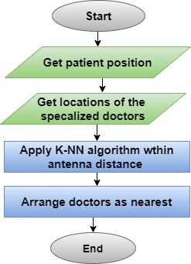

fig 3.6: Nearest physicians Algorithm

**K-Nearest Neighbors (K-NN)** is one of the basic essential classification algorithms in Machine Learning. It belongs to the supervised learning domain and finds intense application in pattern recognition, data mining, and intrusion detection. Nearest Neighbors is the problem of proximity search, which means finding a point in a given set closer to a given point, and proximity depends mainly on the function of calculating distances: the lowest distance, this point is the closest. We will use the patient's location as a reference point and the physicians' locations as other points we will decide which is closer to the reference point [3].

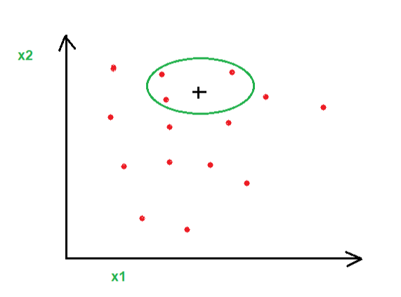**+: patient’s location. X1: GPS x position . X2: GPS y position.**

|  |  |
| --- | --- |
| k-n nearest neighbors | 1-n nearest neighbors |
| 3-n nearest neighbors | 5-n nearest neighbors |

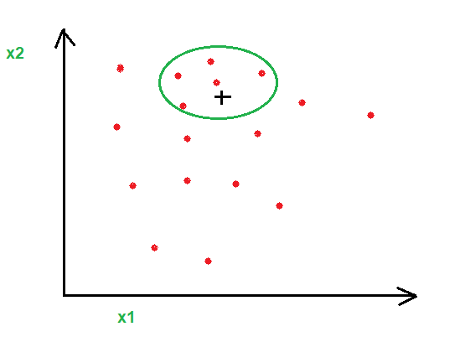  
Fig 3.7: K-NN Algorithm Applied on location on patient and locations of doctors

**K: locations**

**D: distances**

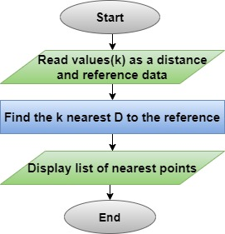

Fig 3.8 k-NN algorithm

## **3.6 Use case diagram**

Below are the use cases for each part that uses the system, as shown in Figure 3.9. For the patient, any user can register the application and then log in to the application. He also can log out of the app. The user can also enter his information such as his residence area, phone number, and personal name, and select the symptoms he suffers from, and he can also choose the appropriate physician for him from among the options offered by the system menus for him, read articles about his illness, ask for home treatment service, book an appointment, and request an ambulance in emergency cases. The user can also report anything harmful or harmful to him through our services (notes). The user can also modify personal information. For a physician, a physician can login to the application. Also, log out of the application. The physician can also send the drug name to nearby clinics and can confirm appointments based on his times. For the system, the system can determine the physician's specialty based on symptoms and determine the nearest physician to the patient's location. It will also be accepted when the user is registered, then check when the user is logged in. The system can call for an ambulance and reminder to give the medicine, and find the nearest pharmacies which have drugs requested by the physician for the current patient.

For pharmacies, it can check the name of a drug given by a physician, confirm if a drug exists, or send a message to the user.

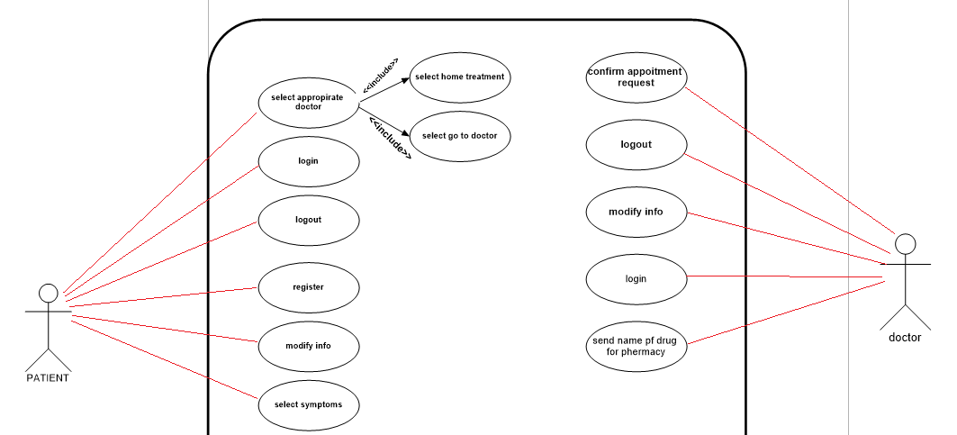

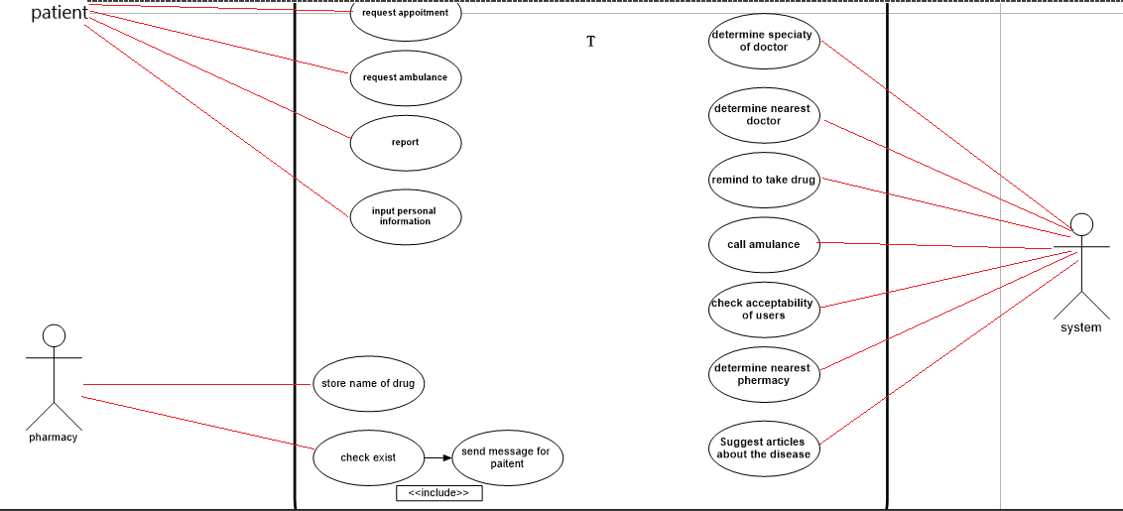

**Fig 3.9 Use case**

## **3.7 Class diagram**

In fig 3.10 we show the system classes we have seven main classes, patient class, physician class that inherits the user class, pharmacy class, symptoms class, specialization class, and article class. Each class has attributes and some methods**.**

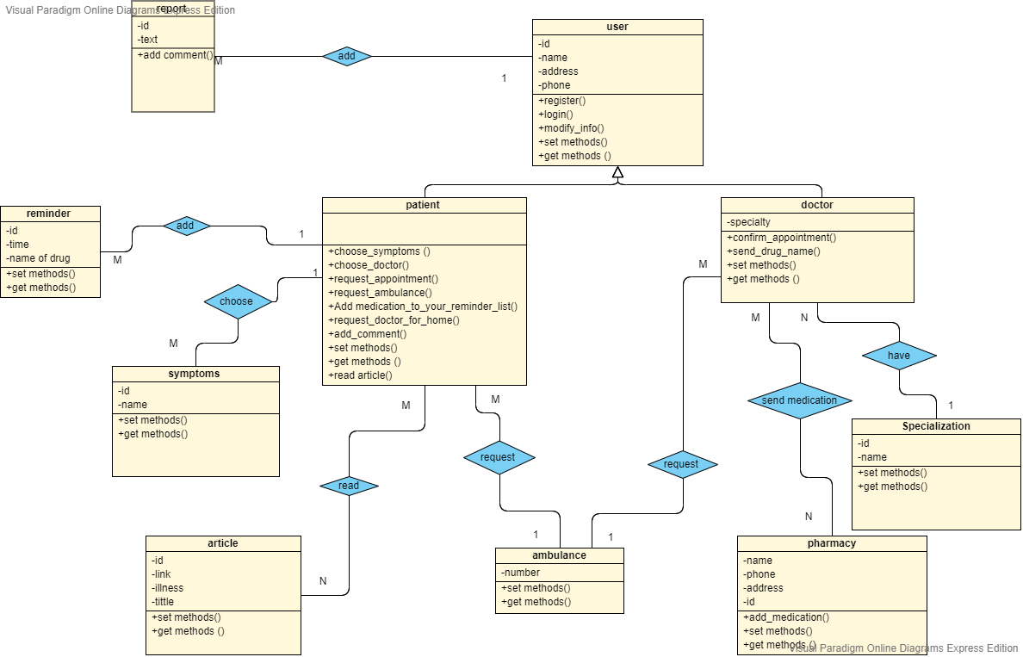

**Fig 3.10 Class diagram**

## **3.8 System Database (entity diagram)**

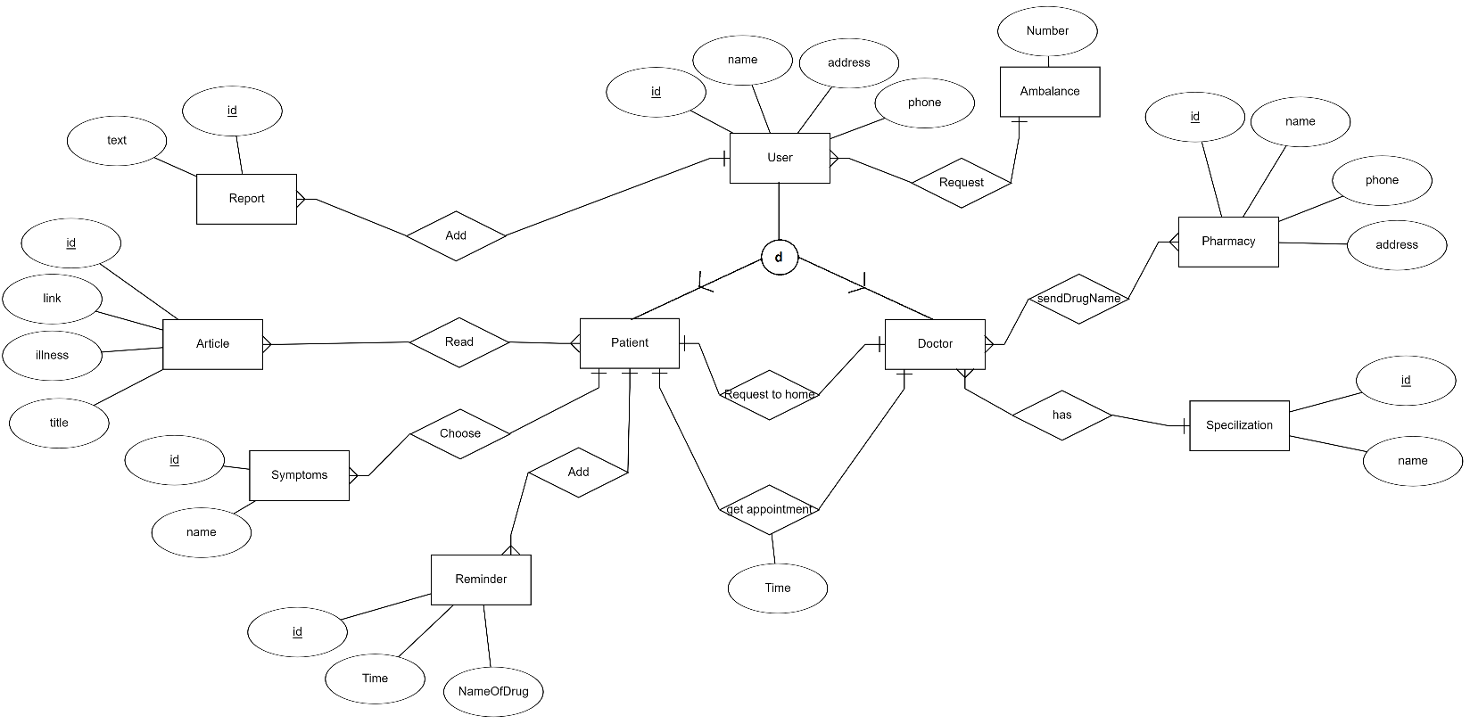

**Fig 3.11 ER diagram**

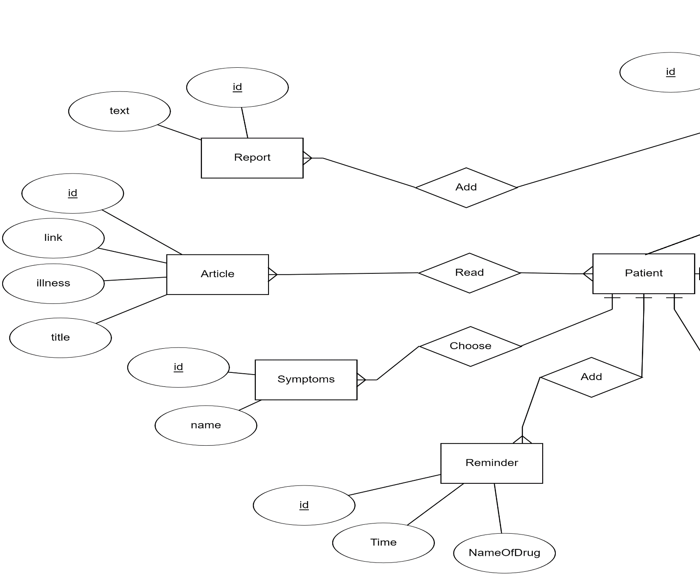

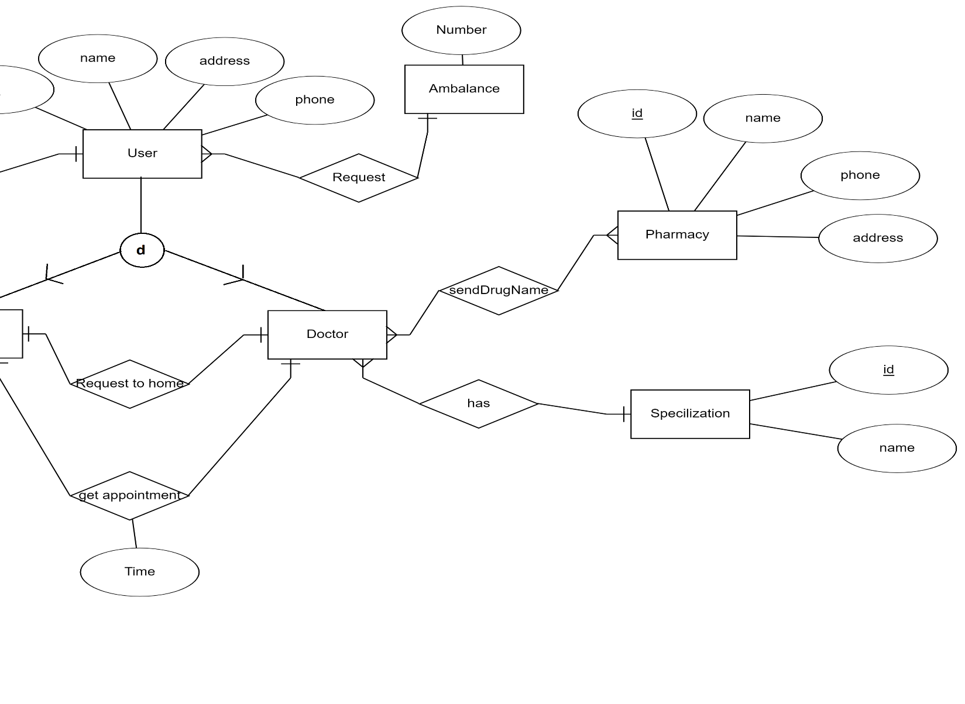

# **Chapter Four**

# **Conclusion and Future Work**

## **4.1 Conclusions**

We introduced the Smart Mobile App to improve the medical situation first and the health status of patients, which will have a significant impact on the state and the people themselves

The system has many benefits, including:

● Create a medical network close to citizens.

● Exploiting time and effort.

● Protecting the health of patients.

Some of the challenges we face in our project, which consider collecting information about diseases adequately and choosing the closest physician and the pharmacy closest to the patient itself is a major challenge.

## **4.2 Future work**

We will use the data collected on the symptoms more widely in the future to accurately predict the disease so that the application will include a large number of disease groups. Using artificial intelligence and data mining, we expect these values. This application can be developed in the future to support the presence of a three-dimensional model of the human body so that the patient can accurately locate the pain with the presence of symptoms that are entered. Then we will develop a method of obtaining symptoms to be more accurate through the use of the patient's voice and sometimes the use of images.

# **References**

[1]Dr.Hempel digital health network [online] Available at : <https://www.dr-hempel-network.com/digital-health-technolgy/top-10-mobile-apps-in-medication-management/>[Accessed 20 march 2020 at 8:45 AM]

[2]Medium.com [online] Available at : [https://medium.com/upday-devs/android-architecture-patterns-part-1-model-view-controller-3baecef5f2b6](https://l.facebook.com/l.php?u=https%3A%2F%2Fmedium.com%2Fupday-devs%2Fandroid-architecture-patterns-part-1-model-view-controller-3baecef5f2b6%3Ffbclid%3DIwAR2BNcpLWm_MfugRaD1SNTtXtXusqTJLF4ej9HSxFs0w-35Omv1V5Q6majg&h=AT0-VTHT0sStMXic5TKD-f9CHk0zVFhGLMh5Gfo8CBcedzD02n8yjR4qiASdFrRINIuDF5I39jwa-MbYhb3ML_9uSniz1Rp_yFbQ53fknVk88EZDeI0lbI5ZWtduI1f6Yi1uxw)[Accessed 7 April 2020 at 5:50 PM]

[3]Wikipedia.org [online] Available at : <https://en.wikipedia.org/wiki/Nearest_neighbor_search>[Accessed 25 April 2020 at 7:22 AM]

[4]Moh.gov.sa [online] Available at : [https://www.moh.gov.sa/HealthAwareness/EducationalContent/Diseases/Gastroenterology/Pages/default.aspx](https://l.facebook.com/l.php?u=https%3A%2F%2Fwww.moh.gov.sa%2FHealthAwareness%2FEducationalContent%2FDiseases%2FGastroenterology%2FPages%2Fdefault.aspx%3Ffbclid%3DIwAR3rlCpwJFxvtf0zbZpnLnA4WPPWnYjent40J1Upqkz1iO40XffmOLP7TOA&h=AT0-VTHT0sStMXic5TKD-f9CHk0zVFhGLMh5Gfo8CBcedzD02n8yjR4qiASdFrRINIuDF5I39jwa-MbYhb3ML_9uSniz1Rp_yFbQ53fknVk88EZDeI0lbI5ZWtduI1f6Yi1uxw) [Accessed 10 April 2020 at 5:50 AM]

[5]ResearchGate.net [online] Available at : <https://www.researchgate.net/publication/323190671_Optimizing_Outpatient_Appointment_System_using_Machine_Learning_Algorithms_and_Scheduling_Rules_A_Prescriptive_Analytics_Framework>[Accessed 18 may 2020 at 2:09 PM]

[6]Palestine medical council [online] Available at : [https://www.pmc.ps/category-20/107.html](https://l.facebook.com/l.php?u=https%3A%2F%2Fwww.pmc.ps%2Fcategory-20%2F107.html%3Ffbclid%3DIwAR3rlCpwJFxvtf0zbZpnLnA4WPPWnYjent40J1Upqkz1iO40XffmOLP7TOA&h=AT0-VTHT0sStMXic5TKD-f9CHk0zVFhGLMh5Gfo8CBcedzD02n8yjR4qiASdFrRINIuDF5I39jwa-MbYhb3ML_9uSniz1Rp_yFbQ53fknVk88EZDeI0lbI5ZWtduI1f6Yi1uxw) [Accessed 23 May 2020 at 5:50 PM]

[7] Awad, M., & Abuhasan, A. (2016). A smart clustering based approach to dynamic bandwidth allocation in wireless networks. Int. J. Comput. Netw. Commun, 8(1), 73-86.‏

[8] Sethy, P. K., Negi, B., & Bhoi, N. (2017). Detection of healthy and defected diseased leaf of rice crop using K-means clustering technique. International Journal of Computer Applications, 157(1), 24-27.‏

[9]doctor on demand.com [online] Available at : [https://www.physicianondemand.com/](https://www.doctorondemand.com/)[Accessed 23 March 2020 at 5:50 PM]

[10] apple.com Vezeeta [online] Available at : <https://apps.apple.com/us/app/vezeeta%D9%81%D9%8A%D8%B2%D9%8A%D8%AA%D8%A7/id1010281314> [Accessed 25 March 2020 at 6:05 PM]

[11] apple.com Zocdoc [online] Available at : [https://apps.apple.com/us/app/zocdoc-physician-dentist-telemed/id391062219](https://apps.apple.com/us/app/zocdoc-doctor-dentist-telemed/id391062219) [Accessed 25 March 2020 at 7:34 PM]