hwk_601_1

Dingxian Cao

September 30, 2015

# ex2

take k=9074463432 mod 35

options(digits = 4)  
setwd("/Users/CDX/WISC_R_HWK/Regression")  
suppressMessages(library(broom))  
library(car)  
ext2<-read.table("HWK2_Ext2.txt")  
(k<-9074463432 %% 35)

## [1] 27

d<-ext2[((k-1)*90+1):(k*90),]  
dim(d)

## [1] 90 3

d1<-d[1:30,]  
d2<-d[31:60,]  
d3<-d[61:90,]

## data 1

knitr::kable(tidy(cor(d1)))

|  |  |  |  |
| --- | --- | --- | --- |
| .rownames | V1 | V2 | V3 |
| V1 | 1.0000 | 0.0473 | -0.1504 |
| V2 | 0.0473 | 1.0000 | -0.2029 |
| V3 | -0.1504 | -0.2029 | 1.0000 |

scatterplotMatrix(d1,spread=F,main="data1")

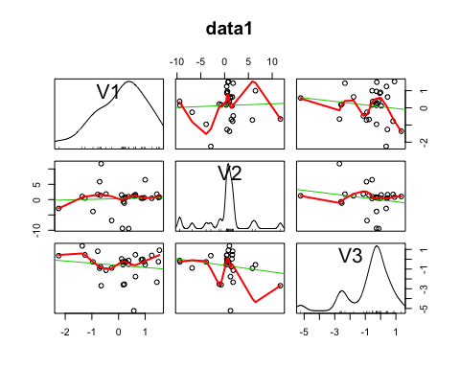

From the scatter plot and the covariance matrix we can see that there are no obvious relationship between V1 and V3, so there shouldn't be a response variable between the two.

But they both have a clear relationship with V2.So,I believe there is V2 is the reponse variable.

d11<-as.data.frame(d1)  
names(d11)<-c("x1","y","x2")

#### data1 for model 1

form1<- as.formula("y ~ 1+x1+x1:x2")  
m1<-lm(form1,data=d11);knitr::kable(tidy(m1))

|  |  |  |  |  |
| --- | --- | --- | --- | --- |
| term | estimate | std.error | statistic | p.value |
| (Intercept) | 0.4117 | 0.7985 | 0.5156 | 0.6104 |
| x1 | 0.2452 | 0.8509 | 0.2882 | 0.7754 |
| x1:x2 | 0.4394 | 0.7492 | 0.5866 | 0.5624 |

#### data1 for model2

form2<-as.formula("1/y ~ 1+x1+x2")  
m2<-lm(form2,data=d11);knitr::kable(tidy(m2))

|  |  |  |  |  |
| --- | --- | --- | --- | --- |
| term | estimate | std.error | statistic | p.value |
| (Intercept) | 0.9073 | 0.1759 | 5.159 | 0.0000 |
| x1 | 0.4133 | 0.1764 | 2.344 | 0.0267 |
| x2 | 0.2998 | 0.1205 | 2.488 | 0.0193 |

#### data1 for model3

form3<-as.formula("y ~ 0+x1+x2+I(x1^2)")  
m3<-lm(form3,data=d11);knitr::kable(tidy(m3))

|  |  |  |  |  |
| --- | --- | --- | --- | --- |
| term | estimate | std.error | statistic | p.value |
| x1 | 0.0885 | 0.8464 | 0.1046 | 0.9175 |
| x2 | -0.5765 | 0.5244 | -1.0995 | 0.2813 |
| I(x1^2) | 0.1536 | 0.5657 | 0.2715 | 0.7881 |

According to the P value of each coefficients, the 2nd model is obviously the best fitted.

## data 2

knitr::kable(tidy(cor(d2)))

|  |  |  |  |
| --- | --- | --- | --- |
| .rownames | V1 | V2 | V3 |
| V1 | 1.0000 | 0.5240 | -0.3549 |
| V2 | 0.5240 | 1.0000 | -0.6859 |
| V3 | -0.3549 | -0.6859 | 1.0000 |

scatterplotMatrix(d2,spread=F,main="data2")

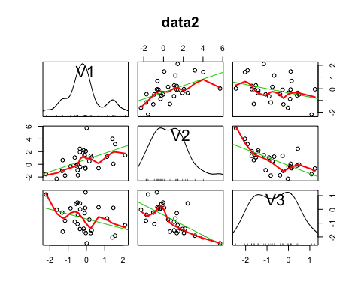

From the scatter plot and the covariance matrix we can see that there are no obvious relationship between V1 and V3, so there shouldn't be a response variable between the two.

But they both have a clear relationship with V2.So,I believe there is V2 is the reponse variable.

d21<-as.data.frame(d2)  
names(d21)<-c("x2","y","x1")

#### data2 for model 1

form1<- as.formula("y ~ 1+x1+x1:x2")  
m1<-lm(form1,data=d21);knitr::kable(tidy(m1))

|  |  |  |  |  |
| --- | --- | --- | --- | --- |
| term | estimate | std.error | statistic | p.value |
| (Intercept) | -0.2692 | 0.2835 | -0.9496 | 0.3508 |
| x1 | -1.2509 | 0.2439 | -5.1289 | 0.0000 |
| x1:x2 | -0.4430 | 0.2153 | -2.0577 | 0.0494 |

#### data2 for model3

form3<-as.formula("y ~ 0+x1+x2+I(x1^2)")  
m3<-lm(form3,data=d21);knitr::kable(tidy(m3))

|  |  |  |  |  |
| --- | --- | --- | --- | --- |
| term | estimate | std.error | statistic | p.value |
| x1 | -0.1247 | 0.3294 | -0.3786 | 0.7080 |
| x2 | 0.6864 | 0.2034 | 3.3739 | 0.0023 |
| I(x1^2) | 0.6342 | 0.1869 | 3.3940 | 0.0021 |

According to the P value of each coefficients, the 1st obviously the best fitted.

## data 3

knitr::kable(tidy(cor(d3)))

|  |  |  |  |
| --- | --- | --- | --- |
| .rownames | V1 | V2 | V3 |
| V1 | 1.0000 | 0.1191 | 0.0780 |
| V2 | 0.1191 | 1.0000 | 0.8426 |
| V3 | 0.0780 | 0.8426 | 1.0000 |

scatterplotMatrix(d3,spread=F,main="data3")

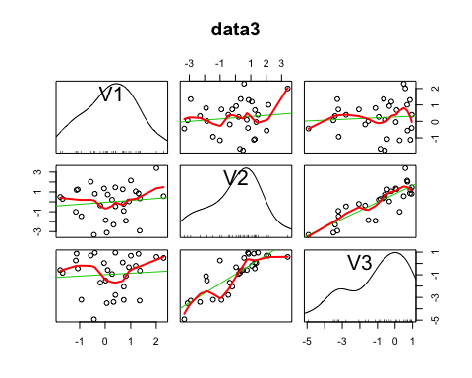

From the scatter plot and the covariance matrix we can see that there are no obvious relationship between V1 and V3, so there shouldn't be a response variable between the two.

But they both have a clear relationship with V2.So,I believe there is V2 is the reponse variable.

d31<-as.data.frame(d3)  
names(d31)<-c("x1","y","x2")

#### data3 for model3

form3<-as.formula("y ~ 0+x1+x2+I(x1^2)")  
m3<-lm(form3,data=d31);knitr::kable(tidy(m3))

|  |  |  |  |  |
| --- | --- | --- | --- | --- |
| term | estimate | std.error | statistic | p.value |
| x1 | 0.0668 | 0.1938 | 0.3449 | 0.7328 |
| x2 | 0.6623 | 0.1008 | 6.5726 | 0.0000 |
| I(x1^2) | 0.3096 | 0.1221 | 2.5345 | 0.0174 |

According to the P value of each coefficients, the 3rd model is obviously the best fitted.

# ex3

#install.packages("SenSrivastava")  
library(SenSrivastava)  
suppressMessages(library(dplyr))  
y_range<-range(E1.19$Price)  
x_range<-range(E1.19$P)  
group<-split(E1.19,E1.19$B)  
par(mfrow=c(1,1))  
plot(group$c[c(2,1)],xlim=x_range,ylim=y_range,pch=10,main="type = c")

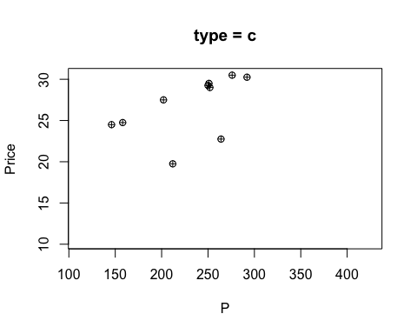

plot(group$p[c(2,1)],xlim=x_range,ylim=y_range,pch=11,main="type = p")

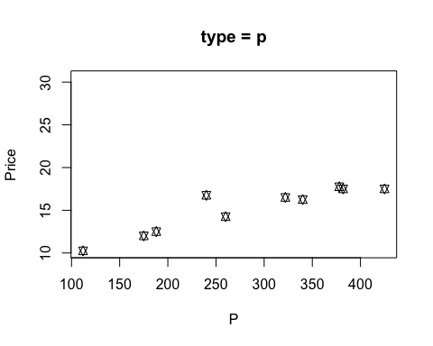

library(ggplot2)  
ggplot(E1.19,aes(x=P,y = Price,group=B,colour=B,shape=B))+ xlab("#page")+geom_line()

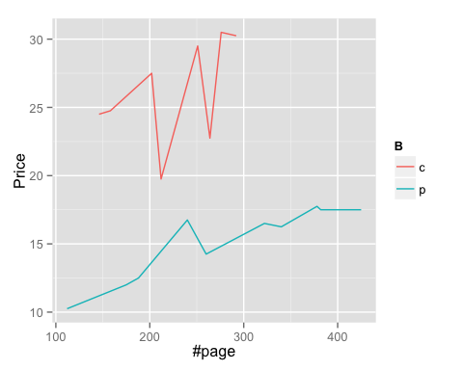

Since their axes are the same, I don't think there is any difference betweent individual and overlaid graph helping me explore the data.

I personally don't want to distroy the structure of original data. But since the x variable varies wider than y variable, I may suggest to scale the x variable by letting each number be divided by their maximum.

qplot(P,Price,data=E1.19)+  
 geom_smooth(aes(colour=B),method="lm",se=F)+  
 facet_wrap( ~ B,scale="free_y")+  
 labs(title="Key Graph")

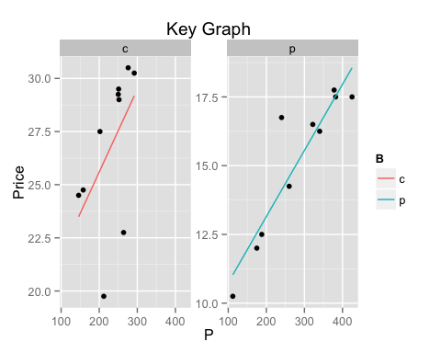

This picture clearly shows the linear relationship between price and page's volume in terms of two different kind of books.

review: I don't think there is meaning in identifying the x1 and x2 by fitting the models.

# ex4

grocery<-read.table("grocery_retailer.txt",header = T)  
plot(grocery)

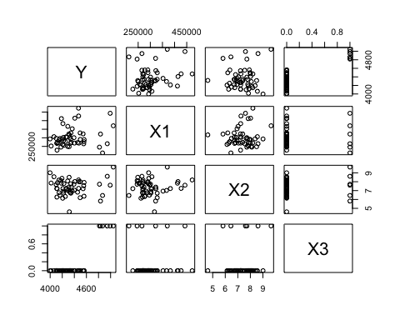

I can get the infomation of pair-wise correlation which can help we varify the signs of coefficients.

m<-lm(Y~X1+X2+X3,data = grocery)  
knitr::kable(tidy(m))

|  |  |  |  |  |
| --- | --- | --- | --- | --- |
| term | estimate | std.error | statistic | p.value |
| (Intercept) | 4149.8872 | 195.5654 | 21.2199 | 0.0000 |
| X1 | 0.0008 | 0.0004 | 2.1590 | 0.0359 |
| X2 | -13.1660 | 23.0917 | -0.5702 | 0.5712 |
| X3 | 623.5545 | 62.6409 | 9.9544 | 0.0000 |

The coefficient of X3 means that if there happens to be a holiday the total labor hours will be about 623 hours more than usual.

plot(resid(m),type="l",main="residuals")  
abline(h=mean(resid(m)))

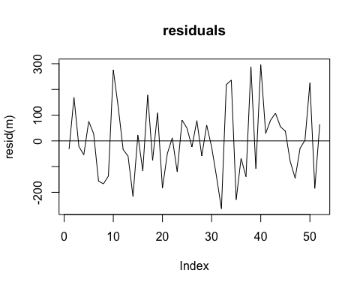

layout(matrix(c(1,2,3,4),2,2,byrow = T))  
plot(x=grocery$X1,y=resid(m),main="X1 vs Residuals")  
plot(x=grocery$X2,y=resid(m),main="X2 vs Residuals")  
plot(x=grocery$X3,y=resid(m),main="X3 vs Residuals")

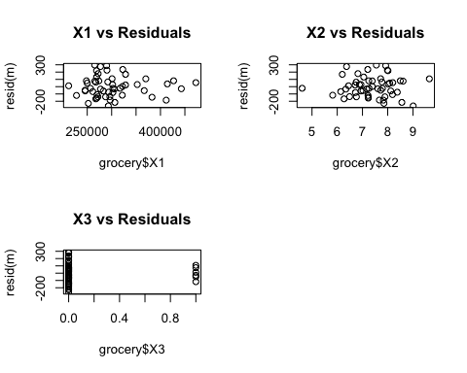

Apparently,there is a pattern between the residuals and independent variable X3.The variance of the error item can change along with X3. So the Gauss-Markov assuption is violated.