**Task 3.**

**Question 5.**

I have added the Stash code from the terminal here to show the changes made on the document. First i was not able to complete. I first had to download xcode to finish the tasks.

|  |
| --- |
| Last login: Sun Apr 28 11:43:03 on ttys000  Amalies-MacBook-Air:~ amaliestrand$ ls  Applications  Creative Cloud Files  Desktop  Documents  Downloads  Library  Movies  Music  Pictures  Public  mallemus.95@hotmail.com Creative Cloud Files  Amalies-MacBook-Air:~ amaliestrand$ cd ./Desktop  Amalies-MacBook-Air:Desktop amaliestrand$ ls  21-04-2019_PM_CA_AmalieStrand (1).pdf  21-04-2019_PM_CA_AmalieStrand.pdf  24-04-2019_Jobbsøknad_Norrøna_ChantelleBrown.pdf  Acrobat  Asset 1.png  Asset 2.png  Chantelle CV.odt  Chantelle CV.pdf  Danny  Discord  Downloads  FRONT-END DEVELOPMENT 18:19  FileZilla.app  Functional-Requirements-Template.docx  Home XD.xd  Illustrator  In Design  Inspo  Interaction design CA  OpenOffice  PORTFOLIO  PROGRESSIONPLAN FRONTEND DEVELOPMENT.numbers  Photoshop  Skjermbilde 2019-04-15 kl. 15.28.12.png  Skjermbilde 2019-04-15 kl. 15.33.59.png  Skjermbilde 2019-04-15 kl. 15.37.54.png  Skjermbilde 2019-04-15 kl. 15.38.06.png  Skjermbilde 2019-04-15 kl. 15.38.12.png  Skjermbilde 2019-04-15 kl. 15.38.32.png  Skjermbilde 2019-04-21 kl. 11.40.55.png  Spotify  Technical-Specification-Template.docx  Thomas vikeså foto  Untitled-1.jpg  chantelle cv 2.JPG  chantelle cv 2.jpeg  chantelle cv bilde.jpeg  github  iMusic.app  icons  mintfuse.no  musikk  vedlegg  webflow  Amalies-MacBook-Air:Desktop amaliestrand$ cd ./github  Amalies-MacBook-Air:github amaliestrand$ ls  gallery.html index.html  Amalies-MacBook-Air:github amaliestrand$ git branch  xcode-select: note: no developer tools were found at '/Applications/Xcode.app', requesting install. Choose an option in the dialog to download the command line developer tools.  Amalies-MacBook-Air:github amaliestrand$ git init  xcode-select: note: no developer tools were found at '/Applications/Xcode.app', requesting install. Choose an option in the dialog to download the command line developer tools.  Amalies-MacBook-Air:github amaliestrand$ git init  xcode-select: note: no developer tools were found at '/Applications/Xcode.app', requesting install. Choose an option in the dialog to download the command line developer tools.  Amalies-MacBook-Air:github amaliestrand$ git init  xcode-select: note: no developer tools were found at '/Applications/Xcode.app', requesting install. Choose an option in the dialog to download the command line developer tools.  Amalies-MacBook-Air:github amaliestrand$ git branch  fatal: not a git repository (or any of the parent directories): .git  Amalies-MacBook-Air:github amaliestrand$ git init  Initialized empty Git repository in /Users/amaliestrand/Desktop/github/.git/  Amalies-MacBook-Air:github amaliestrand$ git branch  Amalies-MacBook-Air:github amaliestrand$ git clone https://github.com/moncrieffstrand/NoroffModuleAssignment.git  Cloning into 'NoroffModuleAssignment'...  remote: Enumerating objects: 6, done.  remote: Counting objects: 100% (6/6), done.  remote: Compressing objects: 100% (5/5), done.  remote: Total 6 (delta 1), reused 0 (delta 0), pack-reused 0  Unpacking objects: 100% (6/6), done.  Amalies-MacBook-Air:github amaliestrand$ git branch  Amalies-MacBook-Air:github amaliestrand$ git checkout master  error: pathspec 'master' did not match any file(s) known to git.  Amalies-MacBook-Air:github amaliestrand$ cd ./NoroffModuleAssignment  Amalies-MacBook-Air:NoroffModuleAssignment amaliestrand$ git branch  * master  Amalies-MacBook-Air:NoroffModuleAssignment amaliestrand$ git checkout feature_gallery  Branch 'feature_gallery' set up to track remote branch 'feature_gallery' from 'origin'.  Switched to a new branch 'feature_gallery'  Amalies-MacBook-Air:NoroffModuleAssignment amaliestrand$ git stash save "save this document"  No local changes to save  Amalies-MacBook-Air:NoroffModuleAssignment amaliestrand$ git branch  * feature_gallery  master  Amalies-MacBook-Air:NoroffModuleAssignment amaliestrand$ git status  On branch feature_gallery  Your branch is up to date with 'origin/feature_gallery'.  Changes not staged for commit:  (use "git add <file>..." to update what will be committed)  (use "git checkout -- <file>..." to discard changes in working directory)  modified: gallery.html  no changes added to commit (use "git add" and/or "git commit -a")  Amalies-MacBook-Air:NoroffModuleAssignment amaliestrand$ git stash save "save this document"  Saved working directory and index state On feature_gallery: save this document  Amalies-MacBook-Air:NoroffModuleAssignment amaliestrand$ https://github.com/moncrieffstrand/NoroffModuleAssignment.git |

**Question 7:**

A “GIT fast forward” is when “master” hasn’t diverged, “GIT” will show the last commit of the featured branch. You will not merge commit when there is a fast-forward merge.

**Question 8:**

Merge conflict is when you make conflicting changes in two branches before merging. The GIT then doesn’t know which fo the changes to accept into a branch while merging.

You start by adding a file and making conflicting changes on another branch. Add a file on another branch an commit. The terminal will then tell us to fix the conflicts and then commit the results.

**Question 9:**

This is an example of how to see which branch you are on. There will be a difference in the text color to make it stand out, and also shown with a star sign (*) next to it. It’s easy to see and work with.

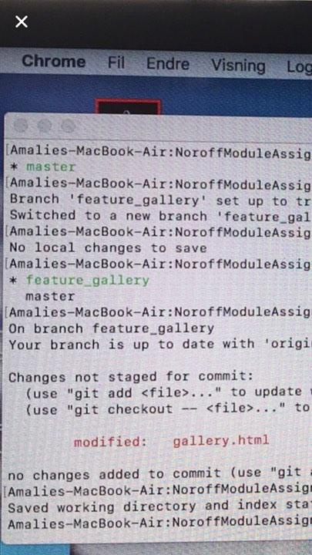

**Question 10:**

A pull-request is when you have pushed changes to a github repository and want to tell another person about this. When you have sent a pull request the other person/persons can see the changes you have made and make comments.