MDTS4214_711_PS4
Daniel D. Mondal
2026-02-18

Problem Set - 3 (continued)

5.Problem to demonstrate the utility of non-linear regression over linear regression
Get the fgl data set from “MASS” library.
rm(list=ls())
library(MASS)
attach(fgl)
str(fgl)
## 'data.frame': 214 obs. of 10 variables:
## $ RI : num 3.01 -0.39 -1.82 -0.34 -0.58 ...
## $ Na : num 13.6 13.9 13.5 13.2 13.3 ...
## $ Mg : num 4.49 3.6 3.55 3.69 3.62 3.61 3.6 3.61 3.58 3.6 ...
## $ Al : num 1.1 1.36 1.54 1.29 1.24 1.62 1.14 1.05 1.37 1.36 ...
## $ Si : num 71.8 72.7 73 72.6 73.1 ...
## $ K : num 0.06 0.48 0.39 0.57 0.55 0.64 0.58 0.57 0.56 0.57 ...
## $ Ca : num 8.75 7.83 7.78 8.22 8.07 8.07 8.17 8.24 8.3 8.4 ...
## $ Ba : num 0 0 0 0 0 0 0 0 0 0 ...
## $ Fe : num 0 0 0 0 0 0.26 0 0 0 0.11 ...
## $ type: Factor w/ 6 levels "WinF","WinNF",..: 1 1 1 1 1 1 1 1 1 1 ...
- Considering the refractive index (RI) of “Vehicle Window glass” as the variable of interest and assuming linearity of regression, run multiple linear regression of RI on different metallic oxides. From the p value, report which metallic oxide best explains the refractive index.
summary(lm(RI ~ .,fgl[,-10]))
##
## Call:
## lm(formula = RI ~ ., data = fgl[, -10])
##
## Residuals:
## Min 1Q Median 3Q Max
## -4.9898 -0.4273 -0.0264 0.4187 4.3833
##
## Coefficients:
## Estimate Std. Error t value Pr(>|t|)
## (Intercept) -64.73269 67.03935 -0.966 0.33539
## Na 1.39526 0.65505 2.130 0.03436 *
## Mg 1.84423 0.67547 2.730 0.00688 **
## Al 0.03262 0.69834 0.047 0.96278
## Si 0.16851 0.67740 0.249 0.80380
## K 1.38287 0.68998 2.004 0.04636 *
## Ca 3.11677 0.66837 4.663 5.61e-06 ***
## Ba 2.98281 0.67600 4.412 1.65e-05 ***
## Fe 0.42627 0.77869 0.547 0.58468
## ---
## Signif. codes: 0 '***' 0.001 '**' 0.01 '*' 0.05 '.' 0.1 ' ' 1
##
## Residual standard error: 1.004 on 205 degrees of freedom
## Multiple R-squared: 0.8948, Adjusted R-squared: 0.8907
## F-statistic: 217.9 on 8 and 205 DF, p-value: < 2.2e-16
We obtain the p-values.
pval = round(summary(lm(RI ~ .,fgl[,-10]))$coefficients[-1,4],5)
pval
## Na Mg Al Si K Ca Ba Fe
## 0.03436 0.00688 0.96278 0.80380 0.04636 0.00001 0.00002 0.58468
Interpretation: From the p-value we see that the oxides of Calcium are the most signicant, in determining the Refractive Index of the glass.
- Run a simple linear regression of RI on the best predictor chosen in (a).
m1 = (lm(RI ~ Ca))
summary(m1)
##
## Call:
## lm(formula = RI ~ Ca)
##
## Residuals:
## Min 1Q Median 3Q Max
## -5.1658 -0.9515 -0.1842 0.8354 6.8121
##
## Coefficients:
## Estimate Std. Error t value Pr(>|t|)
## (Intercept) -15.12400 0.77868 -19.42 <2e-16 ***
## Ca 1.72932 0.08586 20.14 <2e-16 ***
## ---
## Signif. codes: 0 '***' 0.001 '**' 0.01 '*' 0.05 '.' 0.1 ' ' 1
##
## Residual standard error: 1.783 on 212 degrees of freedom
## Multiple R-squared: 0.6568, Adjusted R-squared: 0.6551
## F-statistic: 405.6 on 1 and 212 DF, p-value: < 2.2e-16
We obtain the $R^{2}=0.6568$, which implies that on an average calcium can approximately estimate 66% of the variation in the Refractive Index.
- Can you further improve the regression of the refractive index of “Vehicle Window glass” on the predictor chosen by you in part (a)? Give the new fitted model and compare its performance with the model in (b).
m2 = lm(RI ~ ., fgl)
summary(m2)
##
## Call:
## lm(formula = RI ~ ., data = fgl)
##
## Residuals:
## Min 1Q Median 3Q Max
## -5.2131 -0.3786 -0.0186 0.3697 4.0317
##
## Coefficients:
## Estimate Std. Error t value Pr(>|t|)
## (Intercept) 11.68095 67.73022 0.172 0.863248
## Na 0.60928 0.66840 0.912 0.363100
## Mg 1.32017 0.67269 1.963 0.051086 .
## Al -0.92790 0.70416 -1.318 0.189098
## Si -0.61637 0.68460 -0.900 0.369022
## K 0.74007 0.68789 1.076 0.283286
## Ca 2.47150 0.66700 3.705 0.000273 ***
## Ba 1.97569 0.70198 2.814 0.005374 **
## Fe 0.36329 0.73879 0.492 0.623442
## typeWinNF 0.09996 0.17352 0.576 0.565209
## typeVeh -0.88579 0.26111 -3.392 0.000835 ***
## typeCon 0.39910 0.39687 1.006 0.315810
## typeTabl 0.39263 0.42512 0.924 0.356822
## typeHead 1.58234 0.43890 3.605 0.000394 ***
## ---
## Signif. codes: 0 '***' 0.001 '**' 0.01 '*' 0.05 '.' 0.1 ' ' 1
##
## Residual standard error: 0.9503 on 200 degrees of freedom
## Multiple R-squared: 0.9081, Adjusted R-squared: 0.9021
## F-statistic: 152 on 13 and 200 DF, p-value: < 2.2e-16
From the regression fit we observe that: Calcium is still significant at 0.001 level of significance. We consider a full model and we obtain a model with $R^{2}=0.9081$ which implies that the fit accounts for approximately 91% of the total variation in Refractive index of the window glass.
When we consider the adjusted $R^{2}$ we see that its higher for model 2 (=0.9021) than model 1 (=0.6551). here we use the adjusted $R^{2}$ to compare as the number of predictors is also accounted for in this measure.

Problem Set 4

1 Problem to demonstrate multicollinearity.
Consider the Credit data in the ISLR library. Choose Balance as the response and Age, Limit and Rating as the predictors.
rm(list=ls())
library(ISLR)
library(stargazer)
##
## Please cite as:
## Hlavac, Marek (2022). stargazer: Well-Formatted Regression and Summary Statistics Tables.
## R package version 5.2.3. https://CRAN.R-project.org/package=stargazer
attach(Credit)
str(Credit)
## 'data.frame': 400 obs. of 12 variables:
## $ ID : int 1 2 3 4 5 6 7 8 9 10 ...
## $ Income : num 14.9 106 104.6 148.9 55.9 ...
## $ Limit : int 3606 6645 7075 9504 4897 8047 3388 7114 3300 6819 ...
## $ Rating : int 283 483 514 681 357 569 259 512 266 491 ...
## $ Cards : int 2 3 4 3 2 4 2 2 5 3 ...
## $ Age : int 34 82 71 36 68 77 37 87 66 41 ...
## $ Education: int 11 15 11 11 16 10 12 9 13 19 ...
## $ Gender : Factor w/ 2 levels " Male","Female": 1 2 1 2 1 1 2 1 2 2 ...
## $ Student : Factor w/ 2 levels "No","Yes": 1 2 1 1 1 1 1 1 1 2 ...
## $ Married : Factor w/ 2 levels "No","Yes": 2 2 1 1 2 1 1 1 1 2 ...
## $ Ethnicity: Factor w/ 3 levels "African American",..: 3 2 2 2 3 3 1 2 3 1 ...
## $ Balance : int 333 903 580 964 331 1151 203 872 279 1350 ...
- Make a scatter plot of (i) Age versus Limit
plot(Limit,Age,pch=20)
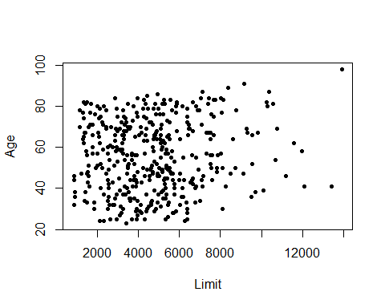
Comment: No linear relationship is seen.
- Rating Versus Limit. Comment on the scatterplot.
plot(Limit,Rating,pch=20)
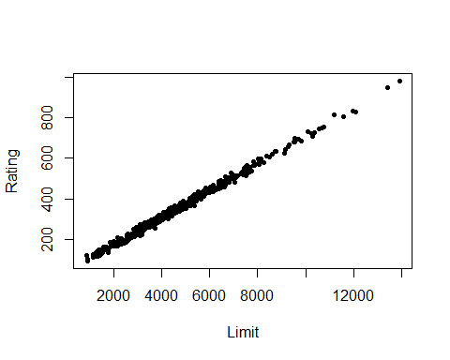
Comment A very strong positive linear relationship is visible.
- Run three separate regressions:
- Balance on Age and Limit
- Balance on Age, Rating and Limit
- Balance on Rating and Limit.
m1 = lm(Balance~ Age + Limit)
m2 = lm(Balance~ Age + Limit + Rating)
m3 = lm(Balance~ Limit + Rating)

Present all the regression output in a single table using stargazer. What is the marked difference that you can observe from the output?
stargazer(m1,m2,m3,type="text")
##
## ==============================================================================================
## Dependent variable:
## --------------------------------------------------------------------------
## Balance
## (1) (2) (3)
## ----------------------------------------------------------------------------------------------
## Age -2.291*** -2.346***
## (0.672) (0.669)
##
## Limit 0.173*** 0.019 0.025
## (0.005) (0.063) (0.064)
##
## Rating 2.310** 2.202**
## (0.940) (0.952)
##
## Constant -173.411*** -259.518*** -377.537***
## (43.828) (55.882) (45.254)
##
## ----------------------------------------------------------------------------------------------
## Observations 400 400 400
## R2 0.750 0.754 0.746
## Adjusted R2 0.749 0.752 0.745
## Residual Std. Error 230.532 (df = 397) 229.080 (df = 396) 232.320 (df = 397)
## F Statistic 594.988*** (df = 2; 397) 403.718*** (df = 3; 396) 582.820*** (df = 2; 397)
## ==============================================================================================
## Note: *p<0.1; **p<0.05; ***p<0.01
- Calculate the variance inflation factor (VIF) and comment on multicollinearity.
r1 = summary(lm(Age~Limit))$r.squared
r2 = summary(lm(Rating~Age))$r.squared
r3 = summary(lm(Limit~Rating))$r.squared
R_sq = c(r1,r2,r3)
R_sq
## [1] 0.01017837 0.01064302 0.99376921
vif = 1/(1-R_sq)
model = c("Age on Limit","Rating on Age","Limit on Rating")
data.frame(model,vif)
## model vif
## 1 Age on Limit 1.010283
## 2 Rating on Age 1.010758
## 3 Limit on Rating 160.493293
Comment the VIF between Limit and Rating is extremely high (as VIF >> 10) so we can say that strong multicollinearity exists between them. other pairs, (age,limit) and (age,rating) have no multicollinearity.

2. Problem to demonstrate the detection of outlier, leverage and influential points
Attach “Boston” data from MASS library in R. Select median value of owner-occupied homes, as the response and per capita crime rate, nitrogen oxides concentration, proportion of blacks and percentage of lower status of the population as predictors. The objective is to fit a multiple linear regression model of the response on the predictors. With reference to this problem, detect outliers, leverage points and influential points if any.
rm(list=ls())
library(MASS)
attach(Boston)
We consider medv as the response and crim, nox, black and lstat as the predictorss. We obtain the multiple Linear Regression as:
model = lm(medv ~ crim + nox + black + lstat)
summary(model)
##
## Call:
## lm(formula = medv ~ crim + nox + black + lstat)
##
## Residuals:
## Min 1Q Median 3Q Max
## -15.564 -4.004 -1.504 2.178 24.608
##
## Coefficients:
## Estimate Std. Error t value Pr(>|t|)
## (Intercept) 30.053584 2.170839 13.844 <2e-16 ***
## crim -0.059424 0.037755 -1.574 0.116
## nox 3.415809 3.056602 1.118 0.264
## black 0.006785 0.003408 1.991 0.047 *
## lstat -0.918431 0.050167 -18.307 <2e-16 ***
## ---
## Signif. codes: 0 '***' 0.001 '**' 0.01 '*' 0.05 '.' 0.1 ' ' 1
##
## Residual standard error: 6.183 on 501 degrees of freedom
## Multiple R-squared: 0.5517, Adjusted R-squared: 0.5481
## F-statistic: 154.1 on 4 and 501 DF, p-value: < 2.2e-16
We obtain the Residual plot by:
plot(resid(model),pch=20, ylab= "Residuals",
main= "Residual Plot for the Fitted Model")
abline(h=0,col="red", lty=2)
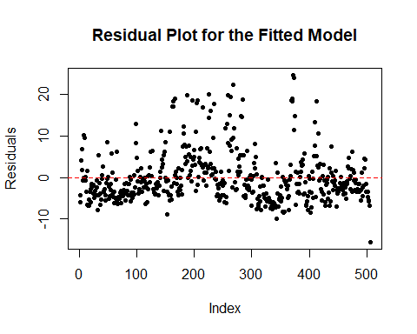
Comment The Residual plot does not reveal any pattern, but we see some high values positive in the residuals.
We obtain the Standardized Residuals and check for the residuals whose absolute value is greater than 3 to check for outliers.
$$r_{i}=\frac{e_{i}}{\hat{σ}\sqrt{1-h_{ii}}}$$
strd_res = rstandard(model)
outliers = which(abs(strd_res) > 3)
cat("Outliers observation number:\n",outliers)
## Outliers observation number:
## 167 187 196 205 226 258 263 268 284 369 370 372 373 413
We obtain the hat-values to check for leverage points. it can be obtained by
$$h_{ii}=x_{i}^{T}{\left(X^{T}X\right)}^{-1}x_{i}$$
hat_v = hatvalues(model)
thres1 = 2*5/nrow(Boston)
cat("Threshold value:", thres1)
## Threshold value: 0.01976285
lev_p = which(hat_v > thres1)
cat("\n\nLeverage point observation number:\n",lev_p)
##
##
## Leverage point observation number:
## 9 33 49 103 142 143 144 145 146 147 148 149 150 151 152 153 154 155 156 157 160 215 374 375 381 386 387 388 399 401 405 406 411 412 413 414 415 416 417 418 419 420 424 425 426 427 428 430 431 432 433 434 435 437 438 439 446 451 455 456 457 458 467 491
We obtain the Cook’s distance to obtain the influential points. It can be obtained by
$$D_{i}=\frac{e_{i}^{2}}{p⋅{\hat{σ}}^{2}}\left[\frac{h_{ii}}{{\left(1-h_{ii}\right)}^{2}}\right]$$
cooks_d = cooks.distance(model)
thres2 = 4/nrow(Boston)
cat("Threshold value:", thres2)
## Threshold value: 0.007905138
influence_p = which(cooks_d > thres2)
cat("\n\nLeverage point observation number:\n",influence_p)
##
##
## Leverage point observation number:
## 9 49 142 149 153 162 163 164 167 187 196 204 205 215 226 234 258 262 263 268 284 369 370 371 372 373 374 375 381 406 410 411 413 415 427 428 439

