711 Boston Dataset
Daniel D. Mondal
2026-01-22
library(MASS)

Question 1
Report the “class” of the data set. How many rows and columns are in this data set? What do the rows and columns represent?
#Class of the Boston Dataset.
class(Boston)
## [1] "data.frame"
#Dimension of the Boston Dataset.
dim(Boston)
## [1] 506 14
#Contents of the Boston Dataset.
str(Boston)
## 'data.frame': 506 obs. of 14 variables:
## $ crim : num 0.00632 0.02731 0.02729 0.03237 0.06905 ...
## $ zn : num 18 0 0 0 0 0 12.5 12.5 12.5 12.5 ...
## $ indus : num 2.31 7.07 7.07 2.18 2.18 2.18 7.87 7.87 7.87 7.87 ...
## $ chas : int 0 0 0 0 0 0 0 0 0 0 ...
## $ nox : num 0.538 0.469 0.469 0.458 0.458 0.458 0.524 0.524 0.524 0.524 ...
## $ rm : num 6.58 6.42 7.18 7 7.15 ...
## $ age : num 65.2 78.9 61.1 45.8 54.2 58.7 66.6 96.1 100 85.9 ...
## $ dis : num 4.09 4.97 4.97 6.06 6.06 ...
## $ rad : int 1 2 2 3 3 3 5 5 5 5 ...
## $ tax : num 296 242 242 222 222 222 311 311 311 311 ...
## $ ptratio: num 15.3 17.8 17.8 18.7 18.7 18.7 15.2 15.2 15.2 15.2 ...
## $ black : num 397 397 393 395 397 ...
## $ lstat : num 4.98 9.14 4.03 2.94 5.33 ...
## $ medv : num 24 21.6 34.7 33.4 36.2 28.7 22.9 27.1 16.5 18.9 ...
attach(Boston)
Class of the data set: The data set is of class data.frame.
Dimensions: Number of rows: 506 Number of columns: 15
Interpretation: Rows represent 506 suburbs of Boston. Columns contain data related to different socio-economic, environmental, and real-estate, such as crime rate, tax rate, pupil–teacher ratio, pollution levels. The column median value of owner-occupied homes (in 1000$) is considered as the dependent variable while other columns are considered independent.

Question 2
Create a smaller data set with the variables median value of owner-occupied homes, per capita crime rate, nitrogen oxides concentration, proportion of blacks and percentage of lower status of the population. Choosing median value of owner occupied homes as the response and the rest as the predictors, make scatter plots of the response versus each predictor. Present the scatter plots in different panels of the same graph. Comment on your findings.
sub_boston = data.frame(medv,crim,nox,black,lstat)
head(sub_boston)
## medv crim nox black lstat
## 1 24.0 0.00632 0.538 396.90 4.98
## 2 21.6 0.02731 0.469 396.90 9.14
## 3 34.7 0.02729 0.469 392.83 4.03
## 4 33.4 0.03237 0.458 394.63 2.94
## 5 36.2 0.06905 0.458 396.90 5.33
## 6 28.7 0.02985 0.458 394.12 5.21
v_names = c("Median Value","Crime Rate","Nitrogen Oxide level","Proportion of Black","Lower Status Level")
par(mfrow=c(2,2))
for(i in 2:5)
{
plot(sub_boston[,i],medv,main=paste("(",(i-1),") \n Scatterplot of\n",v_names[1],"vs",v_names[i]),
ylab=v_names[1], xlab= v_names[i],col="cyan4",pch=20)
}
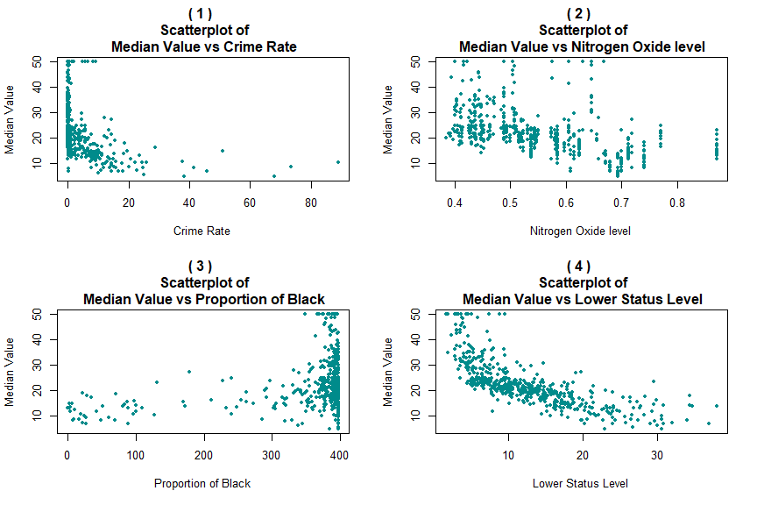
Comments: From the above plots we observe that:
Scatterplot (1): The higher median values of house prices are concentrated towards the lower values of crime rate.
Scatterplot (2): No definite relation between median value and nitrogen dioxide levels is present.
Scatterplot (3): The median values of house prices are concentrated towards the higher values of crime rate.
Scatterplot (4): There a decent negative relation between median value and the population of lower status level population. The lower the proportion, the higher the median value.

Question 3
Which suburb of Boston has lowest median value of owner-occupied homes? What are the values of the other predictors mentioned in (2), for that suburb. How do these values compare to the overall ranges for those predictors? Comment on your findings. Hint: Mention which percentile these values belong to.
#Serial number of lowest median value for house price and the respective data points
df= sub_boston[medv == min(medv),]
df
## medv crim nox black lstat
## 399 5 38.3518 0.693 396.90 30.59
## 406 5 67.9208 0.693 384.97 22.98
We see that the minimum value of median value is 5000$ at suburbs with serial numbers 399 and 406.
p = c()
for(i in 1:4)
{
cat(paste("Range of",v_names[(i+1)],":\n"))
cat(range(sub_boston[,(i+1)]),"\n\n")
}
## Range of Crime Rate :
## 0.00632 88.9762
##
## Range of Nitrogen Oxide level :
## 0.385 0.871
##
## Range of Proportion of Black :
## 0.32 396.9
##
## Range of Lower Status Level :
## 1.73 37.97
cat("\n\nPercentiles of the factors for the following suburbs:\n")
##
##
## Percentiles of the factors for the following suburbs:
k = c(399,406)
for(j in 1:2)
{
cat("\nSuberb no.",k[j],"\n\n")
for(i in 1:4)
{
cat(v_names[(i+1)],":")
cat(floor(ecdf(sub_boston[,(i+1)])(df[j,(i+1)])*100),"\n")
}
}
##
## Suberb no. 399
##
## Crime Rate :98
## Nitrogen Oxide level :85
## Proportion of Black :100
## Lower Status Level :97
##
## Suberb no. 406
##
## Crime Rate :99
## Nitrogen Oxide level :85
## Proportion of Black :34
## Lower Status Level :89
Interpretation: Crim: The crime rate for both suburb lies in the top percentiles (100th and 99th). We can say that higher crime causes the median value to fall.
Lstat: Is the lower status proportion lies at a very percentile (97th and 89th). A higher proportion of the lower status proportion leads to the decline in median value.
Conclusion: The suburbs likely represents an extreme case with very high crime and high lower-status population percentage compared to the other suburbs in consideration.

Question 4
Does any suburb of Boston stand out for having notably high crime rates, tax rates, or pupil–teacher ratios? Hint: Use a boxplot to detect any outliers. If so, identify the suburbs that show the outlier values.
par(mfrow=c(1,3))
df1 = data.frame(crim,tax,ptratio,medv)
var_name= c("Crime Rate","Tax Rate","Pupil-Teacher Ratio")
head(df1)
## crim tax ptratio medv
## 1 0.00632 296 15.3 24.0
## 2 0.02731 242 17.8 21.6
## 3 0.02729 242 17.8 34.7
## 4 0.03237 222 18.7 33.4
## 5 0.06905 222 18.7 36.2
## 6 0.02985 222 18.7 28.7
for(i in 1:3)
{
cat("\nData on Outliers present in", var_name[i],"are:\n")
print(df1[df1[,i] %in% (boxplot.stats(df1[,i])$out),c(i,4)])
cat("\nTotal number of outliers:",length(boxplot.stats(df1[,i])$out),"\n\n")
boxplot(df1[,i],main=paste("Boxplot for",var_name[i]))
}
##
## Data on Outliers present in Crime Rate are:
## crim medv
## 368 13.52220 23.1
## 372 9.23230 50.0
## 374 11.10810 13.8
## 375 18.49820 13.8
## 376 19.60910 15.0
## 377 15.28800 13.9
## 378 9.82349 13.3
## 379 23.64820 13.1
## 380 17.86670 10.2
## 381 88.97620 10.4
## 382 15.87440 10.9
## 383 9.18702 11.3
## 385 20.08490 8.8
## 386 16.81180 7.2
## 387 24.39380 10.5
## 388 22.59710 7.4
## 389 14.33370 10.2
## 393 11.57790 9.7
## 395 13.35980 12.7
## 399 38.35180 5.0
## 400 9.91655 6.3
## 401 25.04610 5.6
## 402 14.23620 7.2
## 403 9.59571 12.1
## 404 24.80170 8.3
## 405 41.52920 8.5
## 406 67.92080 5.0
## 407 20.71620 11.9
## 408 11.95110 27.9
## 410 14.43830 27.5
## 411 51.13580 15.0
## 412 14.05070 17.2
## 413 18.81100 17.9
## 414 28.65580 16.3
## 415 45.74610 7.0
## 416 18.08460 7.2
## 417 10.83420 7.5
## 418 25.94060 10.4
## 419 73.53410 8.8
## 420 11.81230 8.4
## 421 11.08740 16.7
## 423 12.04820 20.8
## 426 15.86030 8.3
## 427 12.24720 10.2
## 428 37.66190 10.9
## 430 9.33889 9.5
## 432 10.06230 14.1
## 435 13.91340 11.7
## 436 11.16040 13.4
## 437 14.42080 9.6
## 438 15.17720 8.7
## 439 13.67810 8.4
## 440 9.39063 12.8
## 441 22.05110 10.5
## 442 9.72418 17.1
## 444 9.96654 15.4
## 445 12.80230 10.8
## 446 10.67180 11.8
## 448 9.92485 12.6
## 449 9.32909 14.1
## 455 9.51363 14.9
## 469 15.57570 19.1
## 470 13.07510 20.1
## 478 15.02340 12.0
## 479 10.23300 14.6
## 480 14.33370 21.4
##
## Total number of outliers: 66
##
## Data on Outliers present in Tax Rate are:
## [1] tax medv
## <0 rows> (or 0-length row.names)
##
## Total number of outliers: 0
##
## Data on Outliers present in Pupil-Teacher Ratio are:
## ptratio medv
## 197 12.6 33.3
## 198 12.6 30.3
## 199 12.6 34.6
## 258 13.0 50.0
## 259 13.0 36.0
## 260 13.0 30.1
## 261 13.0 33.8
## 262 13.0 43.1
## 263 13.0 48.8
## 264 13.0 31.0
## 265 13.0 36.5
## 266 13.0 22.8
## 267 13.0 30.7
## 268 13.0 50.0
## 269 13.0 43.5
##
## Total number of outliers: 15
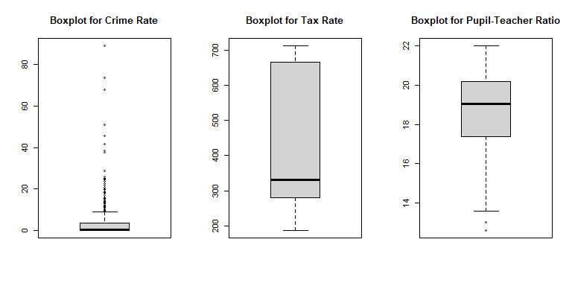
Interpretation: We see a large number of outliers (66) for crime rate and a few (15) for pupil-teacher ratio.

