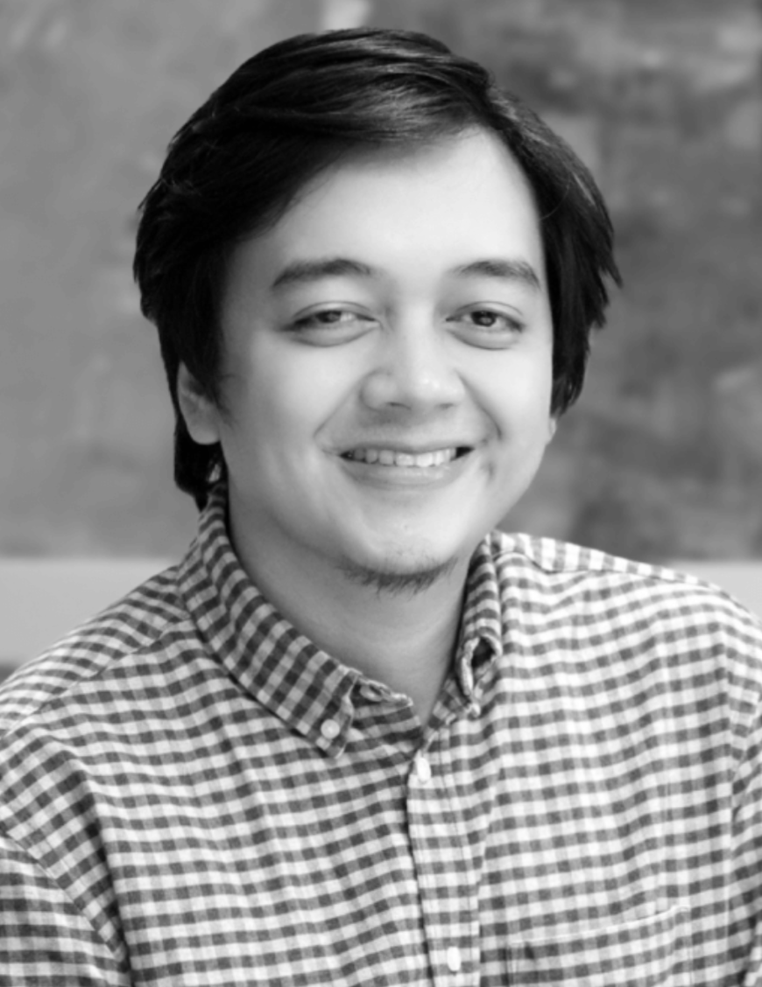

Raymond D. Baldonado
(Mon Baldonado)
Technical Director · Cloud Architect · Web 2, Web 3 & AI Lead
Manila, Philippines · mondbaldonado@gmail.com
GitHub: https://github.com/mondb-dev · LinkedIn: https://www.linkedin.com/in/mon-baldonado-builds/

Summary
Technical Director with 15+ years of experience leading the delivery of scalable web platforms. Specializes in AWS high-availability architecture and modern web ecosystems, while driving research and implementation in Agentic AI and blockchain systems.

Core Competencies
- Cloud Architecture: AWS · High Availability · Scalability · Security
- Web Platforms & Ecosystems: React · Node.js · Modern Web Technologies · API Architecture
- CMS & Digital Platforms: WordPress · Drupal · Sanity (Headless) · Shopify
- AI Systems: Agentic AI · LLM Orchestration · RAG Architectures
- Blockchain & Web3: Solana (Rust/Anchor) · EVM (Solidity) · dApp Development

Professional Experience
Co-Founder & Technical Director — Dthree Digital (2015–Present)
• Lead cloud, web, and AI strategy across enterprise and startup clients
• Architect highly available AWS infrastructures with 99.9% uptime
• Deliver enterprise, e-commerce, and headless CMS platforms
• Manage and mentor cross-functional engineering teams
Web3 Freelance Developer — 0xAnomalia (2022–Present)
• Develop Solana programs and EVM smart contracts
• Build NFT and DeFi decentralized applications
• Advise clients on blockchain architecture, security, and scalability
Technical Lead — Datavault Systems Inc. (2013–2014, Consultant thereafter)
• Led technical initiatives for high-volume data systems
• Architected scalable Node.js APIs and modular system components
• Directed migration from legacy systems to cloud-ready architectures
Lead Backend Developer — Starfish Internet Solutions (2012–2013)
• Led backend development for complex web platforms
• Ensured robust data architecture and system integrations
Information Technology Instructor — STI College (2016–2017, Part-time)
• Taught Systems Analysis, Web Development, and modern architectural patterns

Honors & Recognition
- National Champion — STI Intro to Programming
- Cluster Champion — STI Tagisan ng Talino
- Cluster Second & Third Placer — STI Programming Competitions

